HW_11_DS775

Jarrod Pelkofer

April 2, 2019

## 20.1-3e

sales <- c(rep(2,4), rep(3,7), rep(4,8), rep(5,5), 6)  
set.seed(44)  
sales_sim <- sample(sales, 300, replace = TRUE)  
mean_sim <- mean(sales_sim)  
mean_sim

## [1] 3.613333

1. The 300 day simulation resulted in an average of 3.613 stoves per day, .067 stoves/day less than the 25 day average.

## 20.6-6

simulations <- 1000  
  
purchasePrice <- 1.50  
salesPrice <- 2.50  
refundPrice <- 0.50  
  
copiesOrdered <- c(50:60)  
  
for(i in 1:length(copiesOrdered)){  
 set.seed(101)  
 copiesSold <- sample(40:70, simulations, replace = TRUE)  
 SalesRevenue <- salesPrice*pmin(copiesOrdered[i],copiesSold)  
 PurchasingCost <- purchasePrice*copiesOrdered[i]  
 Refund <- refundPrice*pmax(copiesOrdered[i]-copiesSold,0)  
 Profit <- SalesRevenue-PurchasingCost+Refund  
 avgProfit <- mean(Profit)  
 print(paste("Order Quantity:", copiesOrdered[i], "Mean:", avgProfit))  
}

## [1] "Order Quantity: 50 Mean: 46.27"  
## [1] "Order Quantity: 51 Mean: 46.536"  
## [1] "Order Quantity: 52 Mean: 46.74"  
## [1] "Order Quantity: 53 Mean: 46.876"  
## [1] "Order Quantity: 54 Mean: 46.942"  
## [1] "Order Quantity: 55 Mean: 46.932"  
## [1] "Order Quantity: 56 Mean: 46.87"  
## [1] "Order Quantity: 57 Mean: 46.758"  
## [1] "Order Quantity: 58 Mean: 46.598"  
## [1] "Order Quantity: 59 Mean: 46.356"  
## [1] "Order Quantity: 60 Mean: 46.06"

The average profit it highest at an order quantity of 54.

## HW 20.6-7

set.seed(333)  
Stocks_year0 <- 5000 * (1 + rnorm(1000, .08, .06))  
Stocks_year1 <- (2000 + Stocks_year0) * (1 + rnorm(1000, .08, .06))  
Stocks_year2 <- (2000 + Stocks_year1) * (1 + rnorm(1000, .08, .06))  
Stocks_year3 <- (2000 + Stocks_year2) * (1 + rnorm(1000, .08, .06))  
Stocks_year4 <- (2000 + Stocks_year3) * (1 + rnorm(1000, .08, .06))  
  
Bonds_year0 <- 5000 * (1 + rnorm(1000, .04, .03))  
Bonds_year1 <- (2000 + Bonds_year0) * (1 + rnorm(1000, .04, .03))  
Bonds_year2 <- (2000 + Bonds_year1) * (1 + rnorm(1000, .04, .03))  
Bonds_year3 <- (2000 + Bonds_year2) * (1 + rnorm(1000, .04, .03))  
Bonds_year4 <- (2000 + Bonds_year3) * (1 + rnorm(1000, .04, .03))  
  
Savings_year5 <- 4000  
  
College_Fund <- Stocks_year4 + Bonds_year4 + Savings_year5  
  
#a)  
avg_College_Fund <- mean(College_Fund)  
avg_College_Fund

## [1] 36076.34

#b)  
sd_College_Fund <- sd(College_Fund)  
sd_College_Fund

## [1] 1848.541

#c)  
prob_35K <- sum(College_Fund >=35000)/length(College_Fund)  
prob_35K

## [1] 0.715

#d)  
prob_40K <- sum(College_Fund >=40000)/length(College_Fund)  
prob_40K

## [1] 0.019

1. AVerage college fund at the end of year 5 would be $36,076.34.
2. The standard deviation of the college fund at the end of year 5 would be $1,848.54.
3. There is a probability of 71.5% that the college fund will be at least $35,000.
4. There is a probability of 1.9% that the college fund will be at least $40,000.

## HW 20.6-9

library(triangle)  
library(tidyverse)  
  
#a)  
project_cost <- 5  
bid_cost <- .05  
RPI_Bid <- 5.7  
RPI_Total_Cost <- bid_cost + project_cost  
RPI_Profit <- RPI_Bid - RPI_Total_Cost  
  
set.seed(99)  
competitor_1 <- rtriangle(1000, a = (project_cost*1.05), b = (project_cost*1.40), c = (project_cost*1.20))  
competitor_2 <- rtriangle(1000, a = (project_cost*1.05), b = (project_cost*1.40), c = (project_cost*1.20))  
competitor_3 <- rtriangle(1000, a = (project_cost*1.05), b = (project_cost*1.40), c = (project_cost*1.20))  
competitor_4 <- rtriangle(1000, a = (project_cost*1.05), b = (project_cost*1.40), c = (project_cost*1.20))  
  
RPI_Bids <- rep(RPI_Bid, 1000)  
min_bid <- pmin(RPI_Bids, competitor_1, competitor_2, competitor_3, competitor_4)  
prob_RPI_WIN <- sum(min_bid==RPI_Bid)/length(min_bid)  
  
profit <- double()  
for(b in 1:length(min_bid)){  
 if(min_bid[b] == RPI_Bid){  
 profit <- c(profit, RPI_Profit)  
 }else{  
 profit <- c(profit, -.05)  
 }  
}  
  
avg_profit <- mean(profit)  
  
  
#b)  
RPI_Bid <- seq(5.3,6.0, .1)  
avg_profits <- double()  
st_devs <- double()  
for(b in 1:length(RPI_Bid)){  
 profit <- double()  
 RPI_Bids <- rep(RPI_Bid[b], 1000)  
 min_bid <- pmin(RPI_Bids, competitor_1, competitor_2, competitor_3, competitor_4)  
 for(m in 1:length(min_bid)){  
 if(min_bid[m] == RPI_Bid[b]){  
 gain <- RPI_Bid[b] - RPI_Total_Cost  
 profit <- c(profit, gain)  
 }else{  
 profit <- c(profit, -.05)  
 }  
 }  
 st_devs <- c(st_devs, sd(profit))  
 avg_profits <- c(avg_profits, mean(profit))  
}   
  
parameter_report <- data.frame(RPI_Bid, avg_profits, st_devs)  
parameter_report

## RPI_Bid avg_profits st_devs  
## 1 5.3 0.2470 0.02986456  
## 2 5.4 0.3272 0.09278345  
## 3 5.5 0.3610 0.19135207  
## 4 5.6 0.3580 0.28002574  
## 5 5.7 0.3147 0.34986614  
## 6 5.8 0.2436 0.38578215  
## 7 5.9 0.1408 0.36803643  
## 8 6.0 0.0390 0.28488622

#c)  
ggplot(parameter_report, aes(RPI_Bid, avg_profits)) +  
 geom_line() +  
 geom_point() +   
 geom_ribbon(aes(ymin=avg_profits-st_devs, ymax=avg_profits+st_devs, x=RPI_Bid, fill = "band"), alpha = .3) +   
 scale_fill_manual("", values = 'grey12') +   
 labs(title = "Simulated Avg Profit", y = "Avg Profit (In Millions)", x = "RPI Bid (In Millions)") +  
 theme(legend.position = "none")

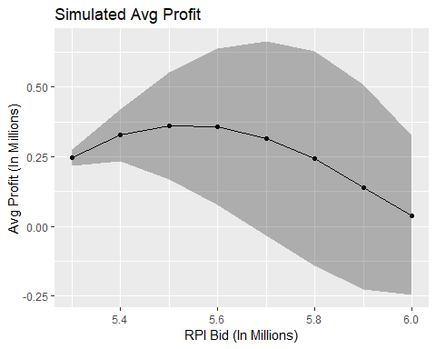

#d)   
  
RPI_Bid <- seq(5.3,6.0, .01)  
avg_profits <- double()  
st_devs <- double()  
for(b in 1:length(RPI_Bid)){  
 profit <- double()  
 RPI_Bids <- rep(RPI_Bid[b], 10000)  
 min_bid <- pmin(RPI_Bids, competitor_1, competitor_2, competitor_3, competitor_4)  
 for(m in 1:length(min_bid)){  
 if(min_bid[m] == RPI_Bid[b]){  
 gain <- RPI_Bid[b] - RPI_Total_Cost  
 profit <- c(profit, gain)  
 }else{  
 profit <- c(profit, -.05)  
 }  
 }  
 avg_profits <- c(avg_profits, mean(profit))  
}  
  
bid_profits <- data.frame(RPI_Bid, avg_profits)  
bid_profits %>% filter(avg_profits==max(avg_profits))

## RPI_Bid avg_profits  
## 1 5.53 0.36817

1. The probability that RPI will win the bid is 52.1%. The average profit would be $314,700.
2. A bid of $5.5 million maximizes RPI’s average profit.
3. Looking at 71 bid amounts and running 10,000 simulations on each, a bid of $5.53 million maximized the mean profit (368,170).

## HW 28.3

1. Uniform distribution with parameters(302, 496)
2. Max Extreme distribution with parameters(363.9972, 46.4134)

## HW 28.4

library(triangle)  
library(tidyverse)  
  
#a)  
sims <- 1000  
set.seed(333)  
funding <- rnorm(sims, 6, 1)  
design <- runif(sims, 6, 10)  
site_prep <- rtriangle(sims, 1.5, 2.5, 2)  
foundation <- rtriangle(sims, 1.5, 3, 2)  
framing <- rtriangle(sims, 3,6,4)  
electric <- rtriangle(sims, 2,5,3)  
plumbing <- rtriangle(sims, 3,5,4)  
walls_roof <- rtriangle(sims, 4,7,5)  
finish_work <- rtriangle(sims, 5,7,6)  
landscape <- rep(5, 1000)  
  
completion_times <- funding+pmax(design,site_prep)+foundation+pmax(electric,(framing + plumbing)) + walls_roof + pmax(finish_work, landscape)  
  
  
avg_completion_time <- mean(completion_times)  
avg_completion_time

## [1] 35.92028

#b)   
thirty_six <- sum(completion_times <= 36)/length(completion_times)  
thirty_six

## [1] 0.529

#c)   
tasks <- data.frame(funding, design, site_prep, foundation, framing, electric, plumbing, walls_roof, finish_work, landscape, completion_times)  
sensitivity <- as.data.frame(t(cor(tasks$completion_times, tasks)))

## Warning in cor(tasks$completion_times, tasks): the standard deviation is  
## zero

sensitivity <- sensitivity %>% rename(cor = V1)  
task <- c('funding', 'design', 'site_prep', 'foundation', 'framing', 'electric', 'plumbing', 'walls_roof', 'finish_work', 'landscape', 'completion_times')  
sensitivity <- data.frame(task, sensitivity$cor)  
sensitivity <- sensitivity %>% rename(cor = sensitivity.cor)  
ggplot(sensitivity %>% drop_na() %>% filter(cor < .99), aes(fct_reorder(task, cor), cor)) +  
 geom_bar(stat = 'identity') +  
 coord_flip() +  
 labs(title = 'Sensitivity Chart', x='Task')

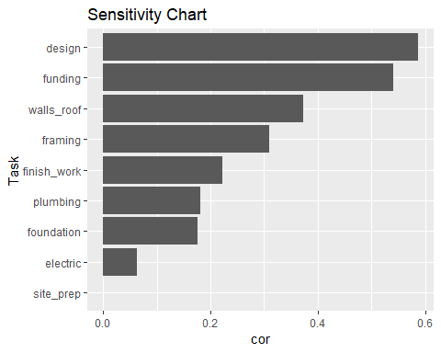

1. The average completion time of the project is 35.92 months over 1000 simulations.
2. There is a 52.9% chance that the project completes in 36 months or less.
3. Based on the sensitivity chart, the design of the builing is having the largest impact on completion time.

## 28.10

#a)  
available_seats <- 150  
operating_cost <- -30000  
ticket_price <- 300  
bump_cost <- -450  
  
reservations_accepted <- c(180:190)  
sim_Size <- 1000   
set.seed(1000)  
demand <- round(rnorm(sim_Size, 195, 30),0)  
  
avg_profit <- double()  
sd_profit <- double()  
for(i in 1:length(reservations_accepted)){  
 actual <- rbinom(sim_Size, pmin(reservations_accepted[i], demand), .80)  
   
 filled_seats <- pmin(available_seats, actual)  
 avg_filled_seats <- mean(filled_seats)  
   
 denied <- pmax(0, actual-available_seats)  
 avg_denied <- mean(denied)  
   
 profit <- operating_cost + (filled_seats*ticket_price) + (denied*bump_cost)  
 avg_profit <- c(avg_profit, mean(profit))  
 sd_profit <- c(sd_profit, sd(profit))  
}  
  
parameter_report <- data.frame(reservations_accepted, avg_profit, sd_profit)  
parameter_report

## reservations_accepted avg_profit sd_profit  
## 1 180 11633.55 3304.927  
## 2 181 11718.45 3193.581  
## 3 182 11780.25 3305.588  
## 4 183 11799.00 3271.755  
## 5 184 11875.50 3351.432  
## 6 185 11898.75 3284.338  
## 7 186 11875.20 3365.571  
## 8 187 11817.00 3337.312  
## 9 188 11874.00 3299.353  
## 10 189 11738.85 3352.839  
## 11 190 11734.95 3387.400

#b)  
ggplot(parameter_report, aes(reservations_accepted, avg_profit)) +  
 geom_line() +  
 geom_point() +  
 scale_x_continuous(breaks = c(180:190)) +   
 theme(legend.position = "none")

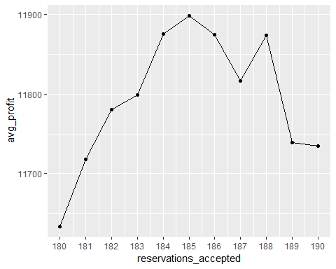

#c)  
reservations_accepted <- c(150:200)  
sim_Size <- 1000   
set.seed(1000)  
demand <- round(rnorm(sim_Size, 195, 30),0)  
  
avg_profit <- double()  
sd_profit <- double()  
for(i in 1:length(reservations_accepted)){  
 actual <- rbinom(sim_Size, pmin(reservations_accepted[i], demand), .80)  
   
 filled_seats <- pmin(available_seats, actual)  
 avg_filled_seats <- mean(filled_seats)  
   
 denied <- pmax(0, actual-available_seats)  
 avg_denied <- mean(denied)  
   
 profit <- operating_cost + (filled_seats*ticket_price) + (denied*bump_cost)  
 avg_profit <- c(avg_profit, mean(profit))  
 sd_profit <- c(sd_profit, sd(profit))  
}  
  
reservations <- data.frame(reservations_accepted, avg_profit)  
best <- reservations %>% filter(avg_profit == max(avg_profit))  
best

## reservations_accepted avg_profit  
## 1 185 11965.2

1. Over 1000 simiulations, accepting 185 reservations yielded the highest average profit (11,898.75). Accepting 180 reservations yielded the lowest average profit (12979.80).
2. Over 1000 simiulations, accepting 185 reservations yielded the highest average profit (11,965.20).