**Team 1 – System Design**

Matt, Erin, Quinton

**START: Below parts on Wednesday June 26th at 10:00am**

1. Package and Architecture Diagrams

* Description
* Diagram
* Build for Cohesion and Coupling

1. Database Tables

* Table Names and Headings
* Foreign Keys, Primary Keys, etc etc outlined

1. Languages Used & Version Used

* Function: Programming, Website User Interface, Database, etc
* Highlight strengths as to why we chose specific language or operating environment as well as to the concerns we have regarding it
* Version Used and system requirements that will impact our development and release

**DUE: Above parts to be done for 4:00pm Tuesday July 2nd**

* Architecture may require more investigation and later due date

**Team 2 – Programming Design**

Everyone other than those in Team 1

Responsible for your Use Case Diagram

*Note:*

* *Some shifting of who will and will not be doing certain methods will occur with Quinton’s Entities. Some people without Use Cases may now be responsible for some*
* *Richard, Henry, Chris -> Based on Quinton’s quote I will not be able to take any use cases off of you guys as I need to redistribute his*

**START: Below part on Wednesday June 26th at 10:00am**

1. 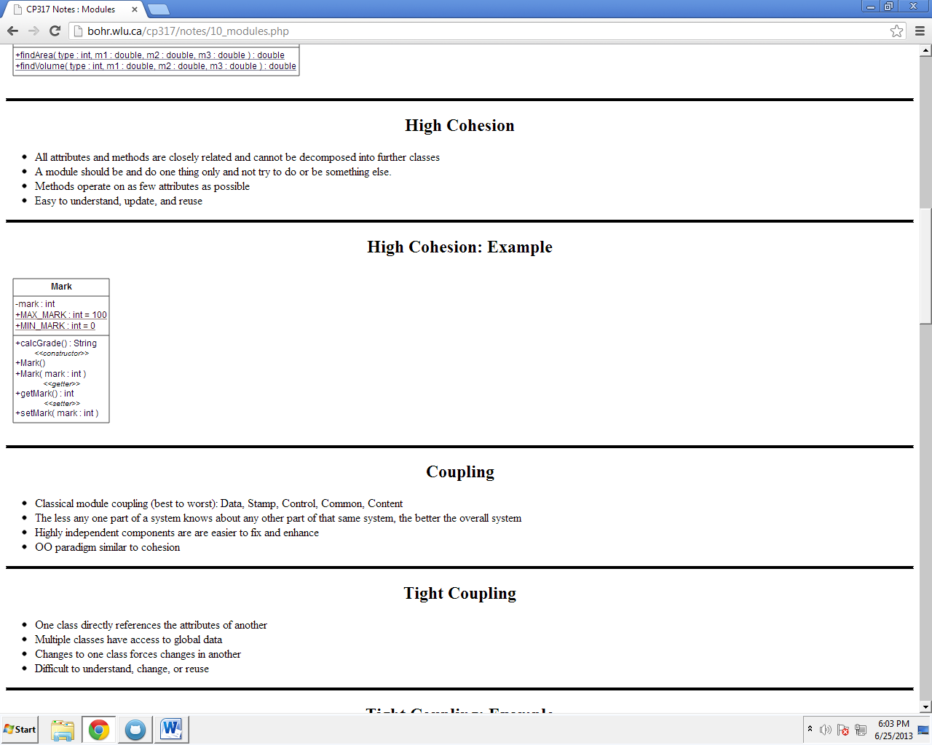Update UML Diagrams
   * Method Names
   * Private, Public, Protected
   * Parameters (i.e. playerID: String)
   * Separate based on:
     1. *<<constructor>>*
     2. *<<getter>>*
     3. *<<setter>>*
     4. *<<operations>>*
     5. *<<helper>>*
2. Method Library
   * Enter Corresponding information into posted HTML Template
   * Will look similar to below except accesses and changes will not be specific to files but incorporate other classes, views, databases, etc

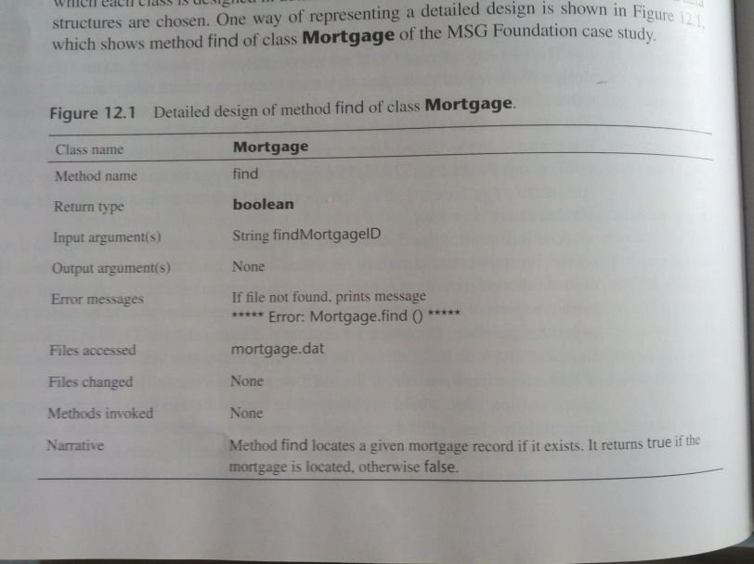

**DUE: Above parts to be done for 4:00pm Thursday June 27th**

**START: Below part on Saturday June 28th at 10:00am**

**(After go ahead from SQA Team has been received)**

1. Pseudo Code for each Method

* 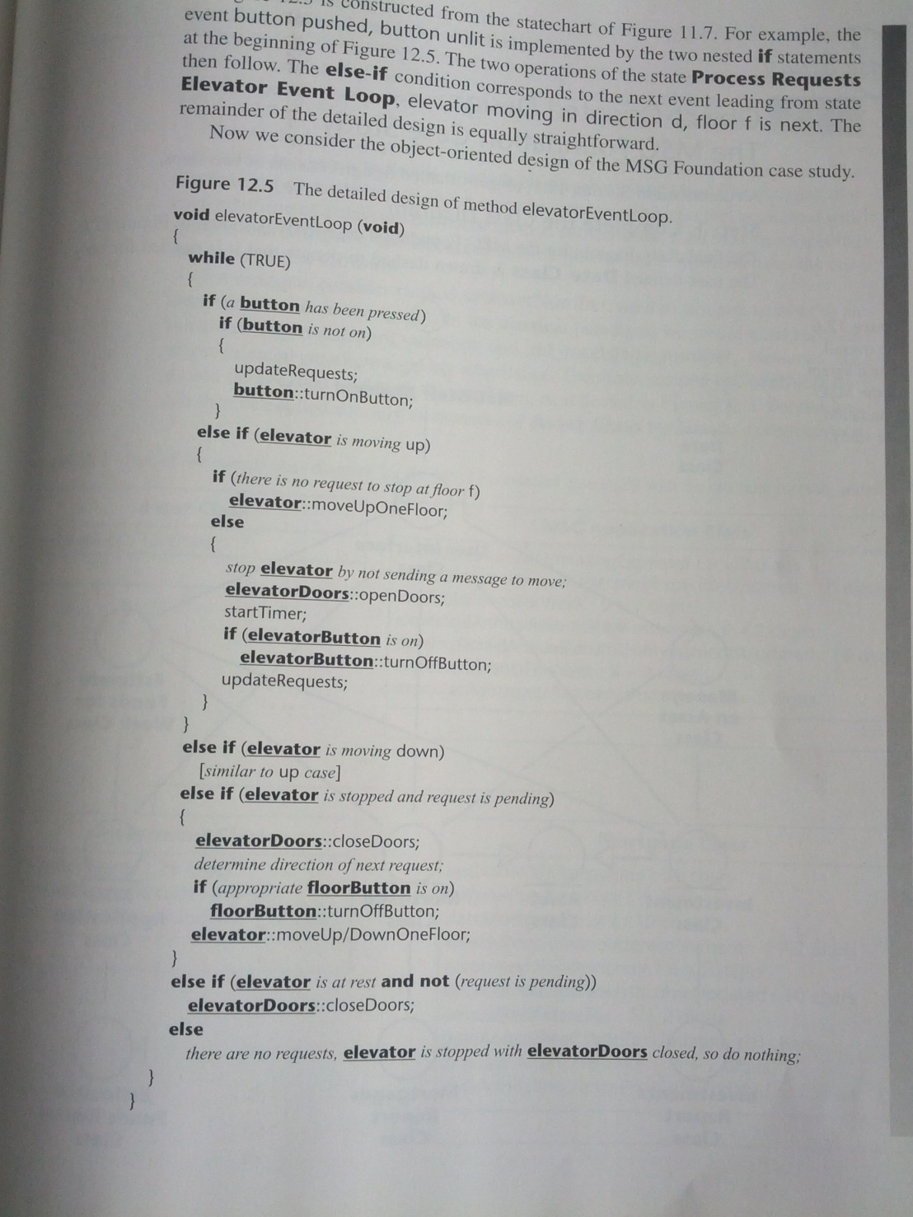Example below

**DUE: Above part to be done for 4:00pm Tuesday July 2nd**

This may be unrealistic but during the Tuesday meeting we will reconvene and see where everyone is

**Team 3 – SQA/Formatting**

Quinton (Head)

Colin

Henry

George

Erin (Formatting)

**START: Below part on Thursday June 27th at 6:00pm**

1. Review methods outlined

* Ensure consistency of naming with methods and variables used
* State variables (private, public) are correct to be properly accessed
* Access and changes to external data correct and accounted for

**DUE: Above part to be done for 11:59pm Friday June 28th**

**START: Below parts on Tuesday July 2nd at 6:00pm**

Assuming Pseudo Code completion

1. Review Pseudo Code for logical correction and error handling
2. Review Team 1’s work for cohesion, coupling, and logical correction

**DUE: Above parts to be done for 4:00pm Thursday July 4th**