**Summary of TrueSkill: How it Works and How to Use it**

**IN PROGRESS**

References:

http://trueskill.org/

http://research.microsoft.com/en-us/projects/trueskill/

http://www.moserware.com/2010/03/computing-your-skill.html

**How it works**

TrueSkills ranking system is based on two numbers: µ (mu) and $σ$ (sigma). mu is a arbitrary value reflecting a players skill. Sigma is an arbitrary value reflecting TrueSkills confidence in the mu value. Together, it ranks a player. Loosly, mu is based on the win/loss ratio of a player, and sigma is based on the number of games played (although there is MUCH more to both numbers behind the scenes, which we do not need to know to implement TrueSkill on Pong Tracker)

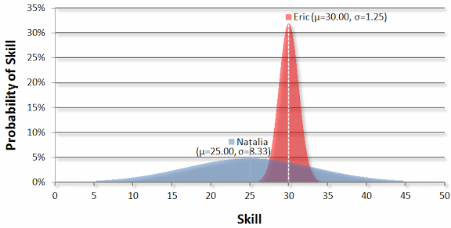

Sigma is the confidence TrueSkill has in a players mu value, and has to do with probability. In the above figure, we have two players, Natalia and Eric. Natalia has a sigma value of 8.33 (which makes her graph wide). TrueSkill, in her case, is saying that her mu is 25. However, her high sigma value says that the probability of her actually having a mu of 25 is low, so her true skill could be in the range from 5 to 45, the likelihood becoming less the farther from mu.

Eric, on the other hand, has a low sigma. TrueSkill is saying that it has confidence that his actual true skill value, mu, is very close to 30, and could be in a range from about 26 to 34, the likelihood falling off very steeply the farther from mu.

These two players, with mu values close to each other, are actually ranked very far apart.

When two players play a game against each other, both values are updated. How much these values change depend on both players mu and sigma values. A player who defeats a player with high mu and sigma values once will not see a huge change in their mu and sigma values. A player who defeats a player with high mu and sigma values many times will see a large change in their mu and sigma values, as TrueSkill becomes more confident that they can defeat high ranked players.

**Implementation**

Each player starts off with a mu value of 25, and a sigma of 8.33334.

We start by giving each player a Rating using the mu and sigma values stored in the database:

r1 = Rating(); // player 1 Rating

r2 = Rating(); // player 2 Rating

r3 = Rating(); // player 3 Rating

r4 = Rating(); // player 4 Rating

Each Rating contains mu and sigma for a given player.

This then allows us to set up teams using lists:

t1 = [r1, r2]; // team 1

t2 = [r3, r4]; // team 2

When a game is complete and confirmed, new TrueSkill mu and sigma values are calculated for each player. To do this, we use the rate() function, and specify who defeated who using a ranks list:

(new_r1, new_r2), (new_r3, new_r4) = rate([t1, t2], ranks=[0, 1]);

// team 2 defeated team 1

In Pong Tracker, two teams can NOT draw, so ranks can either be [0, 1] or [1,0], where 0 is loss and 1 is win.