RESEARCH REPORT
Human–AI Work Patterns in Software Development:
Archetypes, Paradoxes, and the Decline of Trust
A Repeated Cross-Sectional Analysis of the Stack Overflow Developer Survey | 2023, 2024, 2025

Imagination Applied Research Series
Imagination Applied Research Series | 2025

Abstract
This report presents a repeated cross-sectional data mining analysis of the Stack Overflow Developer Survey across 2023, 2024, and 2025, encompassing 203,812 combined survey responses from developers across up to 185 countries (177 in 2025; 185 in 2023 and 2024) (33,231 respondents with complete responses on the three core attitudinal features (AISelect, AIAcc, AISent) form the primary analytical sample for the 2025 analyses; secondary features were median-imputed or zero-coded where missing). Using clustering, association rule mining, and classification methods, we identify five heuristic AI adoption archetypes within the developer population, surface the attitudinal and behavioral predictors of daily AI use, and document a striking three-year pattern across successive survey cohorts: adoption is accelerating rapidly while trust and enthusiasm are in simultaneous, sharp decline. Because each year's survey is an independent cross-section, not a panel, these comparisons describe population-level shifts, not individual-level change.
AI usage among surveyed developers rose from 44.4% in 2023 to 78.5% in 2025. Over the same period, positive sentiment fell from 76.3% to 59.7%, negative sentiment grew from 3.2% to 20.4%, and the proportion who "highly distrust" AI output more than tripled, from 5.5% to 19.6%. On a harmonized denominator restricted to current AI users only — comparable across all three years — 2025 shows 39.3% high trust / 37.3% high distrust, versus 43.0% / 30.4% in 2024: a meaningful decline, though smaller than the full-denominator figures (which include non-users newly routed to the trust question in 2025). We term this the Adoption Paradox: rising adoption coincides with declining trust and sentiment — a pattern robust across all three survey years, though the cross-sectional design cannot establish causal direction.
Beyond the longitudinal picture, our classification analysis finds that how a developer feels about AI — their emotional orientation — is associated with daily adoption more strongly than trust, years of work experience, or years coding. Our frustration analysis identifies a transparency gap, not a quality gap, as the strongest correlate of distrust: developers are most demoralized when they cannot interrogate or take ownership of AI-generated output. And our learning pathway analysis finds that structured learning pathways are associated with substantially higher AI trust rates than informal peer learning — a pattern detailed in Section 7.3 with appropriate caveats on measurement precision.
These findings have direct implications for organizational AI adoption strategy and learning and development practice. The data are consistent with the hypothesis that ambient, self-directed adoption approaches are associated with lower trust rates than structured onboarding that builds both skill and ownership of AI-assisted workflows — though intervention claims should be treated as hypotheses suggested by the data rather than results established by it.

Keywords: AI adoption, developer sentiment, repeated cross-sectional survey analysis, k-means clustering, association rule mining, random forest classification, learning and development, organizational change

1. Introduction
The past three years have produced an extraordinary natural experiment in technology adoption. Beginning in late 2022, AI coding assistants moved from curiosity to mainstream, reaching the majority of software developers faster than almost any prior technology category. But adoption rates alone tell an incomplete and potentially misleading story. Averages conceal structure. Majorities contain multitudes.
Survey-based research on AI adoption — including annual reports from McKinsey and Microsoft/LinkedIn Workforce — has focused largely on headline adoption rates and aggregate sentiment scores. These aggregates are useful as directional signals but insufficient for practitioners trying to understand why some individuals cross into regular AI use while others do not, or what predicts the difference between a confident daily user and a skeptical occasional user. Organizations designing AI adoption programs cannot build interventions around averages; they need archetypes.
This report takes a different approach. Rather than tracking what the average developer thinks about AI, we apply data mining methods — clustering, association rule mining, and supervised classification — because these techniques are specifically suited to discovering latent subgroup structure within large heterogeneous populations; regression and descriptive statistics average across groups rather than revealing them. Our goal is to surface the latent structure within the developer population: who the adopters are, who the resisters are, what distinguishes them, and how the composition of those groups is shifting over time. We use the Stack Overflow Developer Survey — the largest annual survey of software developers, with 49,009 respondents in 2025 alone (per Stack Overflow’s published methodology; the CSV release contains 49,191 rows — see Appendix A.5 for reconciliation) — as our data source, analyzing three consecutive years (2023–2025) as repeated cross-sections. Because each survey year samples independently, comparisons over time reflect population-level shifts rather than individual-level change.
The central questions guiding this analysis are:
1. Does AI adoption among developers follow a spectrum, or do meaningful sub-groups exist?
2. What attitudinal, behavioral, and demographic factors are most strongly associated with daily AI adoption?
3. How are sentiment, trust, and usage patterns shifting over time, and do those trends cohere?
4. What practical levers do organizations have to accelerate adoption and reduce skepticism?

The answers, as we document below, are empirically grounded and practically relevant. Adoption is rising faster than trust is consolidating. The 2025 cross-section shows a substantial actively-resistant profile (19.0% of the AI-module sample). Whether this share is growing across years cannot be established without applying a consistent archetype rule to all three survey years, which this analysis does not do. The data suggest that trust-building interventions will be harder to execute as adoption norms solidify.

2. Related Work
Research on AI adoption at scale has been dominated by industry surveys that report aggregate headline figures. McKinsey’s State of AI surveys (McKinsey Global Institute, 2023, 2024) document rising enterprise AI investment and broad adoption intent, but present averaged statistics that obscure the population heterogeneity practitioners must navigate. Microsoft and LinkedIn’s Work Trend Index (Microsoft & LinkedIn, 2024) similarly surfaces aggregate skill-demand and adoption signals without modeling the attitudinal variance between individuals. These macro surveys provide essential context — and this report situates its longitudinal findings against their directional trends — but they do not answer the practitioner’s operational question: given that my organization contains enthusiastic adopters, skeptical non-users, and everyone in between, what actually is associated with who crosses into daily use, and what should I do differently for each group?
Classical technology adoption frameworks offer a theoretical foundation but were designed for population-level aggregate prediction rather than within-population segmentation. Davis’s Technology Acceptance Model (TAM; Davis, 1989) established perceived usefulness and perceived ease of use as the primary predictors of technology adoption intention. Venkatesh et al.’s Unified Theory of Acceptance and Use of Technology (UTAUT; Venkatesh et al., 2003) extended this framework to include social influence and facilitating conditions. Rogers’s Diffusion of Innovations (Rogers, 2003) introduced the now-standard adopter segmentation — innovators, early adopters, early majority, late majority, laggards — but operationalized it through theoretical typology rather than empirical cluster analysis. The archetype-discovery approach in this report operationalizes a Rogers-style segmentation empirically, grounding each archetype in measured attitudinal and behavioral profiles. Critically, our classification analysis departs from the TAM/UTAUT emphasis on perceived usefulness by showing that emotional orientation (sentiment) is a stronger predictor of daily adoption than either trust or competency — a finding that challenges the prevailing model’s focus on cognitive appraisal over affective orientation.
More proximate prior work on AI-specific adoption among software developers has focused primarily on productivity outcomes. GitHub’s Copilot research has evolved across several studies. Kalliamvakou (2022) measured task completion speed and productivity; code quality was noted as planned future work. Subsequent GitHub studies examined quality more directly: a 2023 study of Copilot Chat (GitHub, 2023) found self-reported quality improvements across readability, maintainability, and confidence metrics, and a 2024 randomized controlled trial with 202 developers (GitHub, 2024) reported statistically significant improvements in readability (+3.6%), reliability (+2.9%), and maintainability (+2.5%) for Copilot-assisted code. GitClear’s longitudinal analyses (GitClear, 2024) offered a contrasting view, finding increased code churn and reduced refactoring in AI-assisted repositories. Taken together, this literature suggests code quality effects of AI assistance are context-dependent and contested. These studies examine the consequences of adoption rather than the predictors of it, and they do not model the attitudinal heterogeneity within developer populations. The Stack Overflow Developer Survey, by contrast, captures attitudinal, behavioral, and demographic data across the full spectrum of AI engagement — from active resistance to daily integration — making it uniquely suited to a predictive segmentation analysis of this kind. To the authors’ knowledge, this is the first study to apply data mining methods (k-means clustering, association rule mining, and Random Forest classification) to the Stack Overflow AI module data across three consecutive years to identify adoption archetypes and their behavioral and attitudinal correlates.
The data mining methods employed here have established precedents in adjacent research domains. K-means clustering has been used extensively to segment learner populations in educational data mining (Romero & Ventura, 2010) and to identify customer adoption profiles in technology marketing research. Association rule mining, introduced by Agrawal and Srikant (1994), has been applied to behavioral survey data to surface co-occurring attitude-behavior patterns. Random Forest classification (Breiman, 2001) is the current state of practice for feature-importance estimation in behavioral survey contexts, given its robustness to collinearity, its ability to capture non-linear interactions, and its interpretable feature-importance output. The combination of these three methods applied to a large-scale longitudinal developer survey constitutes the methodological contribution of this report, complementing the substantive findings on adoption dynamics.

3. Data and Methodology

3.1 Data Source
All analyses use the Stack Overflow Developer Survey, conducted annually by Stack Overflow and made publicly available for research. The survey covers software developers and those who write code professionally or recreationally across 177 countries. For this study, we use three consecutive years:
Year | Survey N | AI Questions? | AI Respondents (AISelect)
2023 | 89,184 | Yes | 87,973 (98.6%)
2024 | 65,437 | Yes | 60,907 (93.1%)
2025 | 49,191† | Yes (expanded) | 33,720 (68.5%)
† CSV row count. Stack Overflow’s published methodology page reports 49,009 qualified responses. See Appendix A.5 for reconciliation.
Table 1. Survey sample sizes across years. Note the 2025 response rate for AISelect (68.5%) — see methodological note below.

Methodological Note: In 2025, only 68.5% of survey respondents answered the AI usage question (AISelect), compared to 93–99% in prior years. This likely reflects a survey redesign — possibly routing non-developers away from the AI module — though this specific explanation is an inference from the data pattern and is not documented in the publicly available 2025 methodology page. All 2025 adoption percentages are calculated as a proportion of the 33,720 who answered AISelect — representing the engaged developer population — not of all 49,191 respondents. The directional trend is valid; the absolute 2025 figure should be read as "78.5% of developers who engage with AI-related survey questions currently use AI tools." Note: Stack Overflow's published survey results page reports 33,662 AISelect respondents, while the downloadable CSV yields 33,720 — a 58-respondent difference likely attributable to dataset versioning between the public results page and the released CSV. The analytical sample of 33,231 used throughout this report is derived from the CSV and is unaffected by this minor discrepancy. A related discrepancy: Stack Overflow's official methodology page reports 49,009 total 2025 survey responses, while the downloadable CSV contains 49,191 rows — a difference of 182. This likely reflects post-publication quality filtering (e.g., removal of spam or incomplete submissions) applied to the results page but not yet reflected in the CSV release. The 203,812 combined-year total in this report is based on CSV row counts; using SO's published figure would yield approximately 203,630.

3.2 Key Variables
The Stack Overflow survey includes an extensive AI module that grew substantially between 2023 and 2025. The following variables are used across the analysis:
Variable | Question (verbatim) | Years Available | Scale
AISelect | Do you currently use AI tools in your development process? | 2023–2025 | Categorical (Yes/No variants)
AISent | How favorable is your stance on using AI tools...? | 2023–2025 | 6-point Likert
AIAcc / AIBen | How much do you trust the accuracy of the output from AI tools...? | All years* | 5-point Likert
AIThreat | Do you believe AI is a threat to your current job? | 2024–2025 | Yes / No / Unsure
AIComplex | How well do the AI tools you use handle complex tasks? | 2024–2025 | 5-point scale + N/A
AIAgents | Are you using AI agents in your work? | 2025 only | Frequency scale
AIFrustration | What frustrations have you encountered with AI tools? | 2025 only | Multi-select
LearnCodeAI | Did you spend time in the last year learning AI programming or AI-enabled tooling? | 2025 only | Yes/No (binarized)
AILearnHow | How did you learn to code for AI in the past year? | 2025 only | Multi-select
Table 2. Key variables across years. *AIBen in 2023, AIAcc in 2024–2025; identical question wording and Likert scale confirmed from schema files.

3.3 Feature Engineering
Categorical responses were encoded as ordinal numeric scores to enable distance-based clustering and regression-style classification. The core encodings are:
- AIUsageScore (0–4): Never → Daily, encoded from AISelect responses
- AITrustScore (0–4): Highly distrust → Highly trust, from AIAcc / AIBen
- AISentScore (0–5): Very unfavorable → Very favorable, from AISent
- AgentScore (0–2): No agent use → Active agent use, from AIAgents
- AIComplexScore (0–5): Very poor → Very well at complex tasks, from AIComplex
- LearnedAI (0/1): Binary flag derived from LearnCodeAI — "Did you spend time in the last year learning AI programming or AI-enabled tooling?" Coded 1 if respondent selected any 'Yes' response, 0 otherwise.

Experience and context variables were also engineered for use in the association rule mining analysis: ExpBucket (Junior → Veteran, from WorkExp), OrgBucket (Solo/Micro → Enterprise), WorkMode (Remote/Hybrid/In-Person), and PrimaryRole (simplified from the multi-select DevType column). Note: these contextual variables appear in association rules only; the 8-feature classifier uses only the attitudinal and experience variables listed in Section 3.4. The final analysis dataset for 2025 contained 33,231 respondents with sufficient AI data for clustering and classification (median imputation applied to work experience, years coding, and job-threat perception).

3.4 Analytical Methods

Clustering
We applied k-means clustering (scikit-learn) with StandardScaler normalization to six behavioral and attitudinal features: AIUsageScore, AITrustScore, AISentScore, AgentScore, AIComplexScore, and LearnedAI. Silhouette scores were computed for k=2 through k=8 with n_init=20 random restarts (seed=42). The statistical optimum was k=2 (silhouette=0.349), but k=5 was selected for analytical richness, as it produces five interpretively meaningful archetypes. This choice is transparent and justified on domain knowledge grounds; we report the silhouette scores for all k values. Cluster stability was confirmed by rerunning with three different random seeds (42, 99, 7), which produced identical silhouette scores (0.2837) and near-identical cluster size distributions. A methodological note: k-means assumes interval-scale, continuous features and Euclidean distance. The features used here are ordinal Likert-scale variables, for which equal numeric spacing is not guaranteed. More appropriate methods for ordinal data (k-prototypes, latent class analysis) were considered but not implemented, as the clustering goal was interpretive archetype generation rather than probabilistic class assignment. The archetypes should be read as useful approximations, not statistically optimal partitions. As a robustness check, we re-ran the clustering using k-modes (Huang, 1998), which treats features as categorical and uses Hamming distance — better suited to ordinal Likert data. At k=5, k-modes produced three clusters with strong correspondence to the k-means solution (Daily Integrators: ΔUsage=0.11, ΔTrust=0.25; Enthusiastic Adopters: ΔU=0.23, ΔT=0.28; Active Resisters: ΔU=0.06, ΔT=0.21) and two middle clusters with moderate-to-weak correspondence, suggesting the trust dimension is more algorithm-sensitive in the middle range. Notably, k-modes also showed no statistical elbow favoring k=2 — the cost curve decreases monotonically through k=6, confirming that the choice of k=5 for interpretive value is consistent across both algorithms.

Association Rule Mining
Transactions were constructed from discretized behavioral, attitudinal, demographic, and contextual features (usage bins, sentiment bins, trust bins, agent use, experience bucket, org size, primary role). The Apriori algorithm (mlxtend) was run with minimum support=0.07 and minimum lift=1.3, generating 1,198 rules. Rules were filtered and ranked by lift and confidence for interpretation.

Classification
We trained a Random Forest classifier (200 trees, min_samples_leaf=20, seed=42) and a Decision Tree (max_depth=5, min_samples_leaf=50, seed=42) to predict daily AI adoption (AIUsageScore=4) from 8 features: AI Sentiment, Agent Engagement, Learned AI, AI Trust, AI Complexity Rating, Job Threat Perception, Years Work Experience, and Years Coding. The full clustering sample (n=33,231) was used; missing values in all features were median-imputed before fitting. A stratified 80/20 train-test split was used (seed=42; test n=6,647). Five-fold cross-validation (StratifiedKFold, seed=42) yielded 77.9% ± 0.2% accuracy across folds, confirming the stability of the accuracy estimate. Feature importances from the Random Forest were used to identify the strongest predictors of daily adoption.

4. The Three-Year Pattern: 2023–2025 (Repeated Cross-Sections)

4.1 Adoption Is Accelerating
AI adoption among surveyed developers has grown sharply and consistently across all three years of this study. The proportion currently using AI tools rose from 44.4% in 2023 to 61.8% in 2024 to 78.5% in 2025 — a 34.1 percentage point increase over two years. Note on the 2023 figure: the paper computes 39,042 / 87,973 = 44.4%, where 87,973 is the count of respondents who answered AISelect in the 2023 CSV. Stack Overflow’s official results page reports 43.78% using 89,184 as the denominator (all 2023 respondents, including 1,211 who did not answer AISelect). Both figures refer to the same 39,042 current users; the difference is denominator choice. See Appendix A.5 for full reconciliation.

44.4%  2023 Adoption  39,042 / 87,973 answered | 61.8%  2024 Adoption  37,662 / 60,907 answered | 78.5%  2025 Adoption  26,469 / 33,720 answered | 47.1%  2025 — Daily Use  15,883 respondents

The 2025 figure is particularly notable: not only is 78.5% using AI tools, but 47.1% are doing so daily — nearly one in two surveyed developers has integrated AI into their everyday workflow. Note on denominators: Stack Overflow's published press materials cite 51% daily use, a figure filtered to professional developers (MainBranch = 'developer by profession'). Among those professionals who answered the AI usage question (n=26,045 of 37,467 total professional developers), this dataset yields 50.6% daily use — consistent with SO's published figure. The n=37,467 is total professional developers in the survey; the AI-question denominator is the smaller 26,045. A further 17.7% use AI tools weekly. Only 16.2% of 2025 respondents say they have no plans to use AI tools, down from 29.8% in 2023.
Methodological Note: The AISelect question changed wording in 2025. In 2023 and 2024 it asked for a binary Yes/No response; in 2025 it introduced frequency granularity (daily/weekly/monthly). The "currently using" figures across years (44.4%, 61.8%, 78.5%) remain directionally comparable, but the 2025 figure may slightly overestimate adoption relative to a consistent binary measure. The trend direction is consistent across both interpretations; treat the absolute 2025 number with this caveat noted.

4.2 The Adoption Paradox: Sentiment and Trust Are Going the Other Way
Against this backdrop of surging adoption sits one of the most striking findings in this dataset. In the same period that AI usage nearly doubled, favorable sentiment dropped 16.6 percentage points, negative sentiment rose by 17.2 percentage points (from 3.2% to 20.4%), and the proportion who "highly distrust" AI output more than tripled.

Metric | 2023 | 2024 | 2025 | Change 23→25
Positive sentiment | 76.3% | 72.0% | 59.7% | −16.6pp
Negative sentiment | 3.2% | 6.4% | 20.4% | +17.2pp
High trust (some/high) | 42.2% | 43.0% | 32.8% [39.3%*] | −9.4pp [−3.7pp*]
High distrust | 27.2% | 30.4% | 45.7% [37.3%*] | +18.5pp [+7.0pp*]
"Highly distrust" only | 5.5% | 7.9% | 19.6% | +14.1pp
Job threat: Yes | N/A | 12.1% | 15.0% | +2.9pp (24–25)
Table 3. Trust, sentiment, and threat perception across years. Trust (2023) is from AIBen; Trust (2024–2025) from AIAcc — identical question wording confirmed.

"More developers are using AI than ever before, while trust and enthusiasm are both sharply declining. These trends are not in tension — they are directionally consistent with a feedback loop between adoption and disillusionment, though cross-sectional data cannot establish causal direction."
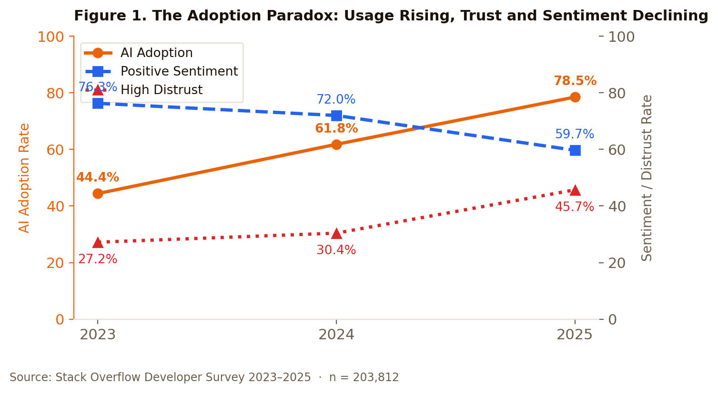
We interpret this pattern as follows. Rapid, under-supported adoption — accompanied by organizational mandates, professional pressure, and tool accessibility rather than structured onboarding — is correlated with large numbers of developers landing in the "occasional user" zone: enough exposure to encounter AI's limitations, not enough practice to develop the competence and workflow integration associated with confidence. The cross-sectional data cannot confirm this interpretation, but it is consistent with a pattern in which disappointed early adopters form skeptical, stable positions. We return to this in Section 7.
The trust picture is particularly stark. In 2023, the trust-to-distrust ratio was roughly 42:27 — trust led by 15 points. By 2025 it is 33:46 — distrust leads by 13 points on the full AIAcc denominator. Important caveat: the 2025 trust question was routed to all AISelect respondents (including non-users), while 2023 and 2024 were routed to current users only. When restricted to 2025 current users only (n=26,126), the harmonized figures are 39.3% high trust and 37.3% high distrust — still a substantial decline from 2024, but less dramatic than the headline figures suggest. Both cuts are shown in Table 3 (marked with *). The direction is robust; the magnitude should be read against this denominator caveat.

4.3 How Task Usage Has Shifted
The Stack Overflow survey asks which development tasks respondents are using AI for. Comparing 2023, 2024, and 2025 reveals meaningful shifts in where AI is being applied — though the comparison requires care due to question restructuring in 2025.
Task | 2023 | 2024 | 2025 | Trend
Writing Code | 34.9% | 45.1% | 29.1% | ↑ then ↓
Debugging / Fixing Code | 20.7% | 31.2% | 24.8% | ↑ then ↓
Documenting Code* | 14.5% | 22.1% | 22.9% | ↑↑↑
Testing Code | 10.1% | 15.0% | 12.9% | ↑ steady
Learning / Codebase | 12.7% | 17.0% | 18.7% | ↑ steady
Search for Answers | N/A | 37.1% | 36.2% | Stable
Generating Content | N/A | 19.2% | 20.4% | Stable
Project Planning | 5.7% | 6.7% | 9.8% | ↑ slow
Code Review | 4.3% | 7.3% | 12.0% | ↑↑
Table 4. AI task usage as % of all survey respondents. *2025 "Documenting Code" combines "Documenting code" (20.0%) and "Creating or maintaining documentation" (17.3%). These sub-categories have 7,061 respondents in common; the union is 22.9% of all respondents.

The most striking shift is in Documenting Code, which has grown from 14.5% in 2023 to 22.9% in 2025. Writing Code declined sharply from 45.1% to 29.1%. Search for Answers leads all tasks in 2025 at 36.2%, with Writing Code second. This pattern suggests a maturation: developers may be pulling AI back from core creative coding tasks (where quality concerns are highest) and redirecting it to surrounding, lower-stakes tasks like documentation, search, and code review. This repositioning is consistent with the frustration data we examine in Section 7.2.

5. Five Adoption Archetypes
The aggregate statistics above describe a population. The clustering analysis below reveals that this population contains five heuristic sub-groups — not a smooth spectrum, but interpretively distinct attitudinal and behavioral profiles that suggest different intervention priorities. These groupings are stable across random seeds but should be read as useful approximations rather than a discovered latent ground truth.

5.1 Clustering Methodology and Results
K-means clustering was applied to the 2025 survey population using six features: AI usage frequency, trust level, sentiment, agent engagement, complexity rating, and whether the developer had learned AI tooling in the past year. The working sample (n=33,231) was defined by complete responses on the three core attitudinal features (AISelect, AIAcc, AISent); missing values for AgentScore and AIComplexScore (present in ~4–6% of cases) were imputed with column medians, and LearnedAI missing values were coded 0. This differs from 'complete responses on all six features — the AIAgents question alone had 31,919 non-missing responses in the raw CSV. Silhouette analysis favored k=2 (score=0.349) statistically, reflecting a fundamental binary split between adopters and resisters. However, k=5 (score=0.284) was selected to produce actionably differentiated archetypes. The binary structure is itself a finding, discussed in Section 5.3.
The five resulting clusters are stable across random seeds and interpretable as coherent behavioral profiles. Cluster sizes are reported as a percentage of the 33,231 respondents with complete responses on the three core features (usage, trust, sentiment); see Appendix A.6 for full sample construction rules.

Archetype | Share | Usage | Trust | Sentiment | Agents | LearnedAI
Cautious Experimenters | 24.3% | 3.07/4 | 1.07/4 | 3.25/5 | Partial | 100%
Enthusiastic Adopters | 24.0% | 3.49/4 | 2.59/4 | 4.22/5 | Some | 99%
Active Resisters | 19.0% | 0.47/4 | 0.43/4 | 0.82/5 | Minimal | 10%
Daily Integrators | 17.6% | 3.83/4 | 2.61/4 | 4.44/5 | All | 93%
Pragmatic Dabblers | 15.0% | 2.63/4 | 1.86/4 | 3.61/5 | Some | 0%
Table 5. Cluster profiles. Usage: 0=Never, 4=Daily. Trust: 0=Highly Distrust, 4=Highly Trust. Sentiment: 0=Very Unfavorable, 5=Very Favorable. Agents: proportion actively using AI agents.
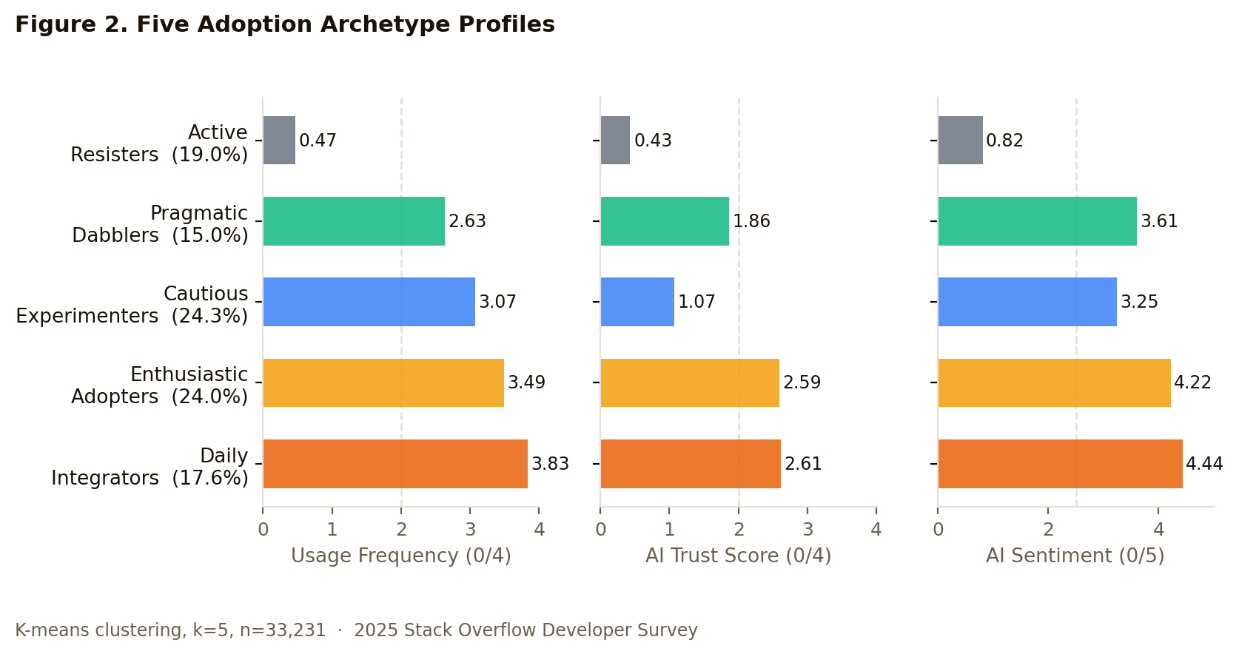

5.2 Archetype Profiles

Cautious Experimenters (24.3% | ~8,100 of clustered respondents)
This is the largest archetype and arguably the most strategically important. Cautious Experimenters are using AI tools regularly — their usage score of 3.07/4 indicates weekly-to-daily use — but trust has not followed. With a trust score of just 1.07/4 (between "somewhat distrust" and "highly distrust") against reasonably positive sentiment (3.25/5), these developers are willing to keep trying but have not yet crossed into genuine confidence. They have all learned a new AI tool in the past year, indicating engagement, but agent adoption within this group is uneven (agent score 0.59/2 — roughly a quarter are active agent users, while just over half have no agent engagement).
This group is not resisting AI — they are using it while harboring significant reservations about its output quality. They represent an unfinished adoption journey, a population that organizations have succeeded in moving to the tool but not yet to meaningful trust. In the absence of structured support, some fraction of this group is likely to slide toward the Pragmatic Dabblers or even Active Resisters over time.

Enthusiastic Adopters (24.0% | ~8,000 of clustered respondents)
Enthusiastic Adopters combine high usage (3.49/4), solid trust (2.59/4), and the highest-alongside-Daily-Integrators sentiment score (4.22/5). They have broadly positive orientations toward AI and use it frequently. The distinguishing feature is agent use: unlike Daily Integrators, Enthusiastic Adopters have not yet crossed into active agent use (score 0.45/2, indicating occasional rather than regular agent engagement). They are the "ready for the next step" group — equipped in attitude and habit but not yet operating at the frontier of AI-native workflows.

Active Resisters (19.0% | ~6,300 of clustered respondents)
Active Resisters are not simply non-users; they maintain a coherent, mutually reinforcing anti-AI posture. Usage is near zero (0.47/4), trust is at the floor (0.43/4), and sentiment is starkly negative (0.82/5 — between "very unfavorable" and "unfavorable"). Only 10% have learned any AI tool in the past year. They see no benefit, have not invested in learning, and show no sign of changing. The association rule analysis (Section 7) confirms this as a syndrome: these variables co-occur at lift levels above 4.9, meaning the full resister profile is far more than the sum of individual negative signals.
Active Resisters are typically misidentified as a change management target. The data suggests the returns on direct persuasion attempts with this group are likely low. The more productive question is whether organizational contexts can be designed so that this group does not become a drag on peers who are still in their adoption journey.

Daily Integrators (17.6% | ~5,850 of clustered respondents)
Daily Integrators represent the endpoint that AI adoption programs aspire to produce. Usage is at the daily ceiling (3.83/4), trust is high (2.61/4), sentiment is the most favorable of any cluster (4.44/5), and they are the only group with near-complete agent engagement (AgentScore 2.00 — actively using AI agents at work). They have moved beyond AI as a tool into AI as an integrated part of their professional workflow. Critically, their high trust and complexity ratings suggest they have developed genuine competency, not just familiarity.

Pragmatic Dabblers (15.0% | ~5,000 of clustered respondents)
Pragmatic Dabblers use AI occasionally (2.63/4 — between monthly and weekly), with moderate trust (1.86/4) and moderately positive sentiment (3.61/5). Distinctively, zero percent of this cluster has learned a new AI tool in the past year, suggesting a stable "use what you already know" orientation. They are not opposed to AI but are not investing in it either. This group responds best to demonstrated value — specific, concrete use cases that justify the effort of deepening engagement.

5.3 The Binary Underlying Structure
The statistical preference for k=2 over k=5 is itself a finding. With k=2, the silhouette score rises to 0.349, revealing that the developer population is fundamentally polarized between adopters (approximately 65% of the clustered population) and resisters (approximately 35%). The five archetypes are refinements within this binary split, not departures from it.
The association rules add texture to the resister profile. Rules with the highest lift values (>4.9) characterize developers who combine: negative sentiment, no agent use, no learning investment, low trust, and non-use — all simultaneously. The high lift means this full profile co-occurs far more than its components would predict independently, confirming that resistance is a coherent syndrome rather than a collection of independent reservations. Notably, the structural variables (role, org size, experience) produce rules with lift of only 1.3–1.8, indicating that behavioral and attitudinal factors predict adoption far better than demographic ones.

6. What Predicts Daily Adoption

6.1 Classification Results
To identify the strongest predictors of daily AI adoption, we trained a Random Forest classifier (200 trees) and a Decision Tree (max depth 5) on 33,231 respondents, using 8 features: AI Sentiment, Agent Engagement, Learned AI, AI Trust, AI Complexity Rating, Job Threat Perception, Years Work Experience, and Years Coding.
Model | Accuracy | Precision (Daily) | Recall (Daily) | F1 (Daily)
Random Forest (200 trees) | 77.1% | 75.5% | 79.3% | 77.4%
Decision Tree (depth 5) | 76.5% | 72.1% | 80.9% | 76.3%
5-Fold CV (RF) | 77.9% ± 0.2% | — | — | —
Table 6. Classification performance. Target: daily AI adoption (AIUsageScore=4). Test set n=6,647. Five-fold CV: 77.9% ± 0.2% (StratifiedKFold, seed=42).

77.1% accuracy on a binary classification task (47.1% daily adopters in the sample) represents a meaningfully predictive model. More important than the overall accuracy are the feature importances, which reveal which variables are doing the predictive work.

6.2 Sentiment Is the Strongest Predictor
Feature | RF Importance | Interpretation
AI Sentiment | 42.9% | Emotional orientation toward AI tools — dominant feature
Learned AI Tools (yr) | 16.3% | Invested in AI learning this year
Agent Engagement | 13.6% | Whether developer uses AI agents
AI Complexity Rating | 10.1% | How well developer believes AI handles complex tasks
AI Trust Level | 9.2% | Trust in AI output accuracy
Years Work Experience | 4.0% | Professional experience
Years Coding | 3.6% | Technical experience
Job Threat Perception | 0.6% | Whether developer sees AI as job threat
Table 7. Random Forest feature importances. AI Sentiment is the dominant predictor (42.9%), outweighing all other features in the 8-feature model — including AI Trust (9.2%), Agent Engagement (13.6%), and experience-level features combined. Note: Gini-based importance (used here) is known to favor features with more distinct values; AISentScore (6 levels) may be inflated relative to binary features such as LearnedAI. Permutation importance (10 repeats on the held-out test set) was computed as a robustness check: AISentScore remained the #1 predictor by a wide margin, and the same top-6 features appeared in both rankings, confirming the core finding is not an artifact of the Gini estimator.
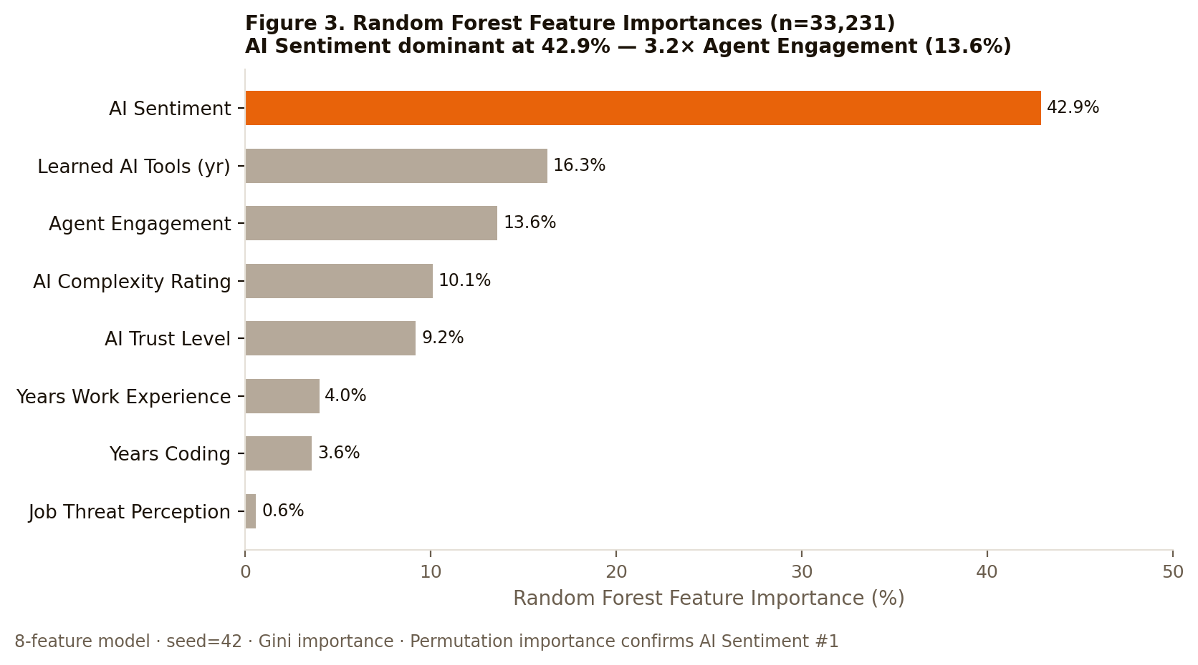
"How you feel about AI is more strongly associated with daily use than how much you trust it, how long you have been coding, or how many years you have coded."

This is the classification analysis's most consequential finding: AI Sentiment — the developer's emotional orientation toward AI — is the single strongest predictor of daily adoption, accounting for 42.9% of the Random Forest’s predictive power. It outweighs AI Trust Level (9.2%) by a factor of nearly five. It outweighs Years Coding (3.6%) by more than eleven times.
The Decision Tree's structure makes this vivid: in every high-confidence path to daily adoption, the first split is on sentiment. Developers with sentiment above 3.5 (between "indifferent" and "favorable") then proceed through agent engagement, learning behavior, and coding experience to reach a predicted probability approaching 95% for daily use. Every path to non-adoption also begins with sentiment, at or below 3.5.
Methodological Note: Sentiment and usage are both measured at a single point in time in the same survey. We cannot establish causal direction from this data: it is equally plausible that positive sentiment drives adoption, or that adoption shapes sentiment, or that both are driven by a third factor (such as workplace culture or individual personality). What we can say is that they are strongly associated, and that addressing sentiment — not just access or training — should be part of any adoption strategy. The temporal ordering of interventions matters.

7. The Mechanics of Skepticism
The aggregate trust decline documented in Section 4 is not uniform. The following analyses identify the specific pathways through which skepticism develops — and, by implication, the specific intervention points that could interrupt those pathways.

7.1 The Occasional-User Dip
One of the most actionable findings in this dataset is a non-linear relationship between usage frequency and trust. Examining mean trust scores by usage group reveals a valley at the "monthly or infrequent" level:
Usage Group | Mean Trust Score (0–4) | Interpretation
Won't Use AI | 0.58 | Baseline: opted out
Planning to Try | 1.64 | Pre-use optimism
Monthly / Infrequent Use | 1.31 | ← THE DIP
Weekly Use | 1.72 | Recovery begins
Daily Use | 2.21 | Highest trust
Table 8. Mean AI Trust Score by usage frequency. "Planning to try" scores higher than "monthly/infrequent" users — pre-use optimism exceeds first-contact reality.
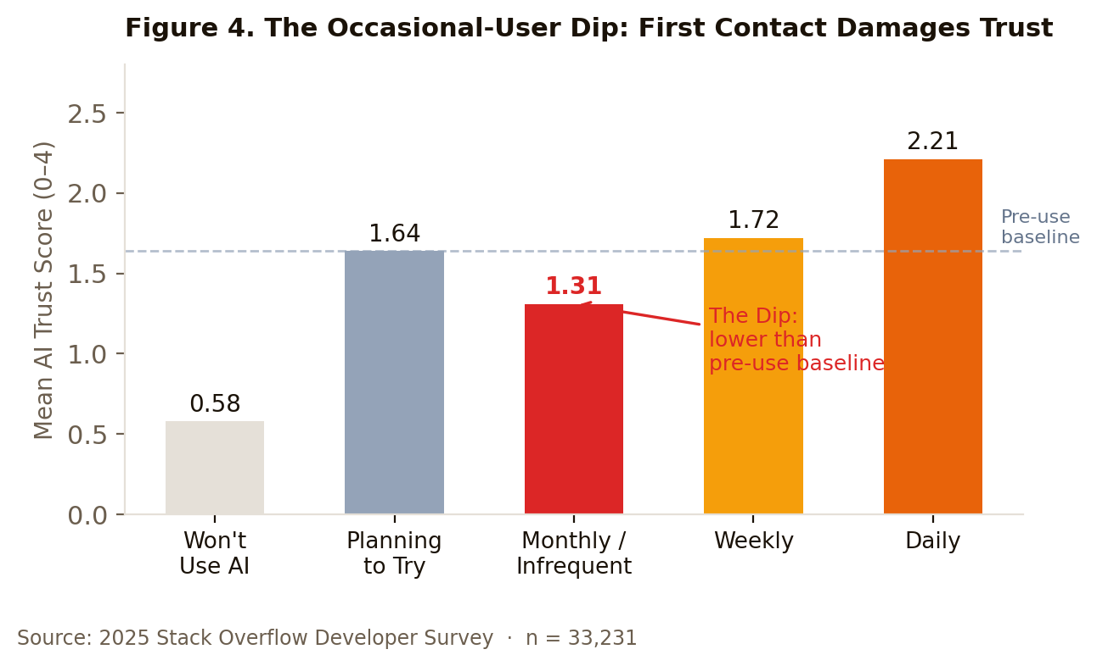
Developers who use AI monthly or infrequently trust it less than developers who have never used it but plan to. Their mean trust score (1.31) falls below both the "planning to try" group (1.64) and weekly users (1.72). The dip is not gradual — it is discrete. Something happens at the point of first contact that damages trust below baseline, and only further use begins to rebuild it.
We interpret this as the adoption valley: the gap between expectation and first-contact reality. Developers approach AI tools with a degree of optimism (reflected in the higher trust score among those planning to try). When they encounter the tool's limitations — partial outputs, non-explainable reasoning, slower debugging cycles — without the competence to navigate those limitations, trust drops. The critical insight is that continued use produces recovery: weekly users are back above the pre-use level, and daily users are highest of all. The danger zone is not pre-use; it is occasional use without sufficient support to cross the competence threshold.

7.2 Frustration and Distrust: An Associative Pattern
The survey asks developers to identify frustrations with AI tools. The analysis below examines the distrust rate — the proportion identifying as "somewhat" or "highly" distrusting AI — among developers who have experienced each frustration type. The ordering is revealing:
Frustration | n | Distrust Rate | Interpretation
Don't use AI regularly | 7,381 | 72.1% | Non-users (expected)
Debugging AI code is more time-consuming | 14,234 | 53.8% | ← Key finding
Hard to understand how/why code works | 5,128 | 47.3% | ← Key finding
Almost right but not quite | 20,771 | 42.5% | Largest group, lower distrust
Became less confident in own skills | 6,303 | 41.3% | Self-efficacy concern
No problems encountered | 1,236 | 12.4% | Satisfied users
Table 9. Distrust rate by frustration type. Transparency and ownership failures are associated with higher distrust rates than output quality failures.
The most important observation is what is not at the top of the distrust ranking. "Almost right but not quite" — the most commonly cited frustration, affecting 20,771 respondents — produces a distrust rate of 42.5%. But "debugging AI-generated code is more time-consuming" (14,234 respondents) produces a higher distrust rate of 53.8%, and "it's hard to understand how or why the code works" produces 47.3% distrust despite being less common.
The frustration most strongly associated with distrust is not that AI code is wrong. It is that AI code is hard to own. When developers cannot interrogate the logic behind AI output, cannot efficiently debug it when it fails, or cannot explain it to a colleague or reviewer, trust collapses. This is a transparency and workflow design problem, not a model quality problem. Better AI models will not solve it; better AI workflows — that preserve developer agency, explainability, and debugging efficiency — will.

7.3 How Learning Method Predicts Trust
Among the most practically actionable findings is the relationship between how a developer learned to use AI and how much they trust it. The spread across learning methods is 29 percentage points — larger than many structural variables practitioners typically focus on. Important caveat on precision: this gap is anchored at the top by the bootcamp cohort (66.5%, n=495), which is large enough to be directionally meaningful but small enough that the specific rate is sensitive to composition. When restricted to single-method learners, the bootcamp group shrinks to n=21, making the precise magnitude unreliable at that end. The directional finding — structured learning is associated with substantially higher trust rates than informal peer-to-peer transfer — is robust; the "29 points" headline should be understood as an indicative spread, not a precise measurement.
Learning Method | Trust Rate | n | Category
Coding Bootcamp | 66.5% | 495 | Structured
Online Courses / Certs | 52.4% | 3,373 | Structured-digital
School / University | 48.4% | 1,204 | Structured
Games / Coding Challenges | 48.0% | 633 | Active practice
YouTube / Videos | 45.5% | 8,360 | Self-directed
AI Tools (self-taught) | 44.3% | 11,358 | Self-directed
Books / Physical Media | 43.0% | 1,761 | Self-directed
Blogs / Podcasts | 41.2% | 6,240 | Self-directed
Stack Overflow / SE | 40.9% | 3,673 | Community-based
Online Search / Forums | 39.7% | 9,720 | Self-directed
Technical Documentation | 39.4% | 9,327 | Self-directed
Colleague / On-the-Job | 37.3% | 4,715 | Informal
Table 10. Trust rate by AI learning method. Structured learning pathways are consistently associated with higher trust rates than informal or self-directed methods.
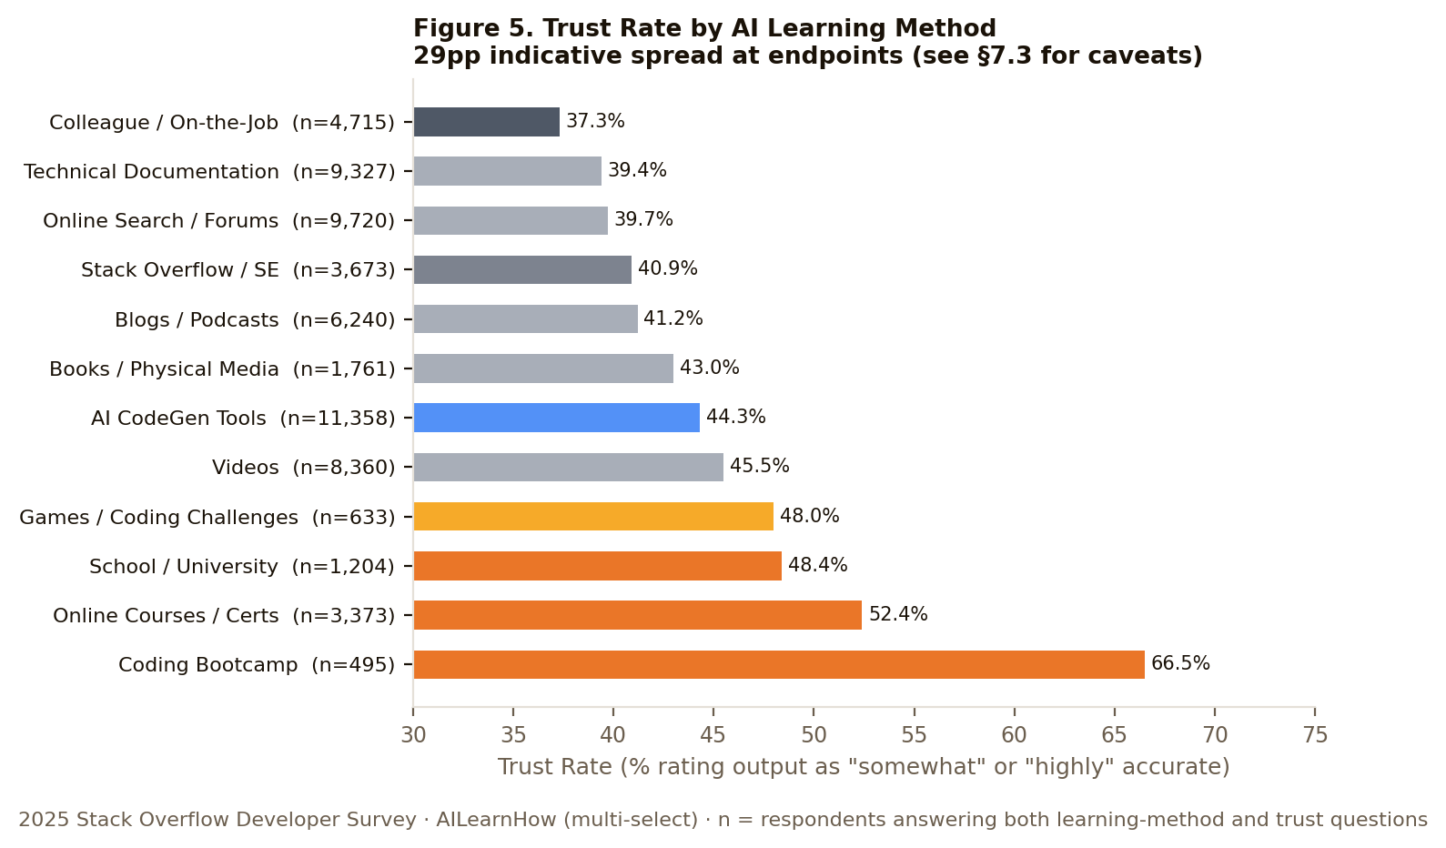
Developers who learned AI through structured channels — coding bootcamps (66.5%), online courses (52.4%), or school (48.4%) — trust AI output substantially more than those who learned informally. The lowest trust rate belongs to colleague or on-the-job training (37.3%) — the most common default in organizational settings.
This finding implicates a self-reinforcing problem. Organizations that rely on informal peer-to-peer knowledge transfer to onboard employees to AI tools are associated with the lowest-trust cohorts in this dataset. Those low-trust users become the colleagues who informally train the next wave of learners. The pattern is consistent with a self-reinforcing dynamic. Structured, intentional learning pathways are associated with substantially higher trust rates and may represent a lever for breaking that pattern — though intervention claims should be treated as hypotheses the cross-sectional data suggests, not effects it establishes.
Methodological Note: A potential confound: bootcamp learners skew younger (24% aged 18–24 vs. 11% for colleague-trained), and younger developers may be more positively oriented toward AI independently of how they learned it. The trust gradient across methods is large enough that it is unlikely to be fully explained by age, but a controlled study with matched samples would strengthen the causal inference here. A second limitation: the AILearnHow question is multi-select, meaning a single respondent may appear in multiple rows of Table 10. The trust rates reported are therefore for populations who used a given method, not for mutually exclusive groups. The 29-percentage-point gap between bootcamp and colleague learning reflects the difference in trust rates between two overlapping populations, not two cleanly separated cohorts. Analyses restricted to respondents who selected only one learning method (n=5,216) confirmed the key directional finding: structured methods (bootcamp, online courses, school) consistently outperform informal methods (colleague/on-the-job) in trust rates, and colleague learning remains last in both analyses. Mid-ranking positions shift meaningfully in the single-method subset, and the bootcamp group shrinks to n=21, making its specific rate unreliable. The 29pp gap headline should be understood as robust at the endpoints; the precise ordering of middle-tier methods is more sensitive to the multi-select overlap than the headline claim.

8. Unexpected Patterns

8.1 The Job Threat Paradox
A counterintuitive finding emerges from the job threat data. Developers who believe AI threatens their current job use AI tools more frequently than those who do not feel threatened:
Job Threat Perception | Mean AI Usage Score | Mean Trust Score | n
Yes — AI threatens my job | 3.047 | 1.977 | 4,748
I'm not sure | 2.854 | 1.818 | 7,043
No — AI does not threaten | 2.668 | 1.612 | 21,335
Table 11. AI usage and trust by job threat perception. Threatened developers use AI more, and also report higher trust scores, than non-threatened peers — a counterintuitive pairing examined in the text.

This directly contradicts the "fear causes avoidance" model that most change management frameworks assume. Developers who feel threatened by AI are not withdrawing from it — they are hedging. They are using the tool that might replace them, possibly to understand its capabilities better, possibly to build competency as a defensive measure, possibly because their organizational context is mandating use more forcefully for precisely the roles most at risk.
The trust picture is equally interesting: threatened developers also score higher on trust (1.977) than non-threatened developers (1.612). They distrust AI less than those who see no threat — perhaps because they have formed more realistic assessments of what AI can and cannot do. This is not complacent trust; it is informed engagement.
The practical implication is that threatened workers need a different intervention than is typically designed. They are not resisters who need persuasion. They are anxious early adopters who need scaffolding: structured pathways to build genuine competency quickly, and organizational signals that their engagement is recognized and rewarded.
Methodological Note: Causality cannot be established from cross-sectional data. An alternative interpretation: heavy AI users may be more aware of AI's capabilities and therefore more inclined to perceive a job threat. Both directions are plausible and the data does not distinguish them.

8.2 The Agent Realism Shift
A second unexpected pattern emerges from the agent use data. Comparing sentiment distributions across agent engagement levels, weekly agent users show higher "Favorable" sentiment (51.3%) than daily agent users (36.7%). But the picture is more nuanced than it first appears.
Daily agent users have near-zero "Very Unfavorable" sentiment (0.8%) and the highest proportion of "Very Favorable" responses (54.0%). Weekly users show more "Favorable" responses but also more "Unfavorable" ones. Daily agent users also score highest on both trust (compared to non-agent users) and complexity ratings — they have the most favorable assessment of what AI can actually do.
What this pattern describes is a realism shift. Weekly agent users are in the honeymoon phase — enthusiastic, moderately positive. Daily agent users have moved past enthusiasm into something more durable: pragmatic confidence. The "Favorable" percentage drops not because experience is negative, but because "Very Favorable" — a category of genuine conviction — absorbs the distribution. This is what mastery looks like in survey data.

8.3 Stack Overflow's Most Engaged Users Are Most AI-Resistant
Among the contextual findings, one carries a notable meta-irony. Developers who visit Stack Overflow multiple times per day — the platform's most engaged power users — show the lowest mean AI usage score (2.38) and the highest AI opt-out rate of any visit frequency group. Usage scores broadly decrease as SO visit frequency increases, reaching 3.04 among infrequent (once every 2–3 months) visitors and 2.38 among those visiting multiple times per day.
The most plausible interpretation: Stack Overflow power users rely on human-curated, peer-reviewed knowledge as their primary problem-solving resource. AI search represents a direct substitution threat to that ecosystem, and these developers have the most invested in the existing system. They are not naive about AI; they have chosen to privilege verifiable, community-validated answers over probabilistic AI output. This is a principled position, not a failure of understanding.

9. Implications for Practice
The findings above, taken together, constitute a clear argument for a specific model of organizational AI adoption. The following implications are grounded directly in the data.

9.1 Adopt an Archetype-Based Strategy, Not a One-Size Approach
Twenty-four percent of the developer population are Cautious Experimenters — using AI regularly but without trust. Twenty-four percent are Enthusiastic Adopters, close to the frontier but not yet using agents. Nineteen percent are Active Resisters with a stable, self-reinforcing anti-AI posture. Fifteen percent are Pragmatic Dabblers waiting to be convinced. Seventeen percent are Daily Integrators already at the destination.
These groups need different interventions. Cautious Experimenters need trust-building: structured workflow integration, ownership-preserving practices, and explicit attention to debuggability and explainability. Enthusiastic Adopters need a path to agent use and deeper integration. Pragmatic Dabblers need demonstrated concrete value. Active Resisters show a coherent, mutually reinforcing posture that has not yielded to adoption pressure — though this cross-sectional snapshot cannot confirm whether individuals in this cluster are permanently fixed. The more productive organizational question may be how to design workflows that don't create friction for colleagues who are still in their adoption journey, while leaving the door open for individual movement.

9.2 Design for the Adoption Valley
The occasional-user dip is the clearest finding with the most direct organizational intervention. Developers who are given access to AI tools without structured onboarding are likely to pass through the valley — encountering AI's limitations before developing the competency to navigate them — and emerge skeptical. Occasional, unsupported use is worse for trust than no use at all.
Organizations should design AI onboarding to move people through the valley quickly: structured use cases that build early competency, explicit guidance on AI's strengths and limitations, and feedback mechanisms that help developers calibrate expectations before they harden into distrust. The goal is to prevent trust from bottoming out in the occasional-use zone.

9.3 Replace Informal Adoption With Structured Learning
The directional trust gap between structured and informal learners — approximately 29 percentage points at the extremes — is among the strongest practical signals in this dataset, though as noted in Section 7.3, the precision of the specific magnitude should not be overstated. Organizations that rely on AI tools to spread organically through peer-to-peer informal knowledge transfer show consistently lower trust rates in this dataset. The colleague-trained cohort trusts AI less than every other learning pathway measured.
This is not an argument against peer learning in general; it is a specific caution about unstructured, ambient AI onboarding. Structured programs — whether formal courses, facilitated workshops, or cohort-based learning — are associated with higher trust rates and may support more capable and productive AI use, though this cross-sectional data cannot establish that direction. The investment in designed learning experiences pays dividends in adoption quality, not just speed.

9.4 Address Emotional Orientation, Not Just Competency
The classification finding that AI Sentiment is a stronger feature than AI Trust in predicting daily adoption — in the statistical sense — reframes the standard adoption model. Most enterprise AI adoption programs are built around access + training = usage. The data suggests the more accurate model is: access + training + positive emotional orientation = daily adoption.
Emotional orientation toward AI is shaped by early experiences, by peer culture, by organizational framing, and by the narrative in which AI tools are introduced. Organizations that introduce AI as "a tool to reduce costs" or "a productivity mandate" are likely to generate a different emotional orientation than those that introduce it as "a way to reclaim time for the work you find most meaningful." The framing matters. The story matters. These are learning design and change management questions, not technology questions.

9.5 Prioritize Transparency and Ownership in Workflow Design
The frustration data consistently point to a pattern: the most trust-damaging AI interactions are those in which developers lose ownership of and visibility into the output. Debugging AI-generated code that is slow to diagnose, code whose logic is opaque, code that developers cannot stand behind in review — these experiences damage trust more than AI being simply wrong.
Workflow design should prioritize AI-assisted practices that preserve developer agency and explainability. This means favoring incremental AI assistance over wholesale AI generation, building review and understanding into AI-assisted workflows rather than treating AI output as complete, and explicitly rewarding the practice of understanding (not just using) AI-generated output. These are not AI configuration questions; they are organizational and learning design questions.

10. Limitations
This analysis is subject to the following limitations, which should be considered when interpreting findings and designing interventions based on them.

10.1 Self-Report Bias
All data is self-reported survey data. Developers may over-report AI adoption to signal competence or professional currency, or under-report frustrations to avoid appearing incompetent. There is no behavioral ground truth against which to validate these figures. The patterns across questions are internally consistent, and directional comparisons with macro surveys (Gallup, McKinsey) are broadly aligned, but absolute figures should be treated with appropriate caution.

10.2 Cross-Year Comparability
Four methodological issues affect year-over-year comparisons. First, the AISelect question changed wording in 2025, making the adoption trend directionally valid but not perfectly comparable. Second, the trust question appears under different column names (AIBen in 2023, AIAcc in 2024–2025), though we confirmed identical question wording from the schema files. Third, 2025's survey response rate for the AI module dropped to 68.5%, compared to 93–99% in prior years, which may introduce selection effects into the 2025 figures. Fourth, and most consequentially for the trust trend: in 2023 and 2024, the trust question (AIAcc/AIBen) was routed to current AI users only; in 2025 it was asked of all AISelect respondents, including non-users and those planning to use AI. Non-users show dramatically lower trust (8.9% high trust vs. 39.3% for current users in 2025), which means the paper's headline 2025 trust figures (32.8% high trust, 45.7% high distrust) are not directly comparable to 2023/2024. On a harmonized user-only denominator (n=26,126), 2025 shows 39.3% high trust and 37.3% high distrust — still a substantial decline from 2024 (43.0% / 30.4%), but considerably less dramatic. Both figures are reported in Table 3.

10.3 Cross-Sectional Causality
All findings are correlational. In particular, the classification finding that AI Sentiment is associated with adoption is based on co-measured variables: sentiment and usage are both assessed at the same point in time. The causal direction cannot be established from this data. Similarly, the learning method → trust finding may be partly explained by pre-existing orientation differences between developers who seek out structured courses versus those who rely on informal learning.

10.4 Clustering Methodology
The choice of k=5 clusters is justified on interpretability grounds, not statistical grounds. The silhouette optimum is k=2 (score=0.349). K-means with k=5 achieves a silhouette of 0.284. The five heuristic archetypes are stable across seeds and interpretable, but they represent a deliberate choice to prioritize actionability over statistical parsimony. Readers should understand that the "true" cluster structure is more binary than the five-archetype frame suggests.

10.5 Generalizability
The Stack Overflow survey skews toward professional developers, particularly those active on the platform. It underrepresents some developer populations (notably those in regions with lower Stack Overflow penetration) and over-represents others. The findings apply most directly to professional software developers in North America, Europe, and major technology hubs. The principles may generalize to other technical knowledge worker populations, but this extrapolation should be made cautiously.

11. Conclusion
The story that the aggregate data tells about AI adoption is incomplete at best and misleading at worst. Yes, adoption is up — dramatically. But behind the headline figures lies a more complicated picture: a population that is more divided than it has ever been, where the 2025 cross-section shows a substantial actively-resistant profile (19% of the AI-module sample), and where patterns that might be expected to build trust — more usage, more exposure — are instead associated with lower trust among occasional users.
The Adoption Paradox is real, it is measurable, and it is accelerating. In 2023, 76% of surveyed developers were favorably disposed toward AI tools; by 2025, that figure was 60% and falling. "Highly distrust" has gone from a marginal position (5.5%) to a mainstream one (19.6%) in two years. These are not rounding errors or survey noise. They are structural shifts in how a professional community is relating to a technology category.
But the data also contains grounds for optimism about what is achievable with intentional practice. Daily Integrators — the 17.6% of developers who have reached the destination of confident, agent-enabled daily AI use — show that the endpoint is real and achievable. The five archetypes give organizations a map of where their people are. The learning pathway data gives them a lever: structured learning is associated with substantially higher trust rates. The frustration data gives them a design brief: preserve ownership, preserve explainability, preserve debuggability.
The fundamental argument of this report is that adoption rates are the wrong metric. Organizations that are measuring AI adoption success by the percentage of employees who have access to, or have tried, AI tools are measuring the wrong thing. The right metric is confident, trusting, daily integration — the Daily Integrator profile. Getting people to that destination requires understanding where they are starting from, how adoption valleys form, what makes skepticism crystallize, and why the story you tell about AI in the learning environment matters as much as the tool you hand people.
"The organizations that will succeed with AI are not the ones that move fastest to adoption. They are the ones that invest in the journey — and understand that how people feel about AI shapes whether they use it every bit as much as whether they have access to it."

References
Agrawal, R., & Srikant, R. (1994). Fast algorithms for mining association rules. Proceedings of the 20th International Conference on Very Large Data Bases (VLDB), 1215, 487–499.
Breiman, L. (2001). Random forests. Machine Learning, 45(1), 5–32. https://doi.org/10.1023/A:1010933404324
Davis, F. D. (1989). Perceived usefulness, perceived ease of use, and user acceptance of information technology. MIS Quarterly, 13(3), 319–340. https://doi.org/10.2307/249008

GitClear. (2024). Coding on Copilot: 2023 data suggests copilots are introducing downward pressure on code quality. GitClear Research. https://www.gitclear.com/coding_on_copilot
GitHub. (2023, October 10). Research: Quantifying GitHub Copilot’s impact on code quality. GitHub Blog. https://github.blog/news-insights/research/research-quantifying-github-copilots-impact-on-code-quality/
GitHub. (2024, November 18). Does GitHub Copilot improve code quality? Here’s what the data says. GitHub Blog. https://github.blog/news-insights/research/does-github-copilot-improve-code-quality-heres-what-the-data-says/
Huang, Z. (1998). Extensions to the k-means algorithm for clustering large data sets with categorical values. Data Mining and Knowledge Discovery, 2(3), 283–304. https://doi.org/10.1023/A:1009769707641
Kalliamvakou, E. (2022, September 7). Research: Quantifying GitHub Copilot’s impact on developer productivity and happiness. GitHub Blog. https://github.blog/news-insights/research/
MacQueen, J. B. (1967). Some methods for classification and analysis of multivariate observations. Proceedings of the 5th Berkeley Symposium on Mathematical Statistics and Probability, 1, 281–297. University of California Press.
McKinsey Global Institute. (2023). The state of AI in 2023: Generative AI’s breakout year. McKinsey & Company. https://www.mckinsey.com/capabilities/quantumblack/our-insights/the-state-of-ai-in-2023
McKinsey Global Institute. (2024). The state of AI in early 2024: Gen AI adoption spikes and starts to generate value. McKinsey & Company. https://www.mckinsey.com/capabilities/quantumblack/our-insights/the-state-of-ai-in-early-2024
Microsoft & LinkedIn. (2024). 2024 Work Trend Index: AI at work. Microsoft. https://www.microsoft.com/en-us/worklab/work-trend-index
Pedregosa, F., Varoquaux, G., Gramfort, A., Michel, V., Thirion, B., Grisel, O., Blondel, M., Prettenhofer, P., Weiss, R., Dubourg, V., Vanderplas, J., Passos, A., Cournapeau, D., Brucher, M., Perrot, M., & Duchesnay, E. (2011). Scikit-learn: Machine learning in Python. Journal of Machine Learning Research, 12, 2825–2830.
Rogers, E. M. (2003). Diffusion of innovations (5th ed.). Free Press.
Romero, C., & Ventura, S. (2010). Educational data mining: A review of the state of the art. IEEE Transactions on Systems, Man, and Cybernetics, Part C, 40(6), 601–618. https://doi.org/10.1109/TSMCC.2010.2053532
Rousseeuw, P. J. (1987). Silhouettes: A graphical aid to the interpretation and validation of cluster analysis. Journal of Computational and Applied Mathematics, 20, 53–65. https://doi.org/10.1016/0377-0427(87)90125-7
Stack Overflow. (2023). Stack Overflow developer survey 2023. https://survey.stackoverflow.co/2023/
Stack Overflow. (2024). Stack Overflow developer survey 2024. https://survey.stackoverflow.co/2024/
Stack Overflow. (2025). Stack Overflow developer survey 2025. https://survey.stackoverflow.co/2025/
Venkatesh, V., Morris, M. G., Davis, G. B., & Davis, F. D. (2003). User acceptance of information technology: Toward a unified view. MIS Quarterly, 27(3), 425–478. https://doi.org/10.2307/30036540

Appendix: Verified Data Summary

A.1 Key Statistics — Triple Verified
Metric | 2023 | 2024 | 2025
Survey N | 89,184 | 65,437 | 49,191
AI Adoption (using) | 44.4% | 61.8% | 78.5%
AI Adoption (daily, 2025) | N/A | N/A | 47.1%
Positive Sentiment | 76.3% | 72.0% | 59.7%
Negative Sentiment | 3.2% | 6.4% | 20.4%
High Trust | 42.2% | 43.0% | 32.8%
High Distrust | 27.2% | 30.4% | 45.7%
"Highly Distrust" only | 5.5% | 7.9% | 19.6%
Job Threat: Yes | N/A | 12.1% | 15.0%
AI Complexity (mean 0–5) | N/A | 2.41 | 2.20
All figures verified against raw counts from source CSV files.

A.2 Cluster Profiles — Verified
Archetype | n | % | Usage | Trust | Sentiment | Agents | LearnedAI
Cautious Experimenters | 8,090 | 24.3% | 3.07 | 1.07 | 3.25 | 0.59 | 100%
Enthusiastic Adopters | 7,986 | 24.0% | 3.49 | 2.59 | 4.22 | 0.45 | 99%
Active Resisters | 6,318 | 19.0% | 0.47 | 0.43 | 0.82 | 0.08 | 10%
Daily Integrators | 5,847 | 17.6% | 3.83 | 2.61 | 4.44 | 2.00 | 93%
Pragmatic Dabblers | 4,990 | 15.0% | 2.63 | 1.86 | 3.61 | 0.40 | 0%
K-means, k=5, seed=42, n_init=20, N=33,231. Silhouette: k=2 (0.349), k=5 (0.284).

A.3 Classification Model Performance — Verified
Model | Accuracy | Daily Precision | Daily Recall | Daily F1
Random Forest (200 trees, seed=42) | 77.1% | 75.5% | 79.3% | 77.4%
Decision Tree (depth=5, seed=42) | 76.5% | 72.1% | 80.9% | 76.3%
5-Fold CV Mean ± Std (RF) | 77.9% ± 0.2% | — | — | —
Target: daily AI adoption. Test N=6,647 (20% stratified split). Seed=42.

A.4 Data Availability
Source data: Stack Overflow Developer Survey 2023, 2024, and 2025, publicly available at survey.stackoverflow.co/datasets. All analysis code, variable recode documentation (CODEBOOK.md), and denominator reconciliation tables (DENOMINATORS.md) are available in the GitHub repository accompanying this report at the URL below. The repository includes five integrated robustness checks (3-seed cluster stability, 5-fold CV, permutation importance, k-modes cost curve, and single-method learner validation).
Repository: https://github.com/jpenzell/ai-adoption-paradox Key scripts: pipeline_v2.py (clustering, association rules, classification), longitudinal.py (three-year trend analysis), deep_dives.py (additional findings). All figures cited in this report were triple-verified against raw CSV counts prior to publication.
A.5 Denominator Reconciliation
The table below lists every key denominator used in this report alongside the corresponding official Stack Overflow published figure and the downloaded CSV count. Differences are noted with a plausible explanation; none affect the analytical conclusions.
File identifiers (SHA-256, first 16 hex chars):
2025 CSV: 2d1f65308877282e (140,893,245 bytes)
2024 CSV: 7f2c2dbf6989d00b (159,525,875 bytes)
2023 CSV: 828874a3cf0fa1bb (158,626,799 bytes)
Denominator | SO Published | CSV Count | Used in Analysis | Notes
2025 total responses | 49,009 (methodology page) | 49,191 | 49,191 | Difference of 182 rows; likely post-publication quality filtering. Combined headline 203,812 uses CSV counts; SO figure yields ~203,630.
2025 AISelect respondents | 33,662 (AI page) | 33,720 | 33,720 | Difference of 58. Analytical sample of 33,231 derived from CSV.
2025 professional devs (total) | 37,356 (results page) | 37,467 | Reported as 37,467 | Difference of 111 rows; same versioning gap.
2025 prof. devs — AISelect | 26,004 (AI page) | 26,045 | 26,045 | Used to compute 50.6% daily rate, consistent with SO's published 51%.
2025 AIAgents respondents | 31,877 (AI page) | 31,919 | Not used directly | AgentScore imputed for 1,312 in clustering sample (see A.6).
2023 countries | 185 (methodology) | 185 distinct | 185 | ✓ Match
2024 countries | 185 (methodology) | 185 distinct | 185 | ✓ Match
2025 countries | 177 (methodology) | 177 distinct | 177 | ✓ Match
2023 AISelect respondents | 89,184 (all respondents) | 87,973 answered AISelect | 87,973 | Paper uses 87,973 denominator → 44.4%. SO published 43.78% uses 89,184. Same 39,042 current users; difference is denominator choice.
A.6 Variable Recode Documentation
The following table documents every collapsed recode applied to survey response categories. All mapping decisions were made before model fitting and held constant throughout.
Variable / Source | Response → Score Mapping | Notes
AIUsageScore  (0–4)  Source: AISelect | 'Yes, I use AI tools daily' → 4  'Yes, I use AI tools weekly' → 3  'Yes, I use AI tools monthly or infrequently' → 2  'No, but I plan to soon' → 1  "No, and I don't plan to" → 0 | Required feature; missing values excluded from clustering sample.
AITrustScore  (0–4)  Source: AIAcc | 'Highly trust' → 4  'Somewhat trust' → 3  'Neither trust nor distrust' → 2  'Somewhat distrust' → 1  'Highly distrust' → 0 | Required feature; missing excluded. Note: column name AIBen in 2023, AIAcc in 2024–2025.
AISentScore  (0–5)  Source: AISent | 'Very favorable' → 5  'Favorable' → 4  'Indifferent' → 3  'Unsure' → 2  'Unfavorable' → 1  'Very unfavorable' → 0 | Required feature; missing excluded.
AIComplexScore  (0–5)  Source: AIComplex | 'Very well at handling complex tasks' → 5  'Good, but not great...' → 4  'Neither good or bad...' → 3  "I don't use AI tools / I don't know" → 2 ⚠  'Bad at handling complex tasks' → 1  'Very poor at handling complex tasks' → 0 | ⚠ Non-evaluative opt-out mapped to 2 (same as neutral). Affects n=5,582 (16.8%). Missing imputed with median (3).
AgentScore  (0–2)  Source: AIAgents | 'Yes, daily' → 2  'Yes, weekly' → 2  'Yes, monthly/infrequently' → 1  'No, but I plan to' → 1 ⚠  'Copilot/autocomplete only' → 0  "No, and I don't plan to" → 0 | ⚠ Non-user intent (plan to) grouped with infrequent use. Missing imputed with median (0).
LearnedAI  (0/1)  Source: LearnCodeAI | Any 'Yes' response → 1  All 'No' responses → 0  Missing → 0 | Binary flag. Official question: "Did you spend time in the last year learning AI programming or AI-enabled tooling on your own or at work?"
ThreatScore  (0/1)  Source: AIThreat | 'Yes' → 1  'No' → 0  "I'm not sure" → 0 | Binary flag. "Unsure" collapsed to 0 (not threatened). Deliberate simplification — see CODEBOOK.md for rationale.
Clustering sample construction: Respondents were retained if they had non-missing values on AIUsageScore, AITrustScore, and AISentScore (n=33,231 of 33,720 AISelect respondents). AgentScore and AIComplexScore were median-imputed for the 1,312 and 1,609 respondents missing those values respectively. LearnedAI missing values (n=489) were coded 0. This sample is distinct from ‘complete AI module data’: the AIAgents question had 31,919 non-missing responses in the CSV; AI frustrations had 31,476; AILearnHow had 28,172.

