Appendix

This appendix includes protocol and data collection tables that could be implemented in future studies.

*Figure A1. Flowchart outlining the reproducibility evaluation protocol. Each color corresponds to a different step in the process (blue is step 1, orange is step 2, and green is step 3).*

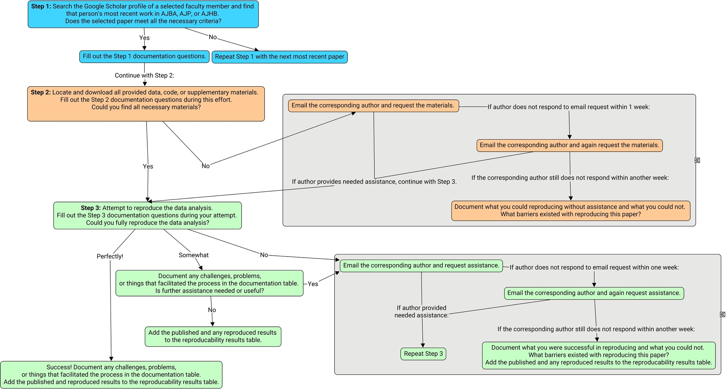

*Table A1: Reproducibility evaluation documentation. Each column corresponds to a different evaluation criterion and each row corresponds to a different publication. Each color corresponds to a different step in the process (blue is step 1, orange is step 2, and green is step 3).*

|  |  |  |  |  |  |  |  |  |  |  |  |  |  |  |
| --- | --- | --- | --- | --- | --- | --- | --- | --- | --- | --- | --- | --- | --- | --- |
| Article citation | Who is the faculty author? | Who is the corresponding author? | What journal is the paper in? | What year was the paper published? | Are all data/materials necessary for analysis included? | Are metadata included? | Is code included? | (If data/materials not included) Did author provide needed materials after first email? After second email? | Are methods written with enough detail to understand data analysis process? | Are references for method provided? | Do methods include a degree of randomness or simulation? | (If reproducibility attempt is failing) Did author provide needed assistance after first email? After second email? | To what degree were you able to reproduce the data analysis? | What prevented you from perfectly reproducing the analysis? |
|  |  |  |  |  |  |  |  |  |  |  |  |  |  |  |
|  |  |  |  |  |  |  |  |  |  |  |  |  |  |  |

*Table A2: Reproducibility documentation metadata. Each color corresponds to a different step in the process (blue is step 1, orange is step 2, and green is step 3).*

|  |  |  |  |  |  |  |  |  |  |  |  |  |  |  |  |
| --- | --- | --- | --- | --- | --- | --- | --- | --- | --- | --- | --- | --- | --- | --- | --- |
| Documentation question | Article citation | Who is the faculty author? | Who is the corresponding author? | What journal is the paper in? | What year was the paper published? | Are all data/materials necessary for analysis included? | Are metadata included? | Is code included? | (If data/materials not included) Did author provide needed materials after first email? After second email? | Are methods written with enough detail to understand data analysis process? | Are references for method provided? | Do methods include a degree of randomness or simulation? | (If reproducibility attempt is failing) Did author provide needed assistance after first email? After second email? | To what degree were you able to reproduce the data analysis? | What prevented you from perfectly reproducing the analysis? |
| Question meaning/significance | Cite the article using the American Psychological Association format. | Which Google scholar profile did you search? | The author listed as the corresponding author is who you will contact. Info on this is found on the publication. | The journal you find the paper in is include | The year that the journal released the article | Do you have what you need (from only materials available online) to attempt to reproduce the results? | Does the journal include metadata? | Is code shared online? | Did the corresponding author respond to your first or second email requesting data/materials? | Do you know what you need to know from the published materials alone to reproduce the data analysis? | Does each data analysis method include a citation to read more about? | Do any methods involve anything that includes randomness, such as bootstrapping, that might prevent perfect reproducibility? | Did the corresponding author respond to your first or second email requesting assistance? | How much could you reproduce? | How was the reproducibility attempt? Where did you succeed, and where did you fail? What kept you from perfectly reproducing the results? |
| Response format | Text | Last name, first name | Last name, first name | AJBA, AJP, or AJBA | Year | 0/1 (0 means no, 1 means yes) | 0/1 (0 means no, 1 means yes) | 0/1 (0 means no, 1 means yes) | NA, 0, 1, 2 (NA if not applicable, 0 if no response, 1 if responded after 1 email, 2 if responded after 2 emails) | 0/1 (0 means no, 1 means yes) | 0/1 (0 means no, 1 means yes) | 0/1 (0 means no, 1 means yes) | NA, 0, 1, 2 (NA if not applicable, 0 if no response, 1 if responded after 1 email, 2 if responded after 2 emails) | all/some/none | Text |

*Table A3: Reproducibility results. Each row corresponds to a different result for each paper.*

|  |  |  |  |
| --- | --- | --- | --- |
| Journal article | Data analysis | Published finding | Reproduced finding |
|  |  |  |  |
|  |  |  |  |

*Table A4: Reproducibility results metadata.*

|  |  |  |  |  |
| --- | --- | --- | --- | --- |
| Table Column | Journal article | Data analysis | Published finding | Reproduced finding |
| Meaning/significance | Which journal article are these results from? | What was the data analysis? Each data analysis gets its own row in the table. | The result published in the paper. Depending on the nature of the analysis, results can be described in a summarized format (ex: relative order of models as determined by AIC) or be the specific result derived from the analysis (an effect size with confidence intervals) | The result found in the reproducibility analysis described in the same manner as the published finding cell. If the result could not be reproduced, then that should be stated. |
| Response format | Text | Text | Text of the result | “Not reproducible” or text of the result |