**TECHNICAL INFORMATION**

**SERVICES**



15th Floor Cebu IT Tower, Arch. Reyes cor. Mindanao Avenue, Cebu Business Park, Cebu City, Philippines

ACCOMPLISHMENT

**REPORT**

Diploma in Computer Engineering Technology

S.Y. 2021 – 2024

Submitted by: Jaypee J. Esgana

Adviser : Mr. Jorge Larobis

# Introduction

GGS Technical Information Services, a globally recognized technical publications company that serves leading manufacturers in transportation, aerospace, construction and agricultural equipment. Utilizing advanced technology as well as human resources, GGS delivers high quality products to an array of customers in the global market. Whether in publication, technical information management or document imaging, it is our mission to create innovative cost-effective solutions that add value to the business of our growing customer base.

GGS, in its modern form, began in 1988. The company has evolved from a type setting company producing textbooks to a lead

# Experience

I am pleased to share my On-the-Job Training (OJT) experience with GGS Technical Information Services, where I am learning about the dynamic world of technical information management. This position allows me to gain hands-on experience with cutting-edge industry technology and procedures, which will help me improve my abilities and knowledge.

My experienced focused on the need of thinking, documentation, and project planning. After assessing our strengths and limitations, I was challenge myself that I can do more

I am excited to bring my excitement and effort to the team while also learning from the specialists at GGS Technical Information Services.

**Documentations During Christmas Party**

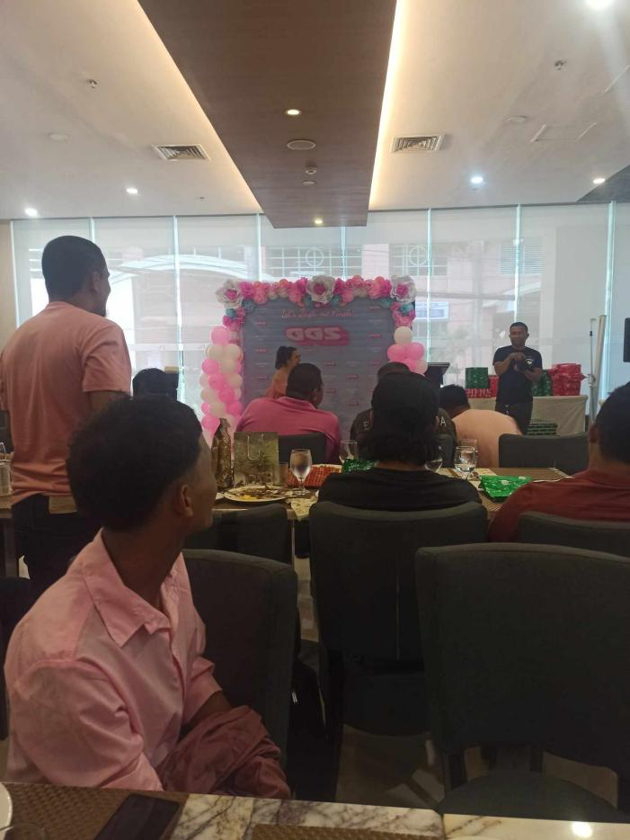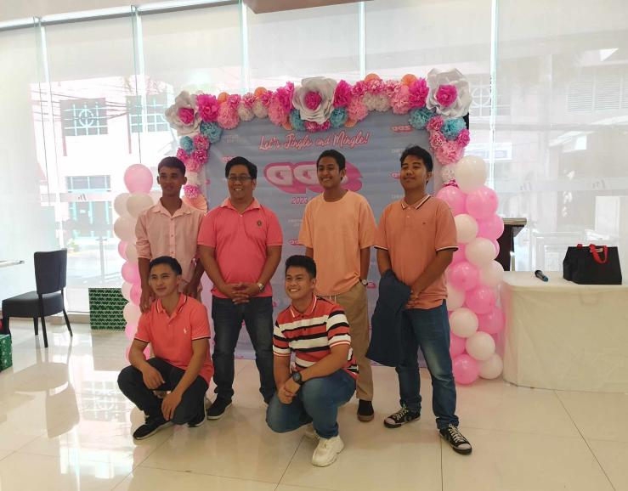

**CHALLENGES**

1. ***Design of Engaging Technical Graphics***:

Produced visually compelling technical illustrations for client documentation, contributing to an improved user experience and comprehension of complex technical concepts.

1. ***Project Assign***:

A tasked with contributing to the creation of visually appealing graphics for a client project, offering me an excellent opportunity to develop my skills and make a meaningful impact within the team at GGS Technical Information Services. Through this assignment, I aimed to learn and apply fundamental illustration techniques while providing valuable support to the project's visual content.

.

1. ***Implementation :***

Still Learning and maintained a thorough style guide for visuals to provide consistent branding throughout technical documentation, so improving the company's visual identity and marketing strategy.

1. ***Adoption of Illustration Software and Techniques:***

Competent in implementing new illustration software and techniques, increasing workflow efficiency and adding to the team's capacity to keep up with the latest industry trends and technologies.

These accomplishments showcase my contributions in terms of design quality, collaboration with diverse teams, commitment to brand consistency, and continuous improvement my skills during my OJT at GGS Technical Information Services.

# Conclusion

In conclusion, my on-the-job training at GGS Technical Information Services was a developing and enjoyable experience. During this time, I not only refined my talents as an illustrator, but I also actively contributed to meaningful projects, establishing a collaborative and innovative atmosphere. Working alongside experienced employees has given me tremendous insight into the technical information business. I am appreciative for the possibilities provided, and I am departing with a strong sense of success and the ability to apply the skills learned in my future activities.