Juan Espitia
MIS 64060-002
Final Exam
12/12/2021
This data is from Kaggle: https://www.kaggle.com/saurabh00007/diabetescsv?select=diabetes.csv
- Pregnancies: Number of pregnancies so far
- Glucose: Plasma glucose concentration
- BloodPressure: Diastolic blood pressure (mm Hg)
- SkinThickness: Triceps skin fold thickness (mm)
- Insulin: 2-Hour serum insulin (mu U/ml)
- BMI: Body mass index (weight in kg/(height in m)^2)
- DiabetesPedigreeFunction: Diabetes pedigree function
- Age: Age (years)
The Problem:
I picked this data set because I wanted to do my project based on the assignment and analysis that I better understand throughout this course. The assignment I better understood and feel more comfortable with is assignment 3 which was on the Naïve Bayes Model. For the Final Exam I used a diabetes dataset from Kaggle. This is a real-world problem because there are hospitals today that use algorithms to see if a patient is at risk of being diabetic based on medical records.

The objective is of this study and the reason for this report to higher level management is to use the Naïve Bayes approach and model to classify if a person has diabetes or not based on their medical records. The predictors that you can see I used in my code were Blood pressure, skin thickness, and Age. I used the 3 predictors to see what the outcome is based on our dataset, if 0 or 1. (0 being no diabetes and 1 being yes diabetes). To keep it simple I will go ahead and show you how I took on this analysis in my code. First, we start with modeling the data. We start doing this by splitting the data into 2 parts (60% and 40%), the training set and then the validation set. The purpose of the training set is to build and train the Naïve Bayes model which is the machine learning model we will be using to categorize patients if they are diabetic or diabetic free based on the medical records in the dataset. The part of the data, validation set, is used at the end to see how accurate our model is. Second, we create a predictive model using the Naïve Bayes function in R to train the model. Finally, we output the confusion matrix to see how accurate our model is.

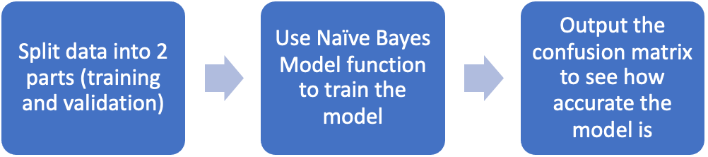

The Approach:
To begin with, read the csv file in r studio, then you will remove all the missing values to make a better data set make the model as accurate as can be, leaving those missing values can have a major impact on the conclusions of the data. This can be seen by the figure below.
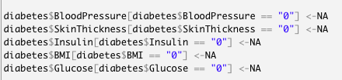
Then the next process is to split the data as it was explained in the problem section, the data was split 60% for the training set and the other 40% for the validation set. Next step is to choose the predictors (variables) that will have an impact on the outcome (0 or 1). The variables chosen to be the predictors were, blood pressure, Skin thickness, and age. To present this to management, the data had to be categorized. For instance, Blood pressure and skin thickness had to be categorized as low, normal, high. Age had to be categorized as, young, middle aged, and elder. This was done to see how these 3 variables relate to the outcome of 0 being diabetic free and 1 being you are diabetic.
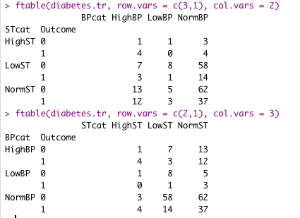
We have another figure below that shows the data in more detail and how the predictors (in this case skin thickness and blood pressure) affect the outcome.
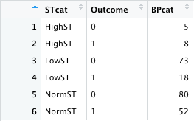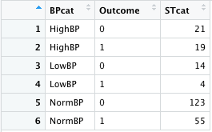
Based on the training data we then get to see our probability of people who are diabetic and those who are diabetic free. The probability is 66.9% are diabetic free and the other 33.1% is diabetic.
Conclusion:
We then create the Naïve Bayes model with the Naïve Bayes Function in R. Once we do that we go ahead and use that model to predict if a person had diabetes or not. We use the validation set of the data on the model. Finally, we can go ahead and use a confusion matrix on the training set and validation set to see how accurate the Naïve Bayes model really is.

After we have finished running our code, we can see the output shows the Naïve Bayes model accuracy to predict whether a person is diabetic or not is around 69%.
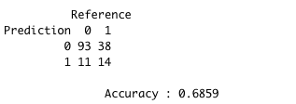
This may not be the most accurate model, but you can surely see that this model was properly explained to high level management. I hope this report serves the company well and gives you more tranquility and confidence on a decision of whether you want to use this model or not. I leave this report to you here so you can go back whenever and understand in high level detail how Naïve bayes model works.
Thank you,
Juan Espitia

