How to use
Since the application is mostly self-explanatory only features noteworthy are explained in this manual. Please also check the FAQs at the end of the document.
The application is intended for flight simulation only - do NOT use any data for real world flights.

Map section
This section provides basic information about the displayed map as its size and location, as well as general information about the currently loaded data file. If your browser supports a Geolocation, you are able to see your location. You can choose some default locations, or just enter a free text, e.g. an airport ICAO code.
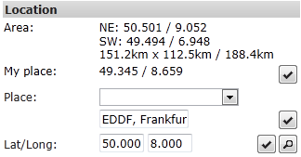
You can show an altitude profile on top of the map. The profile shows a projection of all flights displayed on the map. You will see the altitude of the flight, the elevation at this particular location, and if chosen the altitude profile of the terrain (sampled in the middle of the map).
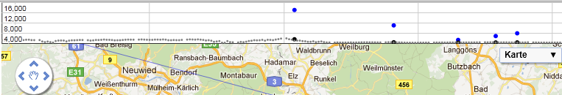
In order to reduce the number of objects you can apply a filter – this filter is configured at the Data section. If you provide the id of a particular flight, the map will center on this object and follow it.
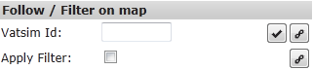

Entities section
Under entities – which basically means all objects displayed on the map – you can define what is displayed, and what is hidden. In general, moving objects (“flight”) will display their properties permanently, while static objects (“airport”) need to be actively selected to display properties.
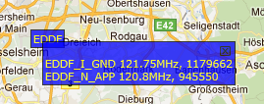

Data section
Here you can see who is online, and search for particular flights / ATCs. Use the grids top bar in order to search / sort the data
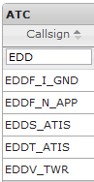
Use the + sign under Flights to set up a filter, or the lock symbol to follow a plane. This corresponds with the settings under map.


Route
Copy the table data from the VATroute details or print page in the text field, then the router can be displayed. Check out the demo data, then it is easy to understand what section needs to be copied.
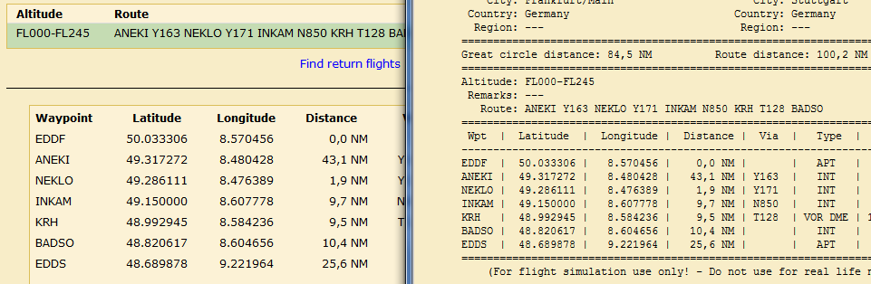

Settings
Define units, colours, and application specifc settings.

Reporting bugs / feature requests
You can report bug and features at the projects team page. Please keep in mind that this is a hobby project, so do not necessarily expect an immediate response.

Bug reports
Report issues under http://vatgm.codeplex.com/workitem/list/basic by providing as detailed information as possible.
- Check the console for information. The console requires that you allow Pop-ups. Check your browser’s help on how to enable Pop-Up for a single site. Do not generally enable Pop-ups unless you do this on purpose.

This can be tested under “Settings/This application”, clicking the console button should show a Pop-up window. In order to continue logging “Minimize” the window. When you close ([X]) the console window, previous information is gone.
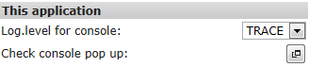
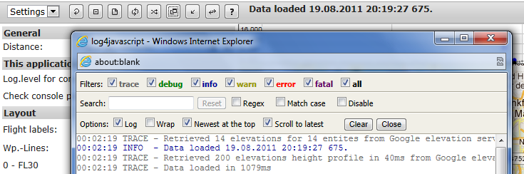
If you do not like this console at all, you can check the log messages on your browser’s console. Not all browsers support such a console and the output might be hard to find / read. Refer to your browsers help on how to open and use the console.
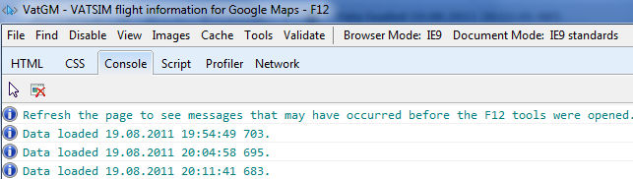
- It can help to provide screenshots or the actual data file. The data file can be accessed via the link button besides the data file information.
.
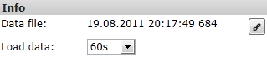
Save the resulting page as .txt file.
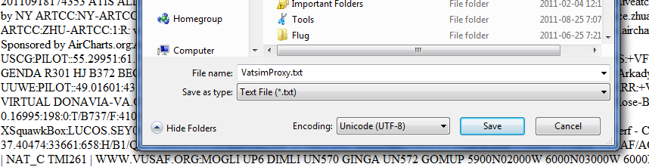
- What is your browser / version?
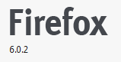 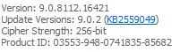

Feature requests
Feature request can be filed under discussions: http://vatgm.codeplex.com/discussions . Please also check the next steps page to follow up on items already in the pipeline.

FAQs
- Why is there a delay before I see updates on the map?
This is called asynchronous updating; it keeps the map responsive by updating the map in background.
- How frequently are the data updated?
Currently VATSIM provides new data every 2 minutes. It is a goal for the future to improve on this, see next steps.
- Why can’t I see my flight?
  - Your flight might me still “on ground”, and settings for grounded flights “off”.
  - You have not filed a flight plan.
  - You have just logged in with VATSIM and your flight is not in the data file yet.
- Can I search for ICAO under places?
Yes you can, but such searches are location sensitive. This means, when your map shows Germany, you’ll find EDDF. But when you are located in China, a search for “EDDF” will find something else, use “Frankfurt, EDDF” in such a situation.
- Will my personal data be stored by the application?
VatGM is written in JavaScript and runs locally in your browser. We might use a tool to monitor the usage (how many users, where from etc.), but no personal data is stored in a database or so.
- I am getting a warning that you want to track my location, why are you tracking my location?
We are not tracking your location; we only use it to display a meaningful default location on the map.
- Why is “My place” not showing any data?
We are using a feature called Geolocation, which depends on your browser. So either your browser cannot determine your current location, or you have disabled the feature. However, the application will run without this – it is a convenience feature.
- Why is the application so slow?
JavaScript runs on your computer in your browser, hence the performance depends on your computer’s setup and equipment. The runtime statistics are a valuable source for tracking such issues.
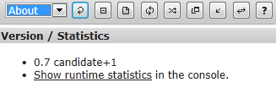
- The application does not run in my XYZ Browser?
We try to support the major browser, however there will be no guarantee that every Browser can be used. So far I have tested with Chrome, IE, and Firefox.

Therefore the elevation service needs to be enabled.
This requires, of course, that your browser supports a console.
This is technically simplified, but describes the situation quite good.

