Fantasy Football Team

Joshua Peterson

9/21/2016

Player analysis and selection for the week of 09.19.2016

Pull Player Data

## Summary Passing & TD Data

## Min. 1st Qu. Median Mean 3rd Qu. Max.   
## 114.0 194.0 231.5 235.1 277.0 432.0

## Min. 1st Qu. Median Mean 3rd Qu. Max.   
## 0.000 1.000 1.000 1.525 2.000 5.000

## [1] 64.91911

## [1] 1.158076

## Histogram of Yards and TDs

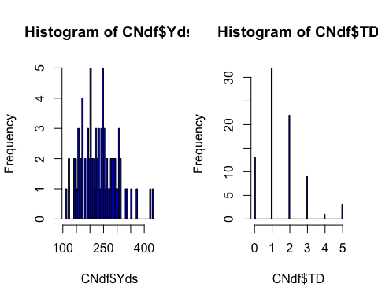

## Least square estimate

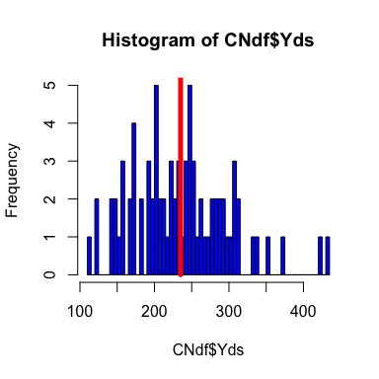

## Current Opponent Analysis (Passing only)

## [1] 24.2

## [1] 16.33333

## [1] 40.53333

Note that the echo = FALSE parameter was added to the code chunk to prevent printing of the R code that generated the plot.