Fantasy Football Team

Joshua Peterson

9/21/2016

Player analysis and selection for the week of 09.19.2016

QB Analysis - Pull Player Data

RB Analysis - Pull Player Data

# QB Analysis

## Cam Newton - Summary Passing Data

Newton Yards Summary

## Min. 1st Qu. Median Mean 3rd Qu. Max.   
## 114.0 194.0 232.0 235.5 276.0 432.0

## Min. 1st Qu. Median Mean 3rd Qu. Max.   
## 0.000 1.000 1.000 1.506 2.000 5.000

## [1] 64.58116

## [1] 1.163222

Newton Histogram of Yards and TDs 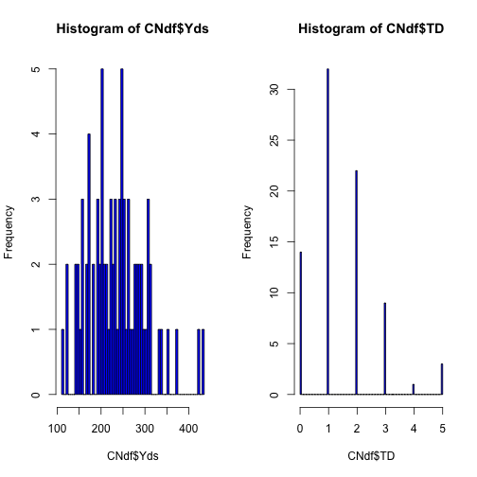

Newton Yards LSE 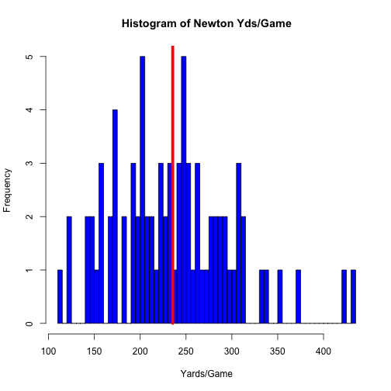

Newton Yards Fitting a linear model using opponent data

CNfitYds<- lm(Yds ~ Opp, data = CNdf)  
summary(CNfitYds)$coefficients

## Estimate Std. Error t value Pr(>|t|)  
## (Intercept) 365.00000 44.41528 8.2178926 7.670142e-11  
## OppATL -142.40000 48.65450 -2.9267590 5.141819e-03  
## OppBAL -168.00000 76.92952 -2.1838170 3.369442e-02  
## OppBUF -136.00000 76.92952 -1.7678519 8.318722e-02  
## OppCHI -50.66667 57.33988 -0.8836200 3.811304e-01  
## OppCIN -81.00000 76.92952 -1.0529118 2.974433e-01  
## OppCLE -164.00000 76.92952 -2.1318214 3.795854e-02  
## OppDAL -157.00000 62.81269 -2.4994949 1.576487e-02  
## OppDEN -147.50000 62.81269 -2.3482516 2.285779e-02  
## OppDET -84.50000 62.81269 -1.3452695 1.846080e-01  
## OppGNB -53.66667 57.33988 -0.9359396 3.538029e-01  
## OppHOU -193.00000 62.81269 -3.0726275 3.430079e-03  
## OppIND -137.00000 62.81269 -2.1810879 3.390728e-02  
## OppJAX -198.50000 62.81269 -3.1601894 2.676464e-03  
## OppKAN -133.00000 76.92952 -1.7288552 9.000593e-02  
## OppMIA -191.00000 76.92952 -2.4827920 1.643614e-02  
## OppMIN -118.00000 54.39739 -2.1692219 3.484658e-02  
## OppNOR -140.30000 48.65450 -2.8835975 5.784024e-03  
## OppNWE -156.00000 76.92952 -2.0278301 4.792316e-02  
## OppNYG -96.66667 57.33988 -1.6858540 9.805552e-02  
## OppNYJ -92.00000 76.92952 -1.1958998 2.373764e-01  
## OppOAK -195.00000 76.92952 -2.5347876 1.442751e-02  
## OppPHI -95.33333 57.33988 -1.6626009 1.026496e-01  
## OppPIT -115.00000 76.92952 -1.4948748 1.412322e-01  
## OppSDG -134.00000 76.92952 -1.7418541 8.768325e-02  
## OppSEA -188.50000 54.39739 -3.4652400 1.096680e-03  
## OppSFO -104.00000 62.81269 -1.6557164 1.040431e-01  
## OppSTL -161.00000 76.92952 -2.0928247 4.146000e-02  
## OppTAM -136.12500 49.65779 -2.7412616 8.467263e-03  
## OppTEN -150.50000 62.81269 -2.3960126 2.035770e-02  
## OppWAS -130.66667 57.33988 -2.2788096 2.698326e-02

The intercept is the expected yardage (currently 365 yards). According to the model, for the current week with the opponent being Atlanta, Cam's yardage would be 142 yards less than the intercept (223 yards) with a SE of 48.6 yards (high 272 yards, low 176 yards)

Newton Yards Plot of Data Yards against opponents

## Error in labs(x = label): object 'Yards' not found

## Error in labs(y = label): object 'Opponent' not found

## Warning in qt((1 - level)/2, df): NaNs produced  
  
## Warning in qt((1 - level)/2, df): NaNs produced  
  
## Warning in qt((1 - level)/2, df): NaNs produced  
  
## Warning in qt((1 - level)/2, df): NaNs produced  
  
## Warning in qt((1 - level)/2, df): NaNs produced  
  
## Warning in qt((1 - level)/2, df): NaNs produced  
  
## Warning in qt((1 - level)/2, df): NaNs produced  
  
## Warning in qt((1 - level)/2, df): NaNs produced  
  
## Warning in qt((1 - level)/2, df): NaNs produced

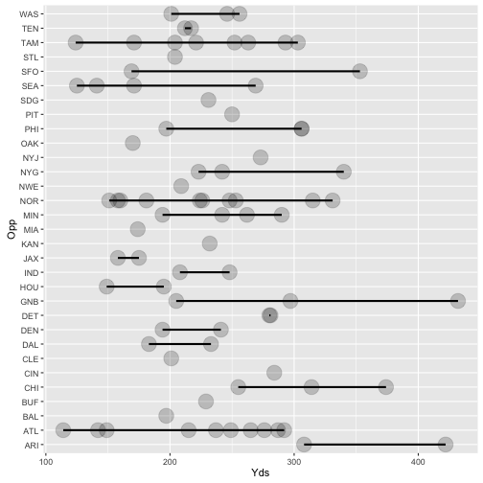

plot of chunk unnamed-chunk-2

Newton Yards Fitting a linear model using location data

CNfitYds2<- lm(Yds ~ Location, data = CNdf)  
summary(CNfit2)$coefficients

## Estimate Std. Error t value Pr(>|t|)  
## (Intercept) 230.875000 10.25003 22.524334 3.949530e-36  
## LocationHome 9.051829 14.40707 0.628291 5.316256e-01

The intercept is the expexcted yardage (281 yards). According to the model, we should expect a 9 yard increase when playing at home with a SE of 14 yards (high + 23 yards, low - 5 yards). Cam will be playing Away this week.

Newton Plot of Data Yards against Location

## Error in labs(x = label): object 'Yards' not found

## Error in labs(y = label): object 'Location' not found

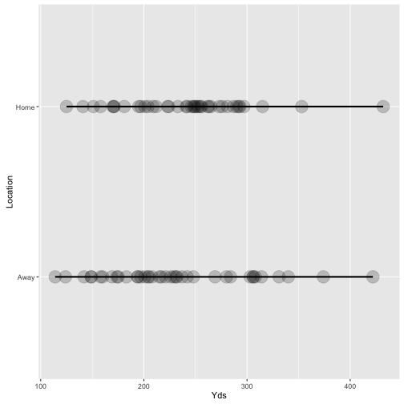

plot of chunk unnamed-chunk-4

Newton Residuals - Yards vs. Opponent

##   
## Call:  
## lm(formula = CNyOpp ~ CNxOpp)  
##   
## Coefficients:  
## (Intercept) CNxOppATL CNxOppBAL CNxOppBUF CNxOppCHI   
## 365.00 -142.40 -168.00 -136.00 -50.67   
## CNxOppCIN CNxOppCLE CNxOppDAL CNxOppDEN CNxOppDET   
## -81.00 -164.00 -157.00 -147.50 -84.50   
## CNxOppGNB CNxOppHOU CNxOppIND CNxOppJAX CNxOppKAN   
## -53.67 -193.00 -137.00 -198.50 -133.00   
## CNxOppMIA CNxOppMIN CNxOppNOR CNxOppNWE CNxOppNYG   
## -191.00 -118.00 -140.30 -156.00 -96.67   
## CNxOppNYJ CNxOppOAK CNxOppPHI CNxOppPIT CNxOppSDG   
## -92.00 -195.00 -95.33 -115.00 -134.00   
## CNxOppSEA CNxOppSFO CNxOppSTL CNxOppTAM CNxOppTEN   
## -188.50 -104.00 -161.00 -136.13 -150.50   
## CNxOppWAS   
## -130.67

## [1] 4.227729e-13

## Warning in abline(CNfitOpp, lwd = 2): only using the first two of 31  
## regression coefficients

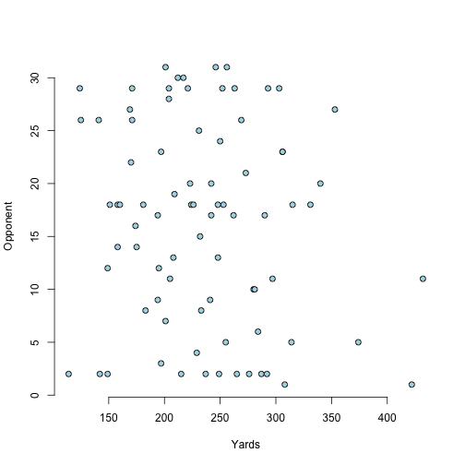

plot of chunk unnamed-chunk-5

Newton Residuals - Yards vs. Location

##   
## Call:  
## lm(formula = CNyLoc ~ CNxLoc)  
##   
## Coefficients:  
## (Intercept) CNxLocHome   
## 230.875 9.052

## Error in eval(expr, envir, enclos): object 'CNyhatLoc' not found

## Error in eval(expr, envir, enclos): object 'CNyhatLoc' not found

## Warning in abline(CNfit, lwd = 2): only using the first two of 31  
## regression coefficients

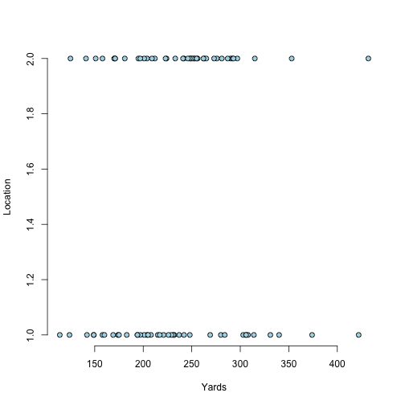

plot of chunk unnamed-chunk-6

## Error in xy.coords(x, y): object 'CNyhatLoc' not found

Newton Yards Opponent Residual Variation

## [1] 62.81269

Newton Yards Location Residual Variation

## [1] 64.82685

Newton Yards Training Sets

## [1] 57 23

## [1] 24 23

Newton Plot Yards vs. Location 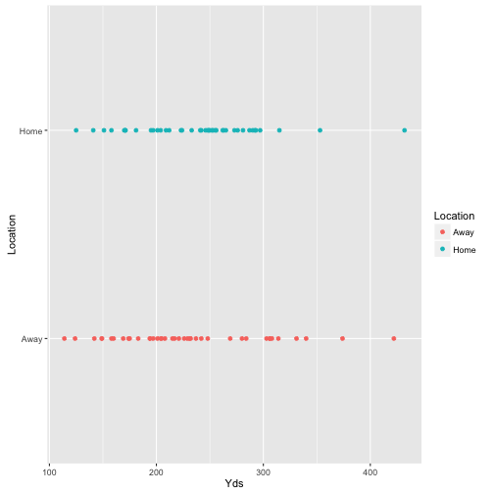

Newton Plot Yards vs. Opponent 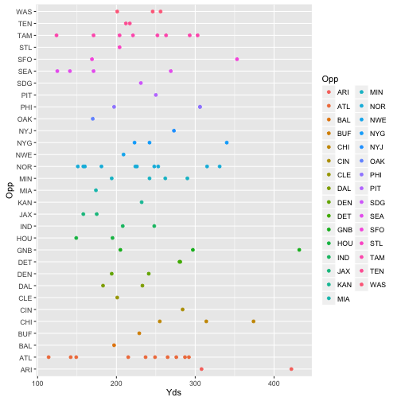

Newton Yards Fit a linear model

## Warning in predict.lm(modelFit, newdata): prediction from a rank-deficient  
## fit may be misleading  
  
## Warning in predict.lm(modelFit, newdata): prediction from a rank-deficient  
## fit may be misleading  
  
## Warning in predict.lm(modelFit, newdata): prediction from a rank-deficient  
## fit may be misleading  
  
## Warning in predict.lm(modelFit, newdata): prediction from a rank-deficient  
## fit may be misleading  
  
## Warning in predict.lm(modelFit, newdata): prediction from a rank-deficient  
## fit may be misleading  
  
## Warning in predict.lm(modelFit, newdata): prediction from a rank-deficient  
## fit may be misleading  
  
## Warning in predict.lm(modelFit, newdata): prediction from a rank-deficient  
## fit may be misleading  
  
## Warning in predict.lm(modelFit, newdata): prediction from a rank-deficient  
## fit may be misleading  
  
## Warning in predict.lm(modelFit, newdata): prediction from a rank-deficient  
## fit may be misleading  
  
## Warning in predict.lm(modelFit, newdata): prediction from a rank-deficient  
## fit may be misleading  
  
## Warning in predict.lm(modelFit, newdata): prediction from a rank-deficient  
## fit may be misleading  
  
## Warning in predict.lm(modelFit, newdata): prediction from a rank-deficient  
## fit may be misleading  
  
## Warning in predict.lm(modelFit, newdata): prediction from a rank-deficient  
## fit may be misleading  
  
## Warning in predict.lm(modelFit, newdata): prediction from a rank-deficient  
## fit may be misleading  
  
## Warning in predict.lm(modelFit, newdata): prediction from a rank-deficient  
## fit may be misleading  
  
## Warning in predict.lm(modelFit, newdata): prediction from a rank-deficient  
## fit may be misleading  
  
## Warning in predict.lm(modelFit, newdata): prediction from a rank-deficient  
## fit may be misleading  
  
## Warning in predict.lm(modelFit, newdata): prediction from a rank-deficient  
## fit may be misleading  
  
## Warning in predict.lm(modelFit, newdata): prediction from a rank-deficient  
## fit may be misleading  
  
## Warning in predict.lm(modelFit, newdata): prediction from a rank-deficient  
## fit may be misleading  
  
## Warning in predict.lm(modelFit, newdata): prediction from a rank-deficient  
## fit may be misleading  
  
## Warning in predict.lm(modelFit, newdata): prediction from a rank-deficient  
## fit may be misleading  
  
## Warning in predict.lm(modelFit, newdata): prediction from a rank-deficient  
## fit may be misleading  
  
## Warning in predict.lm(modelFit, newdata): prediction from a rank-deficient  
## fit may be misleading  
  
## Warning in predict.lm(modelFit, newdata): prediction from a rank-deficient  
## fit may be misleading

##   
## Call:  
## lm(formula = .outcome ~ ., data = dat)  
##   
## Coefficients:  
## (Intercept) LocationHome OppATL OppBAL OppBUF   
## 365.00 24.53 -154.66 -168.00 -136.00   
## OppCHI OppCIN OppCLE OppDAL OppDEN   
## -58.84 -81.00 -188.53 -169.26 -159.76   
## OppDET OppGNB OppHOU OppIND OppJAX   
## -96.76 -70.02 -205.26 -149.26 -210.76   
## OppKAN OppMIA OppMIN OppNOR OppNWE   
## -133.00 -191.00 -130.26 -152.56 -180.53   
## OppNYG OppNYJ OppOAK OppPHI OppPIT   
## -113.02 -116.53 -219.53 -103.51 -139.53   
## OppSDG OppSEA OppSFO OppSTL OppTAM   
## -134.00 -206.90 -116.26 -185.53 -148.39   
## OppTEN OppWAS   
## -162.76 -147.02

Newton Yards Diagnostics 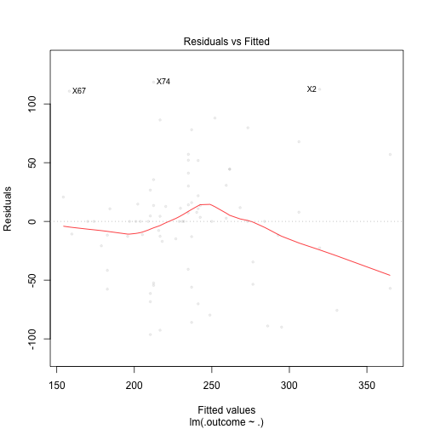

Newton Yards Plot by index 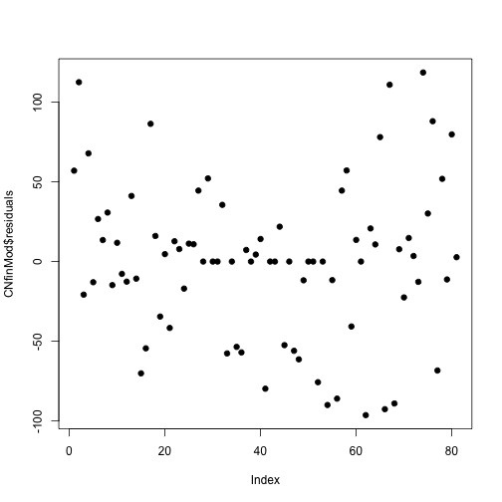

Newton Yards Predicted Values vs. Opponents 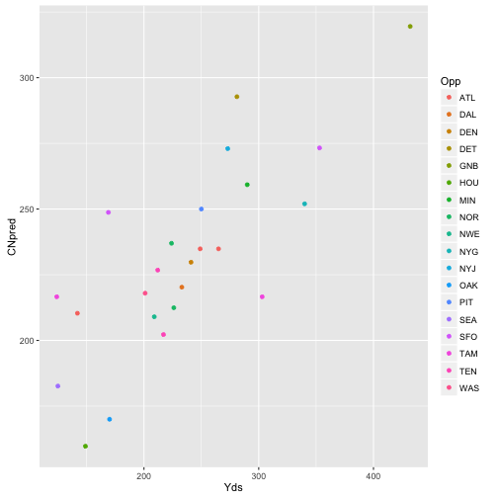

## Cam Newton - Summary TD Data

Newton TD Fitting a linear model using opponent data

CNfitTd<- lm(Opp ~ I(TD - mean(TD)), data = CNdf)

## Warning in model.response(mf, "numeric"): using type = "numeric" with a  
## factor response will be ignored

## Warning in Ops.factor(y, z$residuals): '-' not meaningful for factors

coef(CNfitTd)

## (Intercept) I(TD - mean(TD))   
## 16.1975309 0.6549954

summary(CNfitTd)$coefficients

## Warning in Ops.factor(r, 2): '^' not meaningful for factors

## Estimate Std. Error t value Pr(>|t|)  
## (Intercept) 16.1975309 NA NA NA  
## I(TD - mean(TD)) 0.6549954 NA NA NA

The intercept is the expected number of games (16). According to the model, Cam scores 0.65 TD's/game

Newton Plot of Data TD against opponents

## Error in eval(expr, envir, enclos): object 'CNgTdsplotOpp' not found

## Error in labs(y = label): object 'Opponent' not found

## Warning in qt((1 - level)/2, df): NaNs produced  
  
## Warning in qt((1 - level)/2, df): NaNs produced  
  
## Warning in qt((1 - level)/2, df): NaNs produced  
  
## Warning in qt((1 - level)/2, df): NaNs produced  
  
## Warning in qt((1 - level)/2, df): NaNs produced  
  
## Warning in qt((1 - level)/2, df): NaNs produced

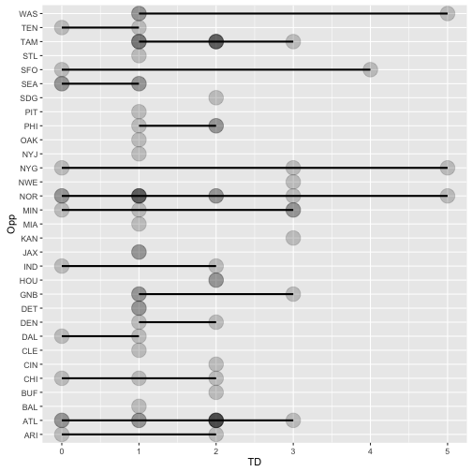

plot of chunk unnamed-chunk-17

Newton TD Fitting a linear model using location data

CNfitTd2<- lm(TD ~ Location, data = CNdf)  
summary(CNfitTd2)$coefficients

## Estimate Std. Error t value Pr(>|t|)  
## (Intercept) 1.4250000 0.1846363 7.7178742 3.084020e-11  
## LocationHome 0.1603659 0.2595182 0.6179369 5.383943e-01

The intercept is the expexcted TDs (1.43). According to the model, we should expect a 0.16 in TDs increase when playing at home with a SE of 0.26 TDs (high + 1.67 TDs, low - 1.27 TDs). Cam will be playing Away this week.

Newton Residuals - TDs vs. Opponent

##   
## Call:  
## lm(formula = CNyTdOpp ~ CNxTdOpp)  
##   
## Coefficients:  
## (Intercept) CNxTdOppATL CNxTdOppBAL CNxTdOppBUF CNxTdOppCHI   
## 1.000e+00 5.000e-01 3.499e-15 1.000e+00 6.150e-15   
## CNxTdOppCIN CNxTdOppCLE CNxTdOppDAL CNxTdOppDEN CNxTdOppDET   
## 1.000e+00 5.933e-15 -5.000e-01 5.000e-01 4.347e-15   
## CNxTdOppGNB CNxTdOppHOU CNxTdOppIND CNxTdOppJAX CNxTdOppKAN   
## 6.667e-01 1.000e+00 1.193e-15 2.373e-15 2.000e+00   
## CNxTdOppMIA CNxTdOppMIN CNxTdOppNOR CNxTdOppNWE CNxTdOppNYG   
## 2.945e-15 7.500e-01 6.000e-01 2.000e+00 1.667e+00   
## CNxTdOppNYJ CNxTdOppOAK CNxTdOppPHI CNxTdOppPIT CNxTdOppSDG   
## 3.977e-15 4.579e-15 6.667e-01 3.487e-15 1.000e+00   
## CNxTdOppSEA CNxTdOppSFO CNxTdOppSTL CNxTdOppTAM CNxTdOppTEN   
## -5.000e-01 1.000e+00 3.440e-15 7.500e-01 -5.000e-01   
## CNxTdOppWAS   
## 1.333e+00

## [1] 1.787459e-14

## Warning in abline(CNfitTdOpp, lwd = 2): only using the first two of 31  
## regression coefficients

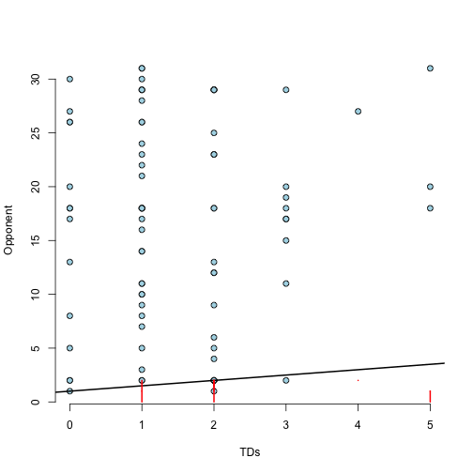

plot of chunk unnamed-chunk-19

Newton Residuals - TDs vs. Location

##   
## Call:  
## lm(formula = CNyTdLoc ~ CNxTdLoc)  
##   
## Coefficients:  
## (Intercept) CNxTdLocHome   
## 1.4250 0.1604

## Error in eval(expr, envir, enclos): object 'CNyhatTdLoc' not found

## Error in eval(expr, envir, enclos): object 'CNyhatTdLoc' not found

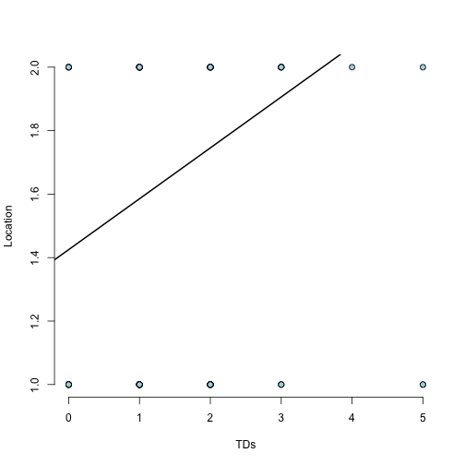

plot of chunk unnamed-chunk-20

## Error in xy.coords(x, y): object 'CNyhatTdLoc' not found

Newton TD Opponent Residual Variation

## [1] 1.283095

Newton TD Location Residual Variation

## [1] 1.167743

Newton TD Training Sets

## [1] 59 23

## [1] 22 23

Newton Plot TDs vs. Location 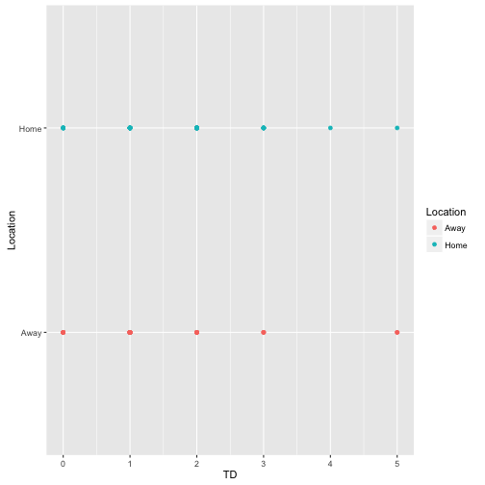

Newton Plot TDs vs. Opponent 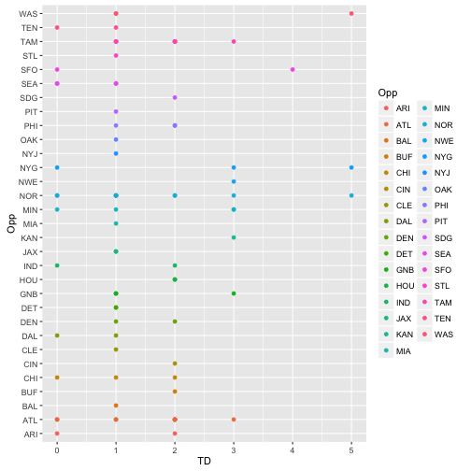

Newton TD Fit a linear model

## Warning in predict.lm(modelFit, newdata): prediction from a rank-deficient  
## fit may be misleading  
  
## Warning in predict.lm(modelFit, newdata): prediction from a rank-deficient  
## fit may be misleading  
  
## Warning in predict.lm(modelFit, newdata): prediction from a rank-deficient  
## fit may be misleading  
  
## Warning in predict.lm(modelFit, newdata): prediction from a rank-deficient  
## fit may be misleading  
  
## Warning in predict.lm(modelFit, newdata): prediction from a rank-deficient  
## fit may be misleading  
  
## Warning in predict.lm(modelFit, newdata): prediction from a rank-deficient  
## fit may be misleading  
  
## Warning in predict.lm(modelFit, newdata): prediction from a rank-deficient  
## fit may be misleading  
  
## Warning in predict.lm(modelFit, newdata): prediction from a rank-deficient  
## fit may be misleading  
  
## Warning in predict.lm(modelFit, newdata): prediction from a rank-deficient  
## fit may be misleading  
  
## Warning in predict.lm(modelFit, newdata): prediction from a rank-deficient  
## fit may be misleading  
  
## Warning in predict.lm(modelFit, newdata): prediction from a rank-deficient  
## fit may be misleading  
  
## Warning in predict.lm(modelFit, newdata): prediction from a rank-deficient  
## fit may be misleading  
  
## Warning in predict.lm(modelFit, newdata): prediction from a rank-deficient  
## fit may be misleading  
  
## Warning in predict.lm(modelFit, newdata): prediction from a rank-deficient  
## fit may be misleading  
  
## Warning in predict.lm(modelFit, newdata): prediction from a rank-deficient  
## fit may be misleading  
  
## Warning in predict.lm(modelFit, newdata): prediction from a rank-deficient  
## fit may be misleading  
  
## Warning in predict.lm(modelFit, newdata): prediction from a rank-deficient  
## fit may be misleading  
  
## Warning in predict.lm(modelFit, newdata): prediction from a rank-deficient  
## fit may be misleading  
  
## Warning in predict.lm(modelFit, newdata): prediction from a rank-deficient  
## fit may be misleading  
  
## Warning in predict.lm(modelFit, newdata): prediction from a rank-deficient  
## fit may be misleading  
  
## Warning in predict.lm(modelFit, newdata): prediction from a rank-deficient  
## fit may be misleading  
  
## Warning in predict.lm(modelFit, newdata): prediction from a rank-deficient  
## fit may be misleading  
  
## Warning in predict.lm(modelFit, newdata): prediction from a rank-deficient  
## fit may be misleading  
  
## Warning in predict.lm(modelFit, newdata): prediction from a rank-deficient  
## fit may be misleading  
  
## Warning in predict.lm(modelFit, newdata): prediction from a rank-deficient  
## fit may be misleading

##   
## Call:  
## lm(formula = .outcome ~ ., data = dat)  
##   
## Coefficients:  
## (Intercept) LocationHome OppATL OppBAL OppBUF   
## 1.000e+00 2.487e-01 3.756e-01 1.028e-14 1.000e+00   
## OppCHI OppCIN OppCLE OppDAL OppDEN   
## -8.290e-02 1.000e+00 -2.487e-01 -6.244e-01 3.756e-01   
## OppDET OppGNB OppHOU OppIND OppJAX   
## -1.244e-01 5.009e-01 8.756e-01 -1.244e-01 -1.244e-01   
## OppKAN OppMIA OppMIN OppNOR OppNWE   
## 2.000e+00 1.085e-14 6.256e-01 4.756e-01 1.751e+00   
## OppNYG OppNYJ OppOAK OppPHI OppPIT   
## 1.501e+00 -2.487e-01 -2.487e-01 5.838e-01 -2.487e-01   
## OppSDG OppSEA OppSFO OppSTL OppTAM   
## 1.000e+00 -6.865e-01 8.756e-01 -2.487e-01 6.256e-01   
## OppTEN OppWAS   
## -6.244e-01 1.168e+00

Newton TD Diagnostics 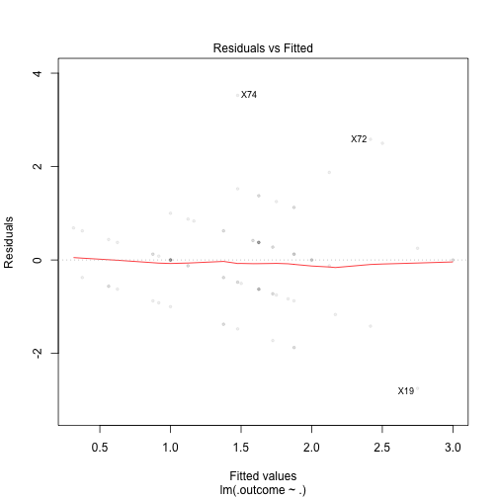

Newton TD Plot by index 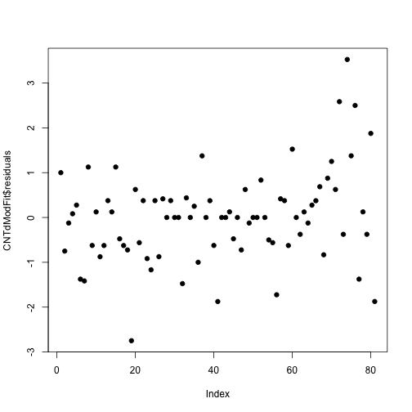

Newton TD Prediction vs. Opponent and Location 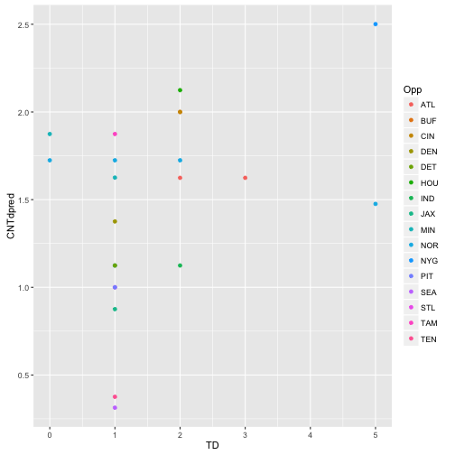

# Andrew Luck - Summary Passing & TD Data

## Min. 1st Qu. Median Mean 3rd Qu. Max.   
## 109.0 202.0 257.0 270.5 333.0 433.0

## Min. 1st Qu. Median Mean 3rd Qu. Max.   
## 0.00 1.00 2.00 1.86 2.00 5.00

## [1] 76.94551

## [1] 1.231123

Luck Histogram of Yards and TDs 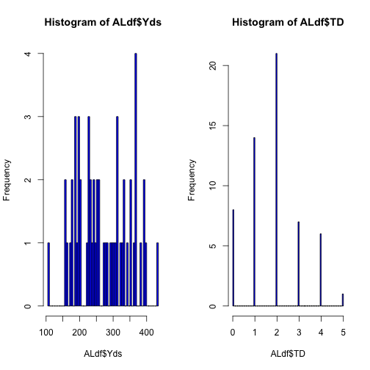

Luck - Least square estimate 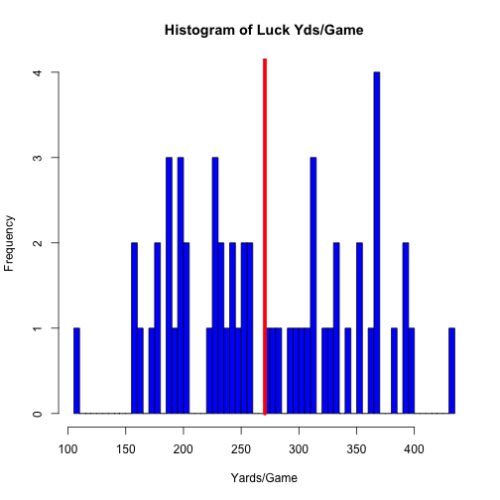

Luck Yards Fitting a linear model using opponent data

ALfitYds<- lm(Yds ~ Opp, data = ALdf)  
summary(ALfitYds)$coefficients

## Estimate Std. Error t value Pr(>|t|)  
## (Intercept) 163.00000 62.64398 2.60200579 0.014647200  
## OppBAL 149.00000 88.59197 1.68186807 0.103716274  
## OppBUF 78.50000 76.72289 1.02316266 0.314990012  
## OppCAR 68.00000 88.59197 0.76756395 0.449171006  
## OppCHI 146.00000 88.59197 1.64800495 0.110529548  
## OppCIN 172.00000 76.72289 2.24183411 0.033078216  
## OppCLE 77.00000 76.72289 1.00361178 0.324160670  
## OppDAL -54.00000 88.59197 -0.60953608 0.547083999  
## OppDEN 98.75000 70.03810 1.40994689 0.169567414  
## OppDET 225.00000 76.72289 2.93263183 0.006631537  
## OppGNB 199.00000 88.59197 2.24625333 0.032760576  
## OppHOU 67.83333 67.66323 1.00251394 0.324681016  
## OppJAX 120.66667 67.66323 1.78334175 0.085375307  
## OppKAN 60.00000 76.72289 0.78203515 0.440757416  
## OppMIA 214.00000 76.72289 2.78925872 0.009394954  
## OppMIN 61.00000 88.59197 0.68855001 0.496772352  
## OppNOR 170.00000 88.59197 1.91890988 0.065241951  
## OppNWE 153.33333 72.33504 2.11976571 0.043023033  
## OppNYG 191.00000 88.59197 2.15595169 0.039827648  
## OppNYJ 102.00000 76.72289 1.32945976 0.194427056  
## OppOAK 15.00000 88.59197 0.16931558 0.866765736  
## OppPHI 9.00000 88.59197 0.10158935 0.919806649  
## OppPIT 237.00000 88.59197 2.67518612 0.012332552  
## OppSDG 39.00000 88.59197 0.44022050 0.663157138  
## OppSEA 66.00000 88.59197 0.74498854 0.462486512  
## OppSFO -4.00000 88.59197 -0.04515082 0.964307571  
## OppSTL 190.00000 88.59197 2.14466398 0.040800870  
## OppTEN 85.28571 66.96923 1.27350593 0.213309621  
## OppWAS 207.00000 88.59197 2.33655497 0.026845348

The intercept is the expected yardage (currently 163 yards). According to the model, for the current week with the opponent being JAX, Luck's yardage would be 121 yards more than the intercept (284 yards) with a SE of 68 yards (high 352 yards, low 216 yards)

Luck Yards Plot of Data Yards against opponents

## Error in labs(x = label): object 'Yards' not found

## Error in labs(y = label): object 'Opponent' not found

## Warning in qt((1 - level)/2, df): NaNs produced  
  
## Warning in qt((1 - level)/2, df): NaNs produced  
  
## Warning in qt((1 - level)/2, df): NaNs produced  
  
## Warning in qt((1 - level)/2, df): NaNs produced  
  
## Warning in qt((1 - level)/2, df): NaNs produced  
  
## Warning in qt((1 - level)/2, df): NaNs produced  
  
## Warning in qt((1 - level)/2, df): NaNs produced

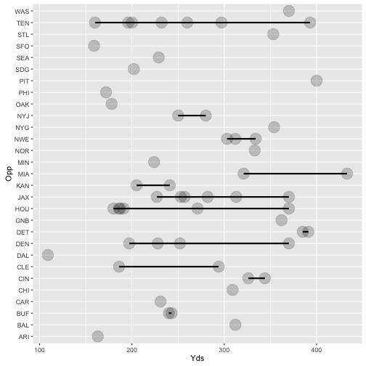

plot of chunk unnamed-chunk-31

Luck Yards Fitting a linear model using location data

ALfitYds2<- lm(Yds ~ Location, data = ALdf)  
summary(ALfitYds2)$coefficients

## Estimate Std. Error t value Pr(>|t|)  
## (Intercept) 265.642857 14.64386 18.1402188 7.093267e-25  
## LocationHome 9.598522 20.53024 0.4675309 6.419673e-01

The intercept is the expexcted yardage (265 yards). According to the model, we should expect a 9.5 yard increase when playing at home with a SE of 20 yards (high + 29.5 yards, low 10.5 yards). Luck will be playing Away this week.

Luck Plot of Data Yards against Location

## Error in labs(x = label): object 'Yards' not found

## Error in labs(y = label): object 'Location' not found

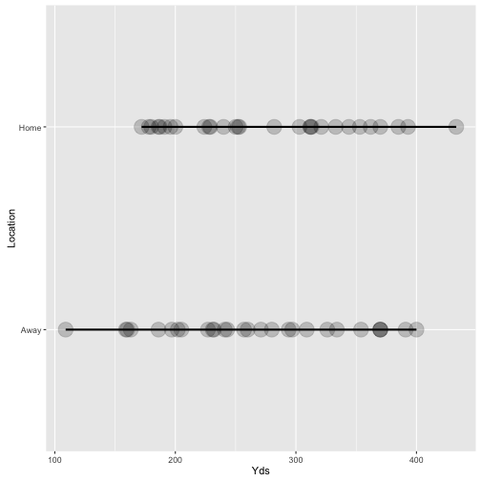

plot of chunk unnamed-chunk-33

Luck Residuals - Yards vs. Opponent

##   
## Call:  
## lm(formula = ALyOpp ~ ALxOpp)  
##   
## Coefficients:  
## (Intercept) ALxOppBAL ALxOppBUF ALxOppCAR ALxOppCHI   
## 163.00 149.00 78.50 68.00 146.00   
## ALxOppCIN ALxOppCLE ALxOppDAL ALxOppDEN ALxOppDET   
## 172.00 77.00 -54.00 98.75 225.00   
## ALxOppGNB ALxOppHOU ALxOppJAX ALxOppKAN ALxOppMIA   
## 199.00 67.83 120.67 60.00 214.00   
## ALxOppMIN ALxOppNOR ALxOppNWE ALxOppNYG ALxOppNYJ   
## 61.00 170.00 153.33 191.00 102.00   
## ALxOppOAK ALxOppPHI ALxOppPIT ALxOppSDG ALxOppSEA   
## 15.00 9.00 237.00 39.00 66.00   
## ALxOppSFO ALxOppSTL ALxOppTEN ALxOppWAS   
## -4.00 190.00 85.29 207.00

## [1] 6.751415e-13

## Warning in abline(ALfitOpp, lwd = 2): only using the first two of 29  
## regression coefficients

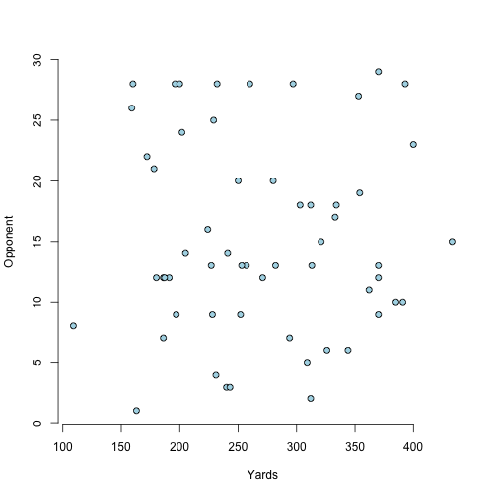

plot of chunk unnamed-chunk-34

Luck Residuals - Yards vs. Location

##   
## Call:  
## lm(formula = ALyLoc ~ ALxLoc)  
##   
## Coefficients:  
## (Intercept) ALxLocHome   
## 265.643 9.599

## Error in eval(expr, envir, enclos): object 'ALyhatLoc' not found

## Error in eval(expr, envir, enclos): object 'ALyhatLoc' not found

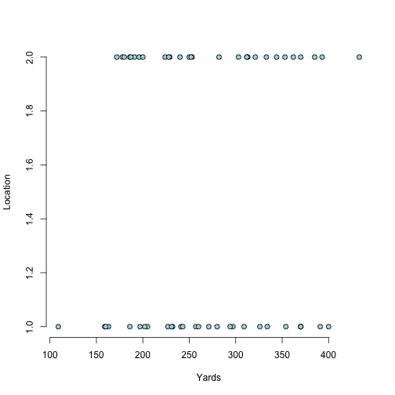

plot of chunk unnamed-chunk-35

## Error in abline(ALfit, lwd = 2): object 'ALfit' not found

## Error in xy.coords(x, y): object 'ALyhatLoc' not found

Luck Yards Opponent Residual Variation

## [1] 62.64398

Luck Yards Location Residual Variation

## [1] 77.48803

Luck Yards Training Sets

## [1] 41 22

## [1] 16 22

Luck Plot Yards vs. Location 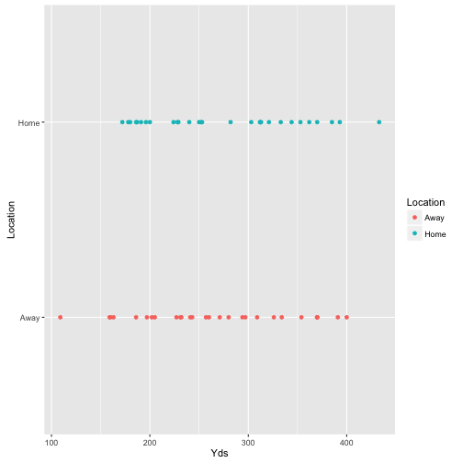

Luck Plot Yards vs. Opponent 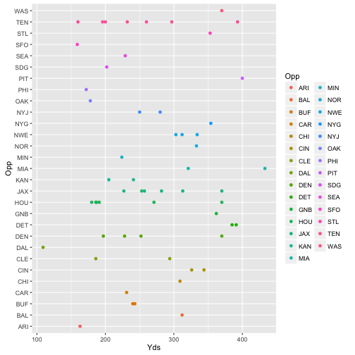

Luck Yards Fit a linear model

## Warning in predict.lm(modelFit, newdata): prediction from a rank-deficient  
## fit may be misleading  
  
## Warning in predict.lm(modelFit, newdata): prediction from a rank-deficient  
## fit may be misleading  
  
## Warning in predict.lm(modelFit, newdata): prediction from a rank-deficient  
## fit may be misleading  
  
## Warning in predict.lm(modelFit, newdata): prediction from a rank-deficient  
## fit may be misleading  
  
## Warning in predict.lm(modelFit, newdata): prediction from a rank-deficient  
## fit may be misleading  
  
## Warning in predict.lm(modelFit, newdata): prediction from a rank-deficient  
## fit may be misleading  
  
## Warning in predict.lm(modelFit, newdata): prediction from a rank-deficient  
## fit may be misleading  
  
## Warning in predict.lm(modelFit, newdata): prediction from a rank-deficient  
## fit may be misleading  
  
## Warning in predict.lm(modelFit, newdata): prediction from a rank-deficient  
## fit may be misleading  
  
## Warning in predict.lm(modelFit, newdata): prediction from a rank-deficient  
## fit may be misleading  
  
## Warning in predict.lm(modelFit, newdata): prediction from a rank-deficient  
## fit may be misleading  
  
## Warning in predict.lm(modelFit, newdata): prediction from a rank-deficient  
## fit may be misleading  
  
## Warning in predict.lm(modelFit, newdata): prediction from a rank-deficient  
## fit may be misleading  
  
## Warning in predict.lm(modelFit, newdata): prediction from a rank-deficient  
## fit may be misleading  
  
## Warning in predict.lm(modelFit, newdata): prediction from a rank-deficient  
## fit may be misleading  
  
## Warning in predict.lm(modelFit, newdata): prediction from a rank-deficient  
## fit may be misleading  
  
## Warning in predict.lm(modelFit, newdata): prediction from a rank-deficient  
## fit may be misleading  
  
## Warning in predict.lm(modelFit, newdata): prediction from a rank-deficient  
## fit may be misleading  
  
## Warning in predict.lm(modelFit, newdata): prediction from a rank-deficient  
## fit may be misleading  
  
## Warning in predict.lm(modelFit, newdata): prediction from a rank-deficient  
## fit may be misleading  
  
## Warning in predict.lm(modelFit, newdata): prediction from a rank-deficient  
## fit may be misleading  
  
## Warning in predict.lm(modelFit, newdata): prediction from a rank-deficient  
## fit may be misleading  
  
## Warning in predict.lm(modelFit, newdata): prediction from a rank-deficient  
## fit may be misleading  
  
## Warning in predict.lm(modelFit, newdata): prediction from a rank-deficient  
## fit may be misleading  
  
## Warning in predict.lm(modelFit, newdata): prediction from a rank-deficient  
## fit may be misleading

##   
## Call:  
## lm(formula = .outcome ~ ., data = dat)  
##   
## Coefficients:  
## (Intercept) LocationHome OppBAL OppBUF OppCAR   
## 163.00 -24.66 173.66 90.83 68.00   
## OppCHI OppCIN OppCLE OppDAL OppDEN   
## 146.00 184.33 89.33 -54.00 111.08   
## OppDET OppGNB OppHOU OppJAX OppKAN   
## 237.33 223.66 80.16 133.00 60.00   
## OppMIA OppMIN OppNOR OppNWE OppNYG   
## 238.66 85.66 194.66 169.77 191.00   
## OppNYJ OppOAK OppPHI OppPIT OppSDG   
## 114.33 39.66 33.66 237.00 39.00   
## OppSEA OppSFO OppSTL OppTEN OppWAS   
## 90.66 -4.00 214.66 95.86 231.66

Luck Yards Diagnostics 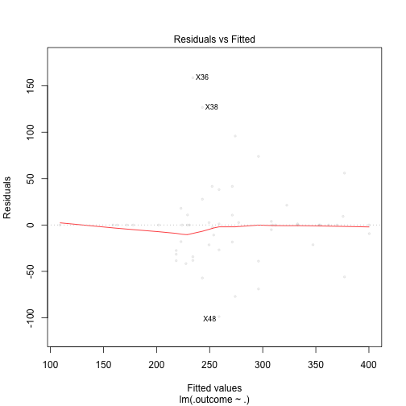

Luck Yards Plot by index 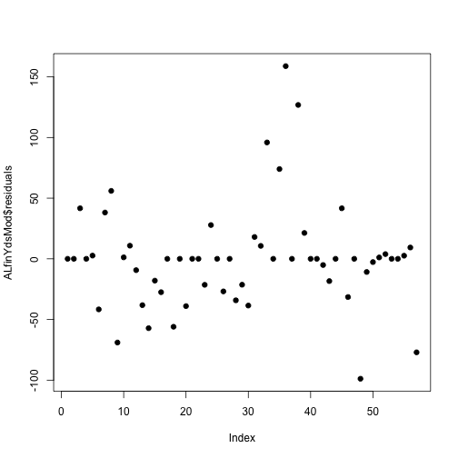

Luck Yards Predicted Values vs. Opponents 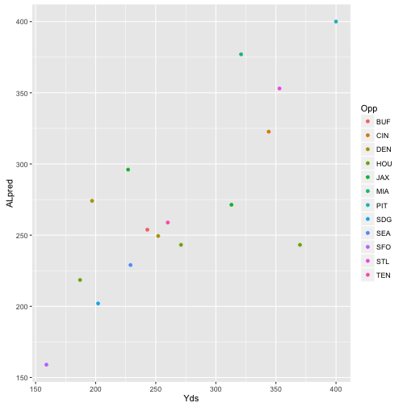

## Andrew Luck - Summary TD Data

Luck TD Fitting a linear model using opponent data

ALfitTd<- lm(Opp ~ TD), data = ALdf))  
coef(ALfitTd)  
summary(ALfitTd)$coefficients

## Error: <text>:1:23: unexpected ','  
## 1: ALfitTd<- lm(Opp ~ TD),  
## ^

The intercept is the expected number of games (15). According to the model, the opponent has no direct affect on Luck's TD's/game

Luck Plot of Data TD against opponents

## Error in eval(expr, envir, enclos): object 'ALgTdsplotOpp' not found

## Error in labs(y = label): object 'Opponent' not found

## Warning in qt((1 - level)/2, df): NaNs produced  
  
## Warning in qt((1 - level)/2, df): NaNs produced  
  
## Warning in qt((1 - level)/2, df): NaNs produced  
  
## Warning in qt((1 - level)/2, df): NaNs produced  
  
## Warning in qt((1 - level)/2, df): NaNs produced

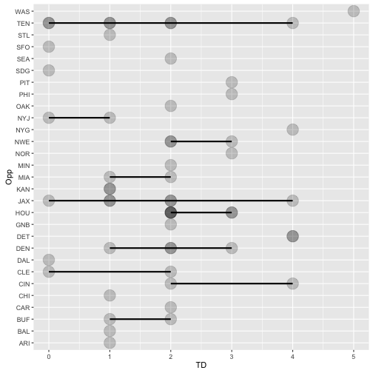

plot of chunk unnamed-chunk-46

Luck TD Fitting a linear model using location data

ALfitTd2<- lm(TD ~ Location, data = ALdf)  
summary(ALfitTd2)$coefficients

## Estimate Std. Error t value Pr(>|t|)  
## (Intercept) 1.7500000 0.2338491 7.483458 6.088541e-10  
## LocationHome 0.2155172 0.3278492 0.657367 5.136867e-01

The intercept is the expexcted TDs (1.75). According to the model, we should expect a 0.21 in TDs increase when playing at home with a SE of 0.32 TDs (high + 2.07 TDs, low - 1.54 TDs). Cam will be playing Away this week.

Luck Residuals - TDs vs. Opponent

##   
## Call:  
## lm(formula = ALyTdOpp ~ ALxTdOpp)  
##   
## Coefficients:  
## (Intercept) ALxTdOppBAL ALxTdOppBUF ALxTdOppCAR ALxTdOppCHI   
## 1.000e+00 -4.543e-15 5.000e-01 1.000e+00 -4.049e-15   
## ALxTdOppCIN ALxTdOppCLE ALxTdOppDAL ALxTdOppDEN ALxTdOppDET   
## 2.000e+00 -5.483e-15 -1.000e+00 1.000e+00 3.000e+00   
## ALxTdOppGNB ALxTdOppHOU ALxTdOppJAX ALxTdOppKAN ALxTdOppMIA   
## 1.000e+00 1.333e+00 6.667e-01 -1.222e-15 5.000e-01   
## ALxTdOppMIN ALxTdOppNOR ALxTdOppNWE ALxTdOppNYG ALxTdOppNYJ   
## 1.000e+00 2.000e+00 1.333e+00 3.000e+00 -5.000e-01   
## ALxTdOppOAK ALxTdOppPHI ALxTdOppPIT ALxTdOppSDG ALxTdOppSEA   
## 1.000e+00 2.000e+00 2.000e+00 -1.000e+00 1.000e+00   
## ALxTdOppSFO ALxTdOppSTL ALxTdOppTEN ALxTdOppWAS   
## -1.000e+00 -8.192e-16 4.286e-01 4.000e+00

## [1] 8.548717e-15

## Warning in abline(ALfitTdOpp, lwd = 2): only using the first two of 29  
## regression coefficients

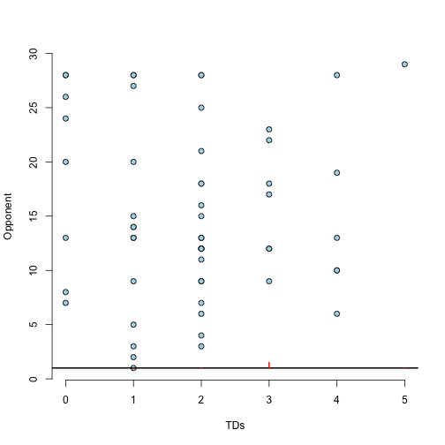

plot of chunk unnamed-chunk-48

Luck Residuals - TDs vs. Location

##   
## Call:  
## lm(formula = ALyTdLoc ~ ALxTdLoc)  
##   
## Coefficients:  
## (Intercept) ALxTdLocHome   
## 1.7500 0.2155

## Error in eval(expr, envir, enclos): object 'ALyhatTdLoc' not found

## Error in eval(expr, envir, enclos): object 'ALyhatTdLoc' not found

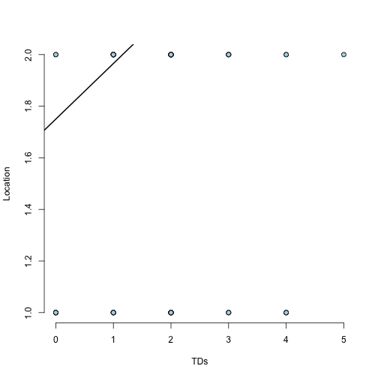

plot of chunk unnamed-chunk-49

## Error in xy.coords(x, y): object 'ALyhatTdLoc' not found

Luck TD Opponent Residual Variation

## [1] 1.044503

Newton TD Location Residual Variation

## [1] 1.237413

Luck TD Training Sets

## [1] 41 22

## [1] 16 22

Luck Plot TDs vs. Location 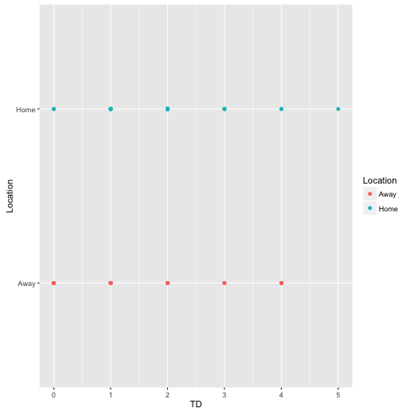

Luck Plot TDs vs. Opponent 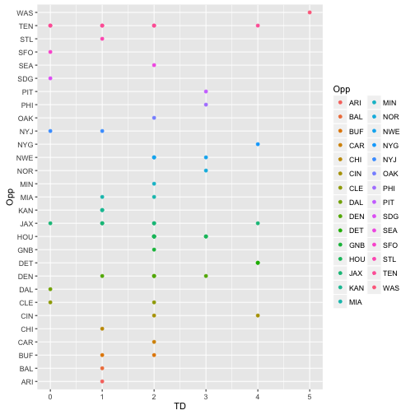

Luck TD Fit a linear model

## Warning in predict.lm(modelFit, newdata): prediction from a rank-deficient  
## fit may be misleading  
  
## Warning in predict.lm(modelFit, newdata): prediction from a rank-deficient  
## fit may be misleading  
  
## Warning in predict.lm(modelFit, newdata): prediction from a rank-deficient  
## fit may be misleading  
  
## Warning in predict.lm(modelFit, newdata): prediction from a rank-deficient  
## fit may be misleading  
  
## Warning in predict.lm(modelFit, newdata): prediction from a rank-deficient  
## fit may be misleading  
  
## Warning in predict.lm(modelFit, newdata): prediction from a rank-deficient  
## fit may be misleading  
  
## Warning in predict.lm(modelFit, newdata): prediction from a rank-deficient  
## fit may be misleading  
  
## Warning in predict.lm(modelFit, newdata): prediction from a rank-deficient  
## fit may be misleading  
  
## Warning in predict.lm(modelFit, newdata): prediction from a rank-deficient  
## fit may be misleading  
  
## Warning in predict.lm(modelFit, newdata): prediction from a rank-deficient  
## fit may be misleading  
  
## Warning in predict.lm(modelFit, newdata): prediction from a rank-deficient  
## fit may be misleading  
  
## Warning in predict.lm(modelFit, newdata): prediction from a rank-deficient  
## fit may be misleading  
  
## Warning in predict.lm(modelFit, newdata): prediction from a rank-deficient  
## fit may be misleading  
  
## Warning in predict.lm(modelFit, newdata): prediction from a rank-deficient  
## fit may be misleading  
  
## Warning in predict.lm(modelFit, newdata): prediction from a rank-deficient  
## fit may be misleading  
  
## Warning in predict.lm(modelFit, newdata): prediction from a rank-deficient  
## fit may be misleading  
  
## Warning in predict.lm(modelFit, newdata): prediction from a rank-deficient  
## fit may be misleading  
  
## Warning in predict.lm(modelFit, newdata): prediction from a rank-deficient  
## fit may be misleading  
  
## Warning in predict.lm(modelFit, newdata): prediction from a rank-deficient  
## fit may be misleading  
  
## Warning in predict.lm(modelFit, newdata): prediction from a rank-deficient  
## fit may be misleading  
  
## Warning in predict.lm(modelFit, newdata): prediction from a rank-deficient  
## fit may be misleading  
  
## Warning in predict.lm(modelFit, newdata): prediction from a rank-deficient  
## fit may be misleading  
  
## Warning in predict.lm(modelFit, newdata): prediction from a rank-deficient  
## fit may be misleading  
  
## Warning in predict.lm(modelFit, newdata): prediction from a rank-deficient  
## fit may be misleading  
  
## Warning in predict.lm(modelFit, newdata): prediction from a rank-deficient  
## fit may be misleading

##   
## Call:  
## lm(formula = .outcome ~ ., data = dat)  
##   
## Coefficients:  
## (Intercept) LocationHome OppBAL OppBUF OppCAR   
## 1.000e+00 -2.198e-01 2.198e-01 6.099e-01 1.000e+00   
## OppCHI OppCIN OppCLE OppDAL OppDEN   
## 1.641e-15 2.110e+00 1.099e-01 -1.000e+00 1.110e+00   
## OppDET OppGNB OppHOU OppJAX OppKAN   
## 3.110e+00 1.220e+00 1.443e+00 7.766e-01 3.814e-15   
## OppMIA OppMIN OppNOR OppNWE OppNYG   
## 7.198e-01 1.220e+00 2.220e+00 1.480e+00 3.000e+00   
## OppNYJ OppOAK OppPHI OppPIT OppSDG   
## -3.901e-01 1.220e+00 2.220e+00 2.000e+00 -1.000e+00   
## OppSEA OppSFO OppSTL OppTEN OppWAS   
## 1.220e+00 -1.000e+00 2.198e-01 5.228e-01 4.220e+00

Luck TD Diagnostics 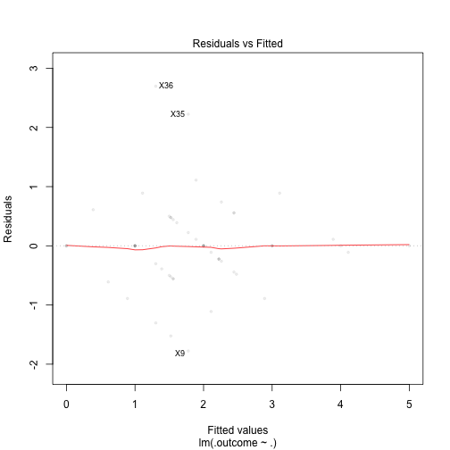

Luck TD Plot by index 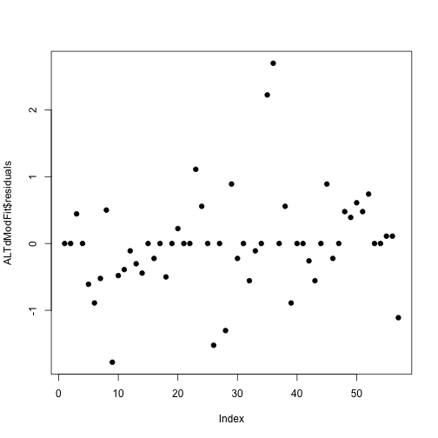

Luck TD Prediction vs. Opponent and Location 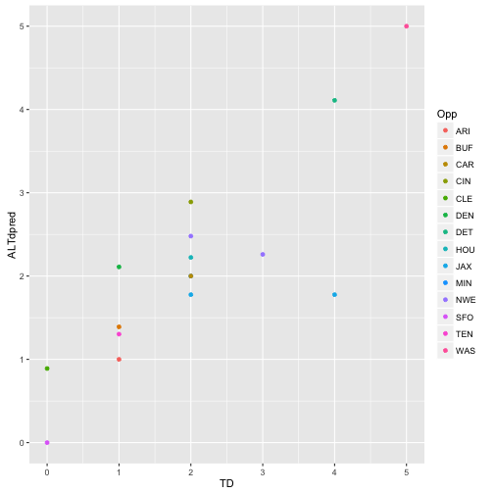

# RB Analysis

## Blount - Summary Rushing TD Data

## Min. 1st Qu. Median Mean 3rd Qu. Max. NA's   
## -3.00 16.25 47.00 50.66 72.00 189.00 4

## Min. 1st Qu. Median Mean 3rd Qu. Max. NA's   
## 0.0000 0.0000 0.0000 0.4024 1.0000 3.0000 4

## [1] NA

## [1] NA

## Anderson - Summary Rushing TD Data

## Min. 1st Qu. Median Mean 3rd Qu. Max. NA's   
## -3.00 22.00 41.00 53.73 85.00 168.00 4

## Min. 1st Qu. Median Mean 3rd Qu. Max. NA's   
## 0.0000 0.0000 0.0000 0.4545 1.0000 3.0000 4

## [1] NA

## [1] NA

## Gore - Summary Rushing TD Data

## Min. 1st Qu. Median Mean 3rd Qu. Max.   
## 0.00 42.25 68.00 73.15 97.00 212.00

## Min. 1st Qu. Median Mean 3rd Qu. Max.   
## 0.0000 0.0000 0.0000 0.4217 1.0000 2.0000

## [1] 40.34061

## [1] 0.6251396

## Hyde - Summary Rushing TD Data

## Min. 1st Qu. Median Mean 3rd Qu. Max.   
## 0.00 16.50 34.00 40.22 50.50 168.00

## Min. 1st Qu. Median Mean 3rd Qu. Max.   
## 0.0000 0.0000 0.0000 0.3913 1.0000 2.0000

## [1] 36.63699

## [1] 0.6563764

## Blount - Histogram of Yards and TDs

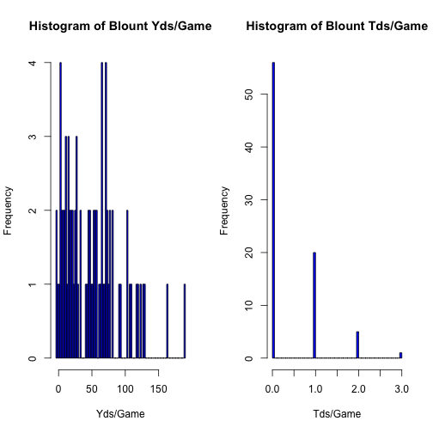

plot of chunk Blount Histogram

## Anderson - Histogram of Yards and TDs

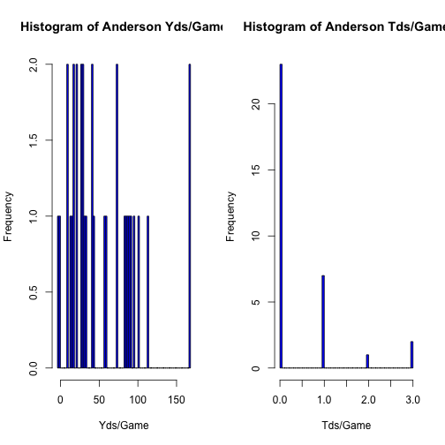

plot of chunk Anderson Histogram

## Gore - Histogram of Yards and TDs

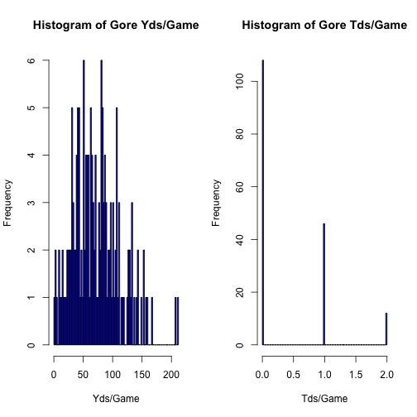

plot of chunk Gore Histogram

## Hyde - Histogram of Yards and TDs

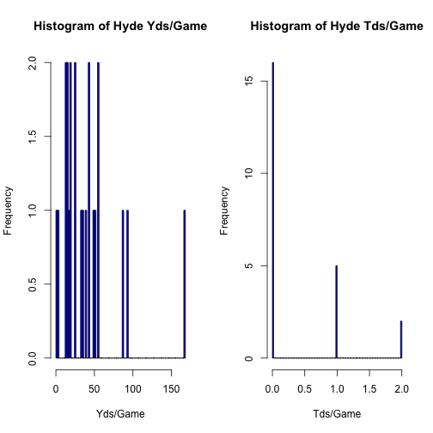

plot of chunk Hyde Histogram

## Blount - Least square estimate

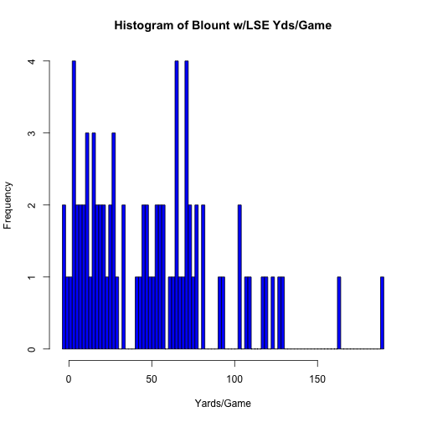

plot of chunk Blount LSE

## Anderson - Least square estimate

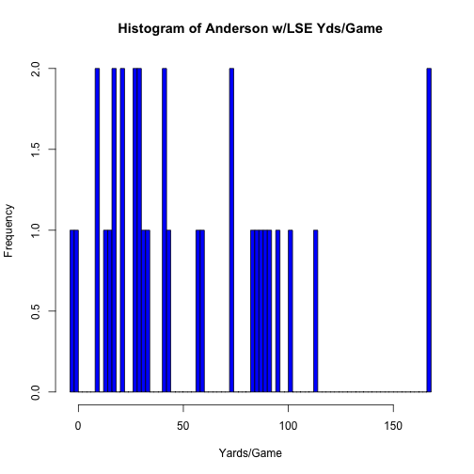

plot of chunk Anderson LSE

## Gore - Least square estimate

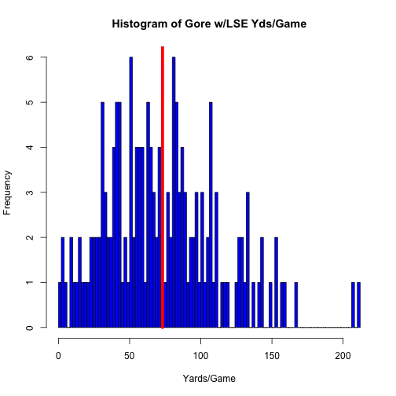

plot of chunk Gore LSE

## Hyde - Least square estimate

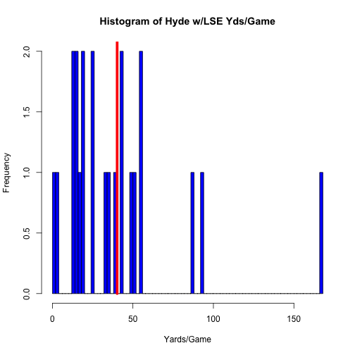

plot of chunk Hyde LSE

## Blount - Current Opponent Analysis (Rushing only)

## [1] 3.5

## [1] 1.75

## [1] 5.25

## Anderson - Current Opponent Analysis (Rushing only)

## [1] 7.8

## [1] 7

## [1] 14.8

## Gore - Current Opponent Analysis (Rushing only)

## [1] 10.65

## [1] 3.5

## [1] 14.15

## Hyde - Current Opponent Analysis (Rushing only)

## [1] 5

## [1] 3.5

## [1] 8.5