Carrion Portfolio Quant Analysis_Sept 2016

Joshua Peterson

9/28/2016

Risk-free rate

## GMT  
## TS.1  
## 2016-10-03 0.0163  
## 2016-09-30 0.0160  
## 2016-09-29 0.0156  
## 2016-09-28 0.0157  
## 2016-09-27 0.0156

Required return 8.5% or a real rate of 6.0% with a 2.5% inflation assumption. This required return was determined using the Personal Capital simulation tool. This assumed growth rate will satsify projected spending of $5,200/month or approx. $60,000/year. This assumes a Social Security benefit of $20,000/year and a VA benefit of $18,516/year.

## Model Benchmark Portfolio

This benchmark portfolio is determined using non-ESG centric holdings

### SPDR S&P 500 Index (SPY)

Standard deviation of returns

## [,1]  
## StdDev 0.1810829

Sharpe ratio

## Error in e1/e2: non-conformable arrays

## GMT  
## TS.1  
## 2016-09-27 0.3844905

### iShares S&P MidCap 400 Index Fund (IJH)

## TS.1  
## Annualized Return 0.1176209

Standard deviation of returns

## [,1]  
## StdDev 0.1468885

Sharpe ratio

## Error in e1/e2: non-conformable arrays

## GMT  
## TS.1  
## 2016-09-27 0.6826374

### iShares Russell 2000 ETF (IWM)

## TS.1  
## Annualized Return 0.1123608

Standard deviation of returns

## [,1]  
## StdDev 0.1829323

Sharpe ratio

## Error in e1/e2: non-conformable arrays

## GMT  
## TS.1  
## 2016-09-27 0.3164178

### iShares MSCI EAFE ETF (EFA)

## TS.1  
## Annualized Return 0.01473366

Standard deviation of returns

## [,1]  
## StdDev 0.1176595

Sharpe ratio

## Error in e1/e2: non-conformable arrays

## GMT  
## TS.1  
## 2016-09-27 119.9649

### iShares MSCI Emerging Markets ETF (EEM)

## TS.1  
## Annualized Return -0.03371195

Standard deviation of returns

## [,1]  
## StdDev 0.1434364

Sharpe ratio

## Error in e1/e2: non-conformable arrays

## GMT  
## TS.1  
## 2016-09-27 -22.38956

### iShares International Developed Real Estate ETF (IFGL)

## TS.1  
## Annualized Return -0.02121399

Standard deviation of returns

## [,1]  
## StdDev 0.07191995

Sharpe ratio

## Error in e1/e2: non-conformable arrays

## GMT  
## TS.1  
## 2016-09-27 -0.4948654

### iShares U.S. Real Estate ETF (IYR)

## TS.1  
## Annualized Return 0.06117474

Standard deviation of returns

## [,1]  
## StdDev 0.1143488

Sharpe ratio

## Error in e1/e2: non-conformable arrays

## GMT  
## TS.1  
## 2016-09-27 0.4204544

### iShares S&P GSCI Commodity fund (GSG)

## TS.1  
## Annualized Return -0.1617588

Standard deviation of returns

## [,1]  
## StdDev 0.2016876

Sharpe ratio

## Error in e1/e2: non-conformable arrays

## GMT  
## TS.1  
## 2016-09-27 -0.9923468

### iShares Global Infrastructure ETF (IGF)

## TS.1  
## Annualized Return 0.04548153

Standard deviation of returns

## [,1]  
## StdDev 0.1327417

Sharpe ratio

## Error in e1/e2: non-conformable arrays

## GMT  
## TS.1  
## 2016-09-27 0.2195517

### iShares Emerging Markets Infrastructure ETF (EMIF)

## TS.1  
## Annualized Return -0.02167109

Standard deviation of returns

## [,1]  
## StdDev 0.1179735

Sharpe ratio

## Error in e1/e2: non-conformable arrays

## GMT  
## TS.1  
## 2016-09-27 -0.3315988

### iShares Listed Private Equity UCITS ETF (IPRV)

## TS.1  
## Annualized Return 0.1023511

Standard deviation of returns

## [,1]  
## StdDev 0.1052126

Sharpe ratio

## Error in e1/e2: non-conformable arrays

## GMT  
## TS.1  
## 2016-09-27 0.785975

### iShares Barclays Aggregate Bond Fund (AGG)

## TS.1  
## Annualized Return 0.003619398

Standard deviation of returns

## [,1]  
## StdDev 0.04056375

Sharpe ratio

## Error in e1/e2: non-conformable arrays

## GMT  
## TS.1  
## 2016-09-27 -0.2883961

### iShares International Treasury Bond ETF (IGOV)

## TS.1  
## Annualized Return -0.003587115

Standard deviation of returns

## [,1]  
## StdDev 0.08477068

Sharpe ratio

## Error in e1/e2: non-conformable arrays

## GMT  
## TS.1  
## 2016-09-27 -0.2096811

### iShares JPMorgan USD Emerging Market Bond Fund ETF (EMB)

## TS.1  
## Annualized Return -0.008145787

Standard deviation of returns

## [,1]  
## StdDev 0.09503473

Sharpe ratio

## Error in e1/e2: non-conformable arrays

## GMT  
## TS.1  
## 2016-09-27 -0.2498643

### iShares Global High Yield Corporate Bond Fund ETF (GHGY)

## TS.1  
## Annualized Return -0.01275439

Standard deviation of returns

## [,1]  
## StdDev 0.09572787

Sharpe ratio

## Error in e1/e2: non-conformable arrays

## GMT  
## TS.1  
## 2016-09-27 -0.3067826

### iShares Emerging Markets High Yield Bond Fund ETF (EMHY)

## TS.1  
## Annualized Return -0.02053939

Standard deviation of returns

## [,1]  
## StdDev 0.1003449

Sharpe ratio

## Error in e1/e2: non-conformable arrays

## GMT  
## TS.1  
## 2016-09-27 -0.3473477

## Aggregated Benchmark Portfolio Returns

This assumes an even exposure across all of the asset classes within the Benchmark Portfolio

## GMT  
## KLD IJH IWM EFA EEM  
## 2013-12-31 0.29688924 0.31573255 0.36812144 0.180091453 -0.05749718  
## 2014-12-31 0.11289182 0.08213138 0.03692788 -0.093293592 -0.06004785  
## 2015-12-31 -0.00812493 -0.03784530 -0.05851864 -0.034845496 -0.18070756  
## 2016-12-31 0.06097027 0.11046512 0.10291245 0.006982289 0.16340478  
## IFGL IYR GSG IGF EMIF  
## 2013-12-31 -0.06851796 -0.02458636 -0.01829826 0.09045085 -0.003212617  
## 2014-12-31 -0.02657161 0.21813570 -0.32960547 0.08243451 -0.050395546  
## 2015-12-31 -0.07190413 -0.02290474 -0.34059314 -0.14733096 -0.158901574  
## 2016-12-31 0.08213773 0.07405434 0.04146170 0.15637173 0.125825385  
## IPRV AGG IGOV EMB GHYG  
## 2013-12-31 0.25490196 -0.04186172 -0.02662003 -0.11914651 0.02030746  
## 2014-12-31 0.08779762 0.03467068 -0.03403533 0.01433062 -0.07031250  
## 2015-12-31 0.02325581 -0.01916092 -0.07346559 -0.03582171 -0.10724290  
## 2016-12-31 0.04344920 0.04082955 0.11977250 0.10805445 0.10623039  
## EMHY  
## 2013-12-31 -0.11523963  
## 2014-12-31 -0.03631568  
## 2015-12-31 -0.05157895  
## 2016-12-31 0.12097669

## [1] 0.01810102

### Creating the optimal portfolio along the efficient frontier

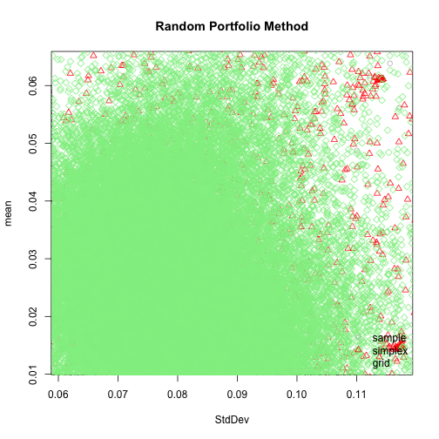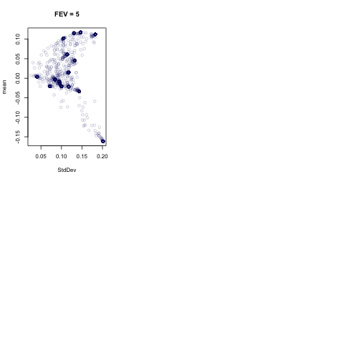

## Error in xy.coords(x, y, xlabel, ylabel, log): 'x' and 'y' lengths differ

### Optimzed portfolio weights

## GMT  
## KLD IJH IWM EFA EEM  
## 2013-12-31 0.29688924 0.31573255 0.36812144 0.180091453 -0.05749718  
## 2014-12-31 0.11289182 0.08213138 0.03692788 -0.093293592 -0.06004785  
## 2015-12-31 -0.00812493 -0.03784530 -0.05851864 -0.034845496 -0.18070756  
## 2016-12-31 0.06097027 0.11046512 0.10291245 0.006982289 0.16340478  
## IFGL IYR GSG IGF EMIF  
## 2013-12-31 -0.06851796 -0.02458636 -0.01829826 0.09045085 -0.003212617  
## 2014-12-31 -0.02657161 0.21813570 -0.32960547 0.08243451 -0.050395546  
## 2015-12-31 -0.07190413 -0.02290474 -0.34059314 -0.14733096 -0.158901574  
## 2016-12-31 0.08213773 0.07405434 0.04146170 0.15637173 0.125825385  
## IPRV AGG IGOV EMB GHYG  
## 2013-12-31 0.25490196 -0.04186172 -0.02662003 -0.11914651 0.02030746  
## 2014-12-31 0.08779762 0.03467068 -0.03403533 0.01433062 -0.07031250  
## 2015-12-31 0.02325581 -0.01916092 -0.07346559 -0.03582171 -0.10724290  
## 2016-12-31 0.04344920 0.04082955 0.11977250 0.10805445 0.10623039  
## EMHY  
## 2013-12-31 -0.11523963  
## 2014-12-31 -0.03631568  
## 2015-12-31 -0.05157895  
## 2016-12-31 0.12097669

## ***********************************  
## PortfolioAnalytics Optimization  
## ***********************************  
##   
## Call:  
## optimize.portfolio(R = port.return.data.final, portfolio = total.port.minEs,   
## optimize_method = "random", trace = TRUE, rp = rp)  
##   
## Optimal Weights:  
## KLD IJH IWM EFA EEM IFGL IYR GSG IGF EMIF IPRV AGG   
## 0.140 0.132 0.138 0.110 0.028 0.082 0.020 0.096 0.026 0.030 0.052 0.028   
## IGOV EMB GHYG EMHY   
## 0.020 0.034 0.044 0.022   
##   
## Objective Measures:  
## mean   
## 0.03645   
##   
##   
## StdDev   
## 0.1008   
##   
##   
## ES   
## 0.1335

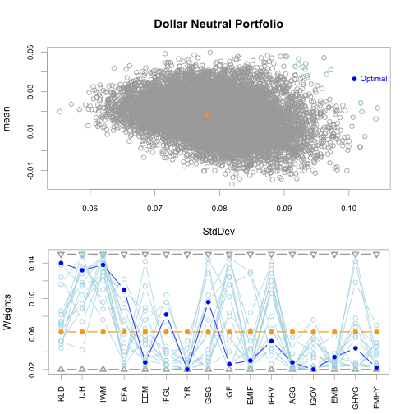

plot of chunk unnamed-chunk-53

Benchmark Portfolio Sharpe Ratio

## Current Portfolio Selections

### Mutual Bond and Fixed Income Holdings

1. iShares 1-3yr International Treasury Bond ETF (ISHG - 1.8yr duration)

Returns

## TS.1  
## Annualized Return -0.03009854

Standard deviation of returns

## [,1]  
## StdDev 0.05869528

Sharpe ratio

## Error in e1/e2: non-conformable arrays

## GMT  
## TS.1  
## 2016-09-27 -0.7777907

Beta

## [1] 0.8133069

Sortino Ratio

## TS.1  
## Sortino Ratio (MAR = 8.5%) -0.9042815

Treynor Ratio

## Warning in class(x) <- oclass: Setting class(x) to multiple strings ("xts",  
## "zoo", ...); result will no longer be an S4 object  
  
## Warning in class(x) <- oclass: Setting class(x) to multiple strings ("xts",  
## "zoo", ...); result will no longer be an S4 object

## [1] 0.02602969

1. Calvert Short Duration Income Fund (CSDAX - 2.5yr duration)

Returns

## TS.1  
## Annualized Return -0.0008545439

Standard deviation of returns

## [,1]  
## StdDev 0.02598303

Sharpe ratio

## Error in e1/e2: non-conformable arrays

## GMT  
## TS.1  
## 2016-09-27 -0.6156598

Beta

## [1] 0.2828307

Sortino Ratio

## TS.1  
## Sortino Ratio (MAR = 8.5%) -0.9629164

Treynor Ratio

## Warning in class(x) <- oclass: Setting class(x) to multiple strings ("xts",  
## "zoo", ...); result will no longer be an S4 object  
  
## Warning in class(x) <- oclass: Setting class(x) to multiple strings ("xts",  
## "zoo", ...); result will no longer be an S4 object

## [1] 0.008430296

1. Access Capital Community Fund (ACASX - 4.2yr duration)

Returns

## TS.1  
## Annualized Return -0.00695073

Standard deviation of returns

## [,1]  
## StdDev 0.02355784

Sharpe ratio

## Error in e1/e2: non-conformable arrays

## GMT  
## TS.1  
## 2016-09-27 -0.9572495

Beta

## [1] 0.7850124

Sortino Ratio

## TS.1  
## Sortino Ratio (MAR = 8.5%) -0.9730031

Treynor Ratio

## Warning in class(x) <- oclass: Setting class(x) to multiple strings ("xts",  
## "zoo", ...); result will no longer be an S4 object  
  
## Warning in class(x) <- oclass: Setting class(x) to multiple strings ("xts",  
## "zoo", ...); result will no longer be an S4 object

## [1] 0.008453524

1. PAX World High Yield Bond Fund (PAXHX - 4.3yr duration)

## TS.1  
## Annualized Return -0.02001561

Standard deviation of returns

## [,1]  
## StdDev 0.06492024

Sharpe ratio

## Error in e1/e2: non-conformable arrays

## GMT  
## TS.1  
## 2016-09-27 -0.5677196

Beta

## [1] 0.4726875

Sortino Ratio

## TS.1  
## Sortino Ratio (MAR = 8.5%) -0.8679028

Treynor Ratio

## Warning in class(x) <- oclass: Setting class(x) to multiple strings ("xts",  
## "zoo", ...); result will no longer be an S4 object  
  
## Warning in class(x) <- oclass: Setting class(x) to multiple strings ("xts",  
## "zoo", ...); result will no longer be an S4 object

## [1] 0.007999039

1. iShares Core Treasury Bond ETF (GOVT - 6.06yr duration)

## Error: {"quandl_error":{"code":"QECx02","message":"You have submitted an incorrect Quandl code. Please check your Quandl codes and try again."}}

## TS.1  
## Annualized Return 0.01027858

Standard deviation of returns

## [,1]  
## StdDev 0.03609648

Sharpe ratio

## Error in e1/e2: non-conformable arrays

## GMT  
## TS.1  
## 2016-09-27 -0.1474222

Beta

## [1] 0.4726875

Sortino Ratio

## TS.1  
## Sortino Ratio (MAR = 8.5%) -0.9225213

Treynor Ratio

## Warning in class(x) <- oclass: Setting class(x) to multiple strings ("xts",  
## "zoo", ...); result will no longer be an S4 object  
  
## Warning in class(x) <- oclass: Setting class(x) to multiple strings ("xts",  
## "zoo", ...); result will no longer be an S4 object

## [1] 0.04747256

1. iShares International Treasury Bond ETF (IGOV - 8.06yr duration)

## Error: {"quandl_error":{"code":"QECx02","message":"You have submitted an incorrect Quandl code. Please check your Quandl codes and try again."}}

## TS.1  
## Annualized Return -0.003587115

Standard deviation of returns

## [,1]  
## StdDev 0.08477068

Sharpe ratio

## Error in e1/e2: non-conformable arrays

## GMT  
## TS.1  
## 2016-09-27 -0.2096811

Beta

## [1] 1

Sortino Ratio

## TS.1  
## Sortino Ratio (MAR = 8.5%) -0.7789117

Treynor Ratio

## Warning in class(x) <- oclass: Setting class(x) to multiple strings ("xts",  
## "zoo", ...); result will no longer be an S4 object  
  
## Warning in class(x) <- oclass: Setting class(x) to multiple strings ("xts",  
## "zoo", ...); result will no longer be an S4 object

## [1] 0.04515759

### Mutual Fund U.S. Stock Holdings

1. Parnassus Endeavor Fund (PARWX - Large Cap Growth)

## TS.1  
## Annualized Return 0.07684704

Standard deviation of returns

## [,1]  
## StdDev 0.1030606

Sharpe ratio

## Error in e1/e2: non-conformable arrays

## GMT  
## TS.1  
## 2016-09-27 0.5881156

Beta

## [1] 0.8724749

Sortino Ratio

## TS.1  
## Sortino Ratio (MAR = 8.5%) -0.1052447

Treynor Ratio

## Warning in class(x) <- oclass: Setting class(x) to multiple strings ("xts",  
## "zoo", ...); result will no longer be an S4 object  
  
## Warning in class(x) <- oclass: Setting class(x) to multiple strings ("xts",  
## "zoo", ...); result will no longer be an S4 object

## [1] 0.009137164

1. Parnassus Mid-Cap Fund (PARMX - Mid Cap Blend)

## TS.1  
## Annualized Return 0.09066998

Standard deviation of returns

## [,1]  
## StdDev 0.1060059

Sharpe ratio

## Error in e1/e2: non-conformable arrays

## GMT  
## TS.1  
## 2016-09-27 0.7013985

Beta

## [1] 0.639725

Sortino Ratio

## TS.1  
## Sortino Ratio (MAR = 8.5%) 0.07848458

Treynor Ratio

## Warning in class(x) <- oclass: Setting class(x) to multiple strings ("xts",  
## "zoo", ...); result will no longer be an S4 object  
  
## Warning in class(x) <- oclass: Setting class(x) to multiple strings ("xts",  
## "zoo", ...); result will no longer be an S4 object

## [1] 0.02127641

1. Pax World Small-Cap Fund (PXSCX - Small Cap Blend)

## TS.1  
## Annualized Return 0.09066998

Standard deviation of returns

## [,1]  
## StdDev 0.1060059

Sharpe ratio

## Error in e1/e2: non-conformable arrays

## GMT  
## TS.1  
## 2016-09-27 0.7013985

Beta

## [1] 0.639725

Sortino Ratio

## TS.1  
## Sortino Ratio (MAR = 8.5%) 0.07848458

Treynor Ratio

## Warning in class(x) <- oclass: Setting class(x) to multiple strings ("xts",  
## "zoo", ...); result will no longer be an S4 object  
  
## Warning in class(x) <- oclass: Setting class(x) to multiple strings ("xts",  
## "zoo", ...); result will no longer be an S4 object

## [1] 0.02127641

### Mutual Fund Developed Market Stock Holdings

1. Pax MSCI International ESG Index Fund (PXINX - Developed World International)

## TS.1  
## Annualized Return -0.001123857

Standard deviation of returns

## [,1]  
## StdDev 0.1218419

Sharpe ratio

## Error in e1/e2: non-conformable arrays

## GMT  
## TS.1  
## 2016-09-27 -0.1734403

Beta

## [1] 0.9210095

Sortino Ratio

## TS.1  
## Sortino Ratio (MAR = 8.5%) -0.6162617

Treynor Ratio

## Warning in class(x) <- oclass: Setting class(x) to multiple strings ("xts",  
## "zoo", ...); result will no longer be an S4 object  
  
## Warning in class(x) <- oclass: Setting class(x) to multiple strings ("xts",  
## "zoo", ...); result will no longer be an S4 object

## [1] 0.005978689

### Mutual Fund Developing Market Stock Holdings

1. Calvert Emerging Markets Equity Fund (CVMAX - Developing International)

## [1] 0.01816068

Standard deviation of returns

## [,1]  
## StdDev 0.0869076

Sharpe ratio

## Error in e1/e2: non-conformable arrays

## GMT  
## TS.1  
## 2016-09-27 0.04800099

Beta

## [1] 0.7256115

Sortino Ratio

## yearly.returns  
## Sortino Ratio (MAR = 8.5%) -0.6681232

Treynor Ratio

## Warning in class(x) <- oclass: Setting class(x) to multiple strings ("xts",  
## "zoo", ...); result will no longer be an S4 object

## [1] NA

# Single Stock Holdings

## Real Assets

1. Avalonbay Communities Inc. (AVB)

## TS.1  
## Annualized Return 0.1344944

Standard deviation of returns

## [,1]  
## StdDev 0.2610724

Sharpe ratio

## Error in e1/e2: non-conformable arrays

## GMT  
## TS.1  
## 2016-09-27 0.459995

Beta

## [1] 1.525012

Sortino Ratio

## TS.1  
## Sortino Ratio (MAR = 8.5%) 0.3214165

Treynor Ratio

## Warning in class(x) <- oclass: Setting class(x) to multiple strings ("xts",  
## "zoo", ...); result will no longer be an S4 object  
  
## Warning in class(x) <- oclass: Setting class(x) to multiple strings ("xts",  
## "zoo", ...); result will no longer be an S4 object

## [1] 0.004786509

1. ProLogis Inc. (PLD)

## TS.1  
## Annualized Return 0.07883884

Standard deviation of returns

## [,1]  
## StdDev 0.2012641

Sharpe ratio

## Error in e1/e2: non-conformable arrays

## GMT  
## TS.1  
## 2016-09-27 0.3178014

Beta

## [1] 0.7175708

Sortino Ratio

## TS.1  
## Sortino Ratio (MAR = 8.5%) -0.03664808

Treynor Ratio

## Warning in class(x) <- oclass: Setting class(x) to multiple strings ("xts",  
## "zoo", ...); result will no longer be an S4 object  
  
## Warning in class(x) <- oclass: Setting class(x) to multiple strings ("xts",  
## "zoo", ...); result will no longer be an S4 object

## [1] 0.003953808

1. Extra Space Storage Inc (EXR)

## TS.1  
## Annualized Return 0.1933297

Standard deviation of returns

## [,1]  
## StdDev 0.2786177

Sharpe ratio

## Error in e1/e2: non-conformable arrays

## GMT  
## TS.1  
## 2016-09-27 0.1061801

Beta

## [1] 0.109607

Sortino Ratio

## TS.1  
## Sortino Ratio (MAR = 8.5%) 0.7399104

Treynor Ratio

## Warning in class(x) <- oclass: Setting class(x) to multiple strings ("xts",  
## "zoo", ...); result will no longer be an S4 object  
  
## Warning in class(x) <- oclass: Setting class(x) to multiple strings ("xts",  
## "zoo", ...); result will no longer be an S4 object

## [1] 0.01192606

1. iShares Gold Trust

## TS.1  
## Annualized Return 0.1006931

Standard deviation of returns

## [,1]  
## StdDev 0.1843145

Sharpe ratio

## Error in e1/e2: non-conformable arrays

## GMT  
## TS.1  
## 2016-09-27 0.4616732

Beta

## [1] 0.2515437

Sortino Ratio

## TS.1  
## Sortino Ratio (MAR = 8.5%) 0.1213491

Treynor Ratio

## Warning in class(x) <- oclass: Setting class(x) to multiple strings ("xts",  
## "zoo", ...); result will no longer be an S4 object  
  
## Warning in class(x) <- oclass: Setting class(x) to multiple strings ("xts",  
## "zoo", ...); result will no longer be an S4 object

## [1] 0.03023124

## Water Utilities & Infrastructure

### US Equities

1. Middlesex Water Company (MSEX)

## TS.1  
## Annualized Return 0.03432783

Standard deviation of returns

## [,1]  
## StdDev 0.1828465

Sharpe ratio

## Error in e1/e2: non-conformable arrays

## GMT  
## TS.1  
## 2016-09-27 0.1061801

Beta

## [1] 0.2680041

Sortino Ratio

## TS.1  
## Sortino Ratio (MAR = 8.5%) -0.3126203

Treynor Ratio

## Warning in class(x) <- oclass: Setting class(x) to multiple strings ("xts",  
## "zoo", ...); result will no longer be an S4 object  
  
## Warning in class(x) <- oclass: Setting class(x) to multiple strings ("xts",  
## "zoo", ...); result will no longer be an S4 object

## [1] 0.01078915

1. Xylem, Inc (XYL)

## TS.1  
## Annualized Return 0.1655347

Standard deviation of returns

## [,1]  
## StdDev 0.1905987

Sharpe ratio

## Error in e1/e2: non-conformable arrays

## GMT  
## TS.1  
## 2016-09-27 0.7894132

Beta

## [1] 1.372663

Sortino Ratio

## TS.1  
## Sortino Ratio (MAR = 8.5%) 1.387564

Treynor Ratio

## Warning in class(x) <- oclass: Setting class(x) to multiple strings ("xts",  
## "zoo", ...); result will no longer be an S4 object  
  
## Warning in class(x) <- oclass: Setting class(x) to multiple strings ("xts",  
## "zoo", ...); result will no longer be an S4 object

## [1] 0.05163357

1. Danaher, Inc (DHR)

## TS.1  
## Annualized Return 0.2366094

Standard deviation of returns

## [,1]  
## StdDev 0.2665522

Sharpe ratio

## Error in e1/e2: non-conformable arrays

## GMT  
## TS.1  
## 2016-09-27 0.8271275

Beta

## [1] -0.2311883

Sortino Ratio

## TS.1  
## Sortino Ratio (MAR = 8.5%) 1.293253

Treynor Ratio

## Warning in class(x) <- oclass: Setting class(x) to multiple strings ("xts",  
## "zoo", ...); result will no longer be an S4 object  
  
## Warning in class(x) <- oclass: Setting class(x) to multiple strings ("xts",  
## "zoo", ...); result will no longer be an S4 object

## [1] 0.009881453

1. American Water Works Co., Inc (AWK)

## TS.1  
## Annualized Return 0.1749945

Standard deviation of returns

## [,1]  
## StdDev 0.07320485

Sharpe ratio

## Error in e1/e2: non-conformable arrays

## GMT  
## TS.1  
## 2016-09-27 2.105498

Beta

## [1] 0.388555

Sortino Ratio

## TS.1  
## Sortino Ratio (MAR = 8.5%) 21.71102

Treynor Ratio

## Warning in class(x) <- oclass: Setting class(x) to multiple strings ("xts",  
## "zoo", ...); result will no longer be an S4 object  
  
## Warning in class(x) <- oclass: Setting class(x) to multiple strings ("xts",  
## "zoo", ...); result will no longer be an S4 object

## [1] 0.03594233

1. Raven Industries, Inc (RAVN)

## TS.1  
## Annualized Return 0.1250224

Standard deviation of returns

## [,1]  
## StdDev 0.3812562

Sharpe ratio

## Error in e1/e2: non-conformable arrays

## GMT  
## TS.1  
## 2016-09-27 0.2861471

Beta

## [1] 2.573338

Sortino Ratio

## TS.1  
## Sortino Ratio (MAR = 8.5%) 0.1841119

Treynor Ratio

## Warning in class(x) <- oclass: Setting class(x) to multiple strings ("xts",  
## "zoo", ...); result will no longer be an S4 object  
  
## Warning in class(x) <- oclass: Setting class(x) to multiple strings ("xts",  
## "zoo", ...); result will no longer be an S4 object

## [1] 0.006154062

1. Hannon Armstrong (HASI)

## TS.1  
## Annualized Return 0.1947091

Standard deviation of returns

## [,1]  
## StdDev 0.1590364

Sharpe ratio

## Error in e1/e2: non-conformable arrays

## GMT  
## TS.1  
## 2016-09-27 1.135745

Beta

## [1] -0.5580826

Sortino Ratio

## TS.1  
## Sortino Ratio (MAR = 8.5%) 2.894068

Treynor Ratio

## Warning in class(x) <- oclass: Setting class(x) to multiple strings ("xts",  
## "zoo", ...); result will no longer be an S4 object  
  
## Warning in class(x) <- oclass: Setting class(x) to multiple strings ("xts",  
## "zoo", ...); result will no longer be an S4 object

## [1] 0.1045975

## Autonomous Vehicles

1. IBM Corp. (IBM)

## TS.1  
## Annualized Return 0.0396722

Standard deviation of returns

## [,1]  
## StdDev 0.3208168

Sharpe ratio

## Error in e1/e2: non-conformable arrays

## GMT  
## TS.1  
## 2016-09-27 0.0748055

Beta

## [1] 0.5784978

Sortino Ratio

## TS.1  
## Sortino Ratio (MAR = 8.5%) -0.1824246

Treynor Ratio

## Warning in class(x) <- oclass: Setting class(x) to multiple strings ("xts",  
## "zoo", ...); result will no longer be an S4 object  
  
## Warning in class(x) <- oclass: Setting class(x) to multiple strings ("xts",  
## "zoo", ...); result will no longer be an S4 object

## [1] 0.001123293

1. Verizon Wireless (VZW)

## TS.1  
## Annualized Return 0.02203071

Standard deviation of returns

## [,1]  
## StdDev 0.2356538

Sharpe ratio

## Error in e1/e2: non-conformable arrays

## GMT  
## TS.1  
## 2016-09-27 0.02750861

Beta

## [1] 0.5072672

Sortino Ratio

## TS.1  
## Sortino Ratio (MAR = 8.5%) -0.3079149

Treynor Ratio

## Warning in class(x) <- oclass: Setting class(x) to multiple strings ("xts",  
## "zoo", ...); result will no longer be an S4 object  
  
## Warning in class(x) <- oclass: Setting class(x) to multiple strings ("xts",  
## "zoo", ...); result will no longer be an S4 object

## [1] 0.001966427

1. Apple Inc (AAPL)

## TS.1  
## Annualized Return 0.2307773

Standard deviation of returns

## [,1]  
## StdDev 0.7081682

Sharpe ratio

## Error in e1/e2: non-conformable arrays

## GMT  
## TS.1  
## 2016-09-27 0.3038506

Beta

## [1] 1.426028

Sortino Ratio

## TS.1  
## Sortino Ratio (MAR = 8.5%) 0.4636536

Treynor Ratio

## Warning in class(x) <- oclass: Setting class(x) to multiple strings ("xts",  
## "zoo", ...); result will no longer be an S4 object  
  
## Warning in class(x) <- oclass: Setting class(x) to multiple strings ("xts",  
## "zoo", ...); result will no longer be an S4 object

## [1] 0.001815149

## Renewable Energy Production/Infrastructure

1. Enersys (ENS)

## TS.1  
## Annualized Return 0.2236345

Standard deviation of returns

## [,1]  
## StdDev 0.4628528

Sharpe ratio

## Error in e1/e2: non-conformable arrays

## GMT  
## TS.1  
## 2016-09-27 0.4494616

Beta

## [1] 2.424678

Sortino Ratio

## TS.1  
## Sortino Ratio (MAR = 8.5%) 0.610811

Treynor Ratio

## Warning in class(x) <- oclass: Setting class(x) to multiple strings ("xts",  
## "zoo", ...); result will no longer be an S4 object  
  
## Warning in class(x) <- oclass: Setting class(x) to multiple strings ("xts",  
## "zoo", ...); result will no longer be an S4 object

## [1] 0.01176088

1. Oramat Technologies Inc (ORA)

## TS.1  
## Annualized Return 0.1512404

Standard deviation of returns

## [,1]  
## StdDev 0.345551

Sharpe ratio

## Error in e1/e2: non-conformable arrays

## GMT  
## TS.1  
## 2016-09-27 0.3925337

Beta

## [1] 0.4360892

Sortino Ratio

## TS.1  
## Sortino Ratio (MAR = 8.5%) 0.3009391

Treynor Ratio

## Warning in class(x) <- oclass: Setting class(x) to multiple strings ("xts",  
## "zoo", ...); result will no longer be an S4 object  
  
## Warning in class(x) <- oclass: Setting class(x) to multiple strings ("xts",  
## "zoo", ...); result will no longer be an S4 object

## [1] 0.01354222

### Optimzed portfolio weights

## GMT  
## TS.1 TS.1.1.1 TS.1.2.1 TS.1.1.3.2 TS.1.2.4.2  
## 2013-12-31 -0.02762317 -0.01215061 -0.05175983 0.005312085 -0.034181240  
## 2014-12-31 -0.10430358 -0.01230018 0.01965066 -0.071334214 0.034979424  
## 2015-12-31 -0.07786982 -0.01556656 -0.02034261 -0.110953058 -0.003578529  
## TS.1.1.1.3.1.5.3.1 TS.1.2.1.4.1.6.3.1 TS.1.1.3.2.5.1.7.4.1  
## 2013-12-31 -0.02662003 0.21741092 0.23828318  
## 2014-12-31 -0.03403533 0.10967029 0.09163347  
## 2015-12-31 -0.07346559 -0.06277132 -0.06715332  
## TS.1.2.4.2.6.1.8.4.1 TS.1.1.1.3.1.5.3.1.7.2.1.9.5.2  
## 2013-12-31 0.28355388 0.147058824  
## 2014-12-31 0.02503682 -0.125000000  
## 2015-12-31 -0.04454023 -0.007326007  
## yearly.returns TS.1.2.1.4.1.6.3.1.8.2.1.10.5.2.1  
## 2013-12-31 0.04971933 -0.1280330  
## 2014-12-31 -0.04736440 0.3819674  
## 2015-12-31 -0.08580593 0.1269356  
## TS.1.1.3.2.5.1.7.4.1.9.2.1.11.6.2.1  
## 2013-12-31 0.012606193  
## 2014-12-31 0.164546685  
## 2015-12-31 -0.002556356  
## TS.1.2.4.2.6.1.8.4.1.10.2.1.12.6.2.1  
## 2013-12-31 0.1577356  
## 2014-12-31 0.3918823  
## 2015-12-31 0.5042633  
## TS.1.1.1.3.1.5.3.1.7.2.9.5.2.11.3.2.13.7.3  
## 2013-12-31 -0.28255528  
## 2014-12-31 -0.02054795  
## 2015-12-31 -0.10576923  
## TS.1.2.1.4.1.6.3.1.8.2.10.5.2.12.3.2.14.7.3.2  
## 2013-12-31 0.07055225  
## 2014-12-31 0.10124154  
## 2015-12-31 0.15091076  
## TS.1.1.3.2.5.1.7.4.1.9.2.11.6.2.13.3.2.15.8.3.2  
## 2013-12-31 0.27675277  
## 2014-12-31 0.10028902  
## 2015-12-31 -0.04123982  
## TS.1.2.4.2.6.1.8.4.1.10.2.1.12.6.2.14.3.2.16.8.3.2  
## 2013-12-31 0.38103757  
## 2014-12-31 0.11023316  
## 2015-12-31 0.08365418  
## TS.1.1.1.3.1.5.3.7.2.9.5.2.11.3.13.7.3.15.4.17.9.4  
## 2013-12-31 0.1381632  
## 2014-12-31 0.2612399  
## 2015-12-31 0.1210131  
## TS.1.2.1.4.1.6.3.8.2.10.5.2.12.3.14.7.3.16.4.18.9.4  
## 2013-12-31 0.5606979  
## 2014-12-31 -0.3923189  
## 2015-12-31 -0.3760000  
## TS.1.1.3.2.5.1.7.4.9.2.11.6.2.13.3.15.8.3.17.4.19.10.4  
## 2013-12-31 0.05681560  
## 2014-12-31 -0.03131502  
## 2015-12-31 -0.13789990  
## TS.1.2.4.2.6.1.8.4.10.2.12.6.2.14.3.2.16.8.3.18.4.3.20.10.4  
## 2013-12-31 -0.02077784  
## 2014-12-31 -0.14463936  
## 2015-12-31 -0.14223390  
## TS.1.1.1.3.5.3.7.2.9.5.11.3.13.7.15.4.17.9.19.5.21.11  
## 2013-12-31 0.13565979  
## 2014-12-31 -0.04802605  
## 2015-12-31 -0.01197089  
## TS.1.2.1.4.6.3.8.2.10.5.12.3.14.7.16.4.18.9.20.5.22.11  
## 2013-12-31 0.05421201  
## 2014-12-31 -0.80325123  
## 2015-12-31 -0.04638517  
## TS.1.1.3.2.5.7.4.9.2.11.6.13.3.15.8.17.4.19.10.21.5.23.12  
## 2013-12-31 0.86260946  
## 2014-12-31 -0.11941783  
## 2015-12-31 -0.09381077  
## TS.1.2.4.2.6.8.4.10.2.12.6.14.3.16.8.18.4.20.10.22.5.24.12  
## 2013-12-31 0.411306929  
## 2014-12-31 -0.001102499  
## 2015-12-31 0.341795475

## GMT  
## ISHG CSDAX ACASX PAXHX GOVT  
## 2013-12-31 -0.02762317 -0.01215061 -0.05175983 0.005312085 -0.034181240  
## 2014-12-31 -0.10430358 -0.01230018 0.01965066 -0.071334214 0.034979424  
## 2015-12-31 -0.07786982 -0.01556656 -0.02034261 -0.110953058 -0.003578529  
## IGOV PARWX PARMX PXSCX PXINX  
## 2013-12-31 -0.02662003 0.21741092 0.23828318 0.28355388 0.147058824  
## 2014-12-31 -0.03403533 0.10967029 0.09163347 0.02503682 -0.125000000  
## 2015-12-31 -0.07346559 -0.06277132 -0.06715332 -0.04454023 -0.007326007  
## CVMAX AVB PLD EXR IAU  
## 2013-12-31 0.04971933 -0.1280330 0.012606193 0.1577356 -0.28255528  
## 2014-12-31 -0.04736440 0.3819674 0.164546685 0.3918823 -0.02054795  
## 2015-12-31 -0.08580593 0.1269356 -0.002556356 0.5042633 -0.10576923  
## MSEX XYL DHR AWK RAVN  
## 2013-12-31 0.07055225 0.27675277 0.38103757 0.1381632 0.5606979  
## 2014-12-31 0.10124154 0.10028902 0.11023316 0.2612399 -0.3923189  
## 2015-12-31 0.15091076 -0.04123982 0.08365418 0.1210131 -0.3760000  
## HASI IBM VZ AAPL ENS  
## 2013-12-31 0.05681560 -0.02077784 0.13565979 0.05421201 0.86260946  
## 2014-12-31 -0.03131502 -0.14463936 -0.04802605 -0.80325123 -0.11941783  
## 2015-12-31 -0.13789990 -0.14223390 -0.01197089 -0.04638517 -0.09381077  
## ORA  
## 2013-12-31 0.411306929  
## 2014-12-31 -0.001102499  
## 2015-12-31 0.341795475

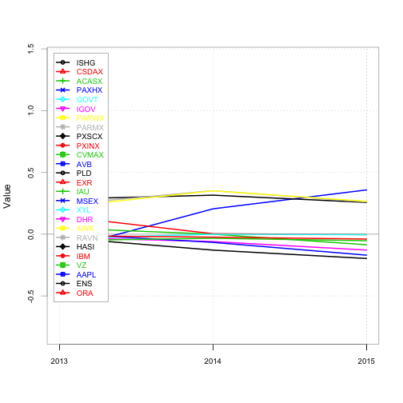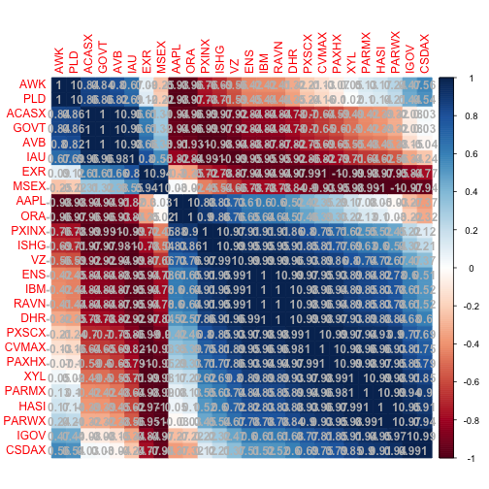

## GMT  
## ISHG CSDAX ACASX PAXHX GOVT  
## 2013-12-31 -0.02762317 -0.01215061 -0.05175983 0.005312085 -0.034181240  
## 2014-12-31 -0.10430358 -0.01230018 0.01965066 -0.071334214 0.034979424  
## 2015-12-31 -0.07786982 -0.01556656 -0.02034261 -0.110953058 -0.003578529  
## IGOV PARWX PARMX PXSCX PXINX  
## 2013-12-31 -0.02662003 0.21741092 0.23828318 0.28355388 0.147058824  
## 2014-12-31 -0.03403533 0.10967029 0.09163347 0.02503682 -0.125000000  
## 2015-12-31 -0.07346559 -0.06277132 -0.06715332 -0.04454023 -0.007326007  
## CVMAX AVB PLD EXR IAU  
## 2013-12-31 0.04971933 -0.1280330 0.012606193 0.1577356 -0.28255528  
## 2014-12-31 -0.04736440 0.3819674 0.164546685 0.3918823 -0.02054795  
## 2015-12-31 -0.08580593 0.1269356 -0.002556356 0.5042633 -0.10576923  
## MSEX XYL DHR AWK RAVN  
## 2013-12-31 0.07055225 0.27675277 0.38103757 0.1381632 0.5606979  
## 2014-12-31 0.10124154 0.10028902 0.11023316 0.2612399 -0.3923189  
## 2015-12-31 0.15091076 -0.04123982 0.08365418 0.1210131 -0.3760000  
## HASI IBM VZ AAPL ENS  
## 2013-12-31 0.05681560 -0.02077784 0.13565979 0.05421201 0.86260946  
## 2014-12-31 -0.03131502 -0.14463936 -0.04802605 -0.80325123 -0.11941783  
## 2015-12-31 -0.13789990 -0.14223390 -0.01197089 -0.04638517 -0.09381077  
## ORA  
## 2013-12-31 0.411306929  
## 2014-12-31 -0.001102499  
## 2015-12-31 0.341795475

## ***********************************  
## PortfolioAnalytics Optimization  
## ***********************************  
##   
## Call:  
## optimize.portfolio(R = jc_port_return_final, portfolio = jc.StdDev,   
## optimize_method = "random", trace = TRUE, rp = jc.rp)  
##   
## Optimal Weights:  
## ISHG CSDAX ACASX PAXHX GOVT IGOV PARWX PARMX PXSCX PXINX CVMAX AVB   
## 0.020 0.020 0.028 0.030 0.020 0.020 0.028 0.020 0.106 0.020 0.026 0.020   
## PLD EXR IAU MSEX XYL DHR AWK RAVN HASI IBM VZ AAPL   
## 0.046 0.020 0.038 0.020 0.020 0.030 0.050 0.092 0.024 0.044 0.020 0.040   
## ENS ORA   
## 0.110 0.098   
##   
## Objective Measures:  
## mean   
## 0.06046   
##   
##   
## StdDev   
## 0.1644

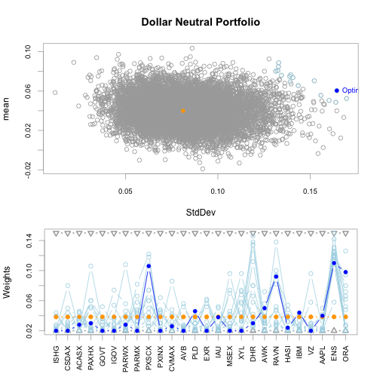

plot of chunk unnamed-chunk-211

### Asset Allocation

## ishg_wt_val csdax_wt_val acasx_wt_val paxhx_wt_val govt_wt_val  
## [1,] 2413.84 2655.224 3379.376 3379.376 2413.84  
## igov_wt_val parwx_wt_val parmx_wt_val pxscx_wt_val pxinx_wt_val  
## [1,] 2896.608 12793.35 3620.76 15689.96 3379.376  
## cvmax_wt_val avb_wt_val pld_wt_val exr_wt_val msex_wt_val xyl_wt_val  
## [1,] 2413.84 4827.68 2413.84 6034.6 2413.84 2413.84  
## dhr_wt_val awk_wt_val ravn_wt_val hasi_wt_val ibm_wt_val vz_wt_val  
## [1,] 2413.84 2413.84 7724.288 2413.84 2534.532 4344.912  
## aapl_wt_val ens_wt_val ora_wt_val  
## [1,] 2655.224 17621.03 2413.84

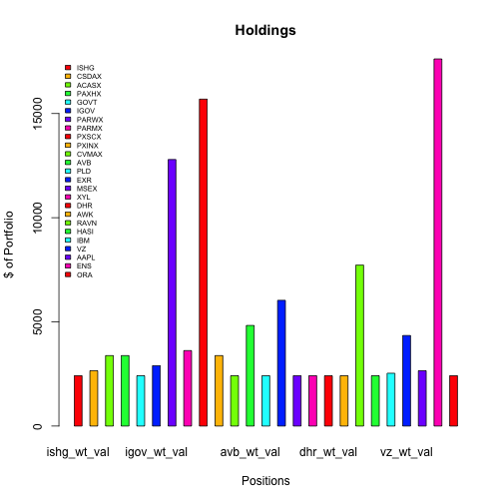

plot of chunk unnamed-chunk-212

## Bond portfolio duration

## [1] 3.755573e-05

##   
##   
## processing file: JC_Quant Report_09.2016.Rmd

## Error in parse_block(g[-1], g[1], params.src): duplicate label 'setup'