Can GDP Determine How Long You May Live?

In recent decades, we have seen an increase in life expectancy due to advances in medical technology and healthier lifestyles. We have also seen an increased in most countries around the world. That begs the question: Can GDP determine how long you may live?

We looked at data from the years 2000-2015 for six countries that are located in different parts of the world: Chile, China, Germany, Mexico, the United States, and Zimbabwe. We looked at GDP and life expectancy data from several different angles to see if there were any interesting finds. We measured all countries’ GDPs in U.S. dollars to offset any effects of other currencies’ inflation that may have taken place during the time period measured.

First, let’s talk about some of our general finds. By looking at the line charts below, we can see that life expectancies and GDP both increased across the board from 2000-2015. We can see some decreases for some countries for a few years, which we will explain in more detail later, but the general trends are pretty clear here.

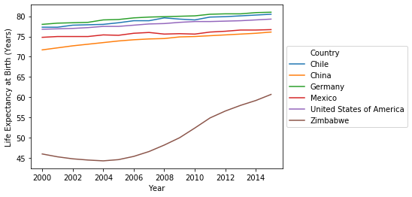

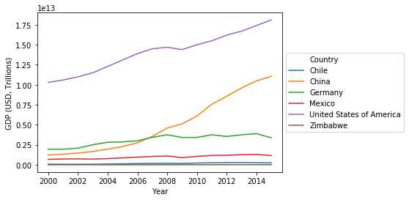

GDP and life expectancy both correlate with each other as these generally increase (or decrease) with each other, as the below charts show. The increases are generally linear, except in the case of China, which is more of an exponential increase.

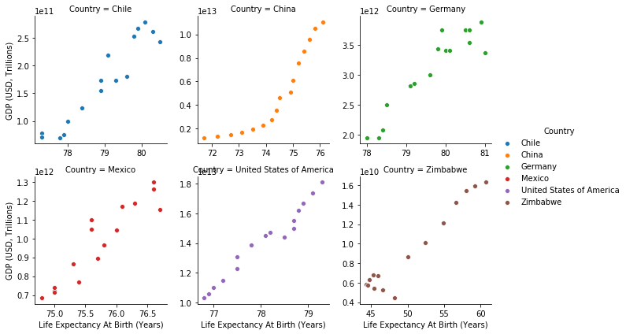

While the changes in the GDP and life expectancy generally mirror each other, the GDPs for each country themselves do not necessarily reflect each country’s life expectancy. Chile has the second-lowest mean GDP, but the second-highest mean life expectancy. Chile’s mean life expectancy is even higher than that of the United States, despite the United States having by far the highest GDP.

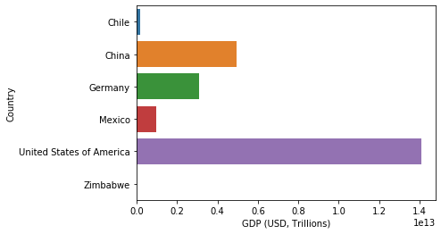

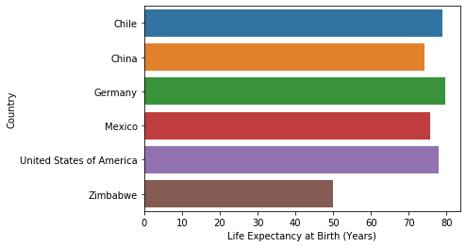

Most of the countries in our dataset took a dip in GDP from about 2008-2010; only China continued to grow during this time period.

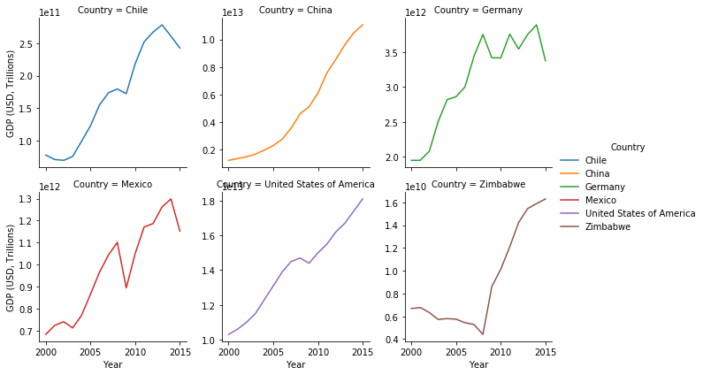

The Great Recession from this time period took a toll on the world’s economy. This somewhat affected life expectancy, but only for Chile and Mexico, who experienced a decrease in life expectancy during this time period.

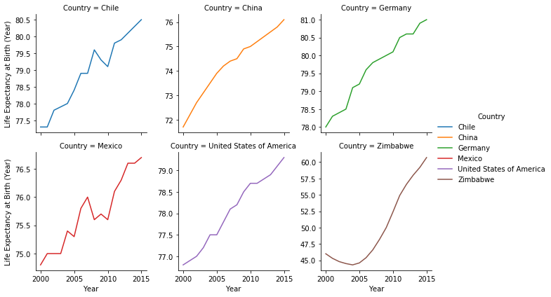

Zimbabwe proved to be quite an interesting country to look at in this study. Not only is their GDP by far the lowest in this study but so is their life expectancy. However, the life expectancy by far was the most widely distributed. This can be explained by the fact that this is by far the least developed of the countries in our study, meaning there were many advances in technology, health, and other areas that needed to be made in order to catch up with the other countries, who were already highly developed. From about 2000-2004, GDP and life expectancy both actually declined as economic and political problems ravaged the country, but began improving afterwards.

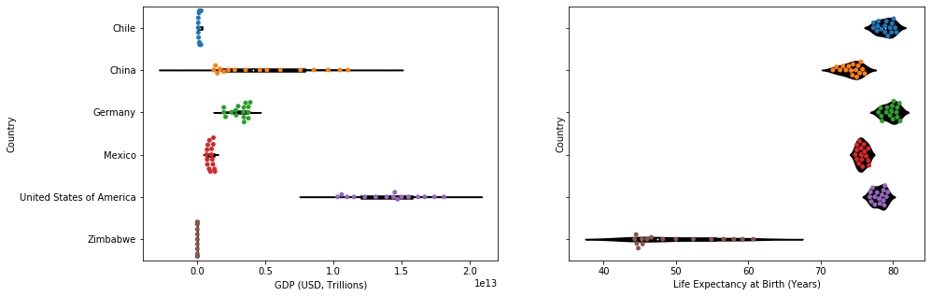

In conclusion, we believe that while GDP by itself does not necessarily increase life expectancy at birth, when GDP increases, life expectancy also increases, and vice versa.