DSIP

Experiment 1

Part A

Code:

#include <graphics.h>
//#include <conio.h>
#include<X11/Xlib.h>
#define origX 320
#define origY 240

void axis(int type, int x, int y, int length);
void impulse(int x, int val);
void unit_ramp(int steps);
void unit_step(int steps);

void wait_for_char()
{

//Wait for a key press
int in = 0;

while (in == 0) {
in = getchar();
}
}
int main() {
XInitThreads();
int gd = DETECT, gm;
int opt;
initgraph(&gd, &gm, NULL);
// Drawing X-axis
axis(0, origX, origY, 240);
// Drawing Y-axis
axis(1, origX, origY, 200);
printf("1. Unit Impulse\n2. Unit Step\n3.Unit Ramp\nEnter your choice: ");
scanf("%d", &opt);
switch(opt) {
case 1:
impulse(0, 1);
break;
case 2:
printf("Enter the number of steps: ");
scanf("%d", &opt);
unit_step(opt);
break;
case 3:
printf("Enter the number of steps: ");
scanf("%d", &opt);
unit_ramp(opt);
break;
default:
printf("Invalid Choice");
break;
}
//getch();
//delay(5000);
//scanf("%d", &opt);
wait_for_char();
closegraph();
return 0;
}

void axis(int type, int x, int y, int length) {
int i;
if (type == 0) {
line(x - length, y, x + length, y);
outtextxy(x + length, y + 10, "Time Steps");
}
else {
line(x, y - length, x, y + length);
outtextxy(x - 10, y - length, "X(n)");
}
}

void impulse(int x, int val) {
int new_x = origX + 30*x;
int new_y = origY - 30*val;
char x_label[2], y_label[2];
y_label[0] = (char) (val + 48);
y_label[1] = '\0';
x_label[0] = (char)(x+48);
x_label[1] = '\0';
setcolor(RED);
line(new_x, origY, new_x, new_y);
outtextxy(new_x, new_y - 10, y_label);
outtextxy(new_x, origY + 10, x_label);
setcolor(WHITE);
}

void unit_ramp(int steps) {
int i;
for (i = 0; i < steps; i++)
impulse(i, i);
}

void unit_step(int steps) {
int i;
for (i = 0; i < steps; i++)
impulse(i, 1);
}

Output:
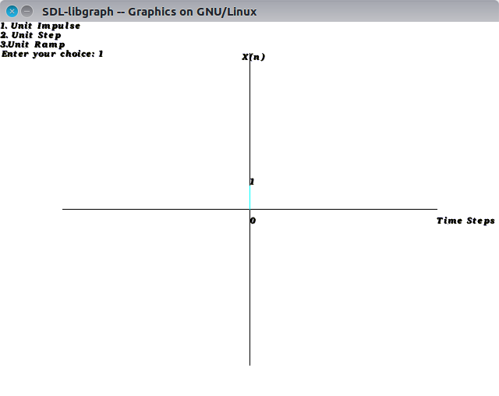
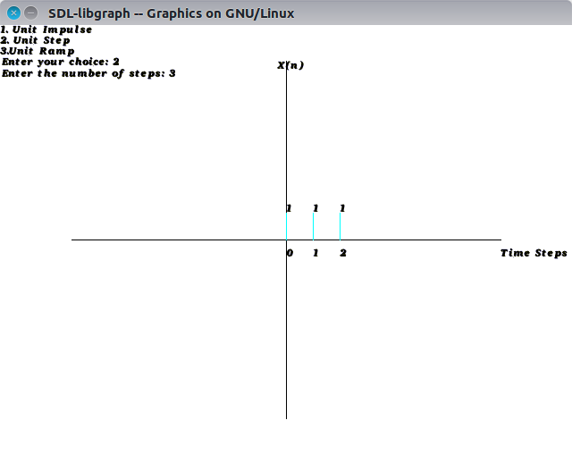
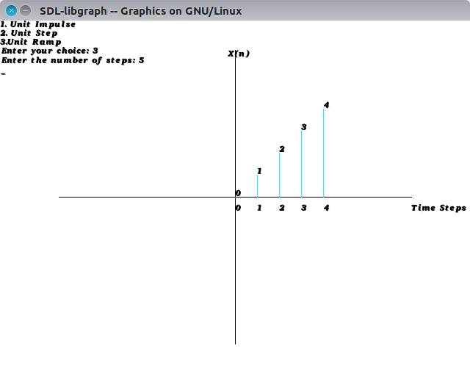

Part B

Code:
#include <graphics.h>
#include <conio.h>
#include <stdio.h>
#define origX 320
#define origY 240

void axis(int type, int x, int y, int length) {
int i;
if (type == 0) {
line(x - length, y, x + length, y);
outtextxy(x + length, y + 10, "Time Steps");
}
else {
line(x, y - length, x, y + length);
outtextxy(x - 10, y - length, "X(n)");
}
}

void impulse(int x, int val) {
int new_x = origX + 30*x;
int new_y = origY - 30*val;
char x_label[2], y_label[2];
y_label[0] = (char) (abs(val) + 48);
y_label[1] = '\0';
x_label[0] = (char)(abs(x)+48);
x_label[1] = '\0';
line(new_x, origY, new_x, new_y);
outtextxy(new_x, new_y - 10, y_label);
outtextxy(new_x, origY + 10, x_label);
}
void show_graph(int x[2][50], int l, int colour) {
int i;
if (colour == 0)
setcolor(RED);
else
setcolor(YELLOW);
for (i = 0; i < l; i++)
impulse(x[0][i], x[1][i]);
setcolor(WHITE);
}
void shift(int x[2][50], int l, int k, int reverse, int result[2][50]) {
int i;
for (i = 0; i < l; i++) {
result[1][i] = x[1][i];
if (!reverse)
result[0][i] = x[0][i] + k;
else
result[0][i] = x[0][i] - k;
}
}

void reverse(int x[2][50], int l, int result[2][50]) {
int i;
for (i = 0; i < l; i++) {
result[0][i] = -x[0][l-i-1];
result[1][i] = x[1][l-i-1];
}
}

void scale(int x[2][50], int l, int lambda, int result[2][50]) {
int i;
for (i = 0; i < l; i++) {
result[1][i] = x[1][i] * lambda;
result[0][i] = x[0][i];
}
}

void add(int x[2][50], int l, int result[2][50]) {
int y[2][50], m;
int i, loc;
int min, max;
printf("Enter the number of time steps: ");
scanf("%d", &m);
printf("Enter the position of the first time step: ");
scanf("%d", &loc);
printf("Enter the time steps: ");
for (i = 0; i < m; i++) {
scanf("%d", &y[1][i]);
y[0][i] = loc + i;
}
min = x[0][0] <= y[0][0] ? x[0][0] : y[0][0];
max = x[0][l-1] >= y[0][m-1] ? x[0][l-1] : y[0][m-1];
for (i = 0; i <= (max - min); i++) {
result[0][i] = min + i;
result[1][i] = 0;
if (min + i >= x[0][0] && min + i <= x[0][l-1])
result[1][i] += x[1][min + i - x[0][0]];
if (min + i >= y[0][0] && min + i <= y[0][m-1])
result[1][i] += y[1][min + i - y[0][0]];
}
show_graph(result, max-min+1, 1);
}

void multiply(int x[2][50], int l, int result[2][50]) {
int y[2][50], m;
int i, loc;
int min, max;
printf("Enter the number of time steps: ");
scanf("%d", &m);
printf("Enter the position of the first time step: ");
scanf("%d", &loc);
printf("Enter the time steps: ");
for (i = 0; i < m; i++) {
scanf("%d", &y[1][i]);
y[0][i] = loc + i;
}
min = x[0][0] <= y[0][0] ? x[0][0] : y[0][0];
max = x[0][l-1] >= y[0][m-1] ? x[0][l-1] : y[0][m-1];
for (i = 0; i <= (max - min); i++) {
result[0][i] = min + i;
result[1][i] = 0;
if (min + i >= x[0][0] && min + i <= x[0][l-1] && min + i >= y[0][0] && min + i <= y[0][m-1])
result[1][i] += x[1][min + i - x[0][0]] * y[1][min+i-y[0][0]];
}
show_graph(result, max-min+1, 1);
}
int main() {
int gd = DETECT, gm;
int opt;
int x[2][50], l, k, rev, result[2][50];
int origin, ch;
int i;
initgraph(&gd, &gm, "");
// Drawing X-axis
axis(0, origX, origY, 240);
// Drawing Y-axis
axis(1, origX, origY, 200);
printf("Enter the number of time steps: ");
scanf("%d", &l);
printf("Enter the X-position at the first step: ");
scanf("%d", &origin);
printf("Enter the time steps.\n");
for (i = 0; i < l; i++) {
x[0][i] = origin + i;
scanf("%d", &x[1][i]);
}
show_graph(x, l, 0);
printf("1. Shift\n2. Reverse\n3. Reverse Shift\n4. Scaling\n5. Addition\n6. Multiplication\nChoice: ");
scanf("%d", &ch);
switch(ch) {
case 1:
printf("Enter the shift value: ");
scanf("%d", &k);
shift(x, l, k, 0, result);
show_graph(result, l, 1);
break;
case 2:
reverse(x, l, result);
show_graph(result, l, 1);
break;
case 3:
reverse(x, l, result);
printf("Enter the shift value: ");
scanf("%d", &k);
shift(result, l, k, 1, result);
show_graph(result, l, 1);
break;
case 4:
printf("Enter the scaling value: ");
scanf("%d", &k);
scale(x, l, k, result);
show_graph(result, l, 1);
break;
case 5:
add(x, l, result);
break;
case 6:
multiply(x, l, result);
break;
default:
printf("Enter a valid choice.");
}
getch();
closegraph();
return 0;
}
Output: 