Laboratory Num. 3: LinkedList and ArrayList

Mateo Sánchez Toro  Universidad Eafit  Medellín, Colombia  msanchezt@eafit.edu.co | Juan Pablo Giraldo Restrepo  Universidad Eafit  Medellín, Colombia  jpgiraldor@eafit.edu.co
Juan Felipe Londoño Gaviria
Universidad Eafit
Medellín, Colombia
jflondonog@eafit.edu.co

3) Project questions

3.1
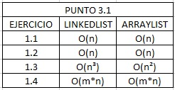

3.2 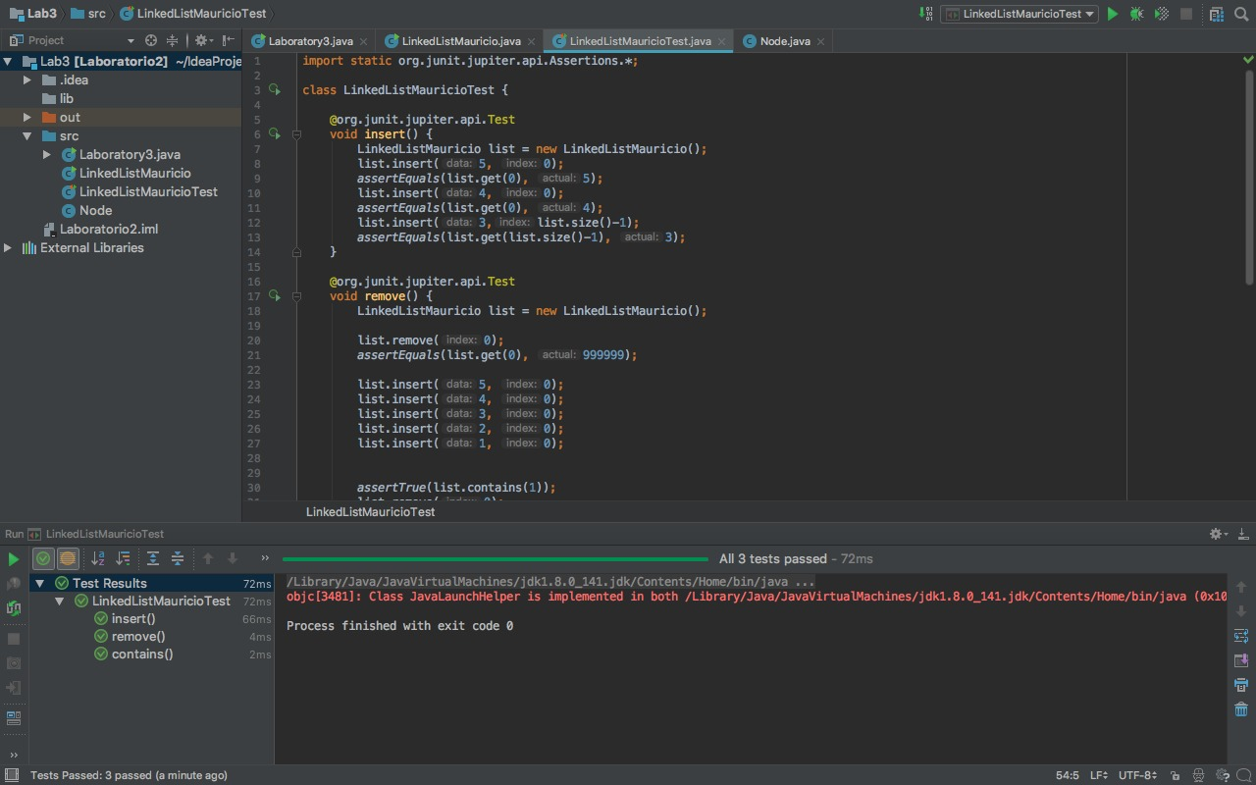

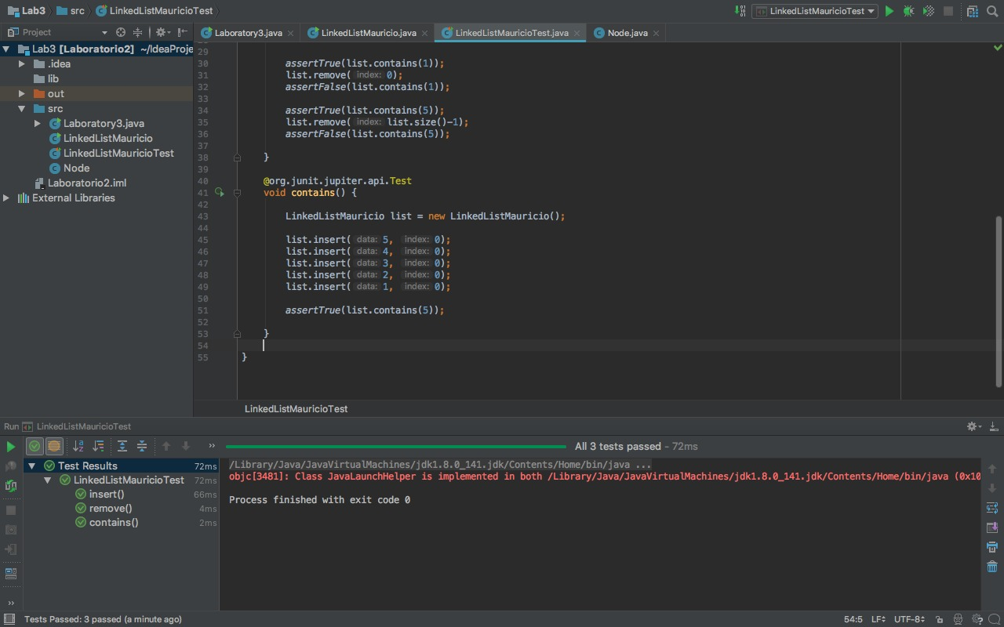

3.3

The user introduces the String with “mistakes” such as “[“or”]” which refer to “End” and “Home”. The program receives it and if it finds” [” it will send what’s after to the beginning and if it finds”]” it will send what’s after to the end of the string. In such case that there is no special character it will return the same String. Last the program will generate the string with the changes made.

3.4

O(n²), there is only one loop and “collections.reverse” also takes O(n); thus, it’s O(n²).

3.5

n is the size of the ArrayList “front” and there is no m variable.

4)Exam simulation

- a
- b
- q.size()<0
<=
q.getLast()
q.remove()
4. lista.size()
Lista.addFirst(auxiliar.pop());
5.auxiliar1.size()<0 auxiliar2.size()<0
Persona.offer(edad)
6. c

5) Trabajo en Equipo y Progreso Gradual (Opcional)
Team work
Mateo Sánchez Toro: Oversaw part 1 and collaborated with parts 2 and 3.
Juan Pablo Giraldo Restrepo: Oversaw part 2 of the lab and also made the translation of the template.

Juan Felipe Londoño Gaviria: Oversaw part 3 of the lab and also made the template in Spanish.

As seen in the pictures, the communication was constant in the WhatsApp group.
