Online Job Application

System Quotation

October, 2017

Prepared for:

**Multinational Maritime Inc.**

Prepared by:

**John Patrick L. Vasquez**

Sr. Software Engineer / Project Lead

***SERVICE PACKAGE CONTENT SUMMARY***

* System Development
* Technical Support
* Payment for Services

***Cost Summary***

* System Development – **PHP 150, 000**
* Technical Support – **3 months FREE Technical Support**
* **Total System Development Cost** – **PHP 150, 000**

***Technical Details***

1. ***System Development***

* As proof of evidence that everything’s works fine, we will perform our latest updates in the system every 15th and 30th of the month.
* System Development cost **PHP 150,000.** We will develop the specific functionality and features you needed for your online application. Below are some website functionality and features that we will integrate to your system:
  + User Account Creation (User Login/Registration)
  + Fill-up Forms (Personal Information, Educational Background, Employment History)
  + File uploads (Documents/Certificates/Licenses)
  + Dormitory Booking
    - Classification / Priority Number / Description
      * Embarking Crew
      * Disembarking Crew
      * On Vacation Crew
    - Type of Accommodation
    - Accommodation
      * Number of Guest
      * Bed Type
    - Number of Rooms and Room Number
    - Room Status – Available / Vacant / Reserved / Occupied
  + Training Booking
    - Subject / Sub-component Enrolled
    - Period covered
    - Name of Enrollee, email address, contact number
  + Transportation Booking
    - Type of transportation (Airline, Land, and sea-in-house services)
    - Date
    - Point to Point (from and to)
    - Name, email address, contact number
  + Admin Dashboard
  + Admin Job Post
  + Email Notifications
* If there’s any needed functionality you need for the system, you can inform us and we will integrate and develop it for you.

1. ***Time Table of the System Development***

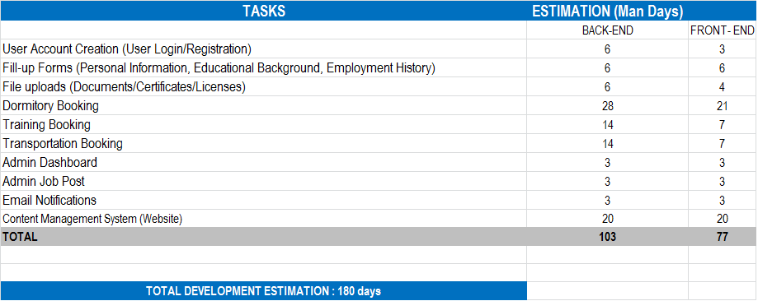

1. ***Technical Support***

* We will provide a 3 months FREE technical support for you after launching your site on the web (www). We will answer your question regarding website management, technical details, content management, user management or anything about operating your own website; we can provide this through email, Skype, Yahoo messenger or by phone (check our phone number below).

1. ***Payment for Services***

* **Payment**: At the start of the development process for your company website, you need to pay us 50% of the total development costs, the remaining balance of 50% will be given upon the completion of the website. We will start the development immediately upon receiving of the initial payment.
* Any revisions, additions or redesign that is not specified in this document shall be considered “additional” and will require separate agreement and payment.

1. ***Website Maintenance Services***

* If you’re too busy and can’t manage or don’t have time to manage and maintain your website, this services fits for you.
* Please look the table below for the complete packages.

|  |  |
| --- | --- |
| Website Maintenance and Support Plans | Package Price |
| 1. Less than 3 hours of work (Mostly content updating) | **Php 3, 000** |
| 1. Less than 8 hours of work | **Php 5, 000** |
| 1. Less than 3 days of work | **Php 10, 000** |
| 1. Less than 1 week of work | **Php 15, 000** |
| 1. More than 1 week of work | **Call or**[**email me**](http://lajuett.com/contact.html) **for a new quotation** |
| 1. Monthly Plan | **Php 5,000/month** (For 1 yr contract) |
| 1. 6 Months Plan | **Php 8,000/month** (For 6 mos. contract) |
| 1. 3 Months Plan | **Php 10,000/month** (For 3 mos. contract) |