How to get ObsidianSound

1. Make sure git for command line is installed.
2. Go to <https://github.com/jpham197/ObsidianSound>
3. 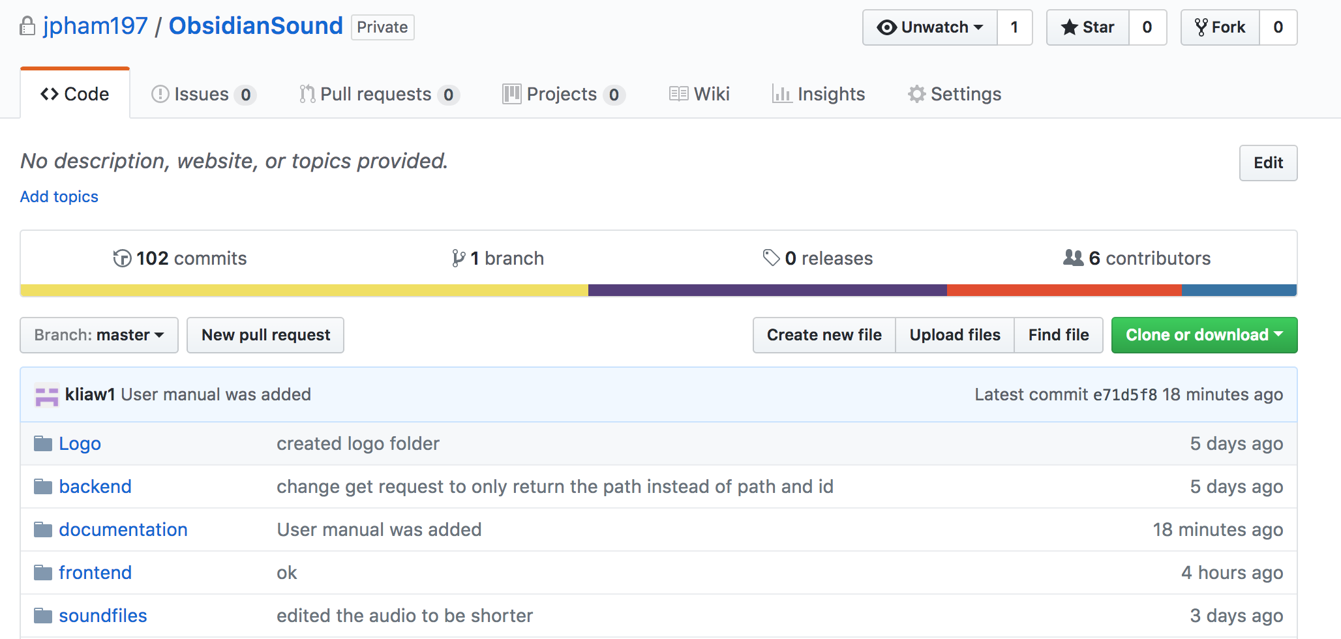Click the green “clone” button on the right side of the page
4. Make sure it is set to HTTPS as opposed to SSH

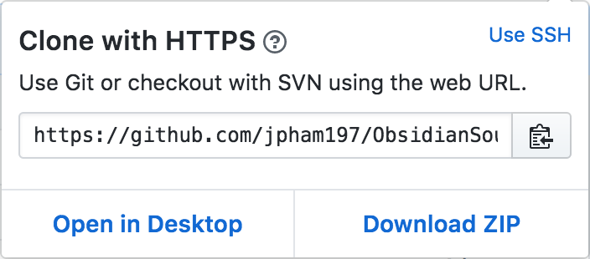

1. Navigate to the directory you want to store the app in
2. 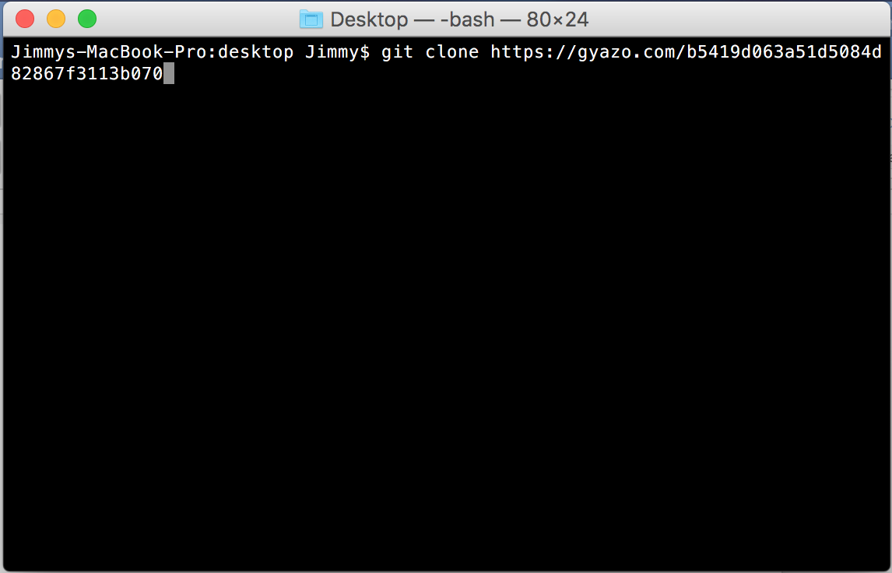Copy the link and go to the command line and type “git clone [paste link]”
3. The source code for the app should now be in your directory.
4. 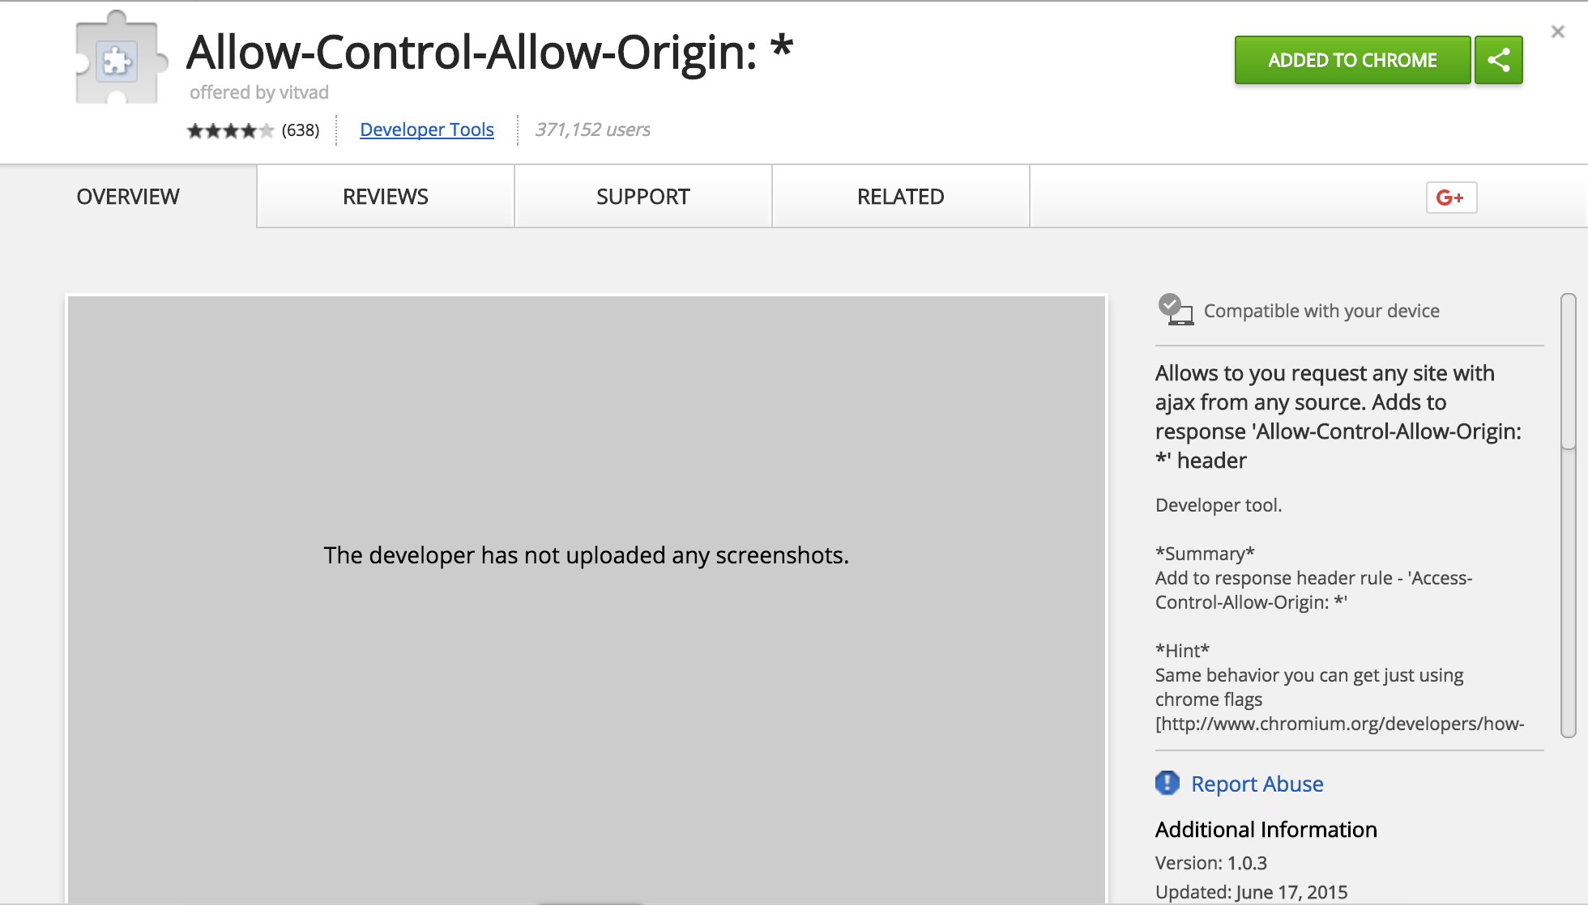Now go to chrome and download an extension that will allow you to toggle CORS. The one used for the project is Allow-Control-Allow-Origin but any will work fine
5. The extension will now appear in the top left of the browser. Click it to open the interface and enable the cross-origin resource sharing

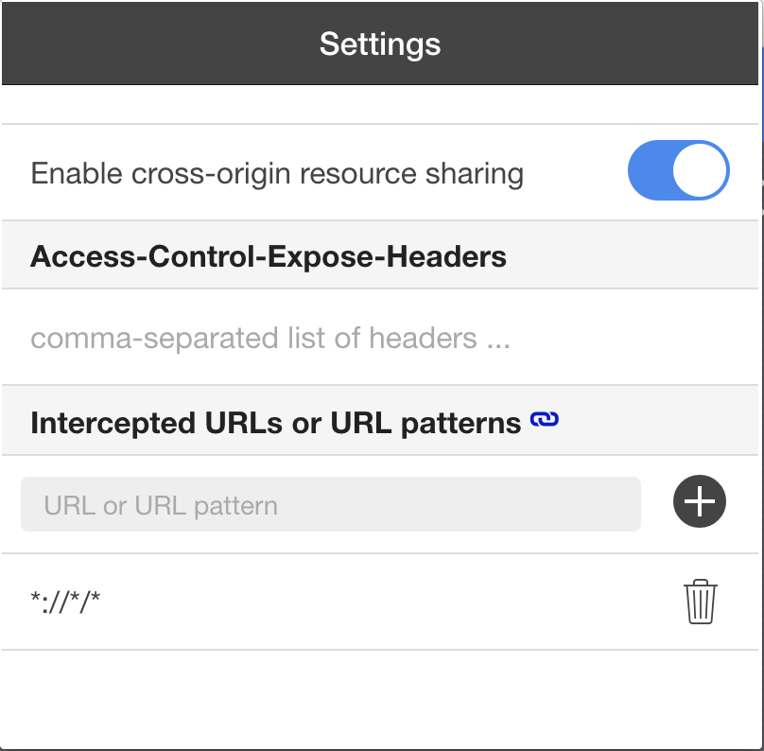

1. Now go back to the command line and navigate to the backend folder of the source code. Type “python run.py” and the database will turn on

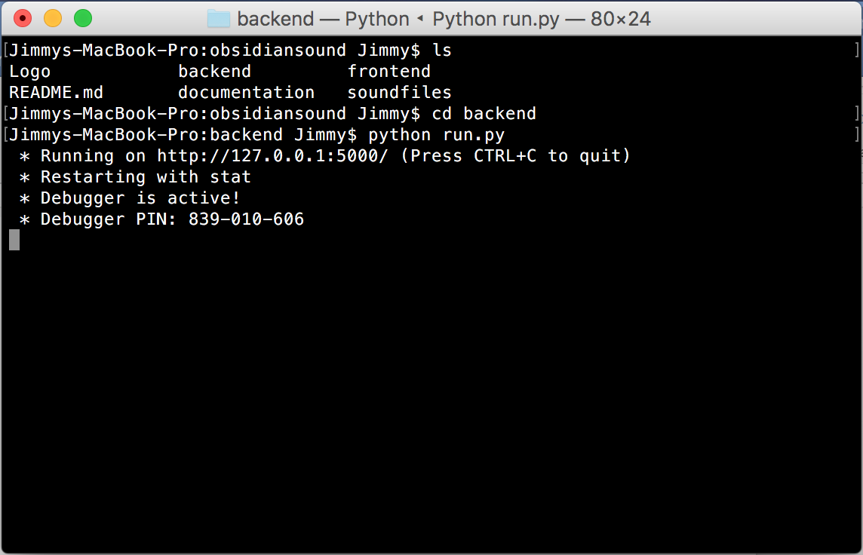

1. Find the index.html file in the frontend folder of the source code and open it. The soundboard will load and work.