**CONSULTA #1**

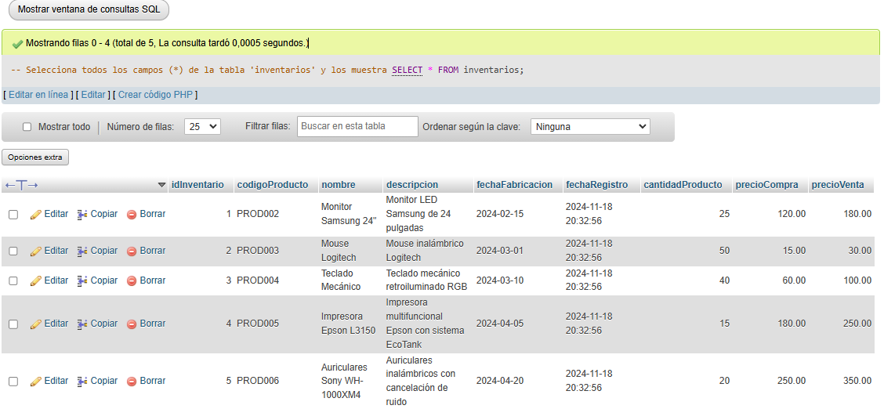

**CONSULTA #2**

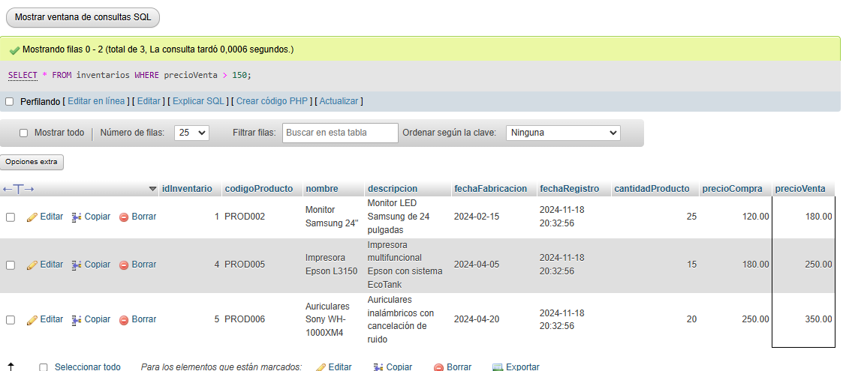

**CONSULTA #3**

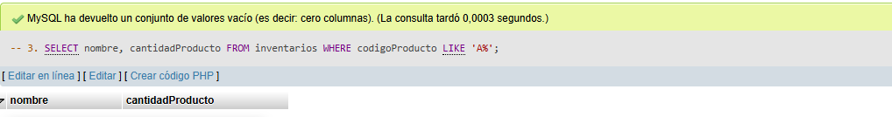

**CONSULTA #4**

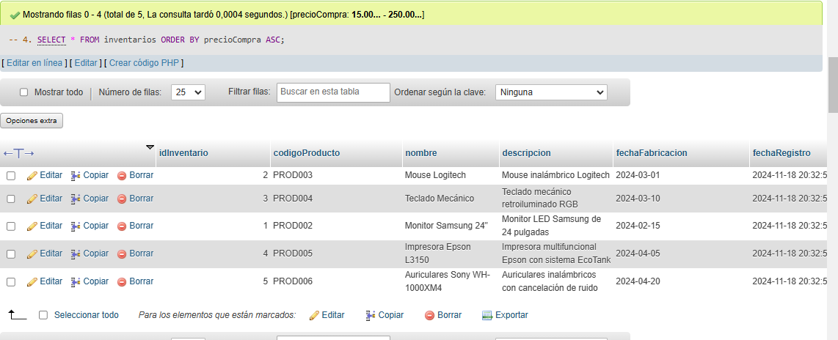

**CONSULTA #5**

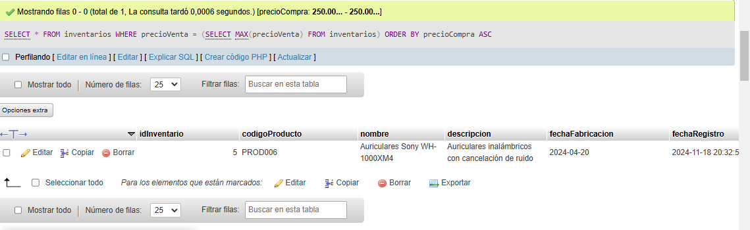

**CONSULTA #6**

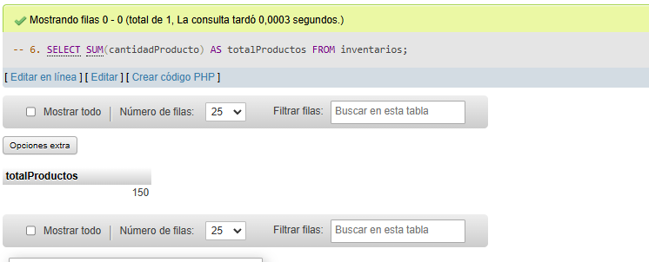

**CONSULTA #7**

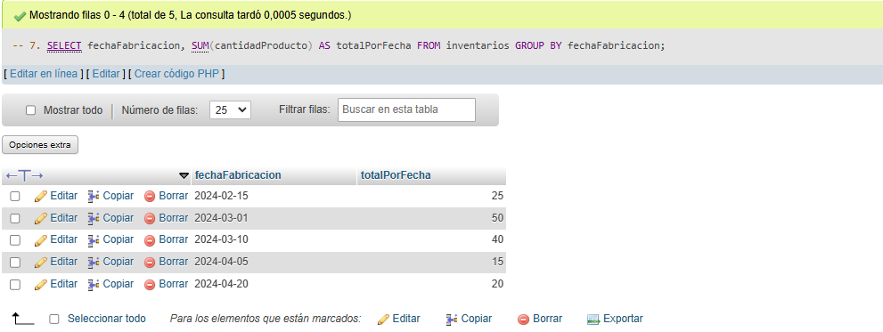

**CONSULTA #8**

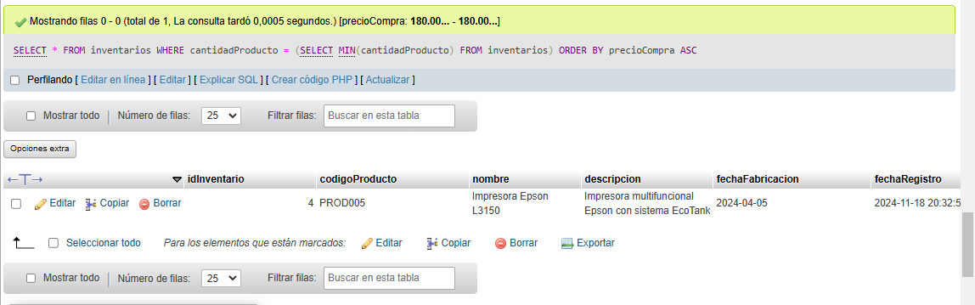

**CONSULTA #9**

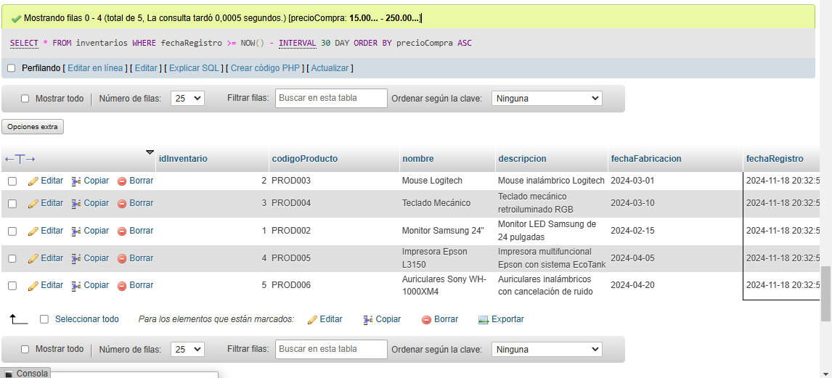

**CONSULTA #10**

