

Driver Compensation
Design Document

Revision History
Date | Version | Description | Author
08/21/08 | 1.0 | Created | Jim Heary
05/19/09 | 2.0 | Updated | Jim Heary

Table of Contents
Overview 3
Business Context 3
Key Abstractions 4
Object States 4
Ratings 5
Application Design 6
Overview 6
Design Model 6
Security 6
Deployment 7
Overview 7
Deployment Model 7
Runtime Configuration 7

Overview
Finance needs to compensate drivers for pickups and outbound deliveries at each of the Argix Direct local terminals. This activity is identified as Driver Compensation. Driver Compensation is initiated on Monday of each week by the Accounts Payable Clerk for each local terminal. The current process uses an Excel spreadsheet to apply rates to driver schedule/route data imported from a Roadshow database, calculate driver compensations, and create summary reports.

Business Context

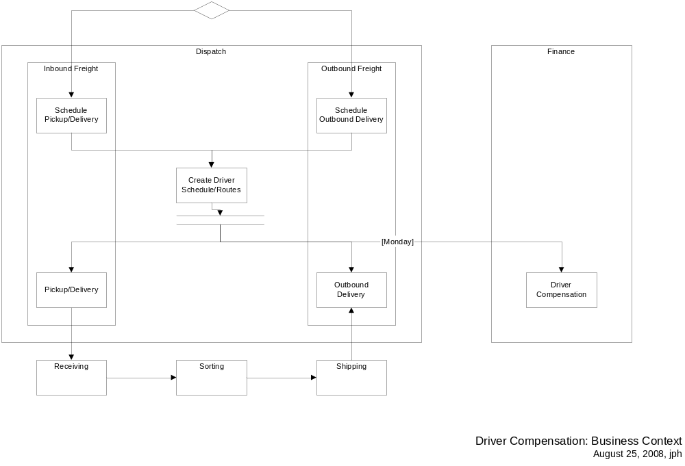

Key Abstractions

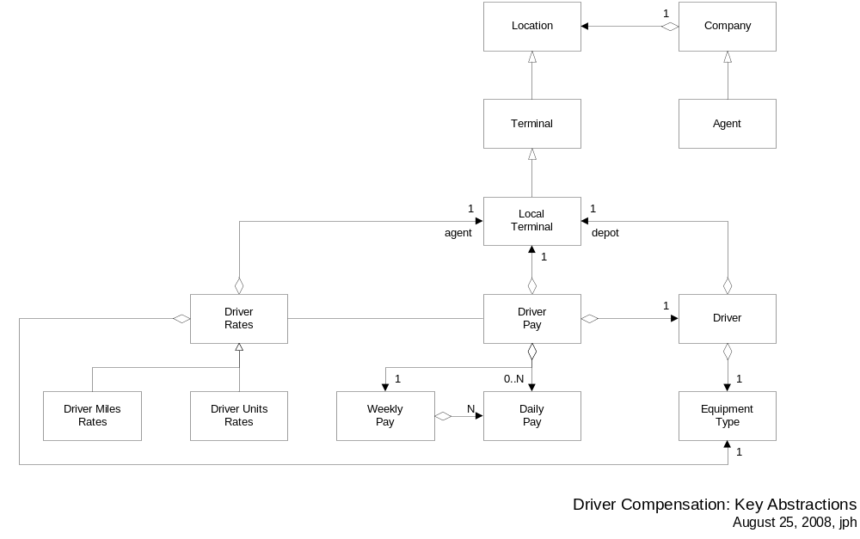

Local Terminal- Argix local terminal that uses non-Argix drivers for local pickups and deliveries.
Driver- non-Argix driver.
Equipment Type- driver equipment type used for local pickup\delivery.
Driver Rates-
Driver Miles Rates-
Driver Units Rates-
Driver Pay-
Daily Pay-
Weekly Pay-

Object States

Ratings

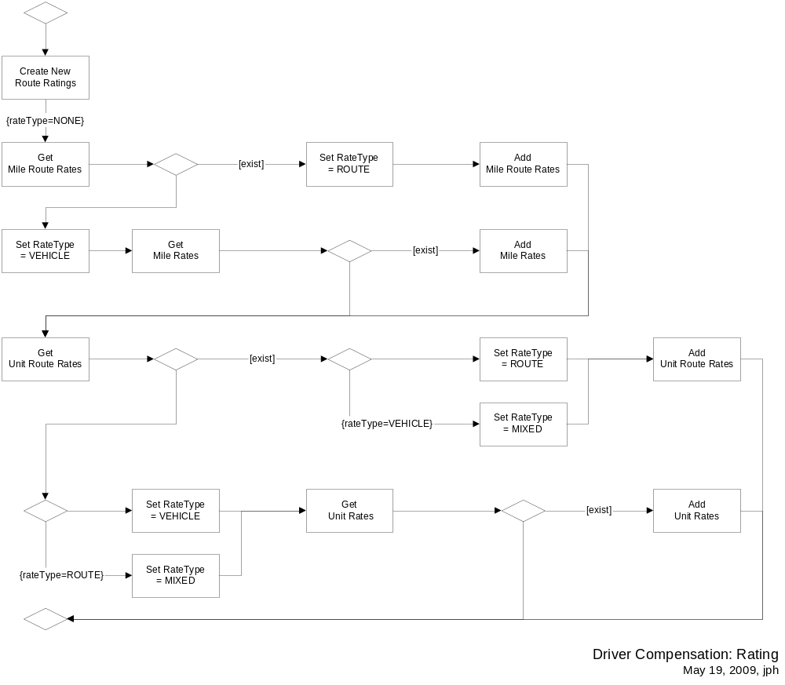

Application Design

Overview

Design Model

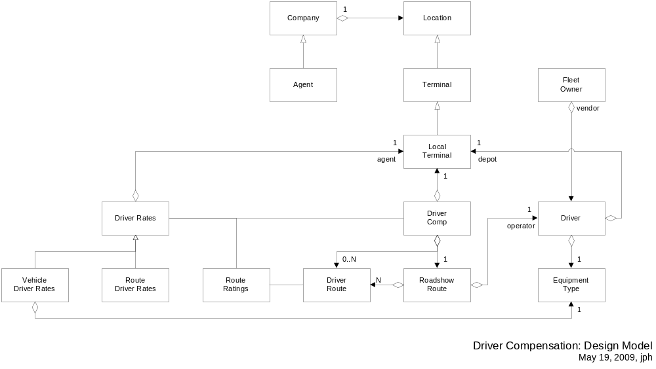

Security

Deployment

Overview

Deployment Model

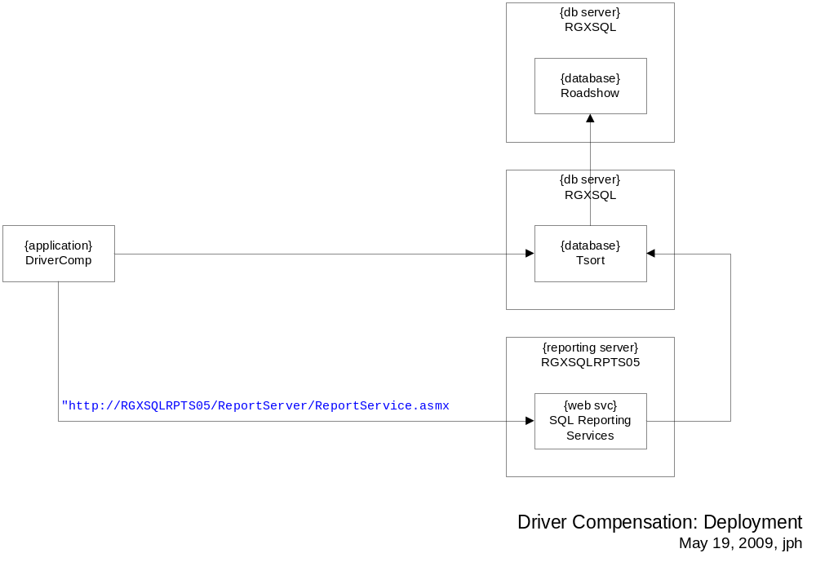

Runtime Configuration

