

RS Reports
Design Document

Revision History
Date | Version | Description | Author
04/01/11 | 1.0 | Created | Jim Heary

Table of Contents
Overview 3
System Behavior 4
Overview 4
Business Processes 4
Systems Design 6
Overview 6
Design Model 6
Deployment 6

Overview
This document describes the RS (Roadshow) Reporting System that provides reporting of Roadshow routing and planning activities in Argix Direct local terminals. The context diagram below shows the RS Reporting System along with associated other systems and company roles.

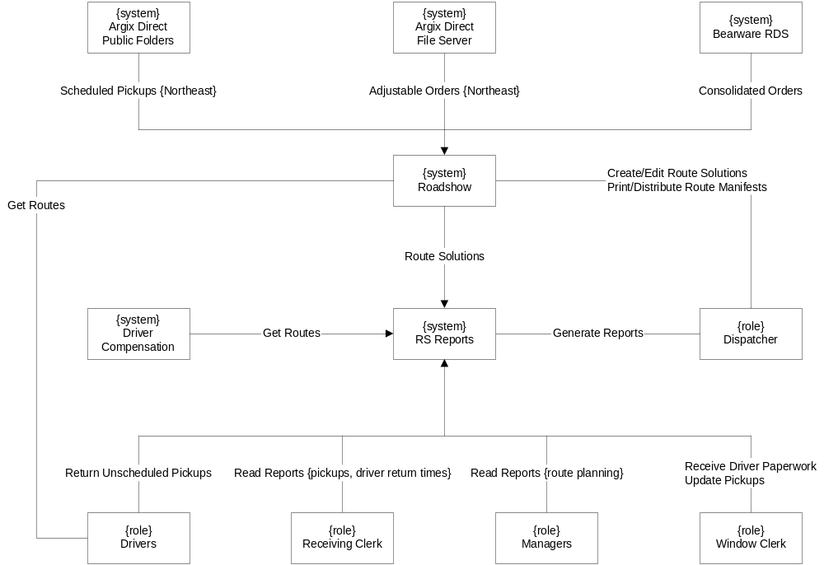

- Argix Direct Public Folders- public folders in the Argix Direct email system that contains lists of scheduled pickup orders for the Argix Direct local terminals in the Northeast (i.e. Ridgefield, South Windsor, and Wilmington). Pickup orders are centrally dispatched to Jamesburg and manually entered into the public folders by the National Dispatch Clerk.
- Argix Direct File Server- a file server that contains comma-delimited text files that represent order templates for the non-Northeast terminals which don’t import pickups from Argix Direct Public Folders.
- Bearware Retail Distribution System- a third party system that contains consolidated delivery orders for direct and indirect freight at the Argix Direct local terminals.
- Roadshow- a third party application that creates optimized route plans for driver deliveries and pickups in the Argix Direct local terminals.
- RS Reports- the reporting system to build
- Dispatcher- the Dispatcher in the local terminal is responsible for creating planned driver routes for local deliveries and pickups. He uses Roadshow to manually enter scheduled pickups from Public Folders, import adjustable orders from File Server, and import consolidated orders from Bearware. He uses RS Reports to capture route information and send notifications to management.
- Window Clerk- the Window Clerk in the local terminal is responsible for receiving driver paperwork for entering pickup information in RS Reports including updating scheduled pickups with actual values and adding unscheduled pickups.
- Receiving Clerk- the Receiving Clerk in the local terminal is responsible for receiving drivers and receiving freight from pickups using driver return times and pickup information from RS Reports.
- Drivers- drivers at the Argix Direct local terminals responsible for deliveries and pickups. The drivers execute the Roadshow Route Plan for local deliveries and scheduled pickups. In addition, unscheduled pickups are also made. Upon return to the local terminal, the driver submits freight from the scheduled and unscheduled pickups and associated paperwork.
- Management- Management includes the Director of Terminal Operations, the local Terminal Manager, and the Roadshow Specialist and they use information from RS Reports to manage, analyze, and improve driver route planning.

System Behavior

Overview
The behavior of the system is described by the associated business processes. The processes of major concern center around two Roadshow events: the creation of the first instance of a daily route solution for each local terminal; and each edit of the daily route solution for each terminal. The information captured by RS Reports when these events occur provides data for the subsequent business processes. These processes are described as follows.

Business Processes

Create Route Plan
The diagram below shows the Create Route Plan activity. This activity is done once daily by the Dispatcher early in the morning (after midnight) or the prior night (before midnight). The Dispatcher uses the Windows Remote Desktop application to access the Roadshow front end server using a login designated for his terminal. He uses the Roadshow application to enter scheduled pickups from Public Folders (Northeast terminals only), import consolidated orders from the Bearware system, and import adjustable orders from file server (non-Northeast terminals only). He then generates a route solution from Roadshow. Next, the clerk runs reports from the RS Reporting application. Information regarding the initial (auto) route solution is captured and notifications are sent to management for the purpose of monitoring the activity.

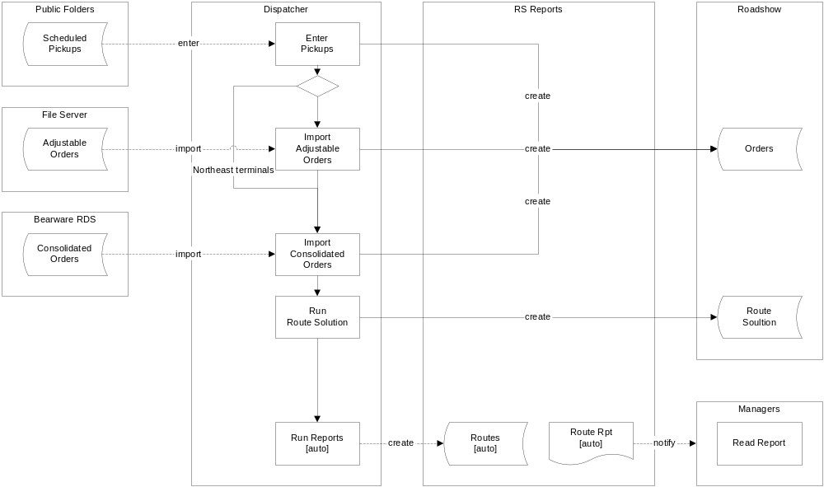

Edit Route Plan
The diagram below shows the Edit Route Plan activity. This activity is performed at least once daily by the Dispatch Clerk early in the morning (after midnight) or the prior night (before midnight). It is repeated as necessary to accommodate changes in scheduled pickups or consolidated orders. The Dispatcher edits the auto route solution using the Roadshow application until the route solution is complete and optimized. Next, the clerk runs reports (edit) from the RS Reporting application. A copy of the edit route solution is captured and a corresponding report is created. Information regarding the edited route solution is captured and notifications are sent to management for the purpose of monitoring the activity.

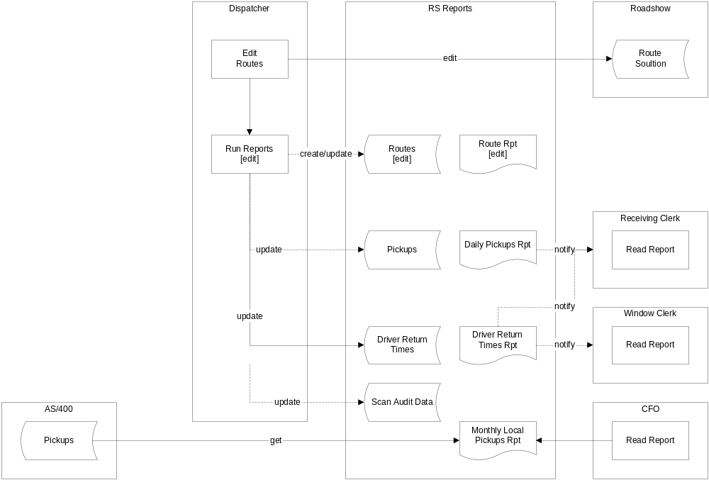

Receive Driver Paperwork
The diagram below shows the Receive Driver Paperwork activities.

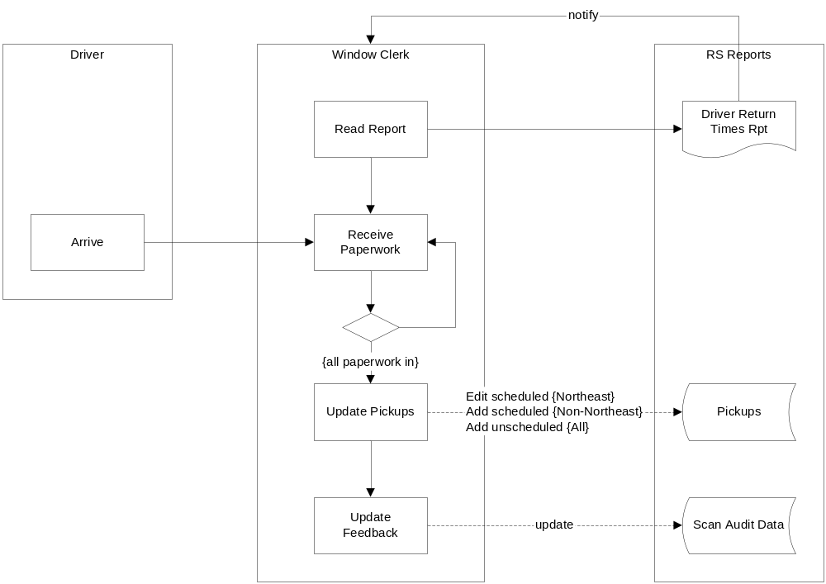

Receive Drivers
The diagram below shows the Receive Paperwork activities.

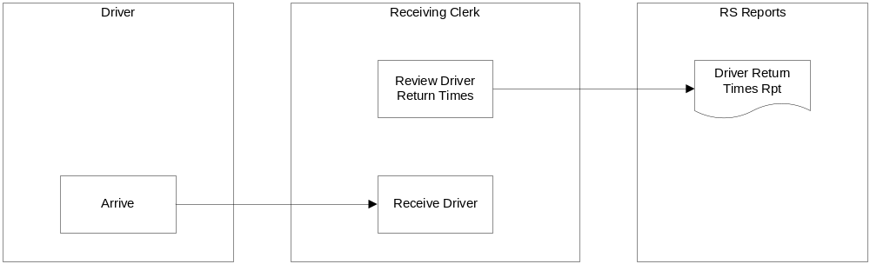

Manage Route Plan
The diagram below shows the Manage Planning activities.

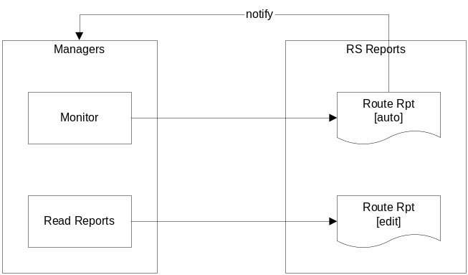

Systems Design

Overview

Design Model

Deployment

