Vertabello pic: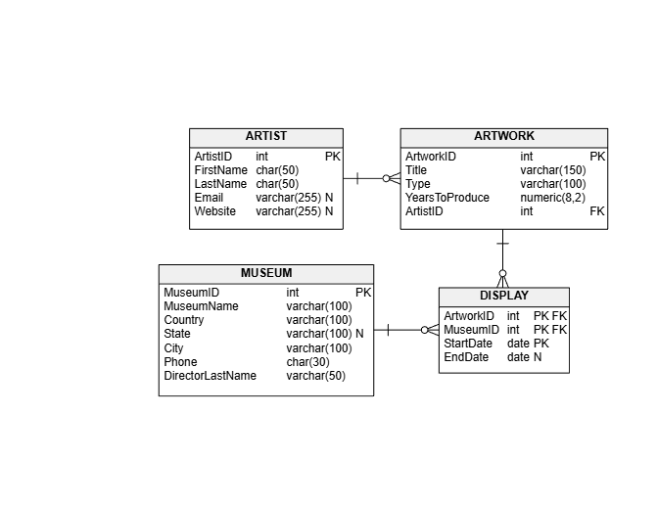-------------------------

SQL Queries:
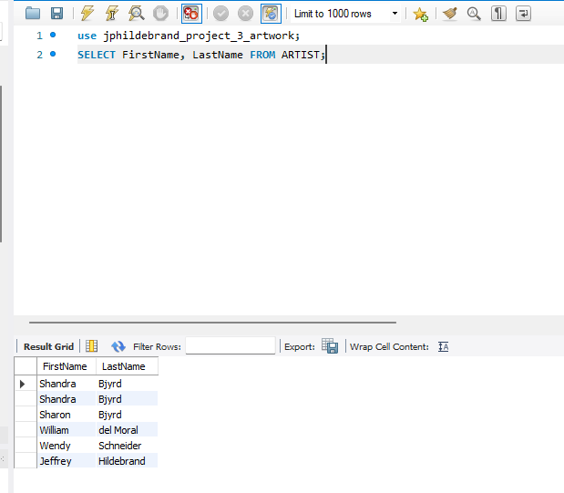
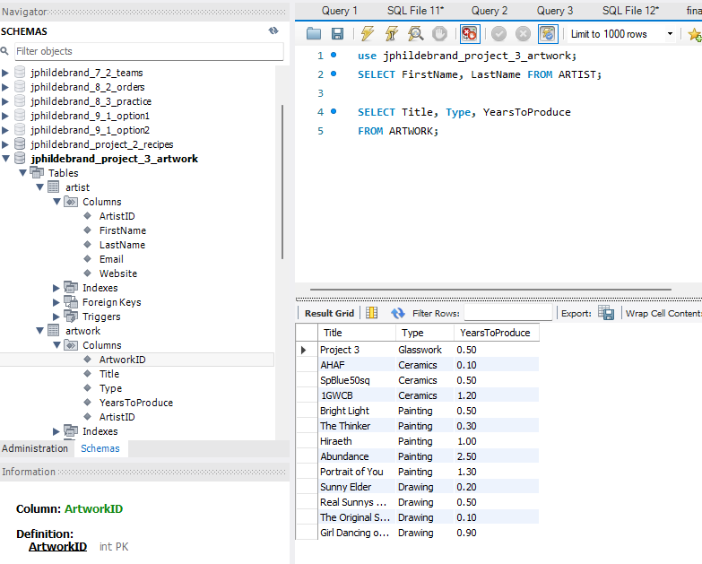

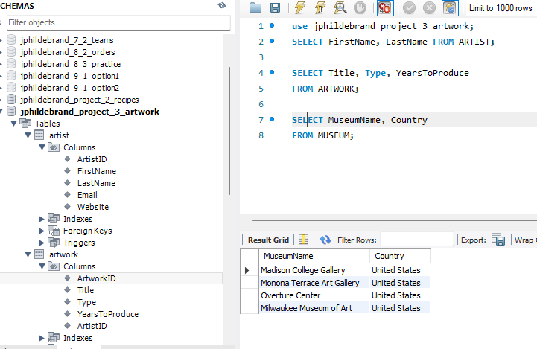
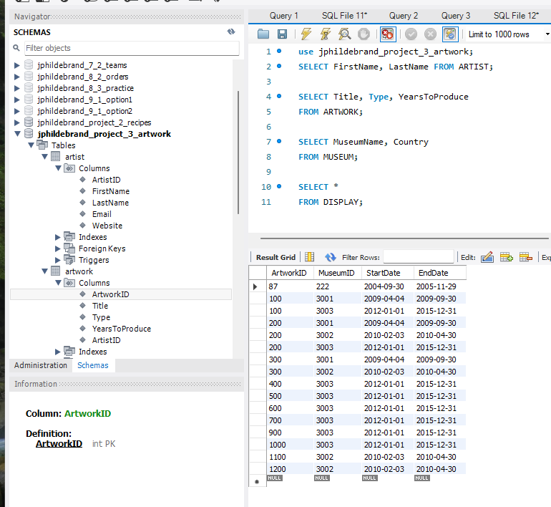
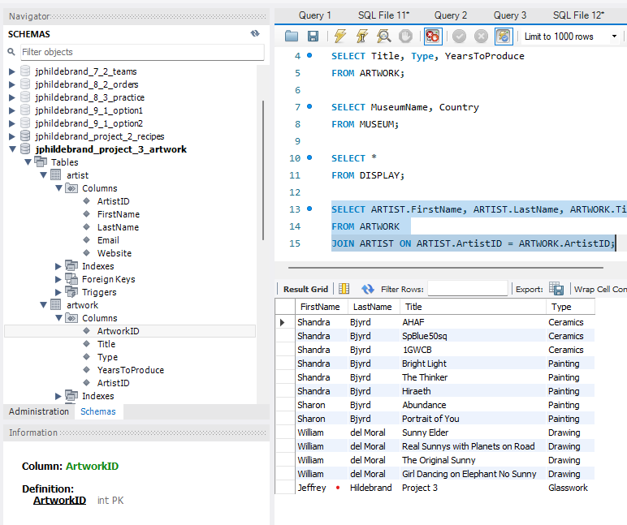
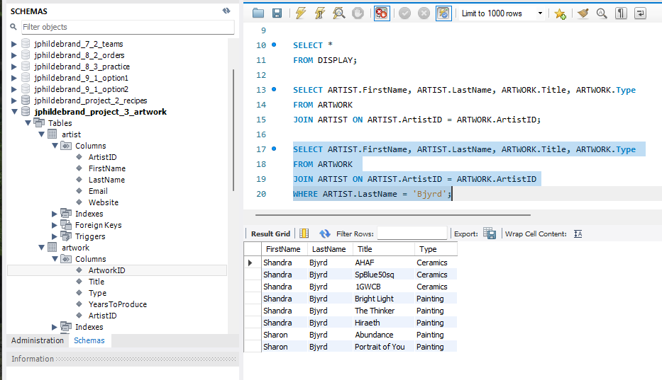
Q & A
1. Does your Vertabelo database diagram meet the normalization requirements in Part A? Answer: Yes
2. Does your MySQL DBMS implementation utilize the proper data types, primary keys, and foreign keys as described in Parts A and B? Answer: Yes
3. Did you insert the data as described in Part C? Answer: Yes
4. Does your sql file from Part D contain the queries that run in your database implementation? Answer: Yes
5. Does Part E function as expected with the localhost web request and display the proper results? Answer: Yes
Issues: I had some issues matching up the php file name and the mysql database name, probably from fatigue. I’ve been in front of the computer 10 hours a day all week to catch up! I finally have!!!! I also messed up by not having the php file in the right directory. That issue was easily rectified though.

