• (RecipeID, IngredientID) -> RecipeName, Notes, AcquiredFrom, IngredientID, Ingredient, Quantity, Technique • (RecipeID) -> RecipeName, Notes, AcquiredFrom • (IngredientID) -> Ingredient
use jphildebrand_8_2_orders;
CREATE TABLE RECIPE (
RecipeID INT NOT NULL AUTO_INCREMENT,
RecipeName VARCHAR(100) NOT NULL,
Notes TEXT,
AcquiredFrom VARCHAR(100),
PRIMARY KEY (RecipeID)
);
CREATE TABLE INGREDIENT (
IngredientID INT NOT NULL AUTO_INCREMENT,
Ingredient VARCHAR(100) NOT NULL,
PRIMARY KEY (IngredientID)
);
CREATE TABLE RECIPE_INGREDIENT (
RecipeID INT NOT NULL,
IngredientID INT NOT NULL,
Quantity VARCHAR(50),
Technique VARCHAR(100),
PRIMARY KEY (RecipeID, IngredientID),
FOREIGN KEY (RecipeID) REFERENCES RECIPE(RecipeID),
FOREIGN KEY (IngredientID) REFERENCES INGREDIENT(IngredientID)
);

Result:
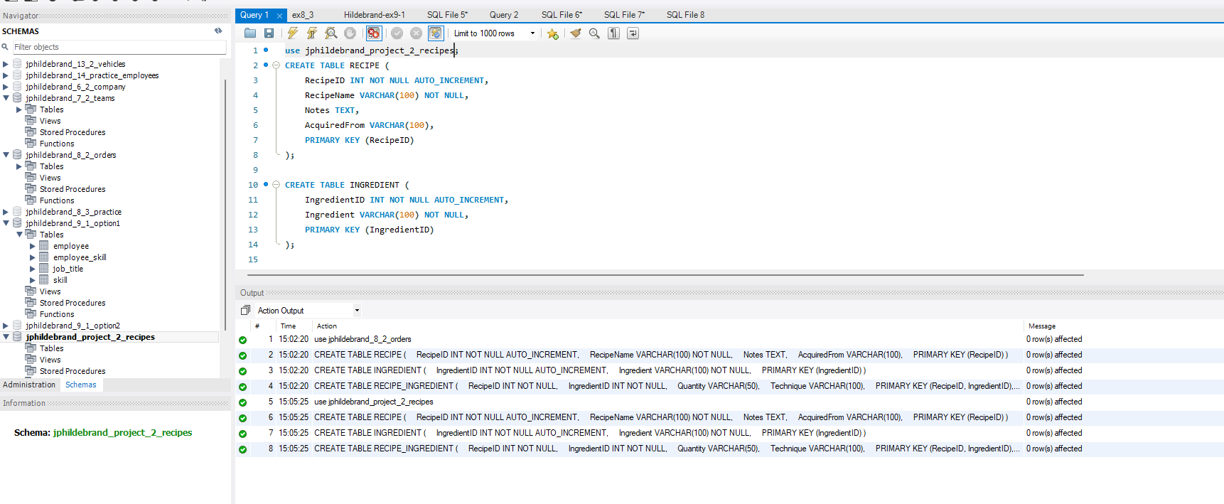
USE jphildebrand_project_2_recipes;

-- Step 1: Insert ALL ingredients first
INSERT INTO INGREDIENT (IngredientID, Ingredient) VALUES
(1, 'Avocados'),
(2, 'Red onion'),
(3, 'Garlic'),
(4, 'Red Peppers'),
(5, 'Limes'),
(6, 'Salt'),
(7, 'Chips'),
(10, 'Olive Oil'),
(15, 'Chicken'),
(25, 'Pasta'),
(26, 'Cherry Tomatoes'),
(27, 'Zucchini'),
(28, 'Parmesan Cheese'),
(29, 'Taco Shells'),
(30, 'Cilantro'),
(31, 'Sour Cream');

-- Step 2: Insert recipes
INSERT INTO RECIPE (RecipeID, RecipeName, Notes, AcquiredFrom) VALUES
(1, 'Guacamole', 'Tasty with or without garlic.', 'Qdoba / trial and error'),
(4, 'Pasta Primavera', 'Light and fresh vegetable pasta', 'Italian cookbook'),
(5, 'Lime Chicken Tacos', 'Quick weeknight dinner', 'Family recipe');

-- Step 3: Insert recipe-ingredient relationships
INSERT INTO RECIPE_INGREDIENT (RecipeID, IngredientID, Quantity, Technique) VALUES
(1, 1, '10', 'Mash'),
(1, 2, '½ large', 'Chopped'),
(1, 3, '2 cloves', 'Minced'),
(1, 4, '½ large', 'Chopped'),
(1, 5, '1', 'Squeezed'),
(1, 6, 'To taste', NULL),
(1, 7, '1 Bag', NULL),
(4, 25, '1 lb', 'Cooked'),
(4, 3, '3 cloves', 'Minced'),
(4, 4, '1 whole', 'Diced'),
(4, 10, '3 tablespoons', NULL),
(4, 26, '2 cups', 'Halved'),
(4, 27, '1 medium', 'Sliced'),
(4, 28, '½ cup', 'Grated'),
(5, 15, '1.5 lbs', 'Grilled and diced'),
(5, 5, '2', 'Juiced'),
(5, 3, '2 cloves', 'Minced'),
(5, 2, '¼ large', 'Diced'),
(5, 29, '8', NULL),
(5, 30, '¼ cup', 'Chopped'),
(5, 31, 'To taste', NULL);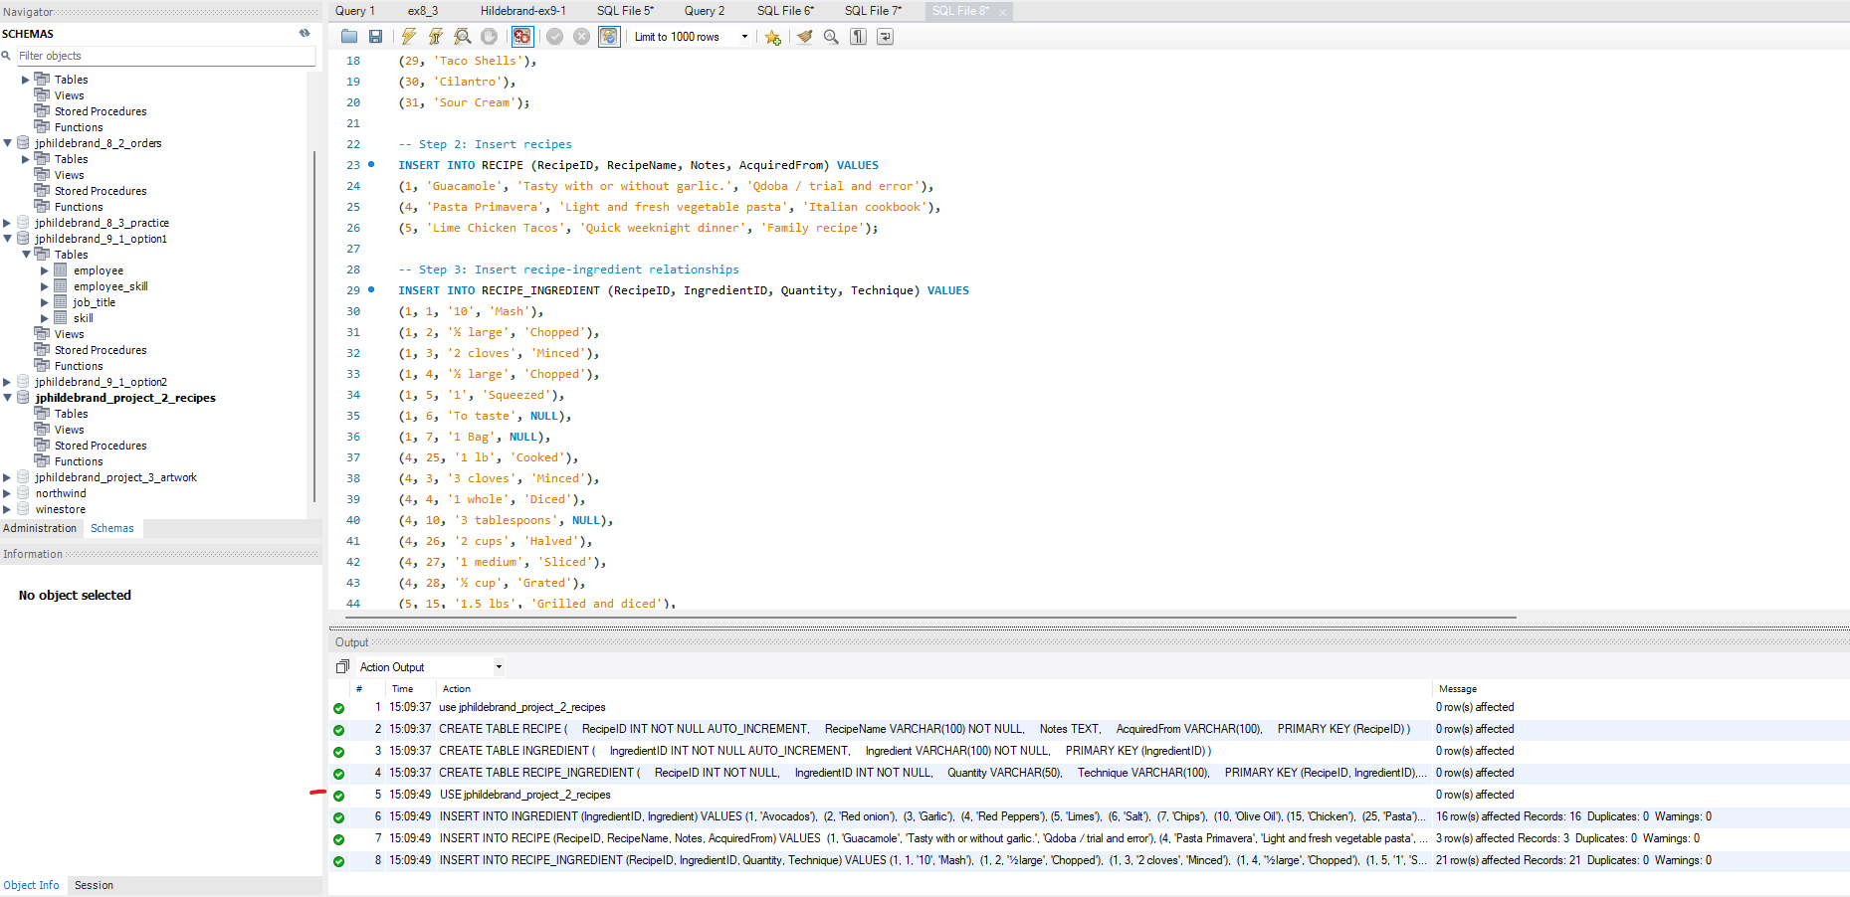

SQL queries:
Query 1: Find recipes mentioning "garlic" (WHERE, LIKE) SELECT RecipeName, Notes FROM RECIPE WHERE Notes LIKE '%garlic%';
Query 2: List ingredients alphabetically (ORDER BY) SELECT Ingredient FROM INGREDIENT ORDER BY Ingredient;
Query 3: Find quantities with "cloves" (WHERE, LIKE) SELECT RecipeName, Ingredient, Quantity FROM RECIPE_INGREDIENT JOIN RECIPE USING (RecipeID) JOIN INGREDIENT USING (IngredientID) WHERE Quantity LIKE '%cloves%';
Query 4: Get recipes by name descending (ORDER BY) SELECT RecipeName, AcquiredFrom FROM RECIPE ORDER BY RecipeName DESC; --
Query 5: Find ingredients starting with 'C' (WHERE, LIKE, ORDER BY) SELECT Ingredient FROM INGREDIENT WHERE Ingredient LIKE 'C%' ORDER BY Ingredient;
Query 6: List ingredients for Guacamole (WHERE, ORDER BY) SELECT Ingredient, Quantity, Technique FROM RECIPE_INGREDIENT JOIN INGREDIENT USING (IngredientID) WHERE RecipeID = 1 ORDER BY Ingredient;

