Author/Course: AWS Academy Lab - Academy Cloud Foundations
Version: ACFv2EN-401
Lab: Activity - AWS Elastic Beanstalk

What You’ll Need
Access to the AWS Cloud Foundations course here: https://awsacademy.instructure.com/

Lab Instructions
Instructions are on the AWS Academy website as part of the lab.

Required Screen Shots / Questions
Capture screen shots and/or answer the following questions & submit to Blackboard for credit.

SCREENSHOT #1
Question at Step 13 - What is the URL for the deployed application? (5pts)
http://c1467-samp-kpxizwudjul6.eba-j2xswztf.us-east-1.elasticbeanstalk.com/
SCREENSHOT #2
Screenshot at Step 13 - Screen shot of the webpage of the deployed application including the URL of the browser window. (5pts)
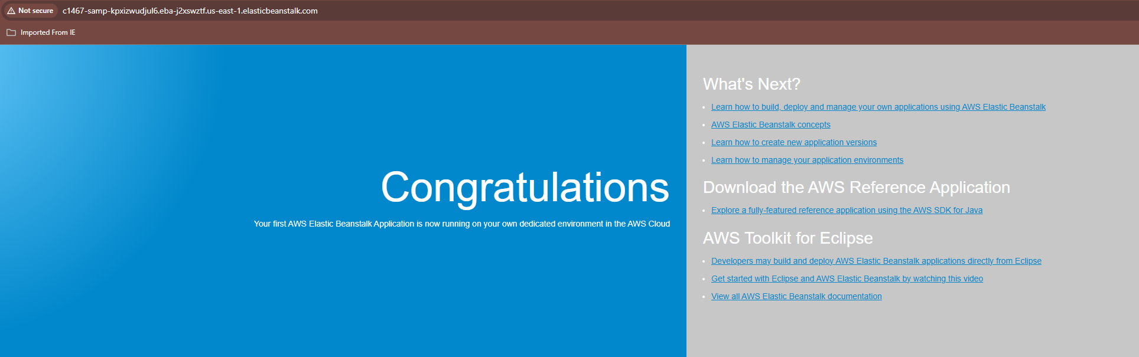
SCREENSHOT #3
Following the instructions as the end of the lab “Submit” your lab for grading. Post a screenshot of your grade from the automated lab grader here (Read instructions on how to see it):
