Author/Course: AWS Academy Lab - Academy Cloud Foundations
Version: ACFv2EN-401
Lab: Activity - AWS Lambda

What You’ll Need
Access to the AWS Cloud Foundations course here: https://awsacademy.instructure.com/

Lab Instructions
Instructions are on the AWS Academy website as part of the lab.

Required Screen Shots / Questions
Capture screen shots and/or answer the following questions & submit to Blackboard for credit.

SCREENSHOT #1
Screenshot at Step 17 - provide a screenshot of your modified code as pasted into the lambda_function tab - this needs to show your modifications to region and instance ID. (10pts)
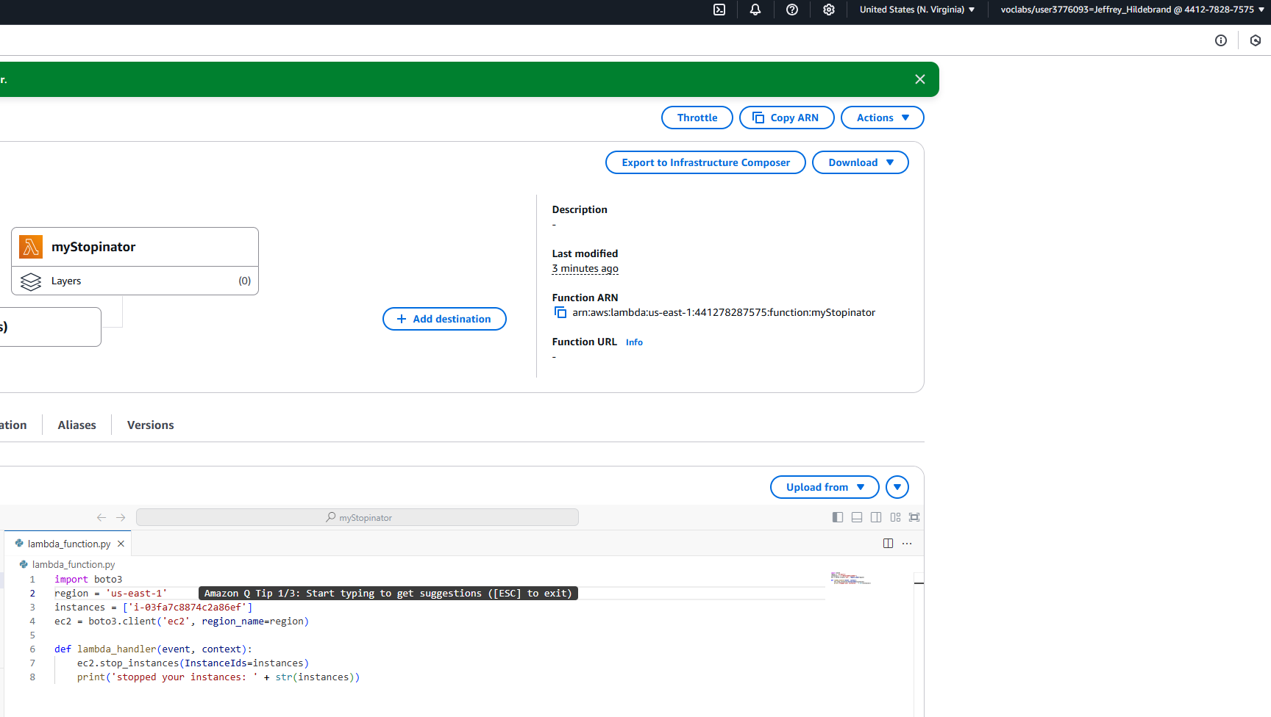
SCREENSHOT #2
Following the instructions as the end of the lab “Submit” your lab for grading. Post a screenshot of your grade from the automated lab grader here (Read instructions on how to see it):
