Intro Assignment
Just a quick assignment to make sure you know where to find resources for class & can locate the critical stuff!
- How many points are required to obtain a grade of C (the minimum considered passing) for this class?

ANSWER: 385

- Search your student email for the AWS Academy “AWS Cloud Foundations” online course access instructions. Follow the directions and login to https://awsacademy.instructure.com/ Paste a screenshot of the site once you have logged in successfully (and if you have already done this just login and paste the screenshot below so that I know you have access):

PASTE SCREENSHOT HERE:
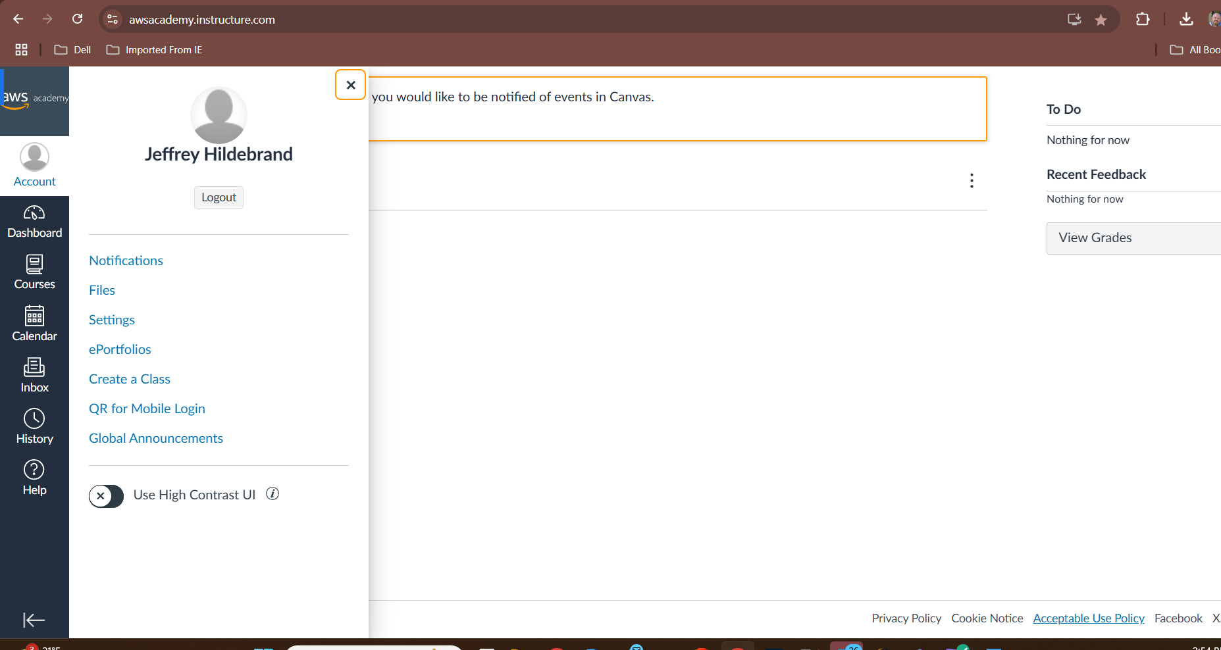

- Based on your current knowledge – who is the largest public cloud provider in the world: Microsoft, Google or Amazon Web Services (AWS):

ANSWER: AWS

- What is the instructor’s email address?

ANSWER:
atgallus@madisoncollege.edu
- On the AWS Cloud Foundations online course (URL above or on Blackboard) locate the “Module 1 Knowledge Check” in the Modules link and make sure you can open it - paste a screenshot of it open below.

PASTE SCREENSHOT HERE:
