Word_Submission

Jordan McGrath

2023-04-14

## Descriptive Statistics

This section is to give an overview of the descriptive statistics for each of our variables. You will see the number of responses, average, and standard deviation of the responses for each of our theoretical variables. You will also see see a bar chart of comparative averages of each of the theoretical variables.

Average of all Theoretical Variables

|  | mean | sd | n |
| --- | --- | --- | --- |
| **Relationship with Coworkers** | 3.681 | 0.8522 | 130 |
| **Satisfaction with Pay** | 3.003 | 0.9324 | 124 |
| **Satisfaction with Benefits** | 3.203 | 1.022 | 124 |
| **Trust in Manager** | 3.524 | 0.8923 | 122 |
| **Communication** | 3.733 | 1.039 | 115 |
| **Procedual Justice** | 3.34 | 0.9729 | 110 |
| **Advancement Opportunity** | 3.065 | 0.9602 | 107 |
| **Lack of Alternative Job Opportunity** | 3.252 | 1.004 | 107 |
| **Perceived Organizational Support** | 3.362 | 1.02 | 108 |
| **Intention for Turnover** | 3.094 | 1.387 | 104 |

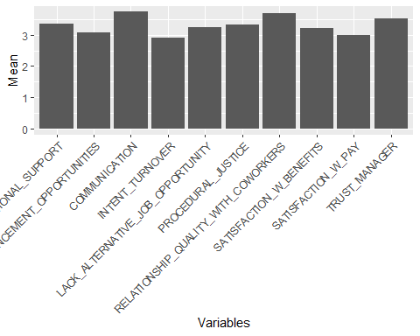

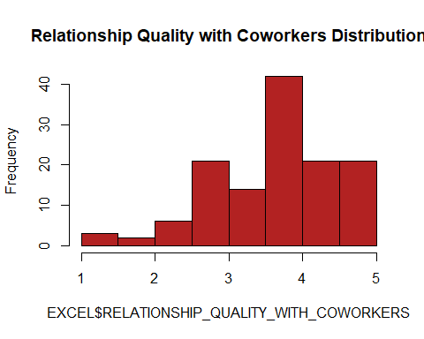

## Exploration of Differences Accross Subgroups

Each of these analysis are done with the following subgroups, Age, Marital Status, Years at your current company, Ethnicity, Annual Household Income, and Education Level. Below, we have given the definitions of each of the numbers given for each subgroups(ex. Education Level: 1 = )

# Intention to quit ANOVAs and T-Tests

Intention to Quit:Age (ANOVA)

Analysis of Variance Model Intention to Quit:Ethnicity (ANOVA)

|  | Df | Sum Sq | Mean Sq | F value | Pr(>F) |
| --- | --- | --- | --- | --- | --- |
| **AGE** | 1 | 8.438 | 8.438 | 4.42 | 0.03831 |
| **Residuals** | 90 | 171.8 | 1.909 | NA | NA |

Analysis of Variance Model Intention to Quit:Education (ANOVA)

|  | Df | Sum Sq | Mean Sq | F value | Pr(>F) |
| --- | --- | --- | --- | --- | --- |
| **RACE** | 6 | 11.17 | 1.861 | 0.9654 | 0.4528 |
| **Residuals** | 97 | 187 | 1.928 | NA | NA |

Analysis of Variance Model Intention to Quit:Years with Company (ANOVA)

|  | Df | Sum Sq | Mean Sq | F value | Pr(>F) |
| --- | --- | --- | --- | --- | --- |
| **EDUCATION** | 5 | 8.857 | 1.771 | 0.9171 | 0.4733 |
| **Residuals** | 98 | 189.3 | 1.932 | NA | NA |

Analysis of Variance Model Intention to Quit:Employment Status (ANOVA)

|  | Df | Sum Sq | Mean Sq | F value | Pr(>F) |
| --- | --- | --- | --- | --- | --- |
| **YEARS_W_COMPANY** | 12 | 24.57 | 2.048 | 1.074 | 0.3915 |
| **Residuals** | 91 | 173.6 | 1.907 | NA | NA |

Analysis of Variance Model Intention to Quit:Income (ANOVA)

|  | Df | Sum Sq | Mean Sq | F value | Pr(>F) |
| --- | --- | --- | --- | --- | --- |
| **EMPLOYEMENT_STATUS** | 3 | 5.914 | 1.971 | 1.025 | 0.3847 |
| **Residuals** | 100 | 192.2 | 1.922 | NA | NA |

Analysis of Variance Model Intention to Quit:Marital Status (T-Test) Quitting from lines 91-92 (MileStone8.Rmd) Error in t.test.formula(formula, data = data, …) : grouping factor must have exactly 2 levels Calls: … t.test -> t_test.formula -> -> t.test.formula # Relationship Quality with Coworkers ANOVAs and T-Tests

|  | Df | Sum Sq | Mean Sq | F value | Pr(>F) |
| --- | --- | --- | --- | --- | --- |
| **INCOME** | 6 | 21.63 | 3.604 | 1.981 | 0.07575 |
| **Residuals** | 97 | 176.5 | 1.82 | NA | NA |

Relationship Quality with Coworkers:Age (ANOVA)

Analysis of Variance Model Relationship Quality with Coworkers:Ethnicity (ANOVA)

|  | Df | Sum Sq | Mean Sq | F value | Pr(>F) |
| --- | --- | --- | --- | --- | --- |
| **AGE** | 1 | 0.3144 | 0.3144 | 0.3736 | 0.5426 |
| **Residuals** | 91 | 76.59 | 0.8416 | NA | NA |

Analysis of Variance Model Relationship Quality with Coworkers:Education (ANOVA)

|  | Df | Sum Sq | Mean Sq | F value | Pr(>F) |
| --- | --- | --- | --- | --- | --- |
| **RACE** | 6 | 1.412 | 0.2354 | 0.3138 | 0.9288 |
| **Residuals** | 123 | 92.27 | 0.7501 | NA | NA |

Analysis of Variance Model Relationship Quality with Coworkers:Years with Company (ANOVA)

|  | Df | Sum Sq | Mean Sq | F value | Pr(>F) |
| --- | --- | --- | --- | --- | --- |
| **EDUCATION** | 5 | 6.09 | 1.218 | 1.724 | 0.1338 |
| **Residuals** | 124 | 87.59 | 0.7064 | NA | NA |

Analysis of Variance Model Relationship Quality with Coworkers:Employment Status (ANOVA)

|  | Df | Sum Sq | Mean Sq | F value | Pr(>F) |
| --- | --- | --- | --- | --- | --- |
| **YEARS_W_COMPANY** | 12 | 7.673 | 0.6394 | 0.8699 | 0.5793 |
| **Residuals** | 117 | 86.01 | 0.7351 | NA | NA |

Analysis of Variance Model Relationship Quality with Coworkers:Income (ANOVA)

|  | Df | Sum Sq | Mean Sq | F value | Pr(>F) |
| --- | --- | --- | --- | --- | --- |
| **EMPLOYEMENT_STATUS** | 3 | 1.237 | 0.4122 | 0.5619 | 0.6412 |
| **Residuals** | 126 | 92.44 | 0.7337 | NA | NA |

Analysis of Variance Model Relationship Quality with Coworkers:Marital Status (T-Test) Quitting from lines 133-134 (MileStone8.Rmd) Error in t.test.formula(formula, data = data, …) : grouping factor must have exactly 2 levels Calls: … t.test -> t_test.formula -> -> t.test.formula

|  | Df | Sum Sq | Mean Sq | F value | Pr(>F) |
| --- | --- | --- | --- | --- | --- |
| **INCOME** | 6 | 3.092 | 0.5154 | 0.6998 | 0.6503 |
| **Residuals** | 123 | 90.59 | 0.7365 | NA | NA |

# Satisfaction of Pay ANOVAs and T-Tests

Satisfaction of Pay:Age (ANOVA)

Analysis of Variance Model Satisfaction of Pay:Ethnicity (ANOVA)

|  | Df | Sum Sq | Mean Sq | F value | Pr(>F) |
| --- | --- | --- | --- | --- | --- |
| **AGE** | 1 | 6.066 | 6.066 | 6.868 | 0.01029 |
| **Residuals** | 91 | 80.37 | 0.8832 | NA | NA |

Analysis of Variance Model Satisfaction of Pay:Education (ANOVA)

|  | Df | Sum Sq | Mean Sq | F value | Pr(>F) |
| --- | --- | --- | --- | --- | --- |
| **RACE** | 6 | 1.985 | 0.3309 | 0.3689 | 0.8974 |
| **Residuals** | 117 | 105 | 0.8971 | NA | NA |

Analysis of Variance Model Satisfaction of Pay:Years with Company (ANOVA)

|  | Df | Sum Sq | Mean Sq | F value | Pr(>F) |
| --- | --- | --- | --- | --- | --- |
| **EDUCATION** | 5 | 2.088 | 0.4175 | 0.4699 | 0.7981 |
| **Residuals** | 118 | 104.9 | 0.8886 | NA | NA |

Analysis of Variance Model Satisfaction of Pay:Employment Status (ANOVA)

|  | Df | Sum Sq | Mean Sq | F value | Pr(>F) |
| --- | --- | --- | --- | --- | --- |
| **YEARS_W_COMPANY** | 12 | 10.82 | 0.9017 | 1.041 | 0.4169 |
| **Residuals** | 111 | 96.12 | 0.866 | NA | NA |

Analysis of Variance Model Satisfaction of Pay:Income (ANOVA)

|  | Df | Sum Sq | Mean Sq | F value | Pr(>F) |
| --- | --- | --- | --- | --- | --- |
| **EMPLOYEMENT_STATUS** | 3 | 3.691 | 1.23 | 1.43 | 0.2374 |
| **Residuals** | 120 | 103.3 | 0.8604 | NA | NA |

Analysis of Variance Model Satisfaction of Pay:Marital Status (T-Test) Quitting from lines 176-177 (MileStone8.Rmd) Error in t.test.formula(formula, data = data, …) : grouping factor must have exactly 2 levels Calls: … t.test -> t_test.formula -> -> t.test.formula

|  | Df | Sum Sq | Mean Sq | F value | Pr(>F) |
| --- | --- | --- | --- | --- | --- |
| **INCOME** | 6 | 10.37 | 1.728 | 2.093 | 0.05913 |
| **Residuals** | 117 | 96.58 | 0.8254 | NA | NA |

# Satisfaction of Benefits ANOVAs and T-Tests

Satisfaction of Benefits:Age (ANOVA)

Analysis of Variance Model Satisfaction of Benefits:Ethnicity (ANOVA)

|  | Df | Sum Sq | Mean Sq | F value | Pr(>F) |
| --- | --- | --- | --- | --- | --- |
| **AGE** | 1 | 0.6481 | 0.6481 | 0.6165 | 0.4344 |
| **Residuals** | 91 | 95.66 | 1.051 | NA | NA |

Analysis of Variance Model Satisfaction of Benefits:Education (ANOVA)

|  | Df | Sum Sq | Mean Sq | F value | Pr(>F) |
| --- | --- | --- | --- | --- | --- |
| **RACE** | 6 | 4.286 | 0.7144 | 0.6724 | 0.6721 |
| **Residuals** | 117 | 124.3 | 1.062 | NA | NA |

Analysis of Variance Model Satisfaction of Benefits:Years with Company (ANOVA)

|  | Df | Sum Sq | Mean Sq | F value | Pr(>F) |
| --- | --- | --- | --- | --- | --- |
| **EDUCATION** | 5 | 9.754 | 1.951 | 1.937 | 0.09324 |
| **Residuals** | 118 | 118.8 | 1.007 | NA | NA |

Analysis of Variance Model Satisfaction of Benefits:Employment Status (ANOVA)

|  | Df | Sum Sq | Mean Sq | F value | Pr(>F) |
| --- | --- | --- | --- | --- | --- |
| **YEARS_W_COMPANY** | 12 | 17.17 | 1.431 | 1.426 | 0.1646 |
| **Residuals** | 111 | 111.4 | 1.004 | NA | NA |

Analysis of Variance Model Satisfaction of Benefits:Income (ANOVA)

|  | Df | Sum Sq | Mean Sq | F value | Pr(>F) |
| --- | --- | --- | --- | --- | --- |
| **EMPLOYEMENT_STATUS** | 3 | 16.56 | 5.519 | 5.912 | 0.0008506 |
| **Residuals** | 120 | 112 | 0.9336 | NA | NA |

Analysis of Variance Model Satisfaction of Benefits:Marital Status (T-Test) Quitting from lines 219-220 (MileStone8.Rmd) Error in t.test.formula(formula, data = data, …) : grouping factor must have exactly 2 levels Calls: … t.test -> t_test.formula -> -> t.test.formula

|  | Df | Sum Sq | Mean Sq | F value | Pr(>F) |
| --- | --- | --- | --- | --- | --- |
| **INCOME** | 6 | 18.67 | 3.112 | 3.312 | 0.004773 |
| **Residuals** | 117 | 109.9 | 0.9395 | NA | NA |

# Trust in Manager ANOVAs and T-Tests

Trust in Manager:Age (ANOVA)

Analysis of Variance Model Trust in Manager:Ethnicity (ANOVA)

|  | Df | Sum Sq | Mean Sq | F value | Pr(>F) |
| --- | --- | --- | --- | --- | --- |
| **AGE** | 1 | 0.3364 | 0.3364 | 0.3643 | 0.5476 |
| **Residuals** | 91 | 84.04 | 0.9235 | NA | NA |

Analysis of Variance Model Trust in Manager:Education (ANOVA)

|  | Df | Sum Sq | Mean Sq | F value | Pr(>F) |
| --- | --- | --- | --- | --- | --- |
| **RACE** | 6 | 1.559 | 0.2599 | 0.3153 | 0.9279 |
| **Residuals** | 115 | 94.79 | 0.8243 | NA | NA |

Analysis of Variance Model Trust in Manager:Years with Company (ANOVA)

|  | Df | Sum Sq | Mean Sq | F value | Pr(>F) |
| --- | --- | --- | --- | --- | --- |
| **EDUCATION** | 5 | 0.8852 | 0.177 | 0.2151 | 0.9555 |
| **Residuals** | 116 | 95.46 | 0.823 | NA | NA |

Analysis of Variance Model Trust in Manager:Employment Status (ANOVA)

|  | Df | Sum Sq | Mean Sq | F value | Pr(>F) |
| --- | --- | --- | --- | --- | --- |
| **YEARS_W_COMPANY** | 12 | 8.697 | 0.7248 | 0.9013 | 0.5481 |
| **Residuals** | 109 | 87.65 | 0.8041 | NA | NA |

Analysis of Variance Model Trust in Manager:Income (ANOVA)

|  | Df | Sum Sq | Mean Sq | F value | Pr(>F) |
| --- | --- | --- | --- | --- | --- |
| **EMPLOYEMENT_STATUS** | 3 | 1.457 | 0.4856 | 0.6038 | 0.6138 |
| **Residuals** | 118 | 94.89 | 0.8042 | NA | NA |

Analysis of Variance Model Trust in Manager:Marital Status (T-Test) Quitting from lines 262-263 (MileStone8.Rmd) Error in t.test.formula(formula, data = data, …) : grouping factor must have exactly 2 levels Calls: … t.test -> t_test.formula -> -> t.test.formula

|  | Df | Sum Sq | Mean Sq | F value | Pr(>F) |
| --- | --- | --- | --- | --- | --- |
| **INCOME** | 6 | 5.232 | 0.872 | 1.101 | 0.3663 |
| **Residuals** | 115 | 91.12 | 0.7923 | NA | NA |

# Communication ANOVAs and T-Tests

Communication:Age (ANOVA)

Analysis of Variance Model Communication:Ethnicity (ANOVA)

|  | Df | Sum Sq | Mean Sq | F value | Pr(>F) |
| --- | --- | --- | --- | --- | --- |
| **AGE** | 1 | 2.249 | 2.249 | 1.911 | 0.1702 |
| **Residuals** | 91 | 107.1 | 1.177 | NA | NA |

Analysis of Variance Model Communication:Education (ANOVA)

|  | Df | Sum Sq | Mean Sq | F value | Pr(>F) |
| --- | --- | --- | --- | --- | --- |
| **RACE** | 6 | 1.578 | 0.263 | 0.2336 | 0.9647 |
| **Residuals** | 108 | 121.6 | 1.126 | NA | NA |

Analysis of Variance Model Communication:Years with Company (ANOVA)

|  | Df | Sum Sq | Mean Sq | F value | Pr(>F) |
| --- | --- | --- | --- | --- | --- |
| **EDUCATION** | 5 | 1.095 | 0.219 | 0.1956 | 0.9636 |
| **Residuals** | 109 | 122.1 | 1.12 | NA | NA |

Analysis of Variance Model Communication:Employment Status (ANOVA)

|  | Df | Sum Sq | Mean Sq | F value | Pr(>F) |
| --- | --- | --- | --- | --- | --- |
| **YEARS_W_COMPANY** | 12 | 10.78 | 0.8987 | 0.8157 | 0.6338 |
| **Residuals** | 102 | 112.4 | 1.102 | NA | NA |

Analysis of Variance Model Communication:Income (ANOVA)

|  | Df | Sum Sq | Mean Sq | F value | Pr(>F) |
| --- | --- | --- | --- | --- | --- |
| **EMPLOYEMENT_STATUS** | 3 | 1.936 | 0.6452 | 0.5907 | 0.6224 |
| **Residuals** | 111 | 121.2 | 1.092 | NA | NA |

Analysis of Variance Model Communication:Marital Status (T-Test) Quitting from lines 305-306 (MileStone8.Rmd) Error in t.test.formula(formula, data = data, …) : grouping factor must have exactly 2 levels Calls: … t.test -> t_test.formula -> -> t.test.formula

|  | Df | Sum Sq | Mean Sq | F value | Pr(>F) |
| --- | --- | --- | --- | --- | --- |
| **INCOME** | 6 | 12.17 | 2.029 | 1.974 | 0.07558 |
| **Residuals** | 108 | 111 | 1.028 | NA | NA |

# Procedural Justice in Organization ANOVAs and T-Tests

Procedural Justice in Organization:Age (ANOVA)

Analysis of Variance Model Procedural Justice in Organization:Ethnicity (ANOVA)

|  | Df | Sum Sq | Mean Sq | F value | Pr(>F) |
| --- | --- | --- | --- | --- | --- |
| **AGE** | 1 | 1.391 | 1.391 | 1.478 | 0.2273 |
| **Residuals** | 91 | 85.66 | 0.9413 | NA | NA |

Analysis of Variance Model Procedural Justice in Organization:Education (ANOVA)

|  | Df | Sum Sq | Mean Sq | F value | Pr(>F) |
| --- | --- | --- | --- | --- | --- |
| **RACE** | 6 | 4.725 | 0.7875 | 0.824 | 0.5539 |
| **Residuals** | 103 | 98.44 | 0.9557 | NA | NA |

Analysis of Variance Model Procedural Justice in Organization:Years with Company (ANOVA)

|  | Df | Sum Sq | Mean Sq | F value | Pr(>F) |
| --- | --- | --- | --- | --- | --- |
| **EDUCATION** | 5 | 1.818 | 0.3637 | 0.3732 | 0.866 |
| **Residuals** | 104 | 101.3 | 0.9745 | NA | NA |

Analysis of Variance Model Procedural Justice in Organization:Employment Status (ANOVA)

|  | Df | Sum Sq | Mean Sq | F value | Pr(>F) |
| --- | --- | --- | --- | --- | --- |
| **YEARS_W_COMPANY** | 12 | 9.282 | 0.7735 | 0.7992 | 0.6504 |
| **Residuals** | 97 | 93.89 | 0.9679 | NA | NA |

Analysis of Variance Model Procedural Justice in Organization:Income (ANOVA)

|  | Df | Sum Sq | Mean Sq | F value | Pr(>F) |
| --- | --- | --- | --- | --- | --- |
| **EMPLOYEMENT_STATUS** | 3 | 0.2262 | 0.07541 | 0.07765 | 0.972 |
| **Residuals** | 106 | 102.9 | 0.9711 | NA | NA |

Analysis of Variance Model Procedural Justice in Organization:Marital Status (T-Test) Quitting from lines 348-349 (MileStone8.Rmd) Error in t.test.formula(formula, data = data, …) : grouping factor must have exactly 2 levels Calls: … t.test -> t_test.formula -> -> t.test.formula

|  | Df | Sum Sq | Mean Sq | F value | Pr(>F) |
| --- | --- | --- | --- | --- | --- |
| **INCOME** | 6 | 5.585 | 0.9308 | 0.9825 | 0.441 |
| **Residuals** | 103 | 97.58 | 0.9474 | NA | NA |

# Advancement Opportunities ANOVAs and T-Tests

Advancement Opportunities:Age (ANOVA)

Analysis of Variance Model Advancement Opportunities:Ethnicity (ANOVA)

|  | Df | Sum Sq | Mean Sq | F value | Pr(>F) |
| --- | --- | --- | --- | --- | --- |
| **AGE** | 1 | 0.03153 | 0.03153 | 0.03323 | 0.8558 |
| **Residuals** | 91 | 86.36 | 0.949 | NA | NA |

Analysis of Variance Model Advancement Opportunities:Education (ANOVA)

|  | Df | Sum Sq | Mean Sq | F value | Pr(>F) |
| --- | --- | --- | --- | --- | --- |
| **RACE** | 6 | 5.506 | 0.9177 | 0.9951 | 0.4329 |
| **Residuals** | 100 | 92.22 | 0.9222 | NA | NA |

Analysis of Variance Model Advancement Opportunities:Years with Company (ANOVA)

|  | Df | Sum Sq | Mean Sq | F value | Pr(>F) |
| --- | --- | --- | --- | --- | --- |
| **EDUCATION** | 5 | 1.467 | 0.2935 | 0.308 | 0.9071 |
| **Residuals** | 101 | 96.25 | 0.953 | NA | NA |

Analysis of Variance Model Advancement Opportunities:Employment Status (ANOVA)

|  | Df | Sum Sq | Mean Sq | F value | Pr(>F) |
| --- | --- | --- | --- | --- | --- |
| **YEARS_W_COMPANY** | 12 | 7.985 | 0.6654 | 0.6971 | 0.7506 |
| **Residuals** | 94 | 89.74 | 0.9546 | NA | NA |

Analysis of Variance Model Advancement Opportunities:Income (ANOVA)

|  | Df | Sum Sq | Mean Sq | F value | Pr(>F) |
| --- | --- | --- | --- | --- | --- |
| **EMPLOYEMENT_STATUS** | 3 | 5.259 | 1.753 | 1.953 | 0.1258 |
| **Residuals** | 103 | 92.46 | 0.8977 | NA | NA |

Analysis of Variance Model Advancement Opportunities:Marital Status (T-Test) Quitting from lines 391-392 (MileStone8.Rmd) Error in t.test.formula(formula, data = data, …) : grouping factor must have exactly 2 levels Calls: … t.test -> t_test.formula -> -> t.test.formula

|  | Df | Sum Sq | Mean Sq | F value | Pr(>F) |
| --- | --- | --- | --- | --- | --- |
| **INCOME** | 6 | 9.529 | 1.588 | 1.801 | 0.1065 |
| **Residuals** | 100 | 88.19 | 0.8819 | NA | NA |

# Lack of other Job Opportunities ANOVAs and T-Tests

Lack of other Job Opportunities:Age (ANOVA)

Analysis of Variance Model Lack of other Job Opportunities:Ethnicity (ANOVA)

|  | Df | Sum Sq | Mean Sq | F value | Pr(>F) |
| --- | --- | --- | --- | --- | --- |
| **AGE** | 1 | 1.504 | 1.504 | 1.551 | 0.2161 |
| **Residuals** | 91 | 88.25 | 0.9698 | NA | NA |

Analysis of Variance Model Lack of other Job Opportunities:Education (ANOVA)

|  | Df | Sum Sq | Mean Sq | F value | Pr(>F) |
| --- | --- | --- | --- | --- | --- |
| **RACE** | 6 | 3.915 | 0.6526 | 0.634 | 0.7027 |
| **Residuals** | 100 | 102.9 | 1.029 | NA | NA |

Analysis of Variance Model Lack of other Job Opportunities:Years with Company (ANOVA)

|  | Df | Sum Sq | Mean Sq | F value | Pr(>F) |
| --- | --- | --- | --- | --- | --- |
| **EDUCATION** | 5 | 12.6 | 2.52 | 2.7 | 0.02476 |
| **Residuals** | 101 | 94.25 | 0.9332 | NA | NA |

Analysis of Variance Model Lack of other Job Opportunities:Employment Status (ANOVA)

|  | Df | Sum Sq | Mean Sq | F value | Pr(>F) |
| --- | --- | --- | --- | --- | --- |
| **YEARS_W_COMPANY** | 12 | 15.12 | 1.26 | 1.291 | 0.2368 |
| **Residuals** | 94 | 91.73 | 0.9758 | NA | NA |

Analysis of Variance Model Lack of other Job Opportunities:Income (ANOVA)

|  | Df | Sum Sq | Mean Sq | F value | Pr(>F) |
| --- | --- | --- | --- | --- | --- |
| **EMPLOYEMENT_STATUS** | 3 | 1.998 | 0.666 | 0.6542 | 0.5821 |
| **Residuals** | 103 | 104.8 | 1.018 | NA | NA |

Analysis of Variance Model Lack of other Job Opportunities:Marital Status (T-Test) Quitting from lines 434-435 (MileStone8.Rmd) Error in t.test.formula(formula, data = data, …) : grouping factor must have exactly 2 levels Calls: … t.test -> t_test.formula -> -> t.test.formula

|  | Df | Sum Sq | Mean Sq | F value | Pr(>F) |
| --- | --- | --- | --- | --- | --- |
| **INCOME** | 6 | 6.042 | 1.007 | 0.9989 | 0.4304 |
| **Residuals** | 100 | 100.8 | 1.008 | NA | NA |

# Perceived Organizational Support ANOVAs and T-Tests

Perceived Organizational Support:Age (ANOVA)

Analysis of Variance Model Perceived Organizational Support:Ethnicity (ANOVA)

|  | Df | Sum Sq | Mean Sq | F value | Pr(>F) |
| --- | --- | --- | --- | --- | --- |
| **AGE** | 1 | 0.5326 | 0.5326 | 0.5112 | 0.4764 |
| **Residuals** | 91 | 94.8 | 1.042 | NA | NA |

Analysis of Variance Model Perceived Organizational Support:Education (ANOVA)

|  | Df | Sum Sq | Mean Sq | F value | Pr(>F) |
| --- | --- | --- | --- | --- | --- |
| **RACE** | 6 | 4.197 | 0.6995 | 0.6598 | 0.6822 |
| **Residuals** | 101 | 107.1 | 1.06 | NA | NA |

Analysis of Variance Model Perceived Organizational Support:Years with Company (ANOVA)

|  | Df | Sum Sq | Mean Sq | F value | Pr(>F) |
| --- | --- | --- | --- | --- | --- |
| **EDUCATION** | 5 | 2.794 | 0.5587 | 0.5253 | 0.7566 |
| **Residuals** | 102 | 108.5 | 1.064 | NA | NA |

Analysis of Variance Model Perceived Organizational Support:Employment Status (ANOVA)

|  | Df | Sum Sq | Mean Sq | F value | Pr(>F) |
| --- | --- | --- | --- | --- | --- |
| **YEARS_W_COMPANY** | 12 | 6.634 | 0.5528 | 0.5018 | 0.9088 |
| **Residuals** | 95 | 104.6 | 1.102 | NA | NA |

Analysis of Variance Model Perceived Organizational Support:Income (ANOVA)

|  | Df | Sum Sq | Mean Sq | F value | Pr(>F) |
| --- | --- | --- | --- | --- | --- |
| **EMPLOYEMENT_STATUS** | 3 | 0.7611 | 0.2537 | 0.2387 | 0.8692 |
| **Residuals** | 104 | 110.5 | 1.063 | NA | NA |

Analysis of Variance Model Perceived Organizational Support:Marital Status (T-Test) Quitting from lines 477-478 (MileStone8.Rmd) Error in t.test.formula(formula, data = data, …) : grouping factor must have exactly 2 levels Calls: … t.test -> t_test.formula -> -> t.test.formula

|  | Df | Sum Sq | Mean Sq | F value | Pr(>F) |
| --- | --- | --- | --- | --- | --- |
| **INCOME** | 6 | 7.1 | 1.183 | 1.147 | 0.3408 |
| **Residuals** | 101 | 104.2 | 1.032 | NA | NA |

## Correlation Analysis

Within this section we will be exporting the relationships of interest. We are looking for the correlation between each of our theoretical variables and intent of turnover by the employee.

Correlation Analysis with Relationship Quality with Coworkers and Intent of Turnover.

Pearson’s product-moment correlation: x and y

| Test statistic | df | P value | Alternative hypothesis | cor |
| --- | --- | --- | --- | --- |
| -2.941 | 102 | 0.00405 * * | two.sided | -0.2796 |

Correlation Analysis with Satisfaction with Pay and Intent of Turnover.

Pearson’s product-moment correlation: x and y

| Test statistic | df | P value | Alternative hypothesis | cor |
| --- | --- | --- | --- | --- |
| -6.647 | 102 | 1.502e-09 * * * | two.sided | -0.5497 |

Correlation Analysis with Satisfaction of Benefits and Intent of Turnover.

Pearson’s product-moment correlation: x and y

| Test statistic | df | P value | Alternative hypothesis | cor |
| --- | --- | --- | --- | --- |
| -4.44 | 102 | 2.284e-05 * * * | two.sided | -0.4025 |

Correlation Analysis with Trust in the Manager and Intent of Turnover.

Pearson’s product-moment correlation: x and y

| Test statistic | df | P value | Alternative hypothesis | cor |
| --- | --- | --- | --- | --- |
| -4.838 | 102 | 4.671e-06 * * * | two.sided | -0.432 |

Correlation Analysis with Effective Communication and Intent of Turnover.

Pearson’s product-moment correlation: x and y

| Test statistic | df | P value | Alternative hypothesis | cor |
| --- | --- | --- | --- | --- |
| -3.017 | 102 | 0.00322 * * | two.sided | -0.2863 |

Correlation Analysis with Procedural Justice and Intent of Turnover.

Pearson’s product-moment correlation: x and y

| Test statistic | df | P value | Alternative hypothesis | cor |
| --- | --- | --- | --- | --- |
| -4.602 | 101 | 1.219e-05 * * * | two.sided | -0.4163 |

Correlation Analysis with Advancement Opportunities and Intent of Turnover.

Pearson’s product-moment correlation: x and y

| Test statistic | df | P value | Alternative hypothesis | cor |
| --- | --- | --- | --- | --- |
| -6.299 | 101 | 7.858e-09 * * * | two.sided | -0.5311 |

Correlation Analysis with Lack of Alternative Job Opportunities and Intent of Turnover.

Pearson’s product-moment correlation: x and y

| Test statistic | df | P value | Alternative hypothesis | cor |
| --- | --- | --- | --- | --- |
| -7.55 | 101 | 1.987e-11 * * * | two.sided | -0.6007 |

Correlation Analysis with Perceived Organizational Support and Intent of Turnover.

Pearson’s product-moment correlation: x and y

| Test statistic | df | P value | Alternative hypothesis | cor |
| --- | --- | --- | --- | --- |
| -6.556 | 102 | 2.301e-09 * * * | two.sided | -0.5445 |

## Regression Analysis

Within this section we will be looking for the regression analysis of the theoretical variables and intention of turnover by the employee.

Regression Analysis of Relationship Quality with Coworkers with Intent of Turnover by employee 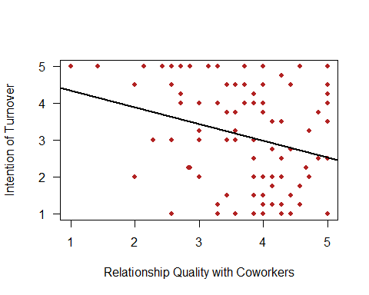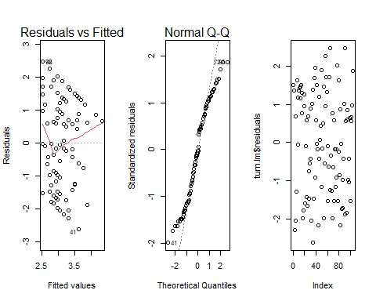

Table continues below

|  | Estimate | Std. Error | t value |
| --- | --- | --- | --- |
| **(Intercept)** | 4.791 | 0.5918 | 8.095 |
| **RELATIONSHIP_QUALITY_WITH_COWORKERS** | -0.453 | 0.154 | -2.941 |

|  | Pr(>|t|) |
| --- | --- |
| **(Intercept)** | 1.271e-12 |
| **RELATIONSHIP_QUALITY_WITH_COWORKERS** | 0.00405 |

Fitting linear model: INTENT_TURNOVER ~ RELATIONSHIP_QUALITY_WITH_COWORKERS

| Observations | Residual Std. Error | $R^{2}$ | Adjusted $R^{2}$ |
| --- | --- | --- | --- |
| 104 | 1.338 | 0.07816 | 0.06913 |

Regression Analysis of Satisfaction with Pay with Intent of Turnover by employee 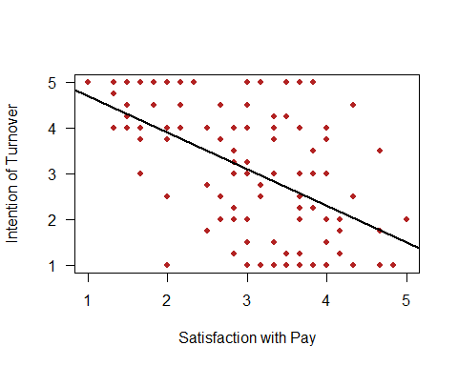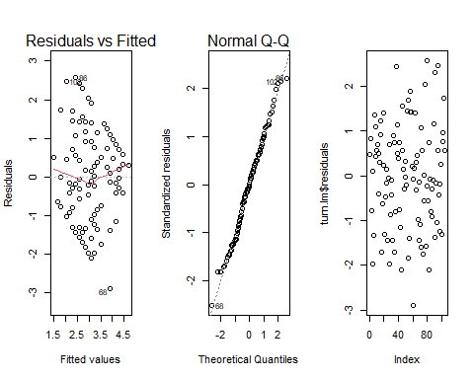

|  | Estimate | Std. Error | t value | Pr(>|t|) |
| --- | --- | --- | --- | --- |
| **(Intercept)** | 5.494 | 0.3788 | 14.51 | 1.545e-26 |
| **SATISFACTION_W_PAY** | -0.7981 | 0.1201 | -6.647 | 1.502e-09 |

Fitting linear model: INTENT_TURNOVER ~ SATISFACTION_W_PAY Regression Analysis of Satisfaction with Benefits with Intent of Turnover by employee 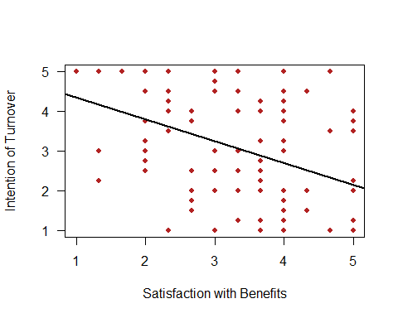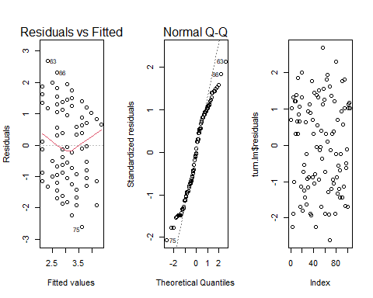

| Observations | Residual Std. Error | $R^{2}$ | Adjusted $R^{2}$ |
| --- | --- | --- | --- |
| 104 | 1.164 | 0.3022 | 0.2954 |

|  | Estimate | Std. Error | t value | Pr(>|t|) |
| --- | --- | --- | --- | --- |
| **(Intercept)** | 4.896 | 0.4248 | 11.53 | 3.518e-20 |
| **SATISFACTION_W_BENEFITS** | -0.5514 | 0.1242 | -4.44 | 2.284e-05 |

Fitting linear model: INTENT_TURNOVER ~ SATISFACTION_W_BENEFITS Regression Analysis of Trust in Manager with Intent of Turnover by employee 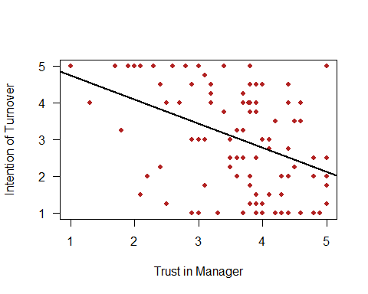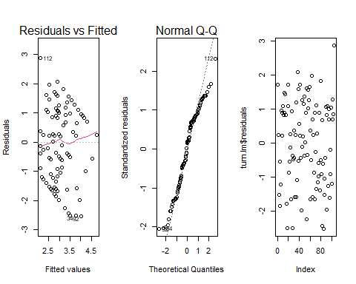

| Observations | Residual Std. Error | $R^{2}$ | Adjusted $R^{2}$ |
| --- | --- | --- | --- |
| 104 | 1.276 | 0.162 | 0.1538 |

|  | Estimate | Std. Error | t value | Pr(>|t|) |
| --- | --- | --- | --- | --- |
| **(Intercept)** | 5.407 | 0.4938 | 10.95 | 6.486e-19 |
| **TRUST_MANAGER** | -0.6557 | 0.1355 | -4.838 | 4.671e-06 |

Fitting linear model: INTENT_TURNOVER ~ TRUST_MANAGER Regression Analysis of Communication with Intent of Turnover by employee 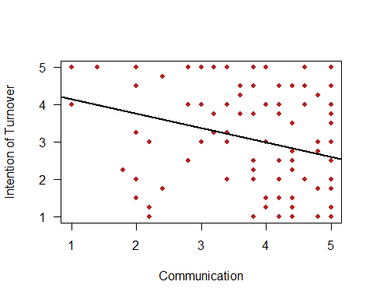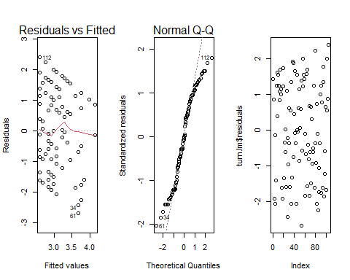

| Observations | Residual Std. Error | $R^{2}$ | Adjusted $R^{2}$ |
| --- | --- | --- | --- |
| 104 | 1.257 | 0.1866 | 0.1786 |

|  | Estimate | Std. Error | t value | Pr(>|t|) |
| --- | --- | --- | --- | --- |
| **(Intercept)** | 4.522 | 0.4911 | 9.208 | 4.611e-15 |
| **COMMUNICATION** | -0.3822 | 0.1267 | -3.017 | 0.00322 |

Fitting linear model: INTENT_TURNOVER ~ COMMUNICATION Regression Analysis of Procedural Justice with Intent of Turnover by employee 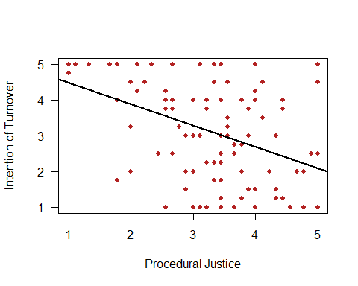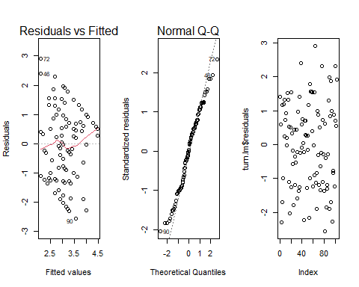

| Observations | Residual Std. Error | $R^{2}$ | Adjusted $R^{2}$ |
| --- | --- | --- | --- |
| 104 | 1.335 | 0.08195 | 0.07295 |

|  | Estimate | Std. Error | t value | Pr(>|t|) |
| --- | --- | --- | --- | --- |
| **(Intercept)** | 5.075 | 0.4519 | 11.23 | 1.782e-19 |
| **PROCEDURAL_JUSTICE** | -0.5946 | 0.1292 | -4.602 | 1.219e-05 |

Fitting linear model: INTENT_TURNOVER ~ PROCEDURAL_JUSTICE Regression Analysis of Advancement Opportunities with Intent of Turnover by employee 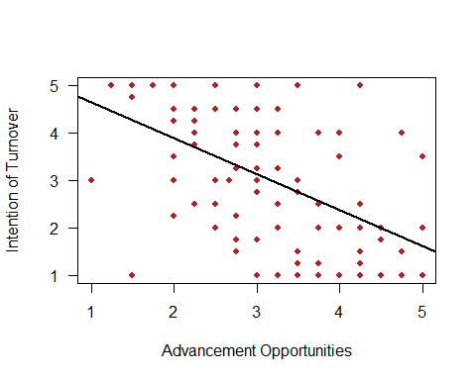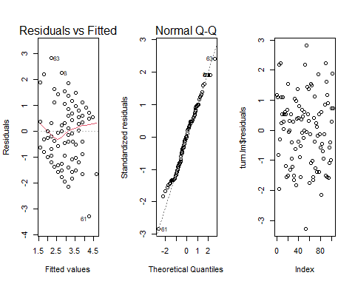

| Observations | Residual Std. Error | $R^{2}$ | Adjusted $R^{2}$ |
| --- | --- | --- | --- |
| 103 | 1.262 | 0.1733 | 0.1652 |

|  | Estimate | Std. Error | t value | Pr(>|t|) |
| --- | --- | --- | --- | --- |
| **(Intercept)** | 5.416 | 0.3892 | 13.92 | 3.203e-25 |
| **ADVANCEMENT_OPPORTUNITIES** | -0.76 | 0.1207 | -6.299 | 7.858e-09 |

Fitting linear model: INTENT_TURNOVER ~ ADVANCEMENT_OPPORTUNITIES Regression Analysis of Lack of Alternative Job Opportunity with Intent of Turnover by employee 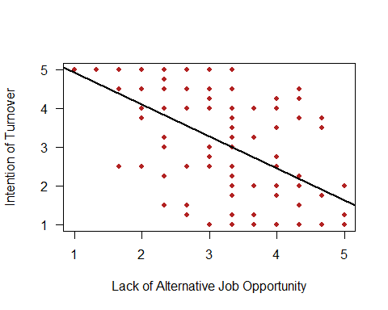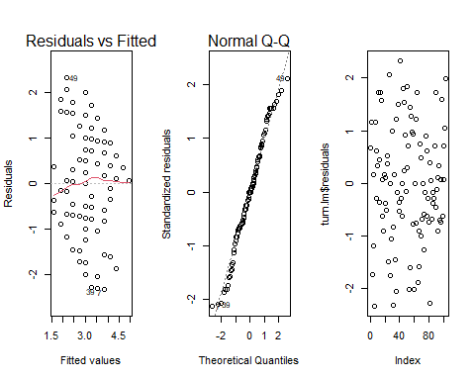 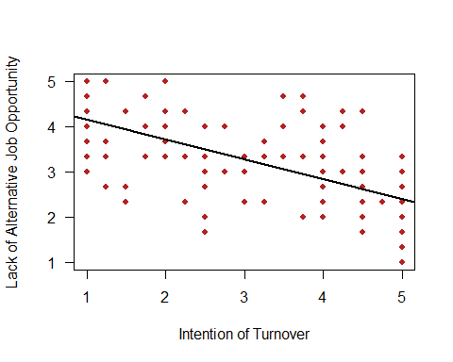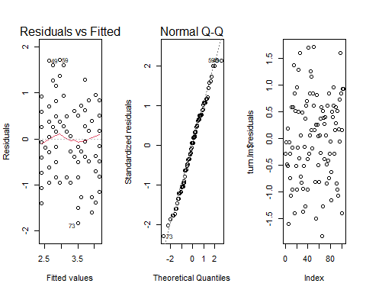

| Observations | Residual Std. Error | $R^{2}$ | Adjusted $R^{2}$ |
| --- | --- | --- | --- |
| 103 | 1.176 | 0.2821 | 0.275 |

|  | Estimate | Std. Error | t value | Pr(>|t|) |
| --- | --- | --- | --- | --- |
| **(Intercept)** | 4.591 | 0.1946 | 23.59 | 7.135e-43 |
| **INTENT_TURNOVER** | -0.4363 | 0.05778 | -7.55 | 1.987e-11 |

Fitting linear model: LACK_ALTERNATIVE_JOB_OPPORTUNITY ~ INTENT_TURNOVER Regression Analysis of Perceived Organizational Support with Intent of Turnover by employee 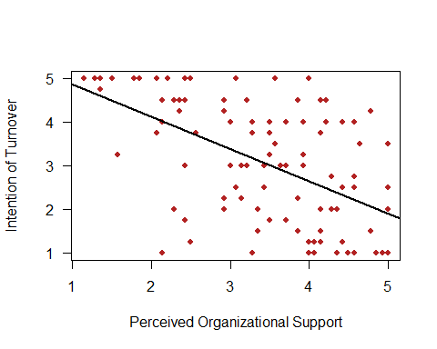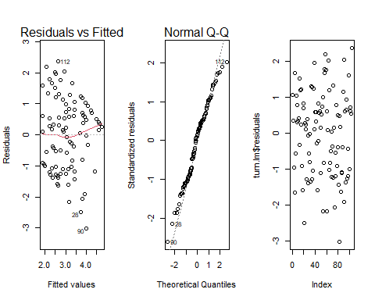

| Observations | Residual Std. Error | $R^{2}$ | Adjusted $R^{2}$ |
| --- | --- | --- | --- |
| 103 | 0.8058 | 0.3608 | 0.3545 |