RJSF Nested Forms
Technical Requirements & Implementation Guide
Multiple Child Forms Within a Parent Form Container
With Independent Per-Section Save and Shared formData

Status: Draft — For Internal Review
Date: April 7, 2026
Revision: 2.1 — Added Mermaid diagrams
Scope: React Frontend — RJSF + Transformer Microservice Integration

Table of Contents
Table of Contents 2
1. Executive Summary 3
2. System Architecture 3
2.1 Architecture Diagram 3
3. The Core Problem 5
3.1 HTML Constraint 5
3.2 RJSF Default Behavior 5
3.3 What We Need 5
4. Architectural Approaches 6
4.1 Approach A: Single Composed Schema 6
4.2 Approach B: Multiple Form Instances with Shared formData (Recommended) 6
4.3 Approach C: Hybrid — Composed Schema with Dynamic Section Loading 6
4.4 Approach Decision Tree 7
5. Recommendation 9
6. Technical Requirements 10
6.1 Schema Architecture 10
6.2 Shared formData Management 10
6.3 Per-Section Save Requirements 10
6.4 UI/UX Requirements 11
6.5 Transformer Microservice Integration 11
6.6 Implementation Requirements 11
7. Data Flow: Shared formData Pattern 13
7.1 Data Flow Diagram 13
7.2 Per-Section Save Sequence 15
8. Working Example: Pre-Award Review with Per-Section Save 16
8.1 Section Schemas (Separate Files) 16
project-info.schema.json 16
budget-info.schema.json 16
compliance-info.schema.json 16
8.2 Composite Form Component (Full Implementation) 18
9. Decision Matrix 21
10. Next Steps 21

1. Executive Summary
RJSF (react-jsonschema-form) renders a single HTML <form> element per Form component instance. The HTML specification prohibits nesting <form> elements inside one another. However, many real-world workflows require presenting multiple logically distinct form sections within a single parent view—for example, a pre-award review with separate sections for project details, budget, compliance, and personnel—while coordinating validation and submission from one parent container.
A key additional requirement is that each individual section must support independent save operations while all sections share a single unified formData object. This means a user can save progress on just the Budget section without touching the others, yet the underlying data model remains one cohesive JSON structure that maps directly to the Transformer Microservice.
This document defines three architectural approaches for achieving nested-form behavior in RJSF, evaluates their trade-offs, recommends a primary approach, specifies the technical requirements for implementation, and provides a complete working code example.

2. System Architecture
The composite form sits within the existing RJSF-to-Transformer pipeline. The diagram below shows how the React frontend, Spring Boot microservice, and PostgreSQL database interact.

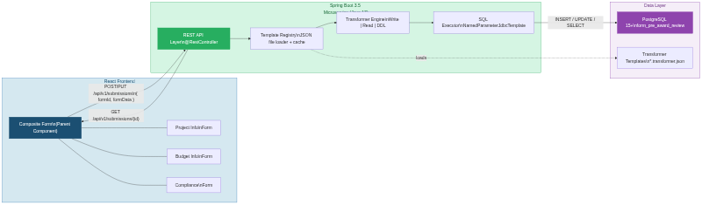
2.1 Architecture Diagram

Mermaid Source: System Architecture
```mermaid
flowchart LR
subgraph Frontend["React Frontend"]
direction TB
CF["Composite Form\n(Parent Component)"]
S1["Project Info\nForm"]
S2["Budget Info\nForm"]
S3["Compliance\nForm"]
CF --- S1
CF --- S2
CF --- S3
end
subgraph Microservice["Spring Boot 3.5 Microservice (Java 17)"]
direction TB
REST["REST API Layer\n@RestController"]
TR["Template Registry\nJSON file loader + cache"]
TE["Transformer Engine\nWrite | Read | DDL"]
SQL["SQL Executor\nNamedParameterJdbcTemplate"]
REST --> TR
TR --> TE
TE --> SQL
end
subgraph Storage["Data Layer"]
direction TB
PG["PostgreSQL 15+\nform_pre_award_review"]
TMPL["Transformer Templates\n*.transformer.json"]
end
CF -->|"POST/PUT /api/v1/submissions\n{ formId, formData }"| REST
REST -->|"GET /api/v1/submissions/{id}"| CF
SQL -->|"INSERT / UPDATE / SELECT"| PG
TR -.->|"loads"| TMPL
```

3. The Core Problem

3.1 HTML Constraint
The HTML spec states that form content must not contain other form elements. Browsers that encounter nested <form> tags exhibit undefined behavior—some ignore the inner form, others break event propagation. This means you cannot simply place one RJSF <Form> inside another RJSF <Form> and expect correct behavior.

3.2 RJSF Default Behavior
Each RJSF Form component renders a <form> tag by default. It owns its own formData state, validation lifecycle, and submit handler. There is no built-in concept of a parent form that coordinates child forms.

3.3 What We Need
The goal is to compose multiple independently-defined JSON Schemas into a single user-facing page where:
- Each schema section can be developed, tested, and versioned independently.
- All sections share a single formData object as the source of truth.
- Each section has its own independent save button that validates only that section before persisting.
- A parent-level submit validates all sections together before final coordinated submission.
- The combined formData maps cleanly to the Transformer Microservice’s template structure.
- Users experience a seamless interaction with clear visual grouping and per-section feedback.

4. Architectural Approaches

4.1 Approach A: Single Composed Schema
Merge multiple sub-schemas into a single JSON Schema using allOf, $ref, and definitions, then render one RJSF Form instance. A custom ObjectFieldTemplate groups sections visually.
Per-section save is possible but requires extra work: each save button must extract the relevant property subset from the full formData, validate it against the sub-schema using a standalone AJV instance, and post the partial or full data.
Advantages | Disadvantages
Single form instance — no HTML nesting issues | Per-section save requires custom AJV validation outside RJSF
One formData object — direct Transformer compatibility | allOf merge can fail on conflicting sub-schemas
Built-in cross-section validation (if/then/else) | Large schemas may reduce rendering performance
Sub-schemas are reusable via $ref | All sections load simultaneously (no lazy loading)

4.2 Approach B: Multiple Form Instances with Shared formData (Recommended)
Render multiple RJSF Form components on the same page, each with tagName="div" to replace the <form> wrapper with a <div>. All child forms read from and write to a single shared formData object held in the parent’s state. Each child form has its own schema, its own save button, and can call its own validateForm() independently.
Advantages | Disadvantages
Per-section save is native — each Form owns its own validateForm() | Must manage shared state and slice/merge logic
Single shared formData — Transformer compatible without merge at submit | Cross-section validation must be implemented at parent level
Each section is a fully independent RJSF Form | Loses native Enter-to-submit behavior (tagName="div")
Supports lazy loading / progressive disclosure of sections | Property names must not collide across sections
Easy to add, remove, or reorder sections dynamically | Error display across sections needs custom coordination

4.3 Approach C: Hybrid — Composed Schema with Dynamic Section Loading
Combine Approach A’s single-schema model with lazy section loading. Per-section save remains difficult. Suitable for very large forms where loading everything at once is a performance concern and per-section save is not a requirement.

4.4 Approach Decision Tree
Use this decision tree to determine which approach fits a given form’s requirements:
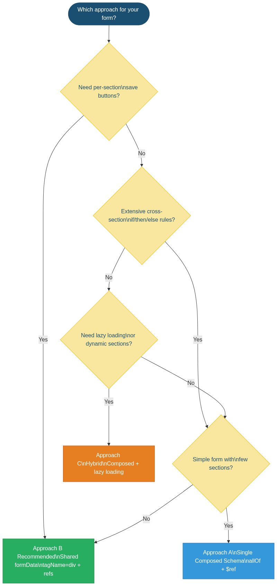
Mermaid Source: Approach Decision Tree
```mermaid
flowchart TD
START(["Which approach for your form?"])
Q1{"Need per-section\nsave buttons?"}
Q2{"Extensive cross-section\nif/then/else rules?"}
Q3{"Need lazy loading\nor dynamic sections?"}
Q4{"Simple form with\nfew sections?"}
A["Approach A\nSingle Composed Schema\nallOf + $ref"]
B["Approach B Recommended\nShared formData\ntagName=div + refs"]
C["Approach C\nHybrid\nComposed + lazy loading"]
START --> Q1
Q1 -->|"Yes"| B
Q1 -->|"No"| Q2
Q2 -->|"Yes"| Q4
Q2 -->|"No"| Q3
Q3 -->|"Yes"| C
Q3 -->|"No"| Q4
Q4 -->|"Yes"| A
Q4 -->|"No"| B
```

5. Recommendation
Approach B (Multiple Form Instances with Shared formData) is the recommended path for the Pre-Award Review system. The rationale:
- Per-Section Save is Native: Each child Form instance has its own validateForm() method and submit lifecycle.
- Shared formData = Transformer Compatibility: A single formData object means the Transformer Microservice still receives one flat JSON blob.
- Independent Development: Each section schema lives in its own file, testable in the RJSF playground.
- Progressive Save UX: Users can save work on one section without completing the entire form.
- Dynamic Sections: Sections can be conditionally shown/hidden or loaded lazily.

6. Technical Requirements

6.1 Schema Architecture
ID | Requirement | Details
SR-01 | Independent section schemas | Each logical section is a standalone JSON Schema file with its own type, properties, and required array.
SR-02 | No property name collisions | Section schemas MUST NOT define overlapping property names. A build-time lint check should enforce this.
SR-03 | Section manifest | A manifest JSON file lists all sections for a given form type, their schema file paths, display order, and per-section configuration.
SR-04 | Schema version tracking | Each section schema carries a custom x-schemaVersion integer. The Transformer Template’s version must reflect the combined version vector.
SR-05 | Cross-section validation rules | Define cross-section rules in the manifest as custom validation functions. Enforced by the parent orchestrator at submit-all time.

6.2 Shared formData Management
ID | Requirement | Details
FD-01 | Single state object | The parent component maintains one formData state object. All section Forms read from and write to this object.
FD-02 | Slice function | A sliceFor(schema) utility extracts only the properties defined in a section’s schema from the shared formData.
FD-03 | Merge-on-change | Each child’s onChange handler merges updated section data back into shared formData via functional updater.
FD-04 | Dirty tracking per section | The parent tracks which sections have unsaved changes. Save buttons are only enabled for dirty sections.
FD-05 | Optimistic persistence | On per-section save, the full formData object is posted to the API, ensuring the backend always has a complete picture.

6.3 Per-Section Save Requirements
ID | Requirement | Details
PS-01 | Section-scoped validation | When a per-section save button is clicked, only that section’s Form instance validates via its ref’s validateForm().
PS-02 | Save endpoint | PUT /api/v1/submissions/{id} with body { formId, formData, savedSection }. The full formData is always persisted.
PS-03 | Save status feedback | Each section displays a save status indicator: unsaved, saving, saved, or error.
PS-04 | Auto-save (optional) | Optionally debounce onChange events and auto-save dirty sections after a configurable idle period.
PS-05 | Concurrent save protection | Prevent simultaneous save requests for the same submission via AbortController or request queue.

6.4 UI/UX Requirements
ID | Requirement | Details
UX-01 | Section grouping | Each child Form is wrapped in a visually distinct panel with title, validation badge, and save button.
UX-02 | Section validation indicators | Each section header shows a status badge: complete, incomplete, or errors.
UX-03 | Single submit action | One submit button triggers validation of all sections. Errors scroll to the first failing field.
UX-04 | Progressive disclosure | Sections can be gated so users must complete section N before N+1 unlocks.

6.5 Transformer Microservice Integration
ID | Requirement | Details
TM-01 | Flat formData output | The shared formData must be a flat JSON structure so each property maps to a Transformer Template field.
TM-02 | Template alignment | The Transformer Template’s fields array includes one entry per property across all section schemas.
TM-03 | Partial save support | The API must accept partial formData gracefully. Missing nullable fields stored as NULL.

6.6 Implementation Requirements
ID | Requirement | Details
TI-01 | RJSF version | Use @rjsf/core v5.x+ and @rjsf/validator-ajv8.
TI-02 | tagName="div" | Every child Form MUST use tagName="div" to prevent nested <form> elements.
TI-03 | noHtml5Validate | Always set noHtml5Validate={true}. Rely on RJSF’s JSON Schema validation.
TI-04 | Ref management | Use useRef with a map keyed by section name to hold refs to each child Form.
TI-05 | Hide default submit | Pass children={<></>} to suppress the default submit button in each child Form.

7. Data Flow: Shared formData Pattern
The diagram below illustrates how the parent component manages a single formData state object, slices it per child form, merges changes on each onChange, and dispatches both per-section saves and a coordinated submit-all.

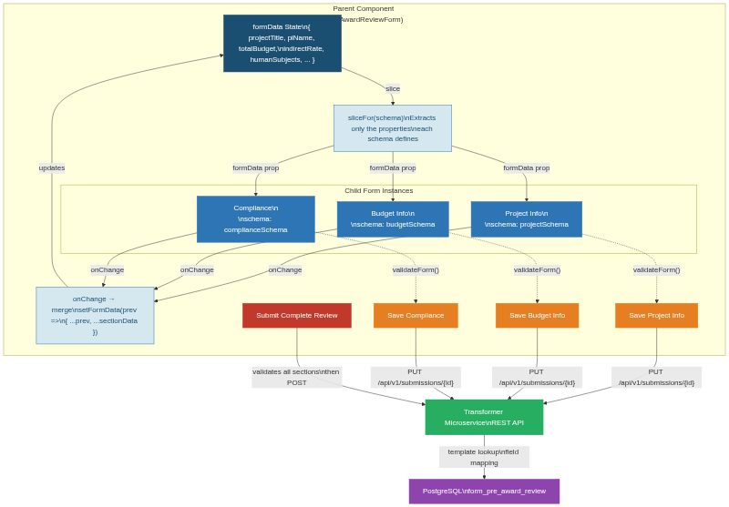
7.1 Data Flow Diagram

Mermaid Source: Shared formData Data Flow
```mermaid
flowchart TD
subgraph Parent["Parent Component (PreAwardReviewForm)"]
FD["formData State\n{ projectTitle, piName, totalBudget,\nindirectRate, humanSubjects, ... }"]
subgraph Sections["Child Form Instances"]
direction LR
S1["Project Info\n<Form tagName=div>\nschema: projectSchema"]
S2["Budget Info\n<Form tagName=div>\nschema: budgetSchema"]
S3["Compliance\n<Form tagName=div>\nschema: complianceSchema"]
end
SLICE["sliceFor(schema)\nExtracts only the properties\neach schema defines"]
MERGE["onChange → merge\nsetFormData(prev =>\n{ ...prev, ...sectionData })"]
SAVE1["Save Project Info"]
SAVE2["Save Budget Info"]
SAVE3["Save Compliance"]
SUBMIT["Submit Complete Review"]
end
FD -->|"slice"| SLICE
SLICE -->|"formData prop"| S1
SLICE -->|"formData prop"| S2
SLICE -->|"formData prop"| S3
S1 -->|"onChange"| MERGE
S2 -->|"onChange"| MERGE
S3 -->|"onChange"| MERGE
MERGE -->|"updates"| FD
S1 -.->|"validateForm()"| SAVE1
S2 -.->|"validateForm()"| SAVE2
S3 -.->|"validateForm()"| SAVE3
SAVE1 -->|"PUT /api/v1/submissions/{id}"| API
SAVE2 -->|"PUT /api/v1/submissions/{id}"| API
SAVE3 -->|"PUT /api/v1/submissions/{id}"| API
SUBMIT -->|"validates all sections\nthen POST"| API
API["Transformer Microservice\nREST API"]
API -->|"template lookup\nfield mapping"| DB["PostgreSQL\nform_pre_award_review"]
```

7.2 Per-Section Save Sequence
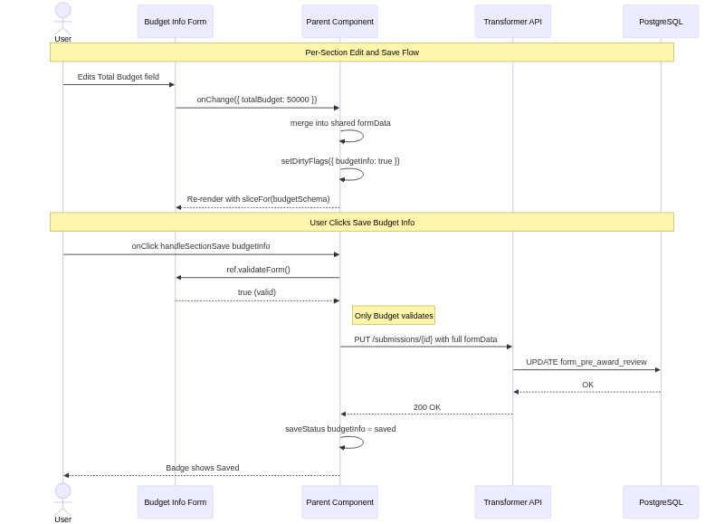
This sequence diagram traces a single per-section save: the user edits a field in the Budget section, the change merges into the shared formData, the user clicks Save, only the Budget section validates, and the full formData is persisted to the backend.

Mermaid Source: Per-Section Save Sequence
```mermaid
sequenceDiagram
actor User
participant Child as Budget Info Form
participant Parent as Parent Component
participant API as Transformer API
participant DB as PostgreSQL
Note over User,DB: Per-Section Edit and Save Flow
User->>Child: Edits Total Budget field
Child->>Parent: onChange({ totalBudget: 50000 })
Parent->>Parent: merge into shared formData
Parent->>Parent: setDirtyFlags({ budgetInfo: true })
Parent-->>Child: Re-render with sliceFor(budgetSchema)
Note over User,DB: User Clicks Save Budget Info
User->>Parent: onClick handleSectionSave budgetInfo
Parent->>Child: ref.validateForm()
Child-->>Parent: true (valid)
Note right of Parent: Only Budget validates
Parent->>API: PUT /submissions/{id} with full formData
API->>DB: UPDATE form_pre_award_review
DB-->>API: OK
API-->>Parent: 200 OK
Parent->>Parent: saveStatus budgetInfo = saved
Parent-->>User: Badge shows Saved
```

8. Working Example: Pre-Award Review with Per-Section Save

8.1 Section Schemas (Separate Files)

project-info.schema.json
{
"x-schemaVersion": 1,
"x-sectionKey": "projectInfo",
"title": "Project Information",
"type": "object",
"properties": {
"projectTitle": { "type": "string", "title": "Project Title" },
"piName": { "type": "string", "title": "Principal Investigator" },
"department": { "type": "string", "title": "Department",
"enum": ["Engineering", "Sciences", "Medicine", "Arts"] },
"proposedStart": { "type": "string", "format": "date", "title": "Proposed Start" },
"proposedEnd": { "type": "string", "format": "date", "title": "Proposed End" },
"sponsorAgency": { "type": "string", "title": "Sponsor / Agency" }
},
"required": ["projectTitle", "piName", "department"]
}

budget-info.schema.json
{
"x-schemaVersion": 1,
"x-sectionKey": "budgetInfo",
"title": "Budget Information",
"type": "object",
"properties": {
"totalBudget": { "type": "number", "title": "Total Budget ($)" },
"indirectRate": { "type": "number", "title": "Indirect Cost Rate (%)", "minimum": 0, "maximum": 100 },
"costSharing": { "type": "boolean", "title": "Cost Sharing?", "default": false },
"costSharePercent": { "type": "number", "title": "Cost Share (%)", "minimum": 0, "maximum": 100 },
"budgetJustification": { "type": "string", "title": "Budget Justification" }
},
"required": ["totalBudget", "indirectRate"]
}

compliance-info.schema.json
{
"x-schemaVersion": 1,
"x-sectionKey": "complianceInfo",
"title": "Compliance",
"type": "object",
"properties": {
"humanSubjects": { "type": "boolean", "title": "Human Subjects?", "default": false },
"irbProtocol": { "type": "string", "title": "IRB Protocol Number" },
"animalSubjects": { "type": "boolean", "title": "Animal Subjects?", "default": false },
"iacucProtocol": { "type": "string", "title": "IACUC Protocol Number" },
"exportControl": { "type": "boolean", "title": "Export Control?", "default": false },
"conflictOfInterest": { "type": "boolean", "title": "Conflict of Interest?", "default": false }
}
}

8.2 Composite Form Component (Full Implementation)
import React, { useRef, useState, useCallback } from "react";
import Form from "@rjsf/core";
import validator from "@rjsf/validator-ajv8";

import projectSchema from "./schemas/project-info.schema.json";
import budgetSchema from "./schemas/budget-info.schema.json";
import complianceSchema from "./schemas/compliance-info.schema.json";

const sections = [
{ key: "projectInfo", schema: projectSchema, title: "Project Information" },
{ key: "budgetInfo", schema: budgetSchema, title: "Budget Information" },
{ key: "complianceInfo", schema: complianceSchema, title: "Compliance" },
];

function PreAwardReviewForm({ submissionId }) {
const [formData, setFormData] = useState({});
const formRefs = useRef({});
const [dirtyFlags, setDirtyFlags] = useState({});
const [saveStatus, setSaveStatus] = useState({});

const sliceFor = useCallback((schema) => {
const keys = Object.keys(schema.properties || {});
const slice = {};
for (const k of keys) {
if (k in formData) slice[k] = formData[k];
}
return slice;
}, [formData]);

const handleChange = useCallback((sectionKey, sectionData) => {
setFormData(prev => ({ ...prev, ...sectionData }));
setDirtyFlags(prev => ({ ...prev, [sectionKey]: true }));
setSaveStatus(prev => ({ ...prev, [sectionKey]: "idle" }));
}, []);

const handleSectionSave = useCallback(async (sectionKey) => {
const ref = formRefs.current[sectionKey];
if (!ref?.validateForm()) return;
setSaveStatus(prev => ({ ...prev, [sectionKey]: "saving" }));
try {
const res = await fetch(`/api/v1/submissions/${submissionId}`, {
method: "PUT",
headers: { "Content-Type": "application/json" },
body: JSON.stringify({ formId: "pre-award-review", formData, savedSection: sectionKey }),
});
if (res.ok) {
setSaveStatus(prev => ({ ...prev, [sectionKey]: "saved" }));
setDirtyFlags(prev => ({ ...prev, [sectionKey]: false }));
} else {
setSaveStatus(prev => ({ ...prev, [sectionKey]: "error" }));
}
} catch { setSaveStatus(prev => ({ ...prev, [sectionKey]: "error" })); }
}, [formData, submissionId]);

const handleSubmitAll = useCallback(async () => {
let allValid = true;
for (const { key } of sections) {
if (formRefs.current[key] && !formRefs.current[key].validateForm()) allValid = false;
}
if (!allValid) return;
if (formData.costSharing && !formData.costSharePercent) {
alert("Cost Share % is required when Cost Sharing is enabled.");
return;
}
await fetch("/api/v1/submissions", {
method: "POST",
headers: { "Content-Type": "application/json" },
body: JSON.stringify({ formId: "pre-award-review", formData }),
});
}, [formData, submissionId]);

return (
<div className="pre-award-review">
<h1>Pre-Award Review</h1>
{sections.map(({ key, schema, title }) => (
<fieldset key={key} className="section-panel">
<legend>
{title}
<span className={`save-badge ${saveStatus[key] || "idle"}`}>
{saveStatus[key] === "saved" && " \u2713 Saved"}
{saveStatus[key] === "saving" && " Saving..."}
{saveStatus[key] === "error" && " \u2717 Error"}
{dirtyFlags[key] && saveStatus[key] === "idle" && " \u2022 Unsaved"}
</span>
</legend>
<Form
ref={el => { formRefs.current[key] = el; }}
tagName="div"
schema={schema}
formData={sliceFor(schema)}
onChange={({ formData: d }) => handleChange(key, d)}
noHtml5Validate
validator={validator}
liveValidate={false}
>
<></> {/* suppress default submit button */}
</Form>
<div className="section-actions">
<button type="button" onClick={() => handleSectionSave(key)}
disabled={!dirtyFlags[key] || saveStatus[key] === "saving"}>
Save {title}
</button>
</div>
</fieldset>
))}
<div className="form-actions">
<button type="button" onClick={handleSubmitAll}>
Submit Complete Pre-Award Review
</button>
</div>
</div>
);
}

export default PreAwardReviewForm;

9. Decision Matrix
Criterion | A: Composed Schema | B: Shared formData (Rec.) | C: Hybrid
Per-section save | Requires custom AJV | Native (validateForm per ref) | Requires custom AJV
Single formData object | Native | Shared state in parent | Native
HTML nesting safety | N/A (single form) | Safe (div wrapper) | N/A (single form)
Transformer compatibility | Direct (flat object) | Direct (flat object) | Direct (flat object)
Cross-section validation | Built-in (if/then) | Custom in parent | Built-in (if/then)
Lazy section loading | Not supported | Supported | Supported
Dynamic add/remove sections | Requires schema rebuild | Trivial (add to manifest) | Requires schema rebuild
Implementation complexity | Low-Medium | Medium | Medium-High

10. Next Steps
- Prototype the Approach B shared-formData pattern using the Pre-Award Review form as a pilot.
- Implement the sliceFor/merge utilities and verify no stale-state issues with rapid cross-section edits.
- Build cross-section validation rules in the parent orchestrator.
- Create the corresponding Transformer Template and verify round-trip through the microservice.
- Add CI lint checks for property name collisions across section schemas.
- Evaluate auto-save with debounced onChange as a follow-up enhancement.

