Template Registry: Configuration-Driven Form Management

Template Registry: Configuration-Driven Form Management

Executive Summary

The Business Problem
Every time a new government form needs to be added to the Pre-Award Review system, the traditional approach requires a developer to write custom database tables, API endpoints, and mapping code. This creates a bottleneck: form changes wait in a development queue, and each change carries the risk of introducing bugs into the production system.

The Solution
The Template Registry eliminates this bottleneck by making form configuration entirely data-driven. Instead of writing code, an administrator creates a simple JSON configuration file — called a Transformer Template — that describes how a form’s fields map to database columns. The system reads these templates automatically, creates the necessary database tables, and handles all data storage without any code changes.

Key Business Benefits
- No code deployments for new forms — Drop a JSON file into the templates directory and the system handles the rest
- Zero-downtime schema changes — New fields can be added to existing forms while the system is running; no restart required
- Safe by design — The system will never delete data. Removed fields are flagged for review but their data is preserved
- Audit trail — Every template version is recorded, enabling historical reconstruction of form data exactly as it was submitted
- Reduced development cost — Form analysts can define templates without requiring backend developer involvement

How It Works (Non-Technical)
Diagram 1
- A form analyst writes a JSON template file describing the form’s fields, their data types, and any validation rules
- The file is placed in the templates directory (or deployed via the standard release process)
- The system automatically detects the file, validates it, and creates the corresponding database table
- Users can immediately begin submitting data through the form
- If the template is updated (e.g., a new field is added), the system detects the change and adds the new column — without losing existing data

Technical Reference

Architecture Overview
The Template Registry is a Spring Boot component subsystem under com.egs.rjsf.transformer.registry that manages the lifecycle of Transformer Templates — JSON configuration files that drive the entire form-to-relational mapping engine.
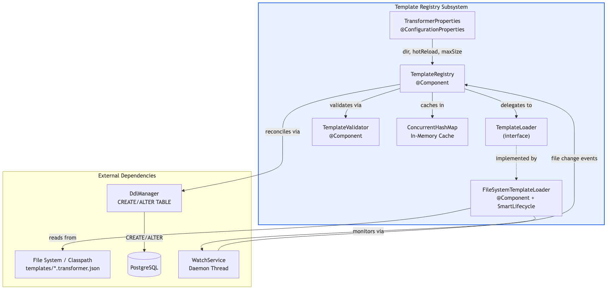
Diagram 2

Components
Component | Class | Responsibility
Properties | TransformerProperties | Binds transformer.* config from application.yml
Loader Interface | TemplateLoader | Abstracts template source (filesystem, S3, Git — pluggable)
Filesystem Loader | FileSystemTemplateLoader | Reads {formId}.transformer.json files from disk or classpath; runs WatchService for hot reload
Validator | TemplateValidator | Programmatic validation: formId not blank, version > 0, fields have jsonPath/column/sqlType, relations have childTable
Registry | TemplateRegistry | Central facade: caching (ConcurrentHashMap), loading, validation, DDL reconciliation, hot-reload callback

Configuration
# application.yml
transformer:
template:
dir: ${TRANSFORMER_TEMPLATE_DIR:classpath:templates} # Template file location
hot-reload: ${TRANSFORMER_HOT_RELOAD:true} # Enable filesystem watching
cache:
max-size: ${TRANSFORMER_CACHE_MAX_SIZE:500} # Max cached templates
Property | Default | Description
transformer.template.dir | classpath:templates | Directory containing .transformer.json files. Supports classpath: prefix for embedded templates or absolute filesystem paths for external templates.
transformer.template.hot-reload | true | When true and using a filesystem path (not classpath), a background WatchService thread monitors for file changes. Automatically disabled for classpath resources.
transformer.cache.max-size | 500 | Maximum number of templates held in the in-memory cache.

Template File Format
Templates are named {formId}.transformer.json and placed in the configured template directory. Here is an annotated example:
{
"formId": "pre-award-overview", // Unique ID, matches filename prefix
"version": 1, // Incremented on each template change
"tableName": "form_pre_award_overview", // Target PostgreSQL table
"description": "Pre-Award Overview", // Human-readable description
"schemaVersion": { // Column that tracks template version per row
"column": "schema_version",
"sqlType": "INTEGER"
},
"auditColumns": { // Auto-populated audit trail columns
"createdAt": "created_at",
"updatedAt": "updated_at",
"submittedBy": "submitted_by"
},
"fields": [ // JSON path → database column mappings
{
"jsonPath": "pi_budget", // Dot-notation path into formData
"column": "pi_budget", // PostgreSQL column name
"sqlType": "NUMERIC", // Column type
"nullable": true, // NOT NULL constraint (on CREATE only)
"transform": { "toDb": "toBigDecimal" } // Named transform function
},
{
"jsonPath": "pi_notification_date",
"column": "pi_notification_date",
"sqlType": "DATE",
"nullable": true,
"transform": {
"toDb": "toLocalDate", // Write: ISO string → LocalDate
"fromDb": "toIsoDateString" // Read: LocalDate → ISO string
}
}
],
"relations": [], // Child tables for array fields (see employee-onboarding template)
"writeHooks": {}, // Named Spring beans invoked during write pipeline
"readHooks": {} // Named Spring beans invoked during read pipeline
}

Startup Sequence
When the Spring Boot application starts, the registry initializes in @PostConstruct:
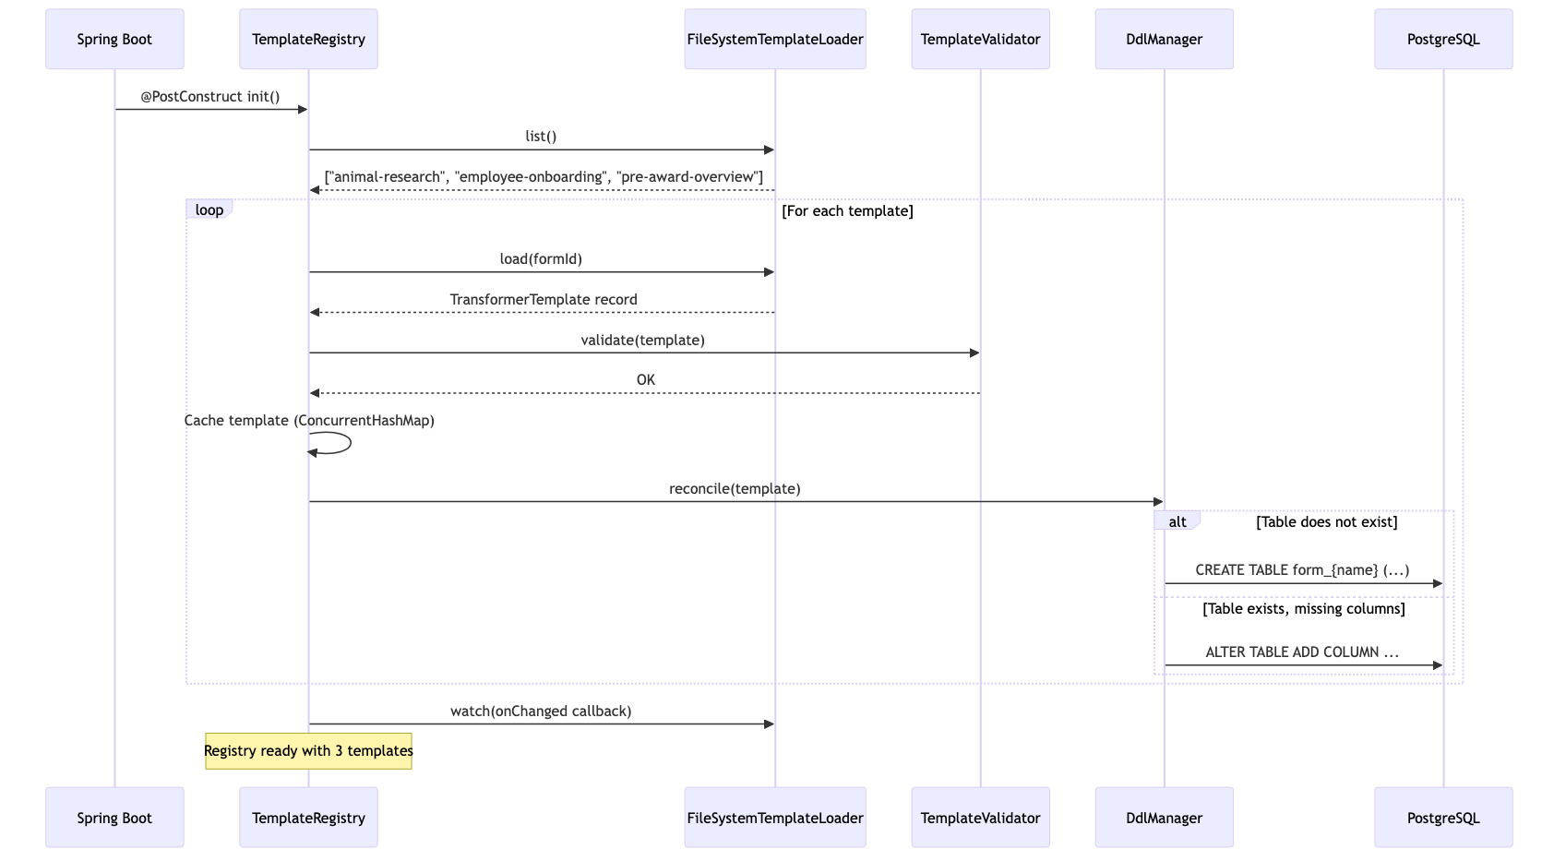
Diagram 3
Startup behavior: 1. TemplateRegistry.init() calls loader.list() to discover all template files 2. For each template, it loads, validates, caches, and reconciles the database schema 3. Invalid templates are logged at ERROR and skipped — they do not block other templates 4. The watch() callback is registered for runtime hot-reload events

Hot Reload Flow
When a template file is modified on disk while the application is running:
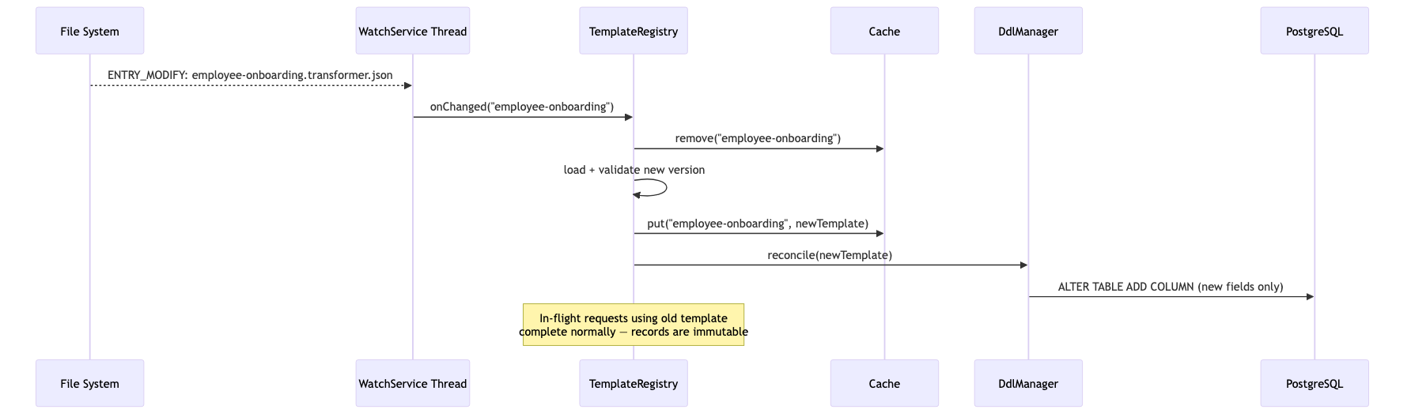
Diagram 4
Hot reload guarantees: - Thread-safe: ConcurrentHashMap provides atomic put/get operations - Non-disruptive: Requests already holding a reference to the old TransformerTemplate record complete normally because Java records are immutable - Additive-only DDL: The DdlManager only adds new columns. It never drops columns or tables. Deprecated columns are logged at WARN level for manual review. - Classpath resources: Hot reload is automatically disabled for classpath: paths (logged at INFO). Only filesystem paths support watching.

DDL Safety Rules
The DdlManager enforces strict safety constraints when reconciling template changes against the live database:
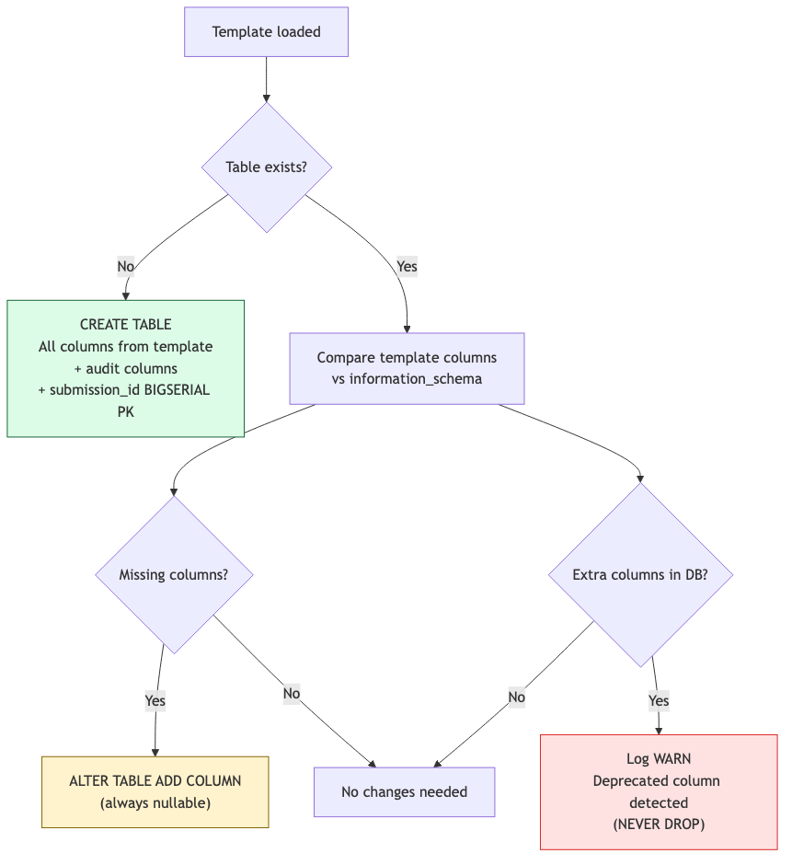
Diagram 5
Rule | Enforcement
Never DROP | DdlManager will never issue DROP COLUMN or DROP TABLE
New columns always nullable | ALTER TABLE ADD COLUMN omits NOT NULL to prevent table-rewrite locks
Identifier validation | All table/column names validated against ^[a-zA-Z_][a-zA-Z0-9_]{0,62}$
SQL type whitelist | Only known PostgreSQL types are permitted (TEXT, INTEGER, NUMERIC, BOOLEAN, DATE, TIMESTAMPTZ, JSONB, UUID, etc.)

Template Version History
Every successfully loaded template is recorded in the transformer_template_history table:
CREATE TABLE transformer_template_history (
id BIGSERIAL PRIMARY KEY,
form_id TEXT NOT NULL,
version INTEGER NOT NULL,
template_json JSONB NOT NULL,
loaded_at TIMESTAMPTZ NOT NULL DEFAULT NOW(),
UNIQUE (form_id, version)
);
This enables historical reads: when a submission was written with template version 1, it can later be read back using version 1’s field mappings — even if the current template is version 3. This is critical for audit and compliance scenarios where the data must be reconstructed exactly as it was captured.

Error Handling
Scenario | Behavior
Template file not found | TemplateNotFoundException thrown (HTTP 400)
Template validation fails | IllegalArgumentException logged at ERROR; template skipped; previous cached version retained
DDL reconciliation fails | Logged at ERROR; does not block other templates
WatchService event for invalid file | Logged at ERROR; cache retains previous valid version
Hot reload disabled (classpath) | Logged at INFO; watch() is a no-op

Adding a New Form
To add a new form to the system:
- Create {formId}.transformer.json in the templates directory
- Define the formId, tableName, fields, and optional relations/hooks
- If hot-reload is enabled, the system picks it up automatically
- If using classpath resources, restart the service
- The DdlManager creates the table on first load
- The form is immediately available for submissions via the transformer API
No Java code changes. No database migration scripts. No service redeployment (with hot-reload).

