Transformer Pipeline: Bidirectional JSON-to-Relational Conversion

Transformer Pipeline: Bidirectional JSON-to-Relational Conversion

Executive Summary

The Business Problem
Government form data is collected as flexible JSON documents from web-based RJSF forms. While JSON storage is convenient for the frontend, it creates challenges for downstream consumers: reporting tools cannot easily query individual fields, compliance audits require structured data access, and cross-form analytics are impractical when data is locked inside opaque JSON blobs.

The Solution
The Transformer Pipeline is a bidirectional data conversion engine that sits between the form frontend and the database. When a user submits a form, the pipeline automatically extracts each field from the JSON document, applies type-safe conversions, and stores the values in dedicated database columns. When the data is read back, the pipeline reconstructs the original JSON structure from the typed columns.
Diagram 1

Key Business Benefits
- Queryable data — Each form field is stored in its own typed database column, enabling direct SQL queries, report generation, and business intelligence without parsing JSON
- Data integrity — Dates are stored as dates, numbers as numbers, and budgets as precise decimals. No more string-to-number conversion errors in reports
- Validation at the gate — Required fields, allowed values, and format rules are enforced before data reaches the database, reducing data quality issues
- Extensible without code changes — Custom business logic (encryption, normalization, audit logging) is injected via named hook points, not hardcoded into the pipeline
- Round-trip fidelity — Data written through the pipeline can be read back and reconstructed into the exact same JSON structure, ensuring the user always sees what they submitted
- Compliance-ready — Every submission is tagged with a schema version, enabling historical reconstruction of data using the exact template that was active when the form was submitted

Real-World Example
When a Pre-Award Overview form is submitted with a PI Budget of $1,448,199.00:
Stage | What Happens | Value
JSON Input | User enters budget in form | "pi_budget": 1448199 (JavaScript number)
Transform | toBigDecimal converts to precise decimal | BigDecimal(1448199.00)
Database | Stored in typed NUMERIC column | 1448199.00 (15,2 precision)
Read Back | Column value retrieved | BigDecimal(1448199.00)
JSON Output | Returned to frontend | "pi_budget": 1448199.0
No precision loss. No string parsing. No rounding errors.

Technical Reference

Pipeline Architecture
The Transformer Pipeline consists of two complementary 7-stage pipelines — one for writes and one for reads — orchestrated by SubmissionWriteService and SubmissionReadService respectively. Both pipelines are driven by the same Transformer Template, ensuring bidirectional consistency.
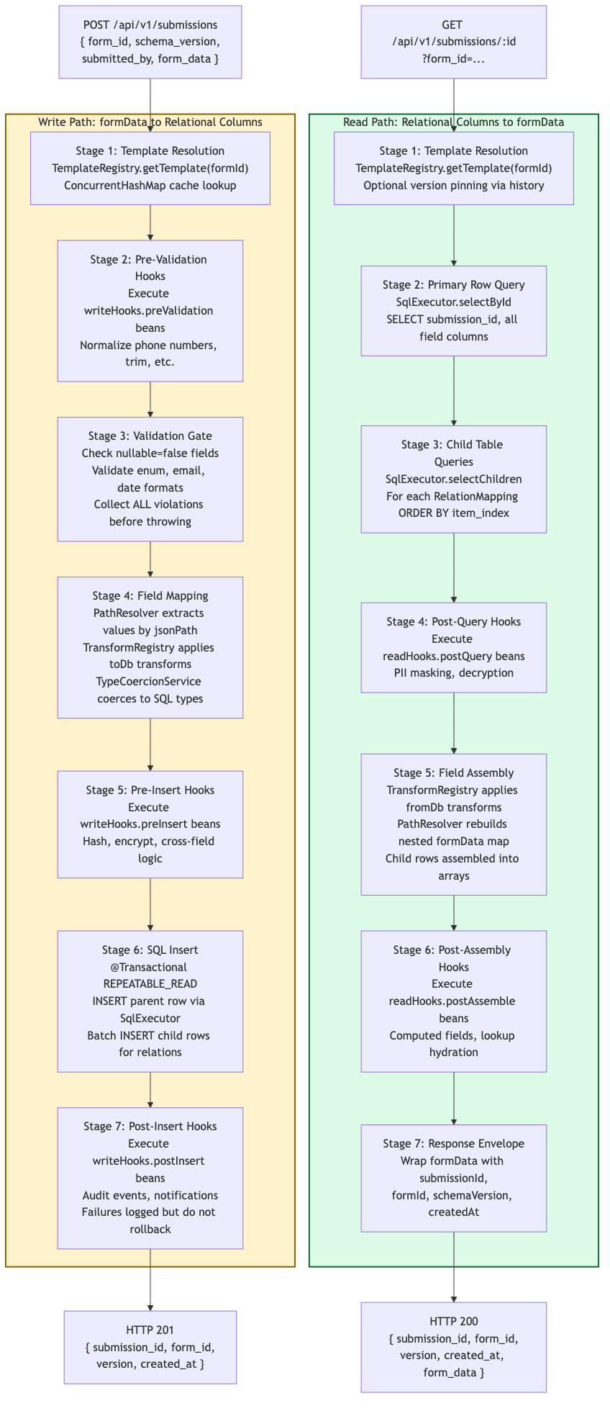
Diagram 2

Write Pipeline — Stage by Stage

Stage 1: Template Resolution
The TemplateRegistry resolves the transformer template by formId. The registry maintains an in-memory ConcurrentHashMap cache. On cache miss, the template is loaded from disk, validated, and cached.
TransformerTemplate template = templateRegistry.getTemplate(request.formId());
If no template exists for the given formId, a TemplateNotFoundException is thrown (HTTP 400, error code TEMPLATE_NOT_FOUND).
If the request specifies a schemaVersion that exceeds the template’s version, a VersionMismatchException is thrown (HTTP 400, error code VERSION_MISMATCH).

Stage 2: Pre-Validation Hooks
If the template declares writeHooks.preValidation bean names, each WriteHook is resolved from the Spring ApplicationContext and applied in declared order to the raw formData map.
Diagram 3
This is the correct stage for data normalization: trimming whitespace, formatting phone numbers to E.164, canonicalizing enum values. Missing hook beans are logged at WARN and skipped — they do not fail the pipeline.

Stage 3: Validation Gate
The ValidationGate iterates each FieldMapping and validates the formData against it:
- Required fields (nullable: false): Value must be present and non-null
- Enum constraints: Value must be in the allowed list
- Format validation: Email fields must contain @; date fields must parse as ISO-8601
All violations are collected before throwing, so the caller receives a complete error list:
{
"error": "VALIDATION_FAILED",
"violations": [
{ "json_path": "program_manager", "message": "Required field is missing" },
{ "json_path": "prime_award_type", "message": "Value 'invalid' is not in allowed values: [extramural, intramural, ...]" }
]
}

Stage 4: Field Mapping
The core transformation stage. For each FieldMapping in the template:
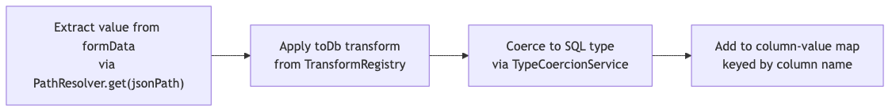
Diagram 4
PathResolver handles dot-notation traversal of nested objects. For example, personal.email navigates into formData.personal.email.
Built-in transforms (13 total):
Transform | Direction | Behavior
toLocalDate | toDb | ISO date string to java.time.LocalDate
toIsoDateString | fromDb | LocalDate to yyyy-MM-dd string
toInstant | toDb | ISO datetime to java.time.Instant
fromInstant | fromDb | Instant to ISO datetime string
jsonStringify | toDb | Map/List to JSON string for JSONB columns
jsonParse | fromDb | JSON string back to Map/List
trimString | toDb | String.strip()
toLowerCase | toDb | String.toLowerCase(Locale.ROOT)
toBoolean | toDb | Coerce “true”/“false”, 1/0 to Boolean
toBigDecimal | toDb | String or Number to BigDecimal
toInteger | toDb | String or Number to Integer
maskLast4 | fromDb | Mask all but last 4 characters
toUUID | toDb | Validate and normalize UUID strings
Custom transforms are registered by annotating a class with @TransformFunction("name") and implementing ToDbFunction or FromDbFunction. The TransformRegistry discovers them automatically at startup.

Stage 5: Pre-Insert Hooks
Applied to the assembled column-value map (not formData). This is the correct stage for: - Field-level encryption or hashing - Cross-field business rules (e.g., if field A is “yes”, field B must be non-null) - Computed column values

Stage 6: SQL Insert
The SubmissionWriteService is annotated @Transactional(isolation = Isolation.REPEATABLE_READ). The SqlExecutor performs:
- Parent table INSERT using NamedParameterJdbcTemplate with a GeneratedKeyHolder to capture the new submission_id
- Child table batch INSERT for each RelationMapping: iterates the array at the relation’s jsonPath, maps each element’s fields, and executes batchUpdate() with submission_id and item_index
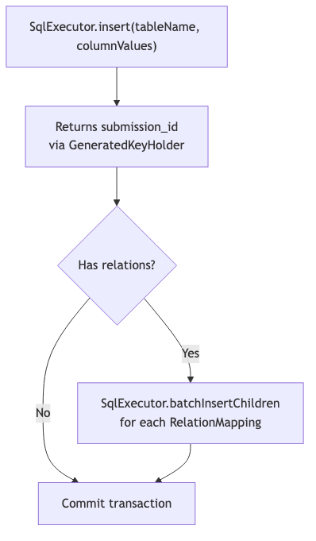
Diagram 5
A DuplicateKeyException is caught and re-thrown as DuplicateSubmissionException (HTTP 409).

Stage 7: Post-Insert Hooks
Executed after the SQL insert (but within the same transaction boundary). Common uses: - Publishing a Spring ApplicationEvent for downstream consumers - Writing to a compliance audit table - Triggering notifications
Post-insert hook failures are logged at WARN but do not roll back the transaction.

Read Pipeline — Stage by Stage

Stages 1-3: Template Resolution and Queries
The read pipeline mirrors stages 1-3 of the write pipeline in reverse: 1. Resolve the template (optionally pinned to a historical version) 2. SELECT the parent row by submission_id 3. SELECT child rows for each relation, ordered by item_index

Stage 4: Post-Query Hooks
Applied to the raw database row before field assembly. Use cases: - PII masking based on the caller’s security context - Decryption of encrypted fields - Conditional field suppression

Stage 5: Field Assembly
The inverse of Stage 4 in the write pipeline. For each FieldMapping:
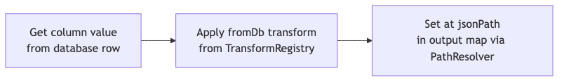
Diagram 6
For RelationMapping entries, child rows are assembled into arrays and placed at the relation’s jsonPath.
PathResolver.set() creates intermediate maps as needed. For example, setting personal.email on an empty map creates { "personal": { "email": "..." } }.

Stages 6-7: Post-Assembly Hooks and Response Envelope
Post-assembly hooks receive the fully reconstructed formData for final transformations (computed display fields, lookup hydration). The response envelope wraps the formData with metadata.

API Contract

Write Endpoint
POST /api/v1/submissions
Content-Type: application/json
{
"form_id": "pre-award-overview",
"schema_version": 1,
"submitted_by": "user-uuid",
"form_data": {
"pi_budget": 1448199,
"program_manager": "Naba Bora",
"prime_award_type": "extramural",
"personnel": [
{ "name": "John Smith", "organization": "Johns Hopkins", "project_role": "PI/PD" }
]
}
}
Success (HTTP 201):
{
"submission_id": 1,
"form_id": "pre-award-overview",
"version": 1,
"created_at": "2026-04-06T14:32:00.000-04:00"
}

Read Endpoint
GET /api/v1/submissions/1?form_id=pre-award-overview
Success (HTTP 200):
{
"submission_id": 1,
"form_id": "pre-award-overview",
"version": 1,
"created_at": "2026-04-06T14:32:00.000-04:00",
"form_data": {
"pi_budget": 1448199.0,
"program_manager": "Naba Bora",
"prime_award_type": "extramural",
"personnel": [
{ "name": "John Smith", "organization": "Johns Hopkins", "project_role": "PI/PD" }
]
}
}

Error Responses
HTTP | Error Code | Condition
400 | TEMPLATE_NOT_FOUND | No template for the given formId
400 | VALIDATION_FAILED | Field constraint violations (includes violations array)
400 | VERSION_MISMATCH | Requested schema version exceeds template version
404 | SUBMISSION_NOT_FOUND | No row for the given submissionId
409 | DUPLICATE_SUBMISSION | Unique constraint violation on target table

Hook System
Hooks are Spring beans that implement WriteHook or ReadHook functional interfaces. They are referenced by bean name in the template JSON and resolved at runtime via the HookRegistry.
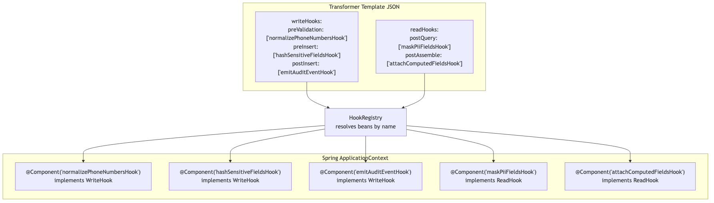
Diagram 7
Writing a custom hook:
@Component("normalizePhoneNumbersHook")
public class NormalizePhoneNumbersHook implements WriteHook {
@Override
public Map<String, Object> apply(Map<String, Object> data) {
// Normalize phone fields to E.164 format
Object phone = data.get("phone");
if (phone instanceof String s) {
data.put("phone", normalizeToE164(s));
}
return data;
}
}

Transaction and Safety Guarantees
Guarantee | Implementation
Atomic writes | Parent and child table writes wrapped in @Transactional(isolation = REPEATABLE_READ)
Rollback on error | Any DataAccessException triggers Spring’s automatic transaction rollback
SQL injection prevention | All table/column names validated via IdentifierValidator regex; all values use named parameters
Additive-only DDL | DdlManager never drops columns or tables
Post-insert isolation | Post-insert hook failures are caught and logged; they do not roll back the committed data

Component Reference
Component | Package | Role in Pipeline
SubmissionWriteService | transformer.service | Orchestrates 7-stage write pipeline
SubmissionReadService | transformer.service | Orchestrates 7-stage read pipeline
TransformerSubmissionController | transformer.controller | REST endpoints: POST + GET
TemplateRegistry | transformer.registry | Template cache and resolution
PathResolver | transformer.engine | Dot-notation get/set on nested maps
TypeCoercionService | transformer.engine | Java value to SQL type coercion
TransformRegistry | transformer.transform | Named transform function registry
BuiltInTransforms | transformer.transform | 13 built-in transform implementations
ValidationGate | transformer.validation | Field validation with violation collection
HookRegistry | transformer.hook | Spring bean resolution by name
SqlExecutor | transformer.db | NamedParameterJdbcTemplate wrappers
DdlManager | transformer.ddl | Dynamic table creation and reconciliation
IdentifierValidator | transformer.util | SQL identifier regex validation
TransformerExceptionHandler | transformer.config | Maps exceptions to HTTP status codes

