Table of Contents
Relational and Object databases 1
Practical differences between MySQL (RDBMS) and MongoDB (OMS) databases 1
OMSs do not support transactions 1
MongoDB doesn't support joins 1

Database structure
Even though MongoDB doesn't force your data to conform to any database schema, it's still a good idea to have one so that it's easier to build the application. Here's a rough image on the data structure:
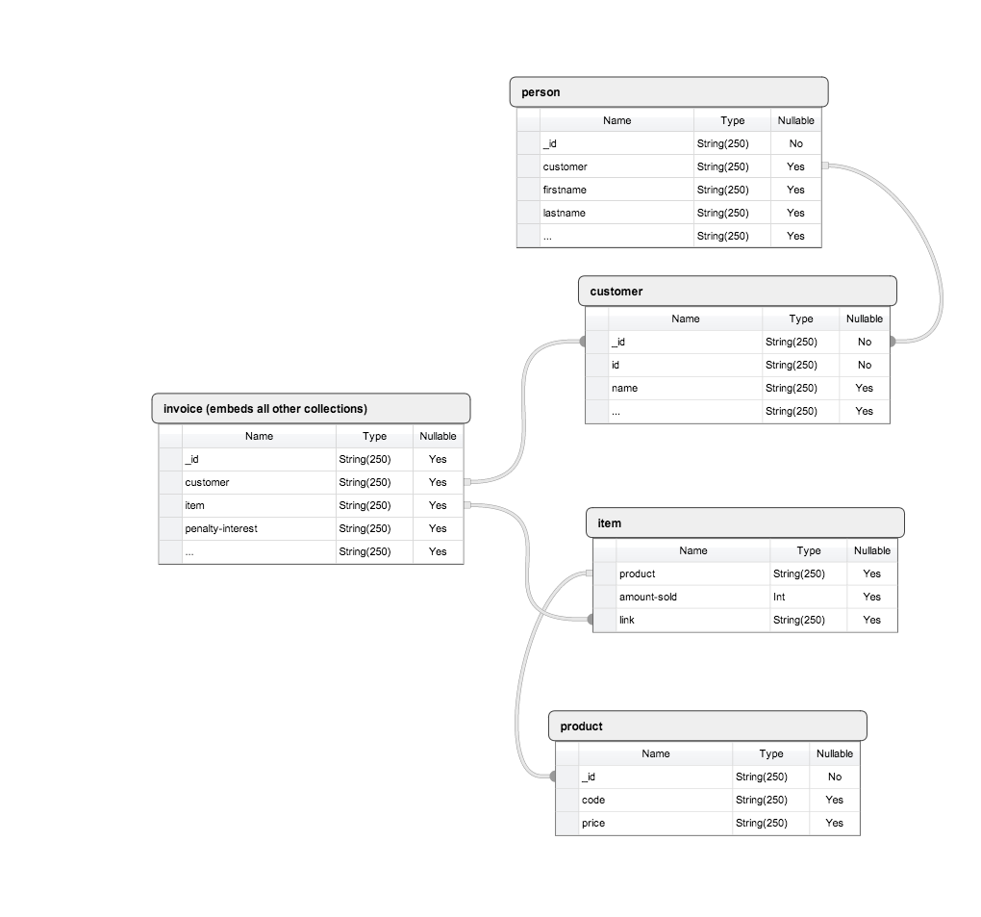
person, customer, item and product collections store references between each others (normalized), but when a new invoice is created or an item added to the invoice that data is embedded in the order. Whether or not this is best way to handle this kind of application is another question but it made sense to keep the invoice data immutable after an invoice has been created.

