Design

Jungpyo Hong

Basic step that I design is that

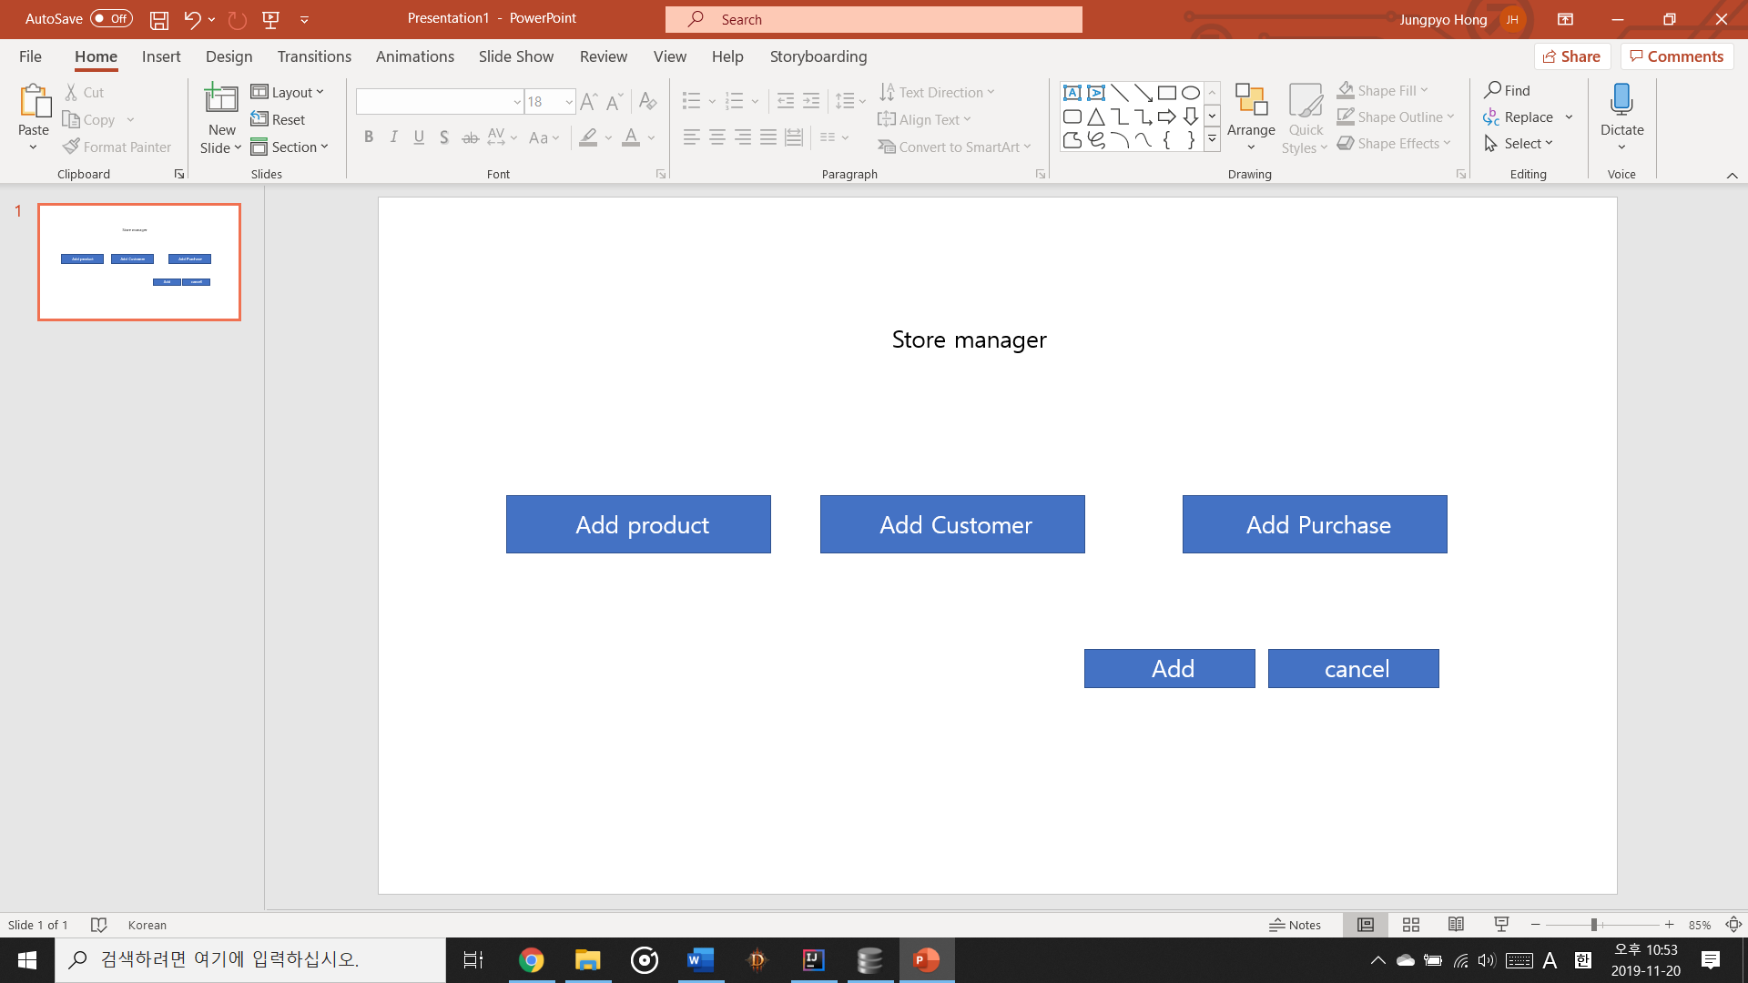

We can choose add product or add customer or add purchase in this program

When we enter product option it will show like this

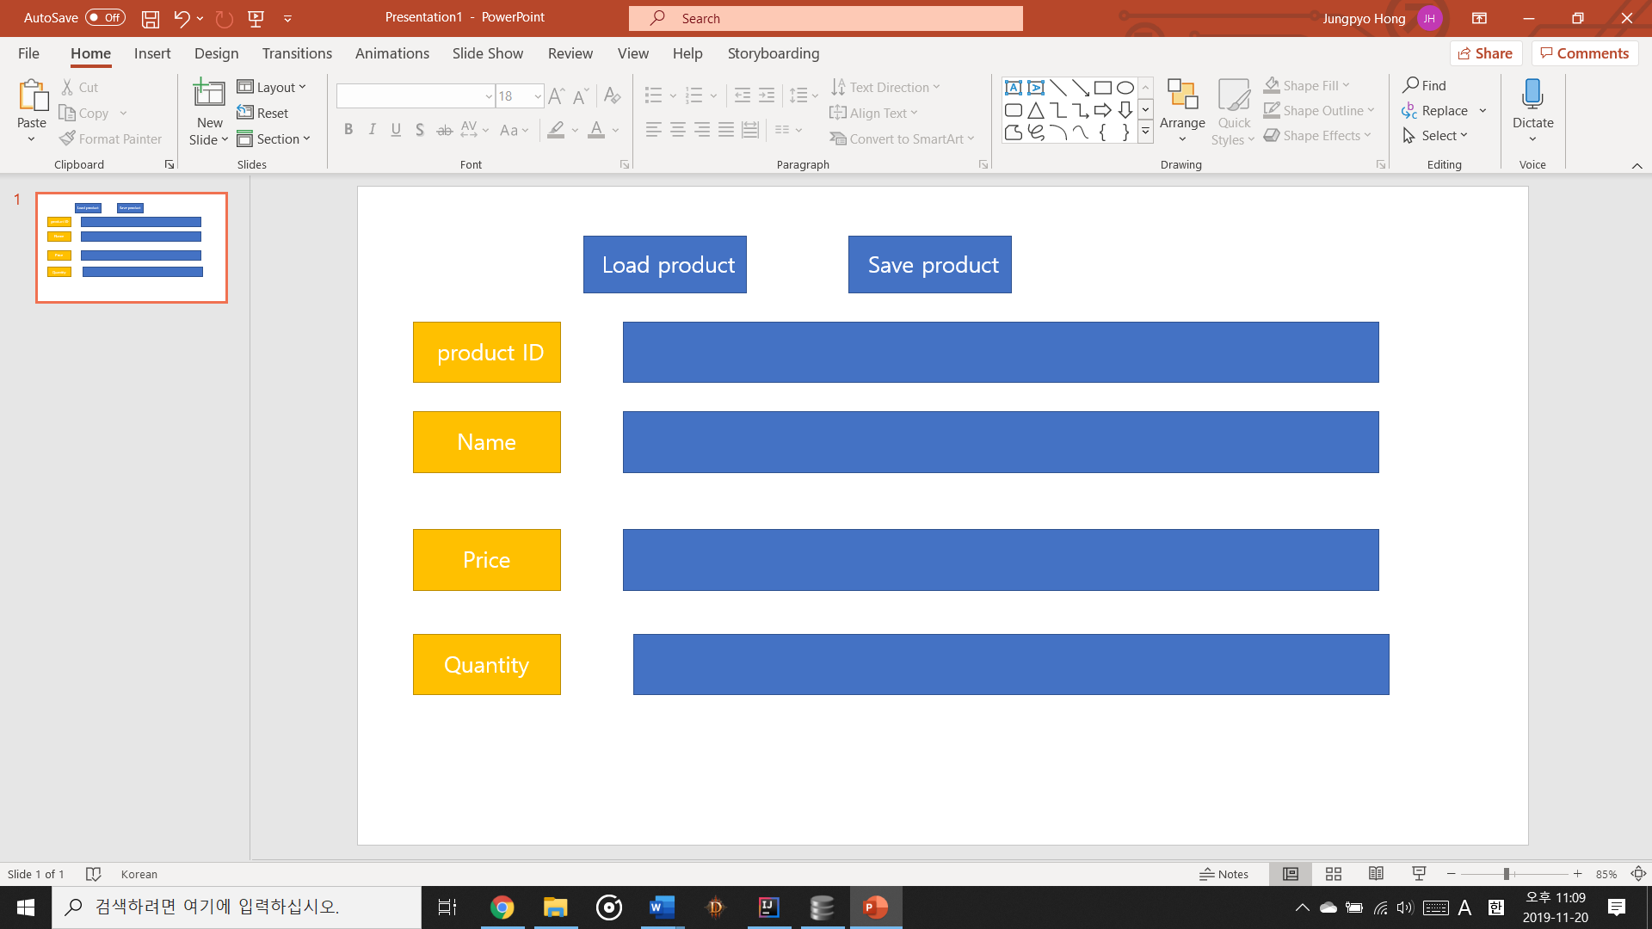

Also when you enter correctlly show this window

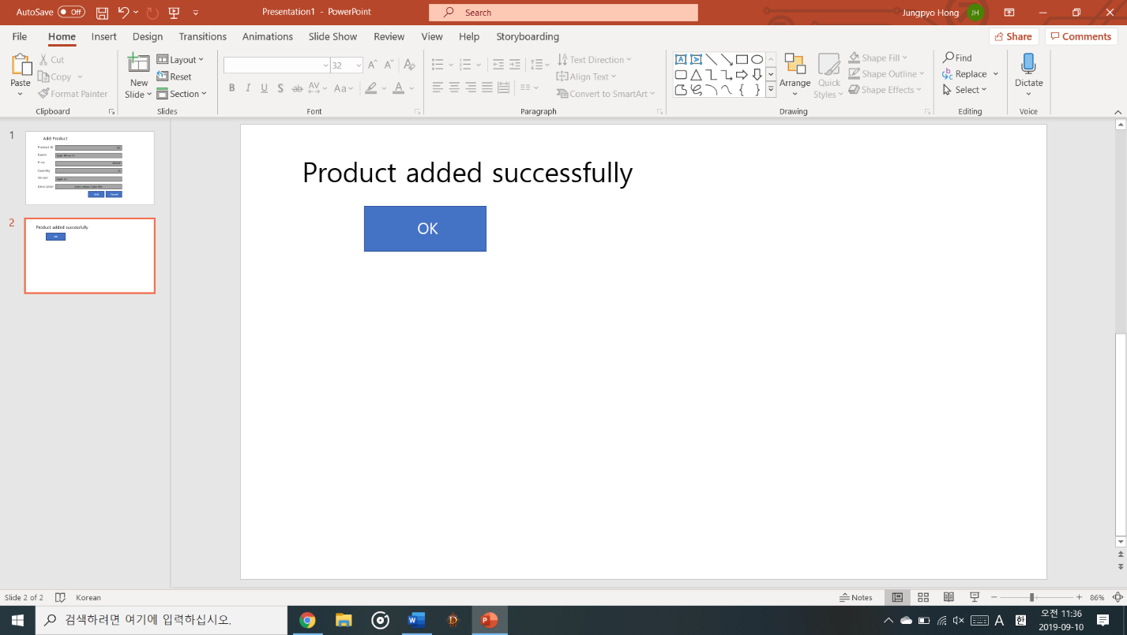

When we enter Customer button

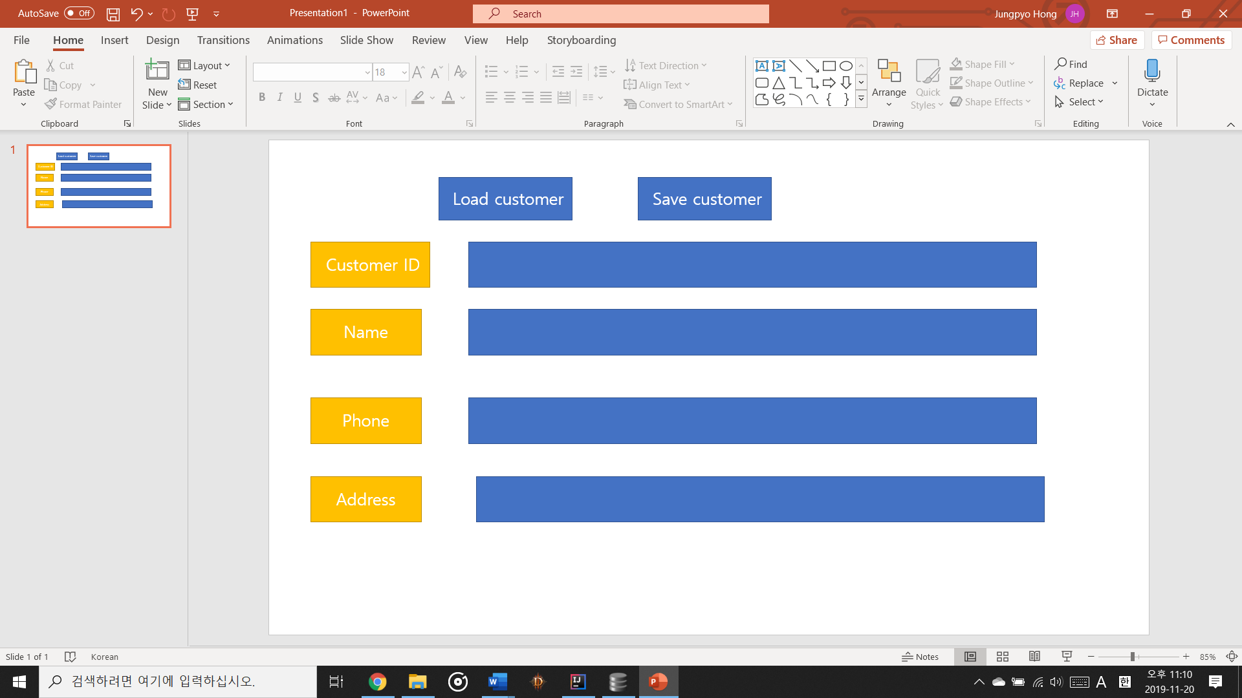

It will show like this

And it we enter each button, we can choose different options in that button

For example if we enter product button

In product button I have four options of button that we can do

1. When you click the make a purchase button it looks like this

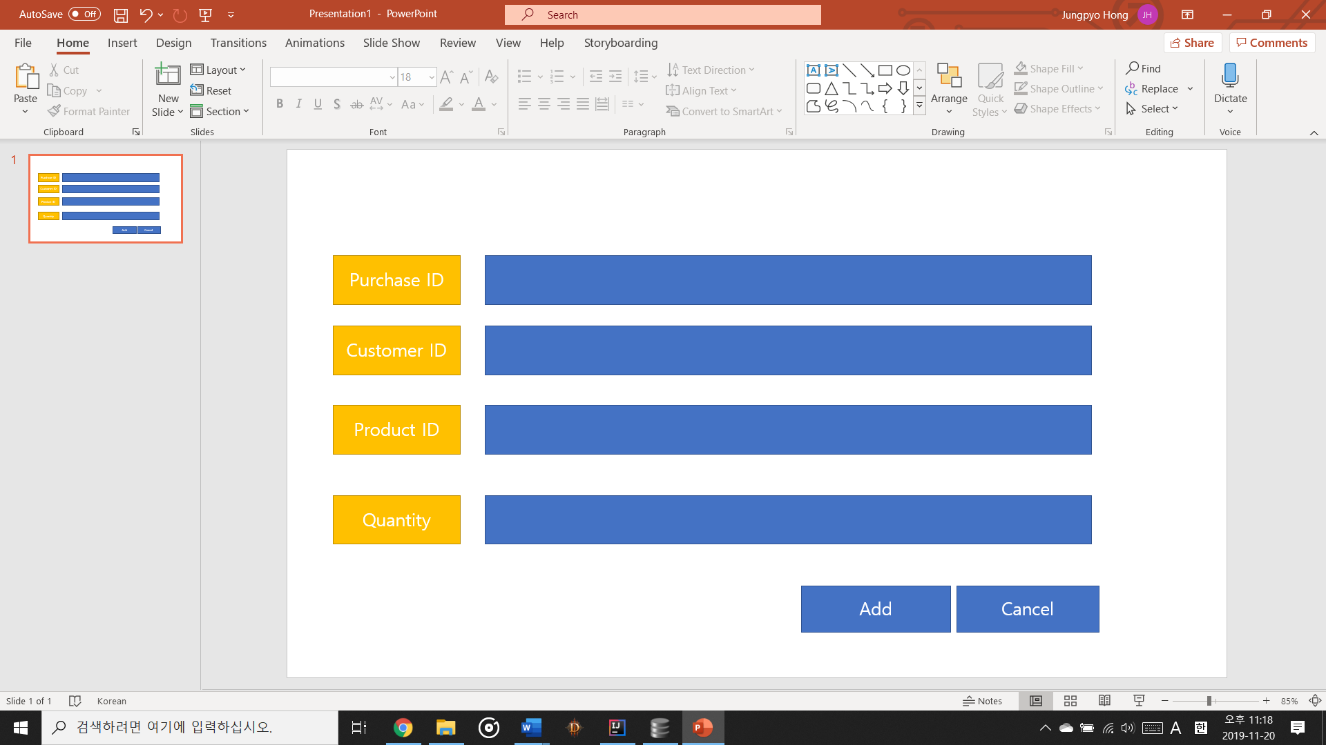

1. When you click the view purchase history button it looks like this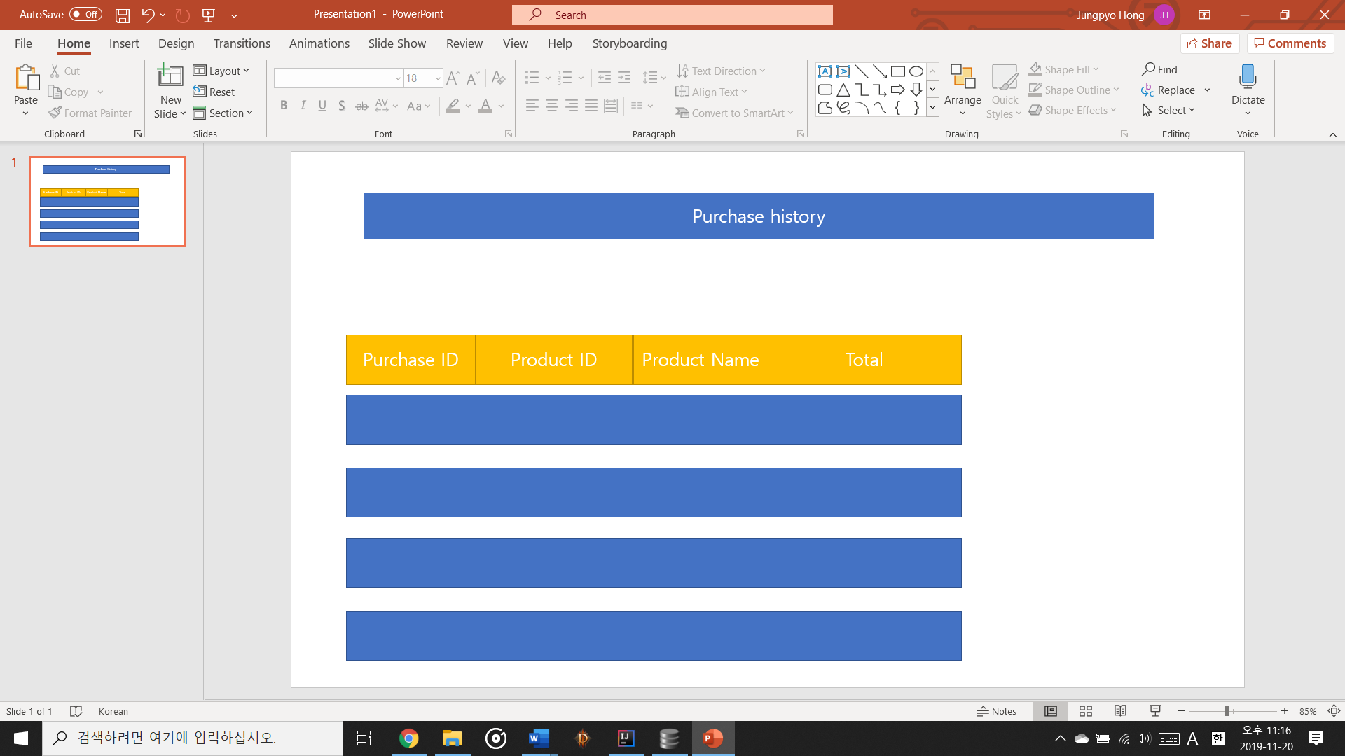
2. When you click the cancel a purchase button it looks like this

You can cancel it with this button with entering customer id and purchase id

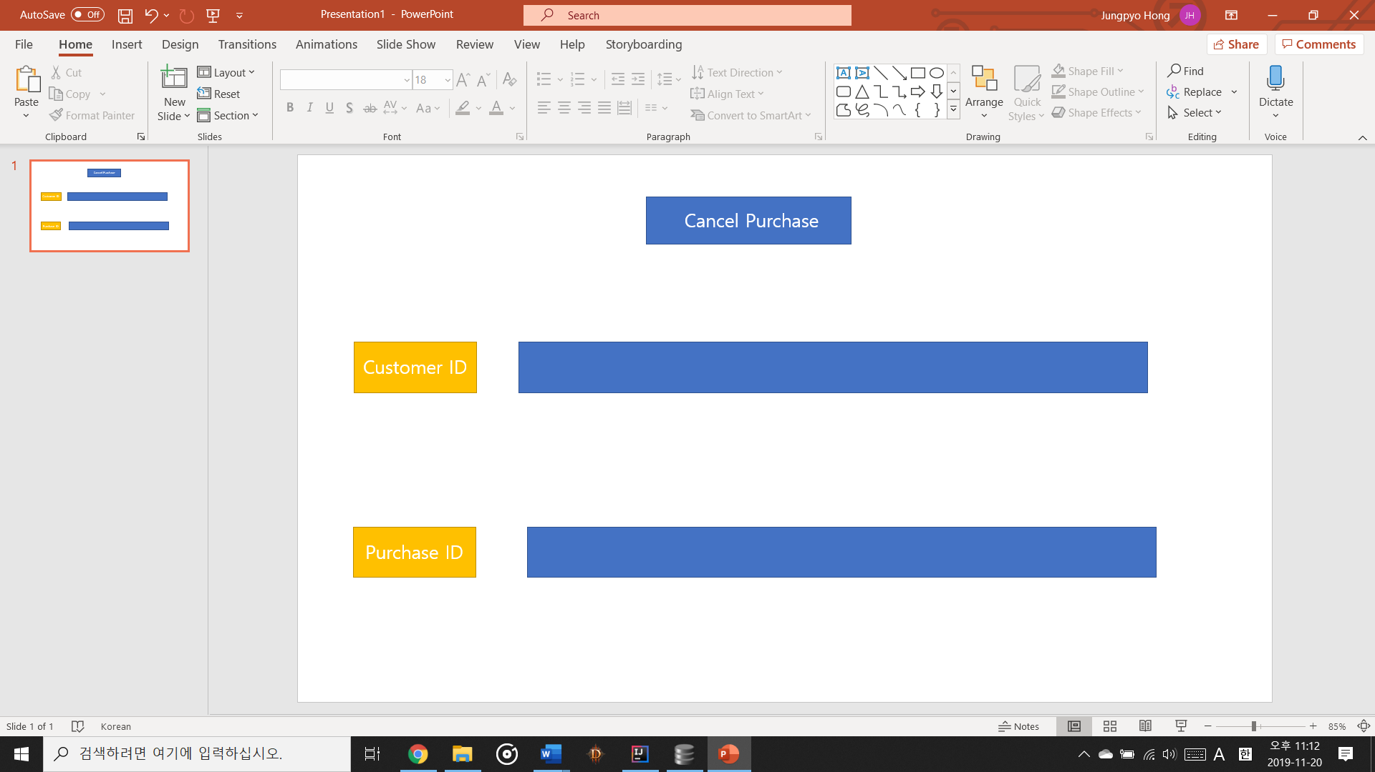

4. When you click the search product button it looks like this

