Project1

COMP 3500

Jungpyo Hong

1. The store owner named Dennis wants to know what kind of products that he has. For example, name, price, quantity of product. Also, he wants to know the name of customer and phone number, also address. And make purchase icon to know the name of customer and the customer’s products that they bought.

This is user interface that I make

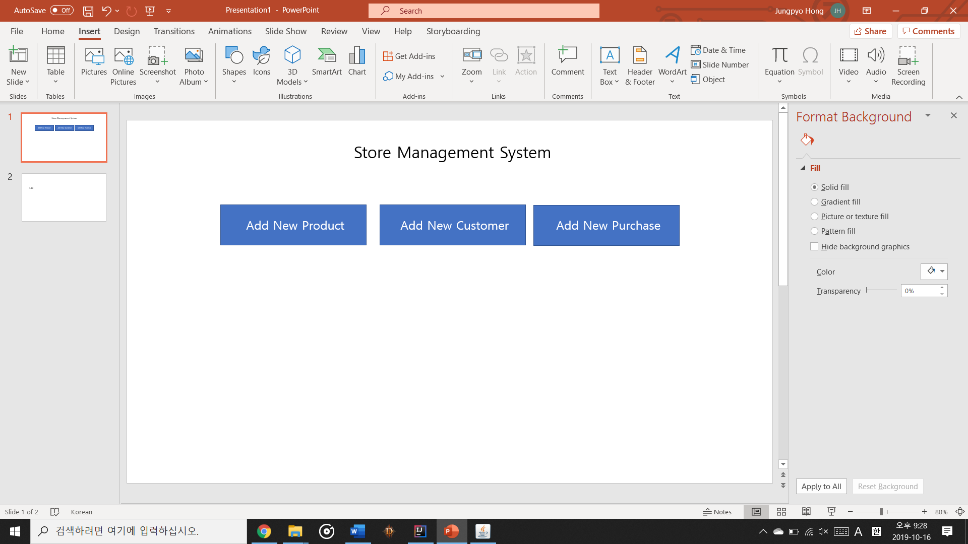

It will have three icon in this start interface

For product, it looks like

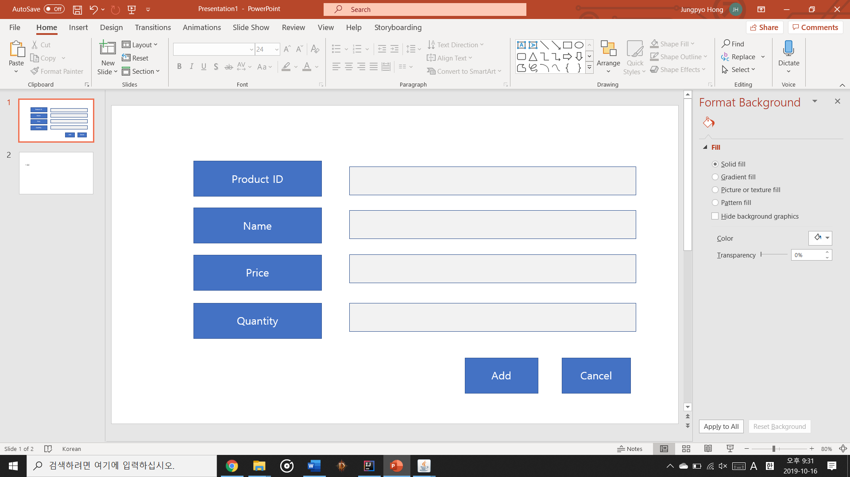

For customer, it looks like

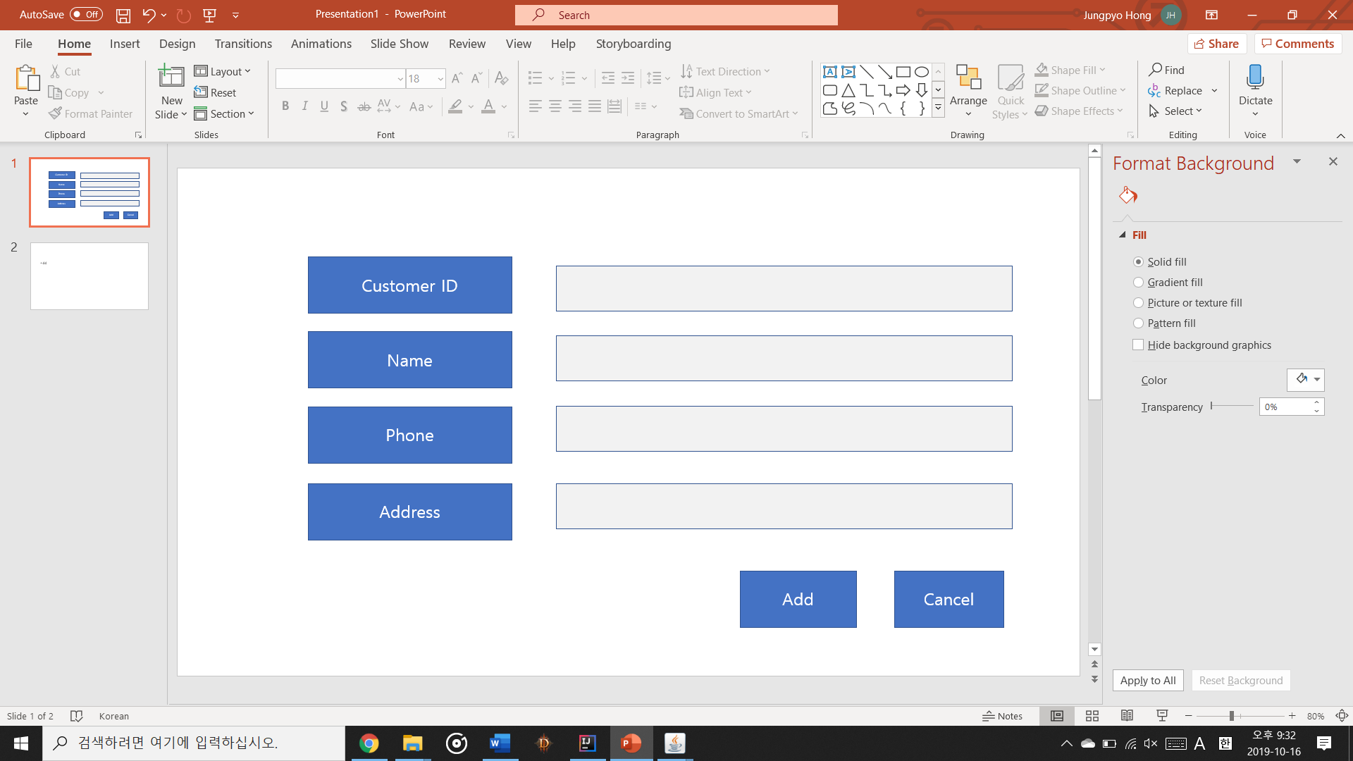

For Purchase, it looks like

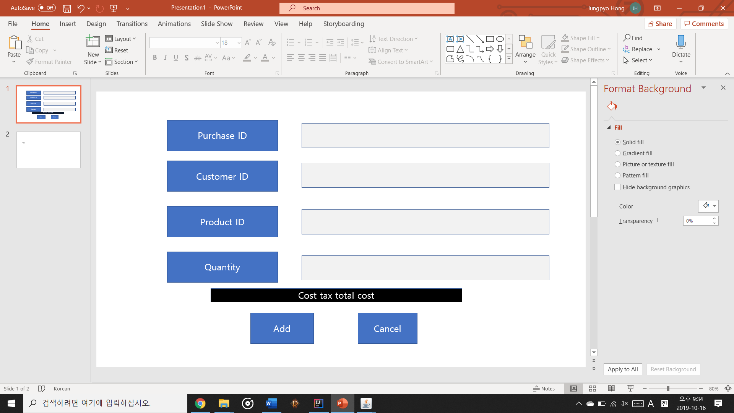

After they added successfully, show this kind of widgets

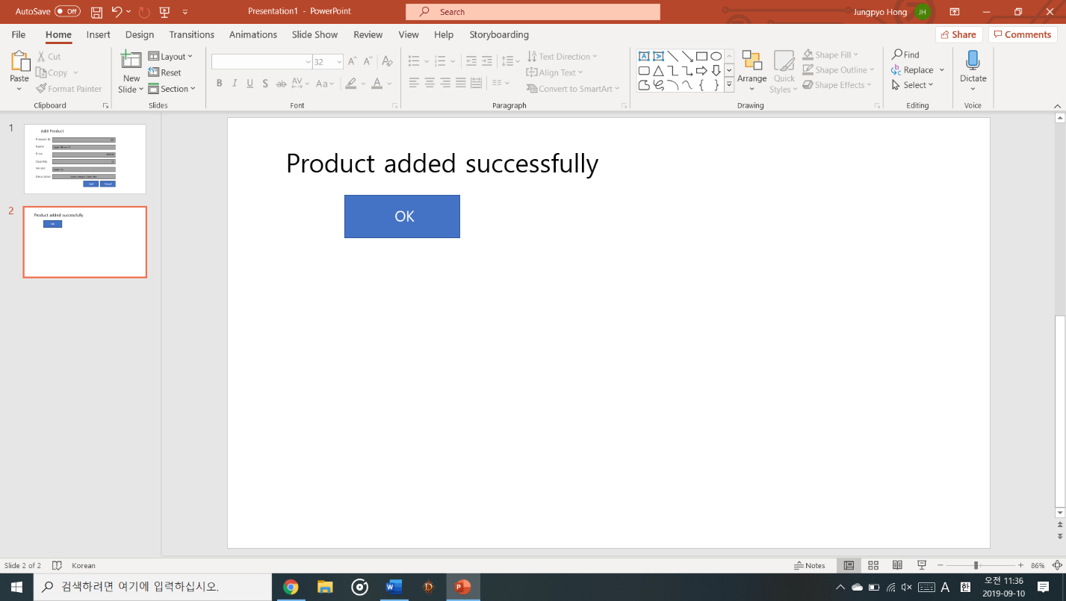

If I put 5products, 5 customer, and 10 purchase it just automatically added to SQL database file so that store manager can manage data with convenient way.

Here is table set and input data that will run in java code (SQL code)

To create Products table

CREATE TABLE "Products" (

"ProductID" INTEGER,

"Name" TEXT,

"Price" NUMERIC,

"Quantity" NUMERIC

);

To create customers table

CREATE TABLE "Customers" (

"CustomerID" INTEGER,

"Name" TEXT,

"Phone" INTEGER,

"Address" TEXT

);

To create Purchases table

CREATE TABLE "Purchases" (

"PurchaseID" INTEGER,

"CustomerID" INTEGER,

"ProductID" INTEGER,

"Quantity" NUMERIC,

"Price" NUMERIC,

"Cost" NUMERIC,

"Tax" NUMERIC,

"Total" NUMERIC,

"Date" TEXT

);

Here is input values (SQL code)

For Products

Insert into Products (ProductID, Name, Price, Quantity)

Values (1, 'Banana', 2, 20),(2, 'Apple', 1, 10),(3, 'Cake', 20, 5),(4, 'Paper', 1, 20),(5, 'Book', 15, 20);

For Customer

Insert into Customers (CustomerID, Name, Phone, Address)

Values (1, 'Dennis', 3344141243, 'Montomgery'),(2, 'Yoon', 3341524875, 'Montgomery'),(3, 'Ashely', 3345691575, 'Auburn'),(4, 'Lee', 3345699985, 'Auburn'),(5, 'Kim', 3341125489, 'Auburn');

For Purchase

Insert into Purchases (PurchaseID, CUstomerID, ProductID, QUantity, Price, Cost, Tax, Total, Date)

Values (1,1,1,2,15,30,2.7,32.7,'Wed Oct 16 21:57:34 CDT 2019'),

(2,2,2,3,15,45,4.05,49.05,'Wed Oct 16 21:57:56 CDT 2019'),

(3,3,3,1,2,2,0.18,2.18,'Wed Oct 16 21:58:05 CDT 2019'),

(4,4,4,4,1,4,0.36,4.36,'Wed Oct 16 21:58:15 CDT 2019'),

(5,5,5,10,1,10,1,11,'Wed Oct 16 21:58:35 CDT 2019'),

(6,6,6,20,2,40,3.6,43.6,'Wed Oct 16 21:58:56 CDT 2019'),

(7,7,7,2,15,30,2.7,32.7,'Wed Oct 16 21:59:02 CDT 2019'),

(8,8,8,1,15,15,1.35,16.35,'Wed Oct 16 21:59:14 CDT 2019'),

(9,9,9,2,20,40,3.6,43.6,'Wed Oct 16 21:59:32 CDT 2019'),

(10,10,10,30,1,30,2.7,32.7,'Wed Oct 16 21:59:59 CDT 2019');