Design

COMP 3700

Jungpyo Hong

I will define five different UI

1. For user
2. For admin
3. For manager
4. For cashier
5. For customer

Each number has token number so that if you enter username and password in login UI they show a token number and show UI relative to token number that shown.

For user UI I will show like this

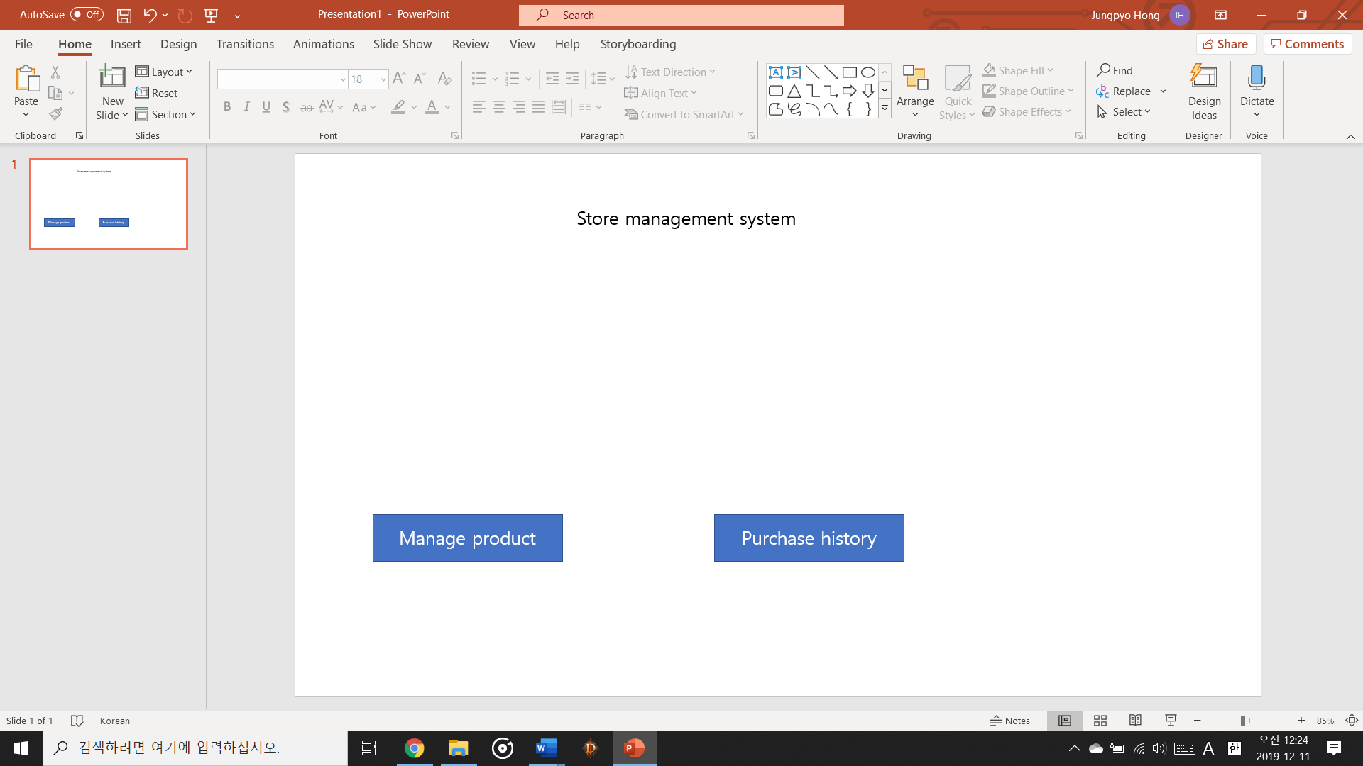

For admin view

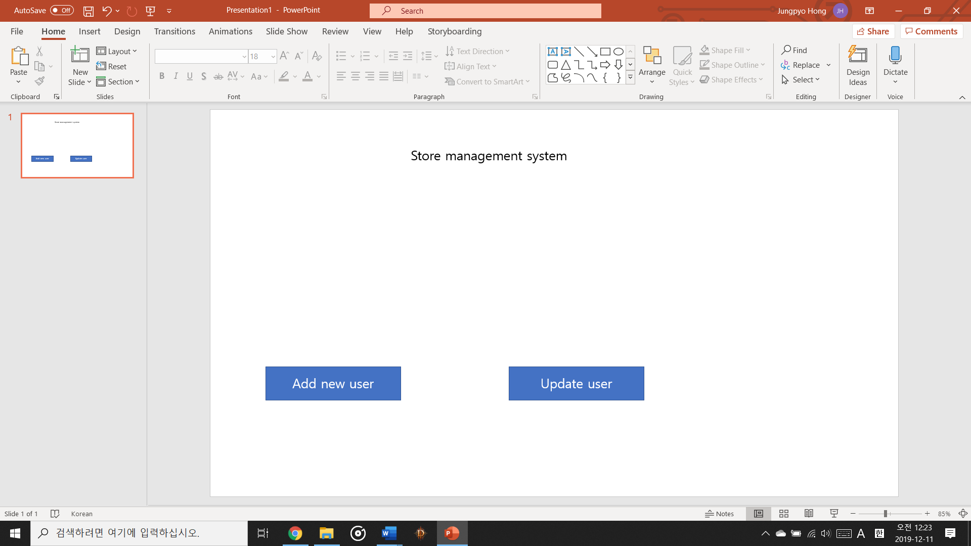

For manager view



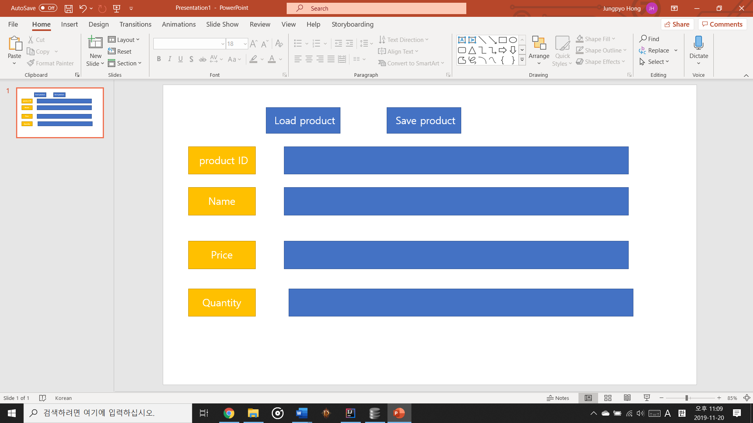

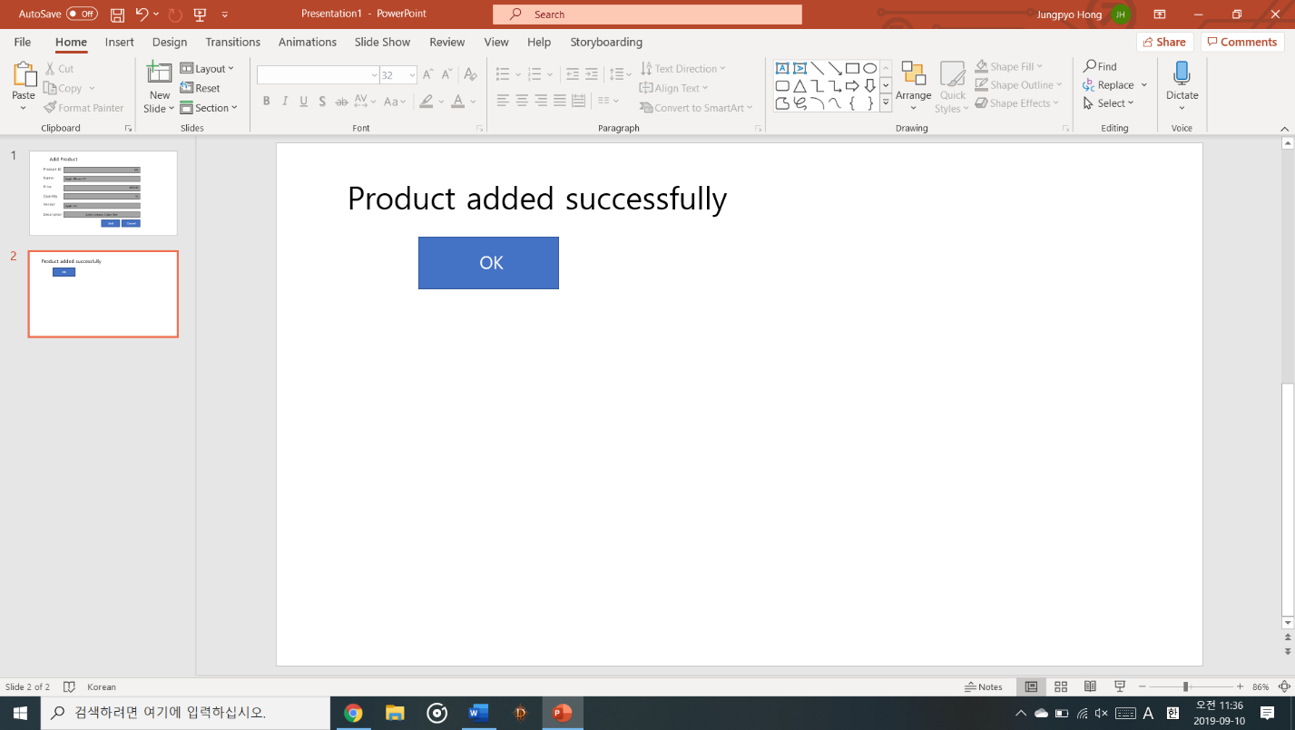

For cashier view

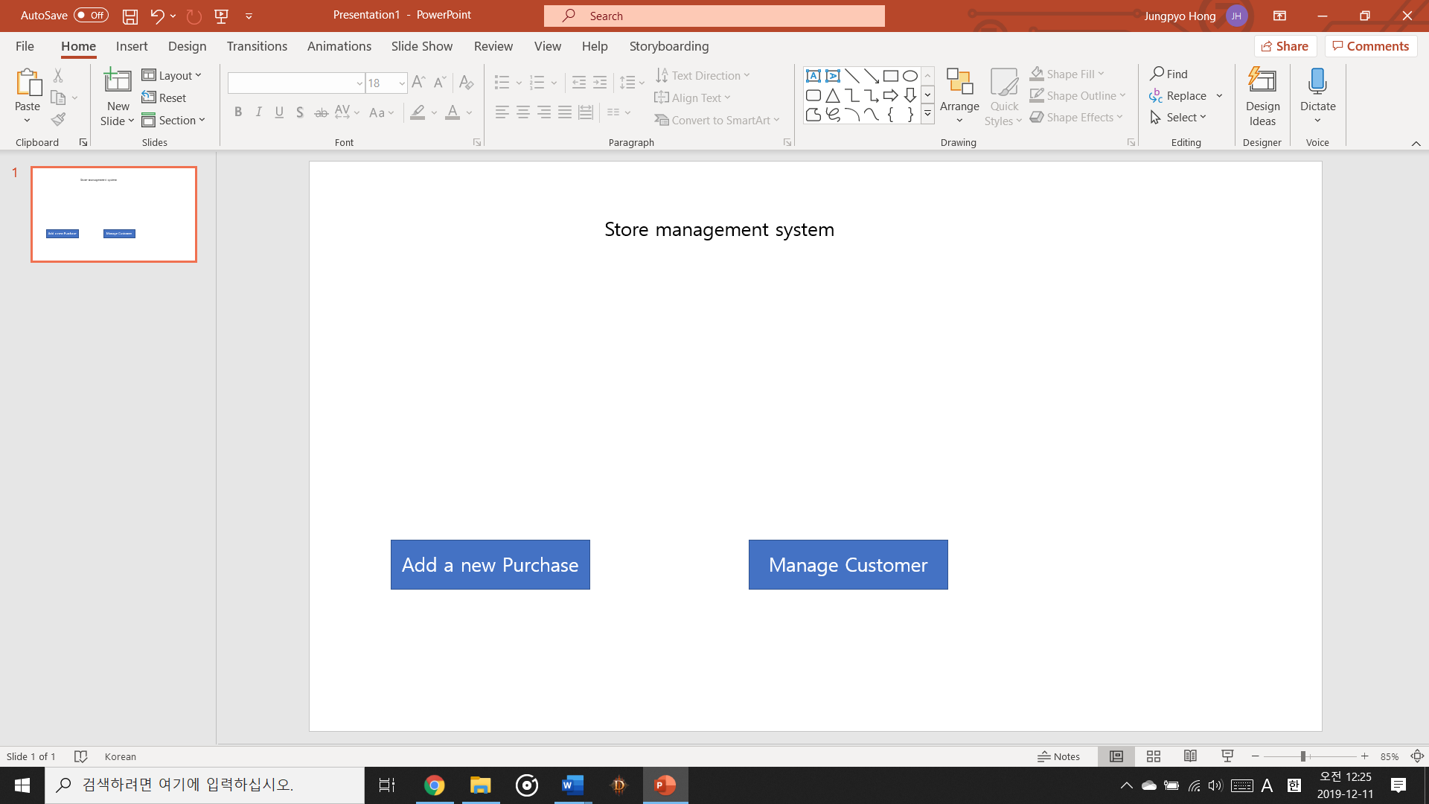





For customer view

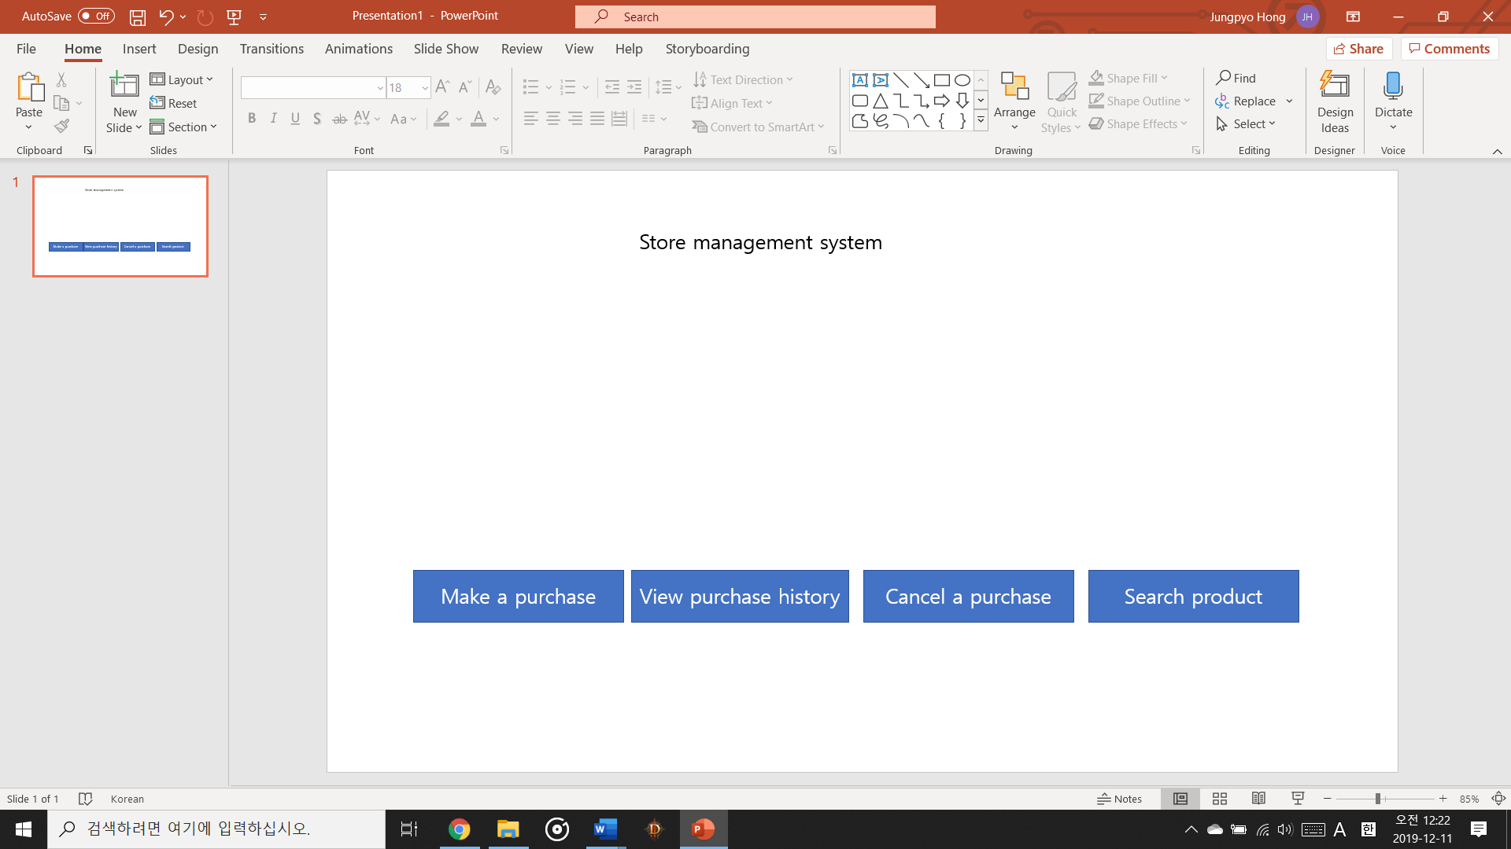

When you click history button, it will show like this

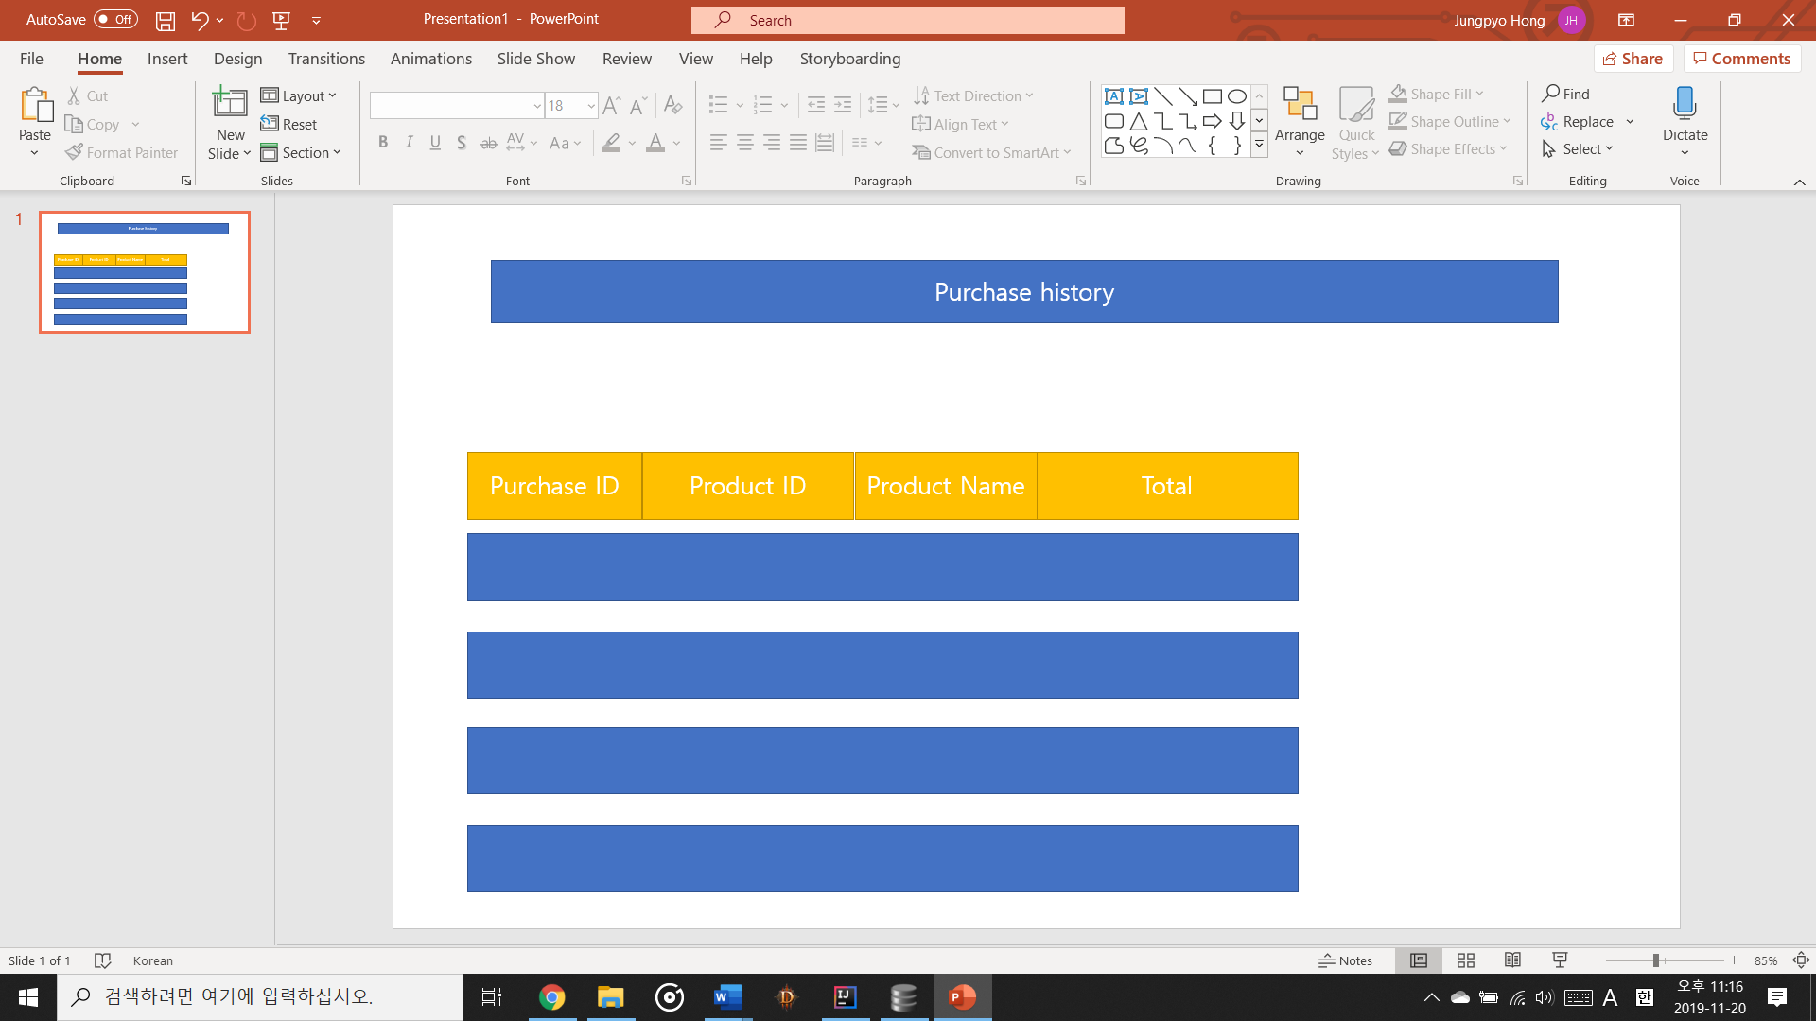

Also if you want to cancel the selection it will show like this

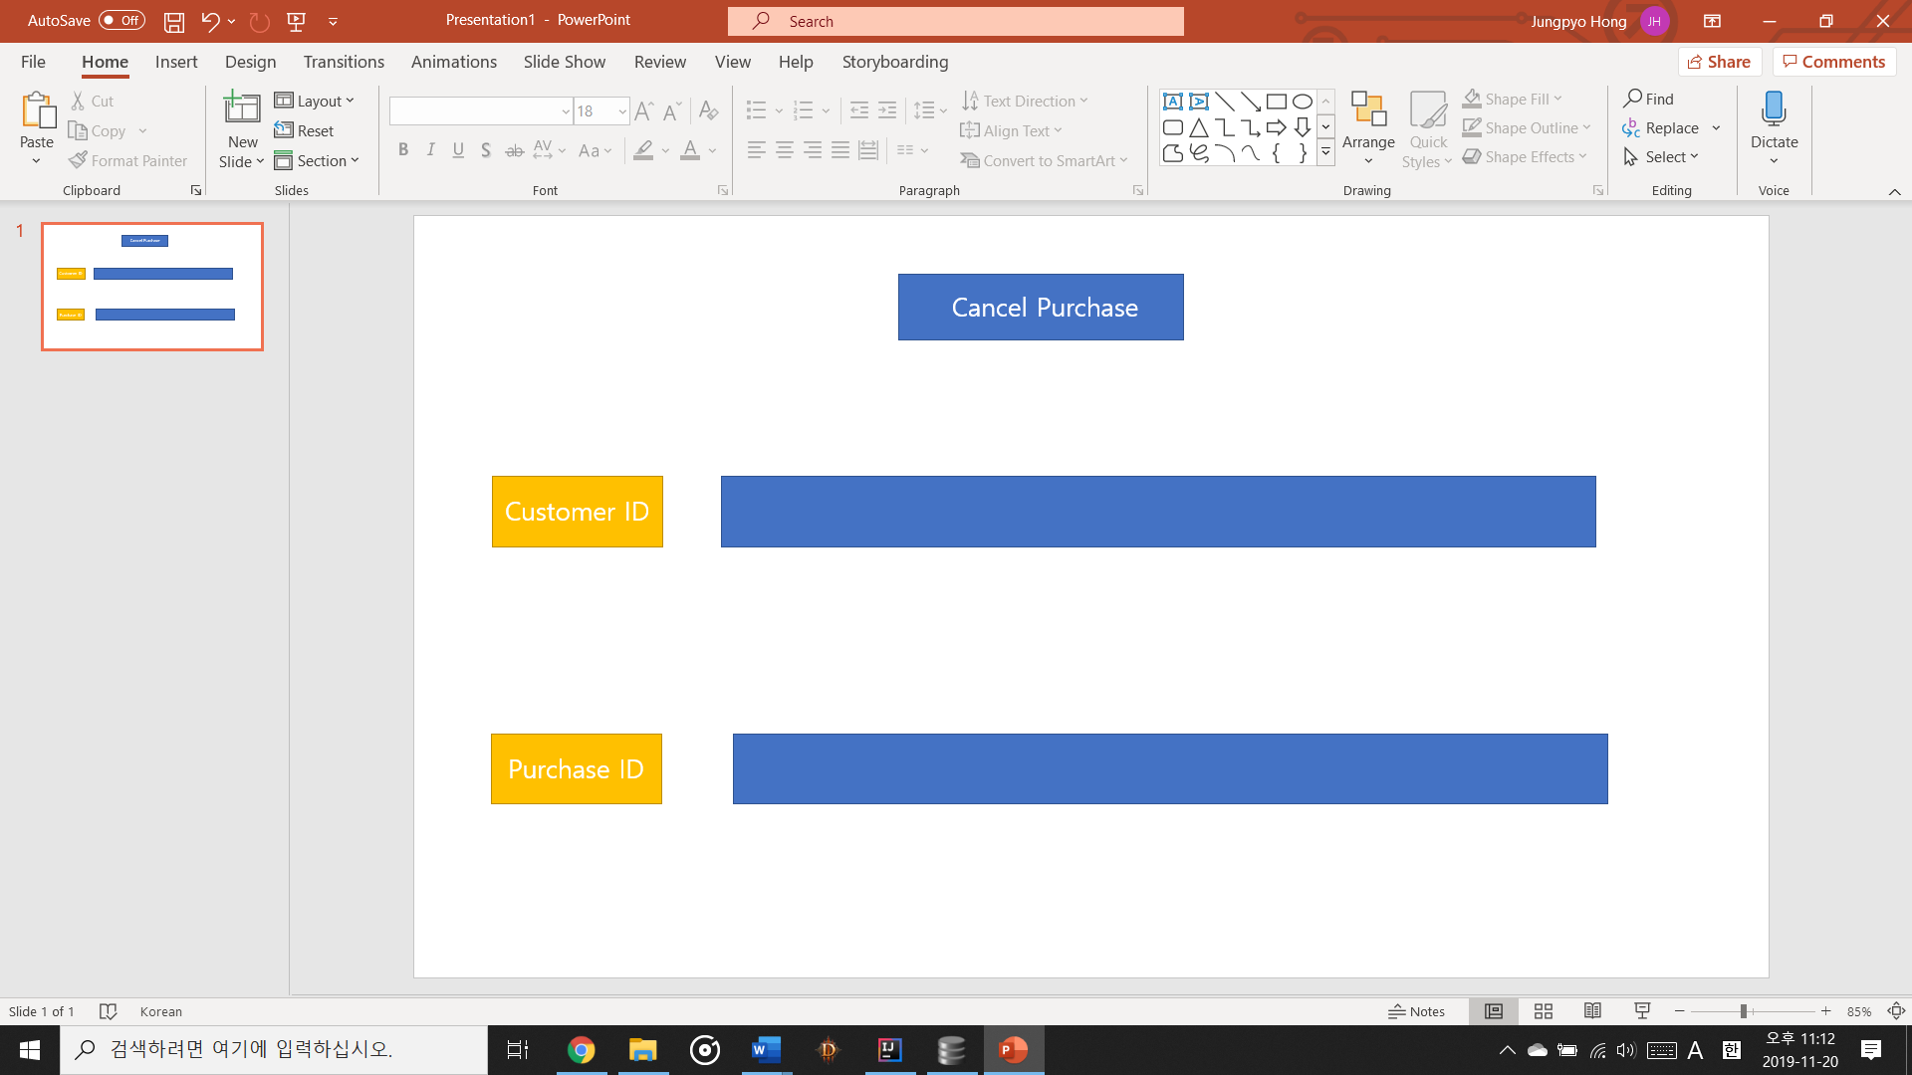

You can manage user, admin, manager, cashier, customer UI like this!