**How to connect to gpu server from home using mobaXterm**

By: Pavel Rastopchin.

1. Install MobaXterm and start a new session.

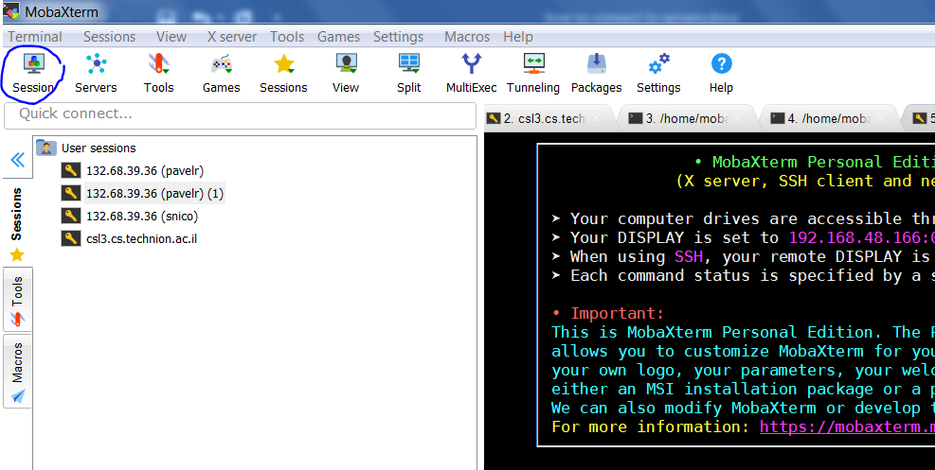

1. Select type of session: SSH

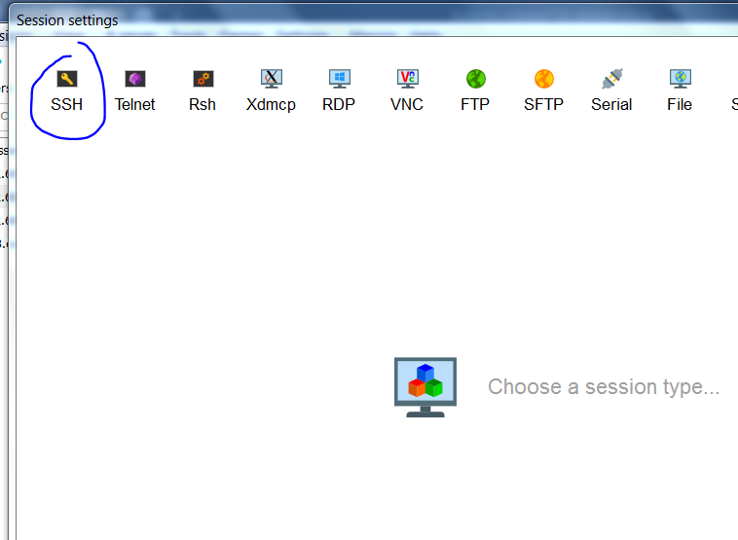

1. Go to “Network settings”

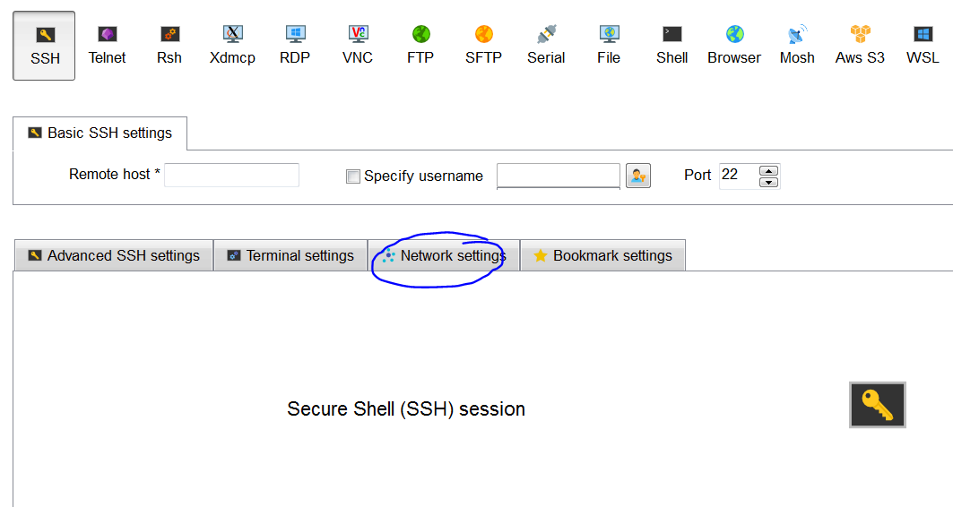

1. Use: csl3.cs.technion.ac.il (or other cs server you have access to) as jump host

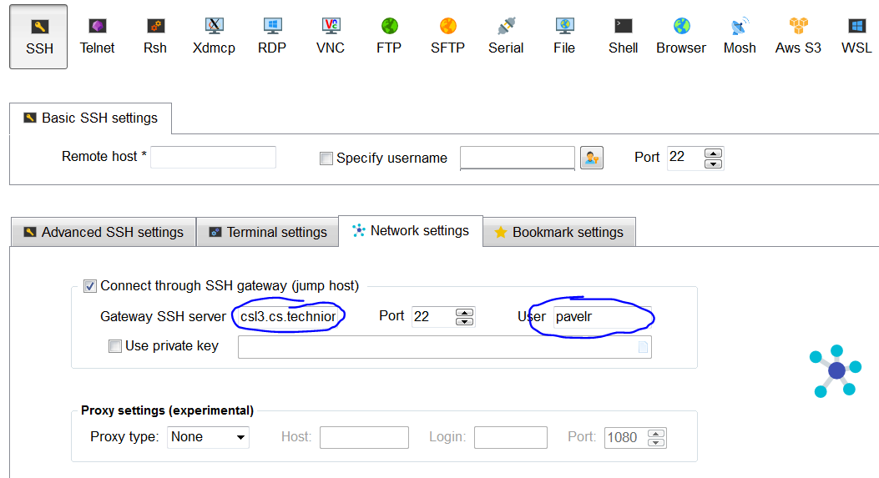

1. Now define the IP of course server.

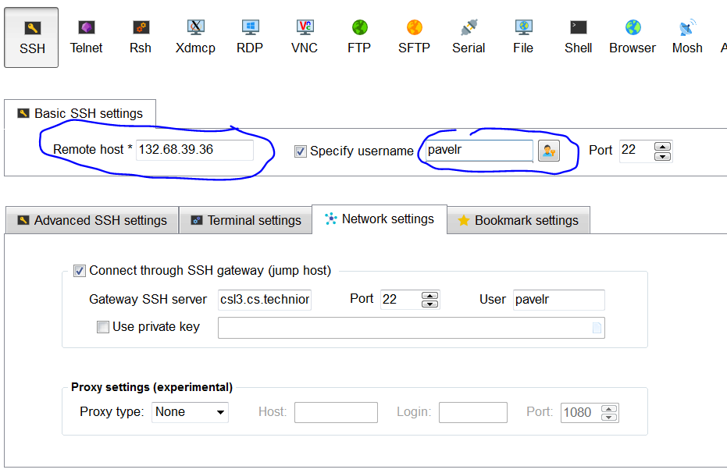

1. press ok

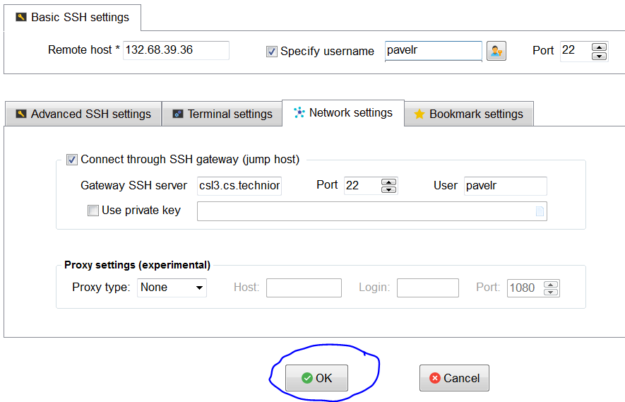

1. You should see the terminal and file system:

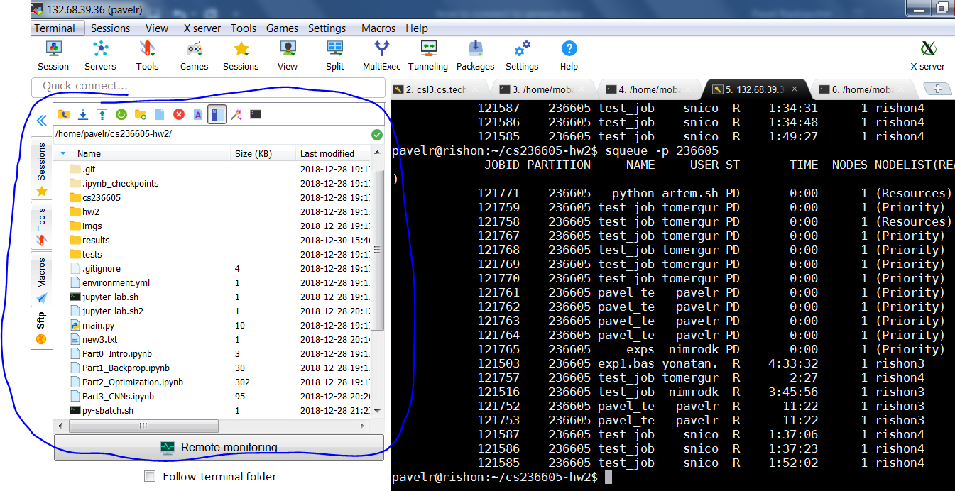

1. You should be able to transfer files using those:

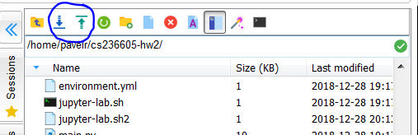

1. And edit files directly on the server:

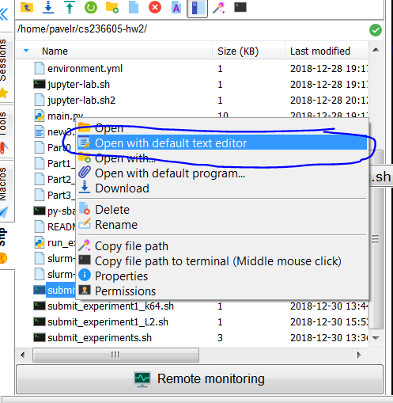

1. Tip: “Enable Follow terminal folder”, do “cd <somewhere>” in terminal and be happy.

