**-Complete functional specification. This will be a document with the headings of: user profile, use cases, and interactions details. The document should be placed in the team repo.**

**User Profile:** Our standard user will be familiar with the use of a terminal and spreadsheets (excel), but not necessarily familiar with Python. The user should be able to call for our file using the terminal and then input at least one excel file for data analysis. Our file will be ideal for a student who is studying the dynamic nature of an ecosystem at a basic and simplified level.

**Use Cases:**

1. User will call for our file from the terminal.
2. Directions will be given on the format of how to submit the parameters (species cannot be changed) in an Excel file. The user will also have the option to use an excel template with examples of 2-3 graph outputs. They will be able to specify which graph outputs they would like displayed.
3. User will input an Excel file following directions in (2).
4. Function will calculate biomass (Bi) per species given input form (3).
5. Function will give 3 outputs:
   1. (automatically given) A table:

|  |  |
| --- | --- |
| Species | Biomass (kg) |
| Species 1 | 01234 |
| Species 2 | 01234 |
| Species 3 | 01234 |
| …etc | ….etc |

* 1. (specified by user) 2 Graphs (in a single window, presented in subplots):

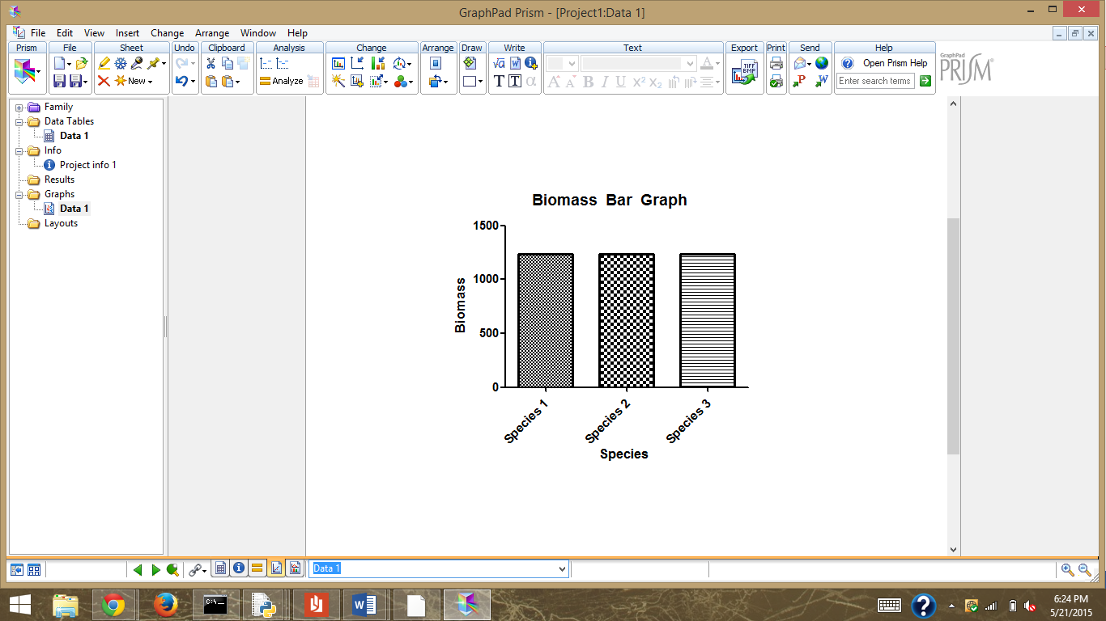

1. Use will be given an option to replace input file with new file (same direction as (2)) up to 3 times. Function will repeat steps 3-4. More specifically, the user will be able to access their previously submitted file and change the numbers within. This will be saved as another file in our program for comparison with the original input.
2. Output with multiple files (Similar as described in 5, where the user can decide on which graph to see):

|  |  |  |  |
| --- | --- | --- | --- |
| Species | Input 1 | Input 2 | Input 3 |
| Species 1 | 01234 | 01234 | 01324 |
| Species 2 | 01234 | 00123 | 00012 |
| Species 3 | 01234 | 02468 | 4936 |

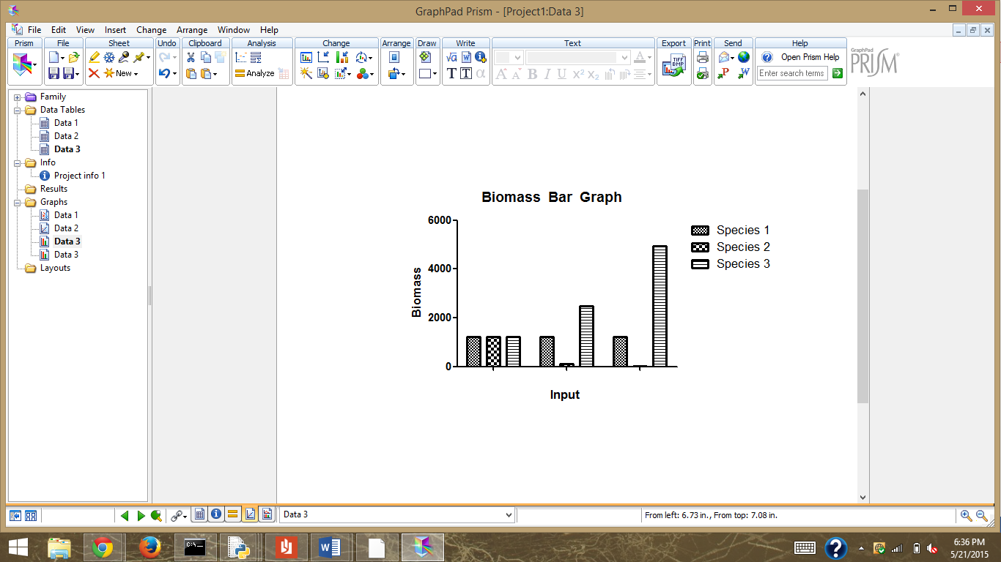

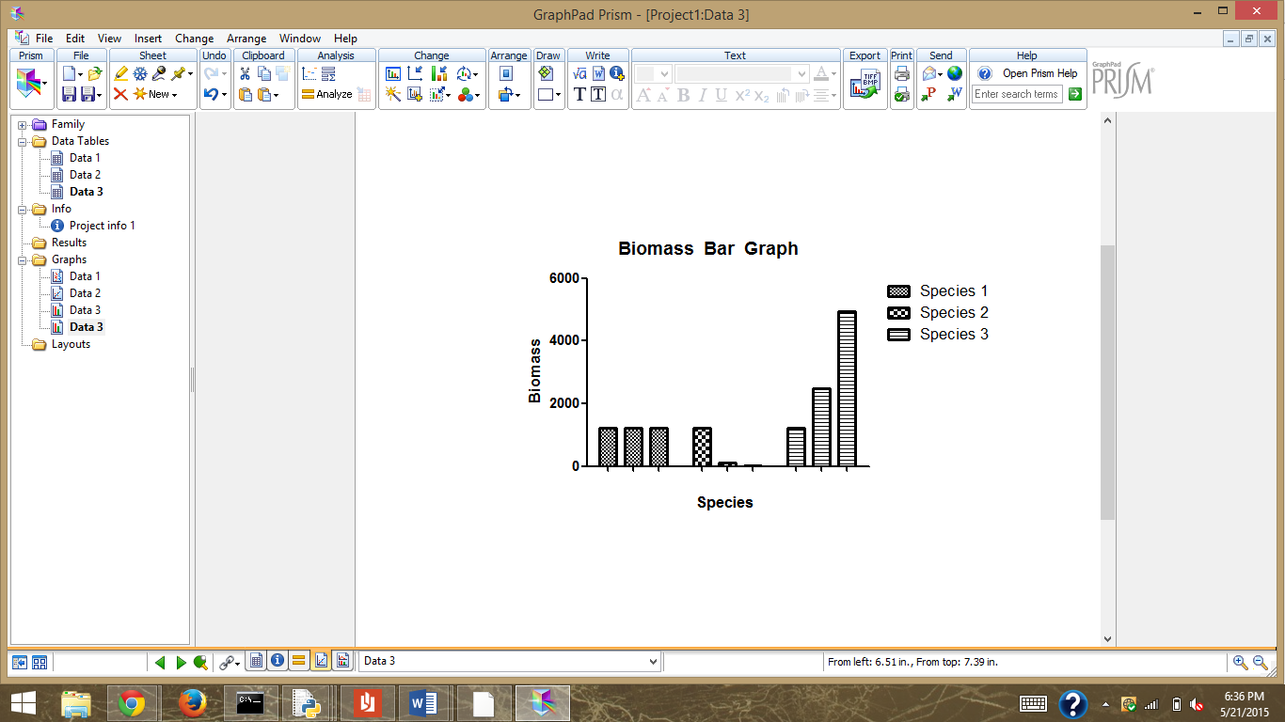

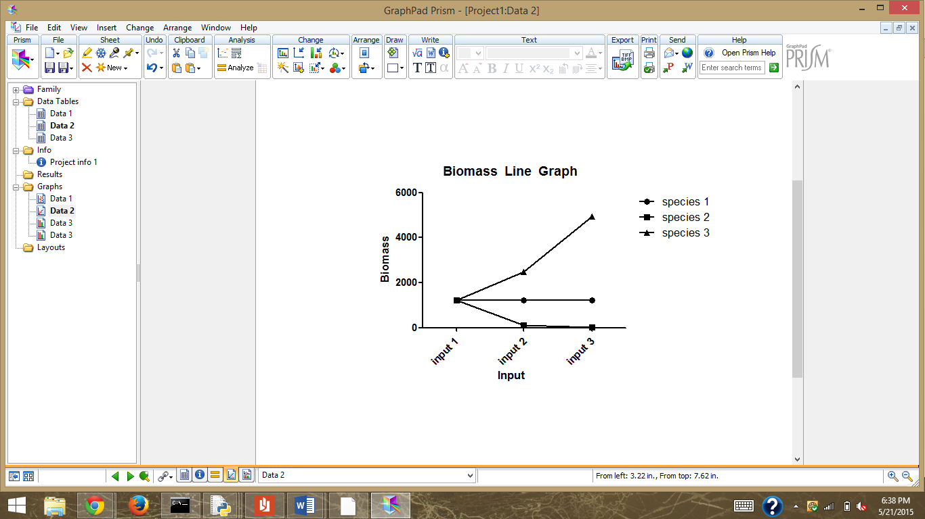

**Interaction Details:**

1. Call file
2. Download template Excel file
3. Input excel file  (format directions given if template not used)

The user will be given directions with every step (more directions can be asked for by user).