Comment Colors:

Julia

~~–Create team repo~~

–Complete functional specification. This will be a document with the headings of: user profile, use cases, and interactions details. The document should be placed in the team repo.

A couple options on how to submit this:

1. Make a folder for Functional Specification and have several text files
2. Submit a word doc for Functional Specification and have everything listed within.

User Profile: ____ is familiar with the use of a terminal.

Use Cases:

1. User will call for the file from the terminal.
2. Directions will be given on the format of how to submit the parameters (species cannot be changed)
3. User will input a cvs (?) file following directions in (2).
4. Function will calculate biomass (Bi) per species given input form (3).
5. Function will give 3 outputs:
   1. A table that looks something like this

|  |  |
| --- | --- |
| Species | Biomass |
| Species 1 | 01234 |
| Species 2 | 01234 |
| Species 3 | 01234 |
| …ect | ….ect |

* 1. 2 Graphs (in a single window, presented in subplots) that look something like this:

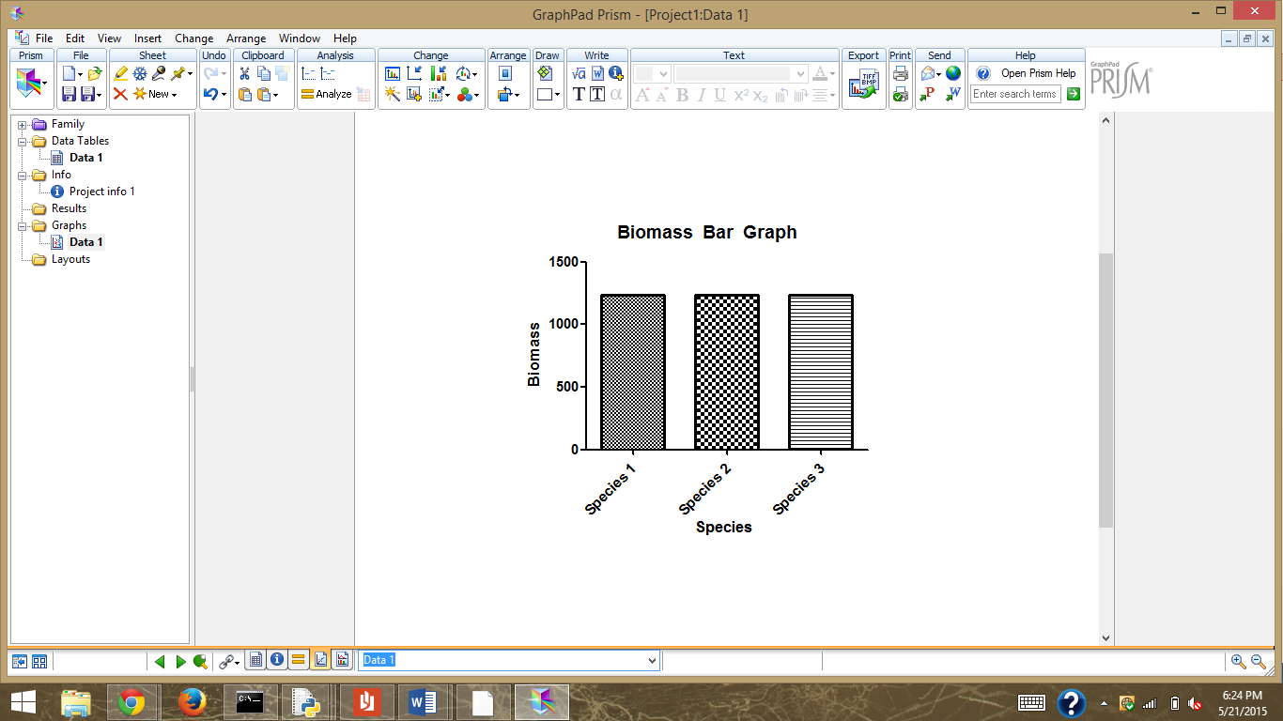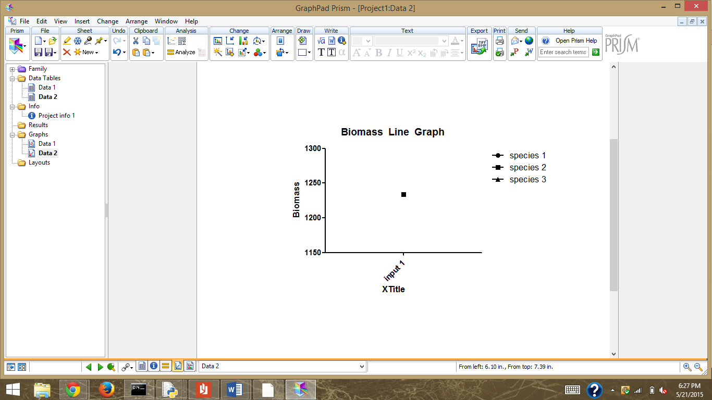

1. Use will be given an option to add in a new file (same direction as (2)). Function will repeat steps 3-4.
2. Out put with multiple files (sameish stuff as described in 5):

|  |  |  |  |
| --- | --- | --- | --- |
| Species | Input 1 | Input2 | Input 3 |
| Species 1 | 01234 | 01234 | 01324 |
| Species 2 | 01234 | 00123 | 00012 |
| Species 3 | 01234 | 02468 | 4936 |

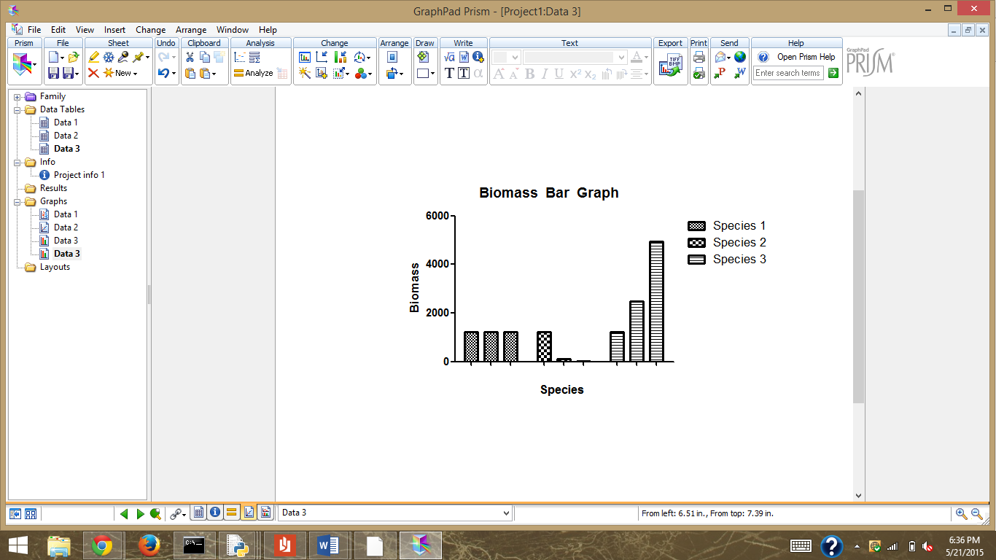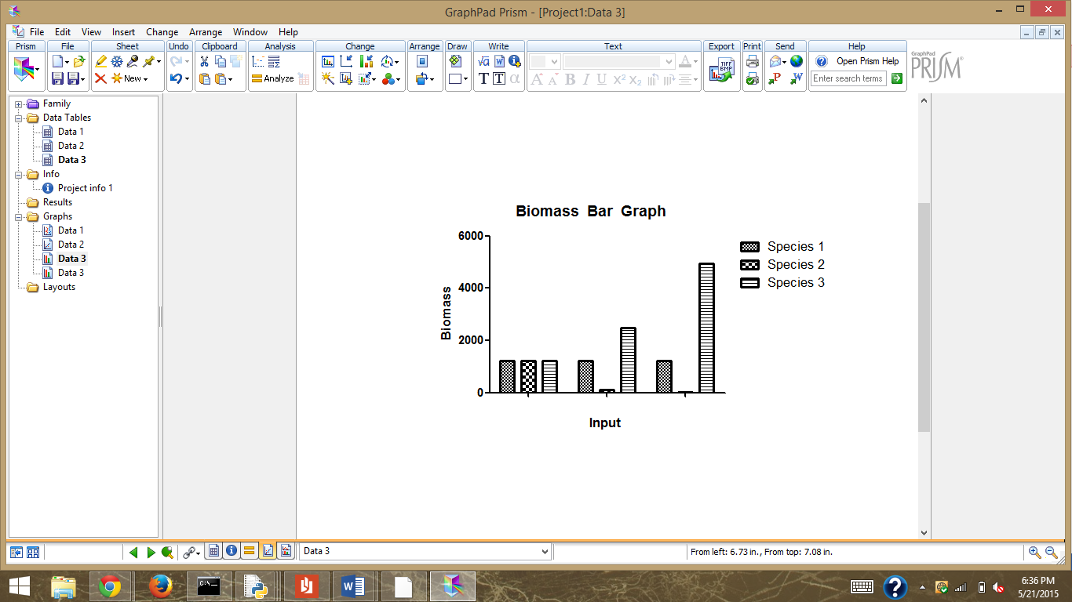

(cant decide between the two Bar graphs)

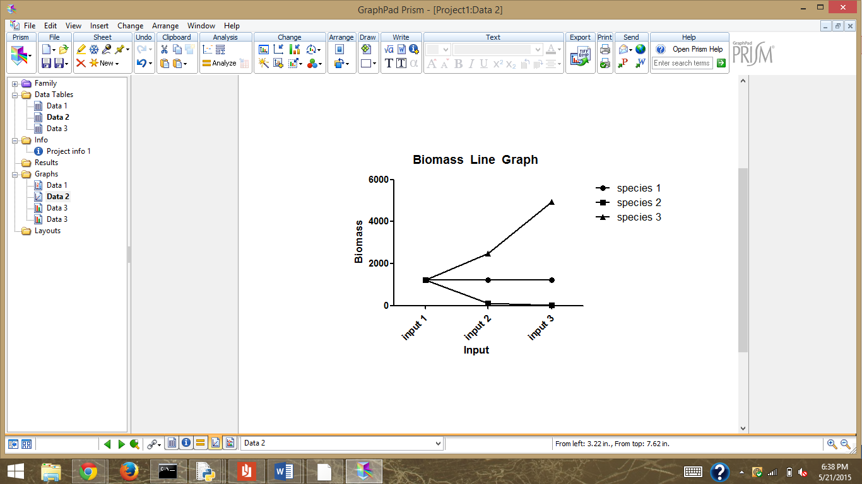

Interaction Details:

1. Call file
2. Input csv (?) file (format directions given)

The user will be given directions with every step (how detailed do we want these directions to be?)

–Select the ecosystem to be analyzed (at least 5 species) and provide the parameter estimates for the ecosystem as described in the lecture notes (lecture 15). The document should be placed in the team repo.