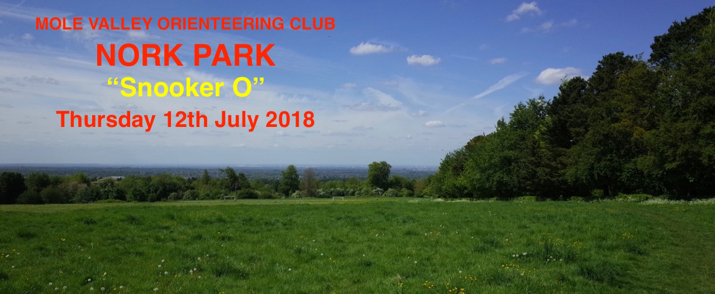
Mole Valley Orienteering Club
Nork Park
“Snooker O”
Thursday 12th July 2018
A Summer evening score event with a scoring system based loosely on the game of Snooker.
NO PREVIOUS EXPERIENCE (OF ORIENTEERING OR SNOOKER!) REQUIRED
Nork Park is situated near Epsom Downs in Surrey with far reaching views over North Surrey and beyond. The area is a gently sloping mixture of open and terraced grass fields interspersed with, and bounded by, areas of mixed woodland.
Parking: at the main car park just inside the park from the end of The Drive at MR TQ 24155890 or in The Drive itself leading up to the park entrance. For those living locally, and others, please do not enter the park from the NW (Nork Way) so as to avoid entering the competition area.
By rail: nearest stations are Tattenham Corner 2km; Epsom Downs 3km.
Registation and Start: from car park. Registation open 5.30pm. Entry on the day only. Please reserve your map by emailing the organiser; davidfisher99@virginmedia.com NOTE: to guarantee a map please let the organiser know you are coming by Tuesday 10th July latest.
Start times: 5.45pm to 7.00pm. Course closes 8.00pm
The Event: 45 minute score event with a snooker based scoring system twist. The Scoring system is a very simple one although everyone that reserves a map will be sent the rules and instructions. The same instructions will be available on the day though some pre-awareness of the rules is recommended. Time penalties will apply. Fastest times & penalties will be taken into account to decide ties.
The Map: A4, Scale 1:5000 with 5m contours, last updated in 2016 with minor organisers’ amendments.
Controls: on the map, as well as being numbered, each will have a colour and value identification to conform with the colours and points values of Snooker balls. Sport Ident electronic punching will be used and dibbers will be available at registration to hire.
Fees: Seniors £5 (£4 BOF members), Juniors £2. Sport Ident dibber hire £1
Clothing and equipment: Due to small areas of nettles and low brambles, full leg cover is advised. A whistle is recommended in case of emergency.

Safety & courtesy to others: The nearest hospital is Epsom Hospital. Details at Registation. The area is frequented mainly by pedestians and dog walkers. They must be shown courtesy at all times. Dogs are allowed on the course but please keep under control.
Results: Will be available at the MV web site as soon as possible after the event at www.mvoc.org
Planned and organised by David Fisher (MV)
Please note that if you have competed in 3 or more orienteering events registered with British Orienteering and have not joined a BOF affiliated orienteering club, then you are NOT covered by their public liability insurance.
You are responsible for your own safety and take part in this event at your own risk

