
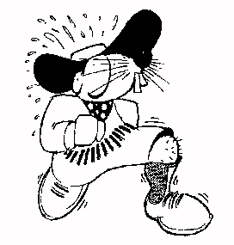
Guildford Orienteers
Invite you to the SE Score Championships event at Waggoners Wells, near Liphook
On Sunday 28th October 2001

The Event will be using Sport-Ident (SI) electronic punching.

SE Score … the rules of the game: As many runners as you want to run - no need to pre-select a team or nominate classes, best 12 scores from 12 separate classes to count, running up automatically applies

Directions: The car park is at Grid Ref : SU 853 333. There will be a parking charge of £1.00 / vehicle. The route to the car park will be signed from the A3, 1 km north of Liphook. You can only access the event from the northbound carriagway of the A3 - do not approach through Bramshott. If approaching from the north, leave the A3 at the first Liphook exit, cross over the A3, rejoin the northbound carriageway, then head north for approximately 1 km before turning left onto a minor road leading to the car park.
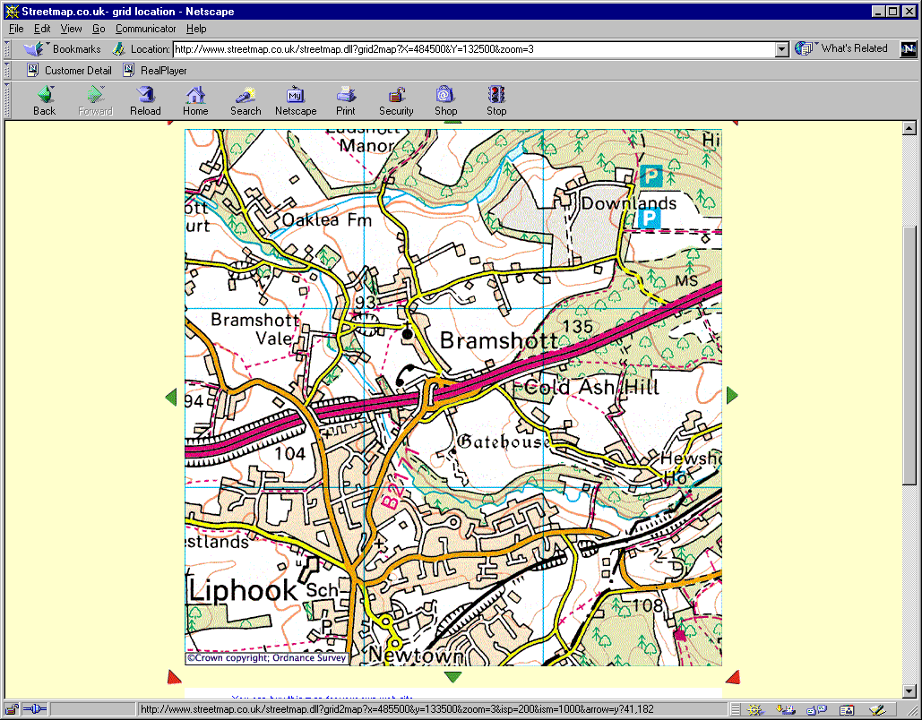
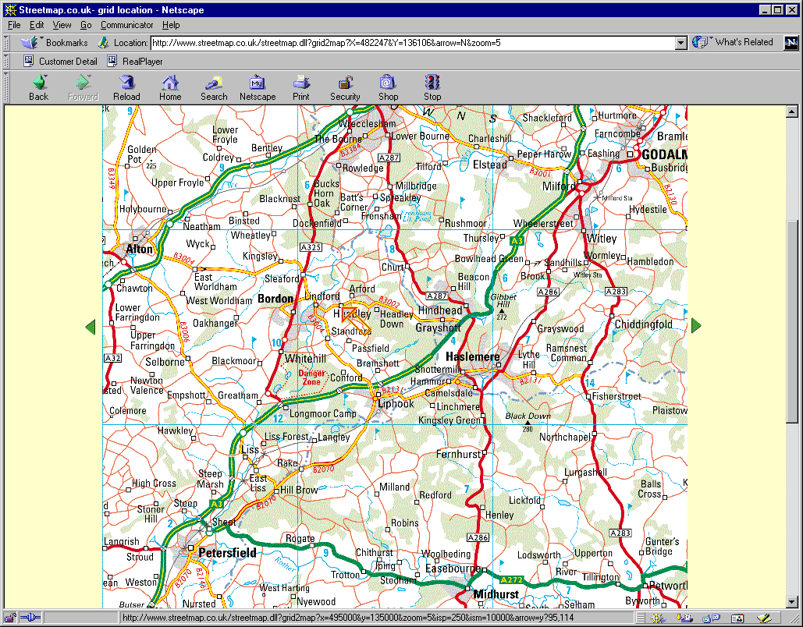
From south
From north
Car Park

Registration/Enquiries: This will be in the Car park. Registration 9.30 – 11.30. Starts from 10.00 - 12.00. Courses close at 13.30. Don't forget the clocks change on the 28th! Note: Please be ready to quote your BOF No (if any) at Registration.

Courses: 60 minute score for all age classes. Entry on the Day only. Free string course. Start and finish a flat and easy 700 m walk from the car park, string course 200 m from the car park

Fees: Seniors £4.00 / Juniors £1.50 (plus £1.00 for SI card hire if required). We hope to have overprinted maps, but come prepared for master maps just in case!

Map: 1:15,000, as used for the 2000 Badge event

Terrain: Mixture of undulating forest and heathland, mostly runnable and fast … apart from where it isn't!!

Results: Will be available on the GO Web page (http://www.go-pages.fsnet.co.uk) and by post.

Facilities: Squash at the finish. Toilets, Traders and First Aid in the car park. Dogs and cats are welcome under control.

Officials: Planner: Gary Simmons (GO)
Controller: Robin Smith (SO)
Organiser: Alastair Doyle Tel. 01428 724297
(7.00 p.m. - 9.30 p.m only please) or adoyle@zeh.co.uk

Please do not come to this event if you are in, or have to pass through, an area infected by Foot and Mouth.
COMPETITORS PARTICIPATE AT THIS EVENT AT THEIR OWN RISK.

You can find out more about GO at …. http://www.go-pages.fsnet.co.uk

