|  |  |  |
| --- | --- | --- |
|  | **Mole Valley Orienteering Club**  (affiliated to British Orienteering)  invites you to  **COME AND TRY ORIENTEERING**  **SUNDAY 23 SEPTEMBER 2018**  **Denbies Vineyard, Dorking** | C:\Users\dsullivan\AppData\Local\Microsoft\Windows\Temporary Internet Files\Content.Outlook\LY8793U6\map sample.jpg |

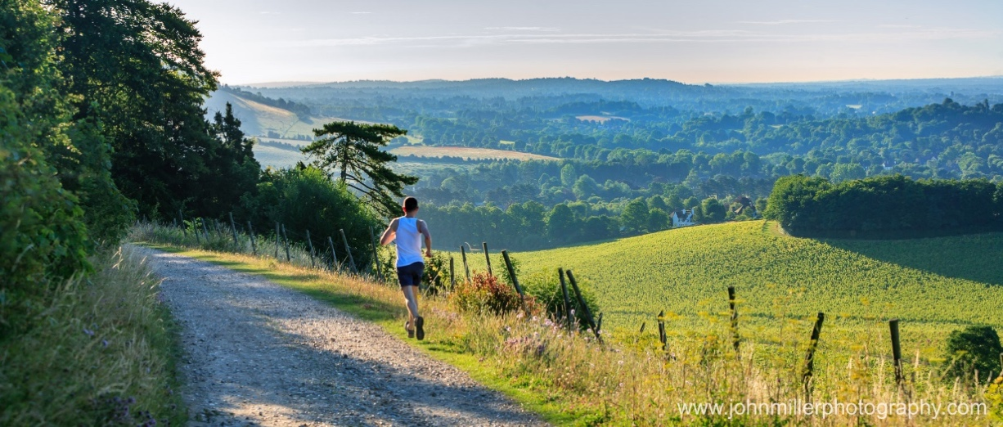

This event is part of The Surrey Hills Festival of Sport

**Parking:** Denbies Vineyard, Dorking, RH5 6AA. Follow signs for festival parking

**Registration:** We will be in the arena. Look out for the MVOC flag

**Fees:** Free

**Map:** 1:1800, 5m contours, surveyed July 2018 by Philip Gristwood using OCAD 12

**Course:**  Simple course for novice orienteers

The event will be using SportIdent electronic punching

**Registration:** From 12 noon **Start:** 12.30pm - 3pm **Course close:** 3.30pm



**Results:**  Will be emailed to runners after the event has finished

**Event Officials:** Planner & Organiser – Philip Gristwood & Deborah Sullivan.

**Please note:** Runners must not run though the vines or finishing lanes for other events.

***You are responsible for your own safety and you take part in this event at your own risk***