

**FINAL DETAILS**

**HOLMBUSH & BUCHAN**

**LEVEL C BOF RANKING NIGHT EVENT**

**Saturday 18th November 2017**

**Key points:**

**Signal early to turn off the A264 – thus is a VERY fast road! Beware finishers as approach parking**

**£1 for parking, please have correct change ready Map 1:10 000 as used at Day 3 JK 2017**

**Starts <10m from Assembly may have to be delayed until 18:00 Finish <20m from Assembly**

**Whistles/Cagoules may be compulsory if the weather justifies them Courses close 20.30 sharp**

**Safety bearing N to the dual carriageway then E or W to the farm – *but* *do not walk along the A264***

**Location and Parking**

Holmbush lies S of the A264 between Crawley and Horsham. The whole site has the postcode RH12 4SE. Please approach on the westbound carriageway via the Kilnwood Vale roundabout.

Heading west from the roundabout take the second entrance on the left into the estate – GR TQ227344, Lat/Long 51.095929, -0.24831355 – approx. 400m after the roundabout. Look for a large BOF-style O sign just before it and the big ‘PAINTBALL’ sign on the actual entrance. **Signal early.**

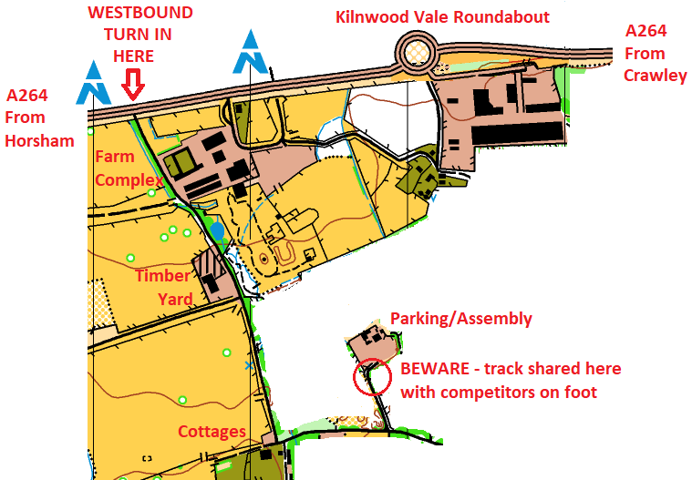

Follow this roadway southwards past the farm complex on your left, *over the speed bumps*, past the timber yard on your right and straight on down to the cottages at the southern end of the road. Then turn left into the forest and after another 150 metres left again into the car parking. **The last 20m into the car park is shared with competitors walking from the Finish to Download. Take care and drive slowly as you approach this area.** Please have your £1 parking fee ready.

Please do not arrive before 16.30 as the parking team will not be in place until then. Beware meeting the vehicles of departing paint-ballers heading the other way if you arrive early!

If you finish early and leave before 20.30 please beware the possibility of meeting finishers along this entrance route. The recommended exit route is the same as you entered by – turn West along the A264 and use the next roundabout (approx. 1 mile W) if you need to turn East back towards Crawley. Those with local knowledge may prefer to use the underpass from the farm onto the eastbound carriageway but this will not be signed by the Organiser. **Watch out for fast traffic!**

**SAFETY**

**Competitors must wear full leg cover. The current forecast is for dry, partly cloudy weather temperatures falling from 7 to 5oC over the evening. Please dress appropriately!**

**All competitors M/W14 and below must be accompanied by a responsible adult.**

**Whistles are strongly advised. Cagoules may be compulsory – in which case you will be informed by the Car Parking team. If travelling alone, please leave your keys at Enquiries.**

**There are 2 large lakes which may be used by night fishermen. Courses have been planned to avoid them, and the planner doesn't expect you to use any of the adjacent paths. To aid relocation these are not marked OOB. If you are lost and find a lake, please give fishermen and their equipment a wide berth.**

**If you become disorientated or wish to retire, head North until within sight/sound of the dual carriageway along the northern edge of the map. Then head East or West according to your last known position, to regain Holmbush Farm and then follow the route you drove in along until you reach Assembly.**

**Courses close at 20.30, *after this we may instigate a search for you*. Competitors MUST report to the Finish and Download by this time whether they complete their course or not.**

The nearest A & E Hospitals are in Redhill and Haywards Heath. Details will be held at Enquiries.

**Hazards**

Please be careful in the vicinity of all water features as their banks can be both steep and slippery. Lakes outlined in black on the map cannot be crossed.

Marshes mapped as crossable, vary as to their nature – approach with caution.

Holmbush and Buchan have many deer which may be spooked and run through the area.

Watch out for the numerous wooden structures in the paintball area and the high, black mesh, net fences – not to be climbed or crossed in any other way for your own safety.

The area is not known for its use by any unsavoury characters after dark but you may come across anglers and/or local residents out for a walk – please be courteous.

**Course Details**

|  |  |  |  |  |
| --- | --- | --- | --- | --- |
| **Course** | **Length** | **Climb** | **Controls** | **Difficulty** |
| Chocolate (night Brown) | 5.9km | 125m | 21 | Hard |
| Navy (night Blue) | 4.6km | 65m | 15 | Hard |
| Olive (night Light Green) | 2.8km | 50m | 16 | Moderate |
| Ochre (night Orange) | 2.0km | 30m | 15 | Easier, but it's still dark out there ☺ |

Start and Finish are both adjacent to Assembly. The Finish is on the parking access road with a punch each side. **Please use the punch on the side you approach from, do not race across the road!** And then please download before returning to your car, even if cold and wet.

**Start Times –** we areaiming for17:30 but may have to delay until 18:00 if we can’t access the paintball site early enough to get all the controls out in time. Last start 19:00. Courses close at 20:30. *If you expect to be out for a long time please start early!*

**Map/Terrain notes**

* The map is as used for Day 3 of the JK this year – 1:1000 updated by Mike Elliot Oct 2017
* Courses do not cross any public roads, nor should you need to run along one.
* The paintball area contains many man-made features. Only the larger ones are mapped.
* Some “blue” features, including some used as control sites, are completely dry. Other “blue” features, again including some control sites, are still very wet!
* The paintball area contains some high black mesh fences. These are impossible to cross. However some mapped paths do go through small gaps in said fences.
* Paths covered with leaves can be hard to follow.
* All fenced fields are OOB but are not marked as such, to aid relocation.
* Some of the larger paintball buildings have been used as control sites. The control will be inside the building. You may have to skirt around the edge to find a door.
* A black cross on the map is a man-made object, either a branch hide or a helicopter. The black cross in the control descriptions is the helicopter.

**Facilities**

We are grateful to Holmbush Paintball for the use of their site as our Assembly area. It enjoys the benefit of a dry well compacted gravel/hard-core area for parking and a number of sheltered spaces with benches and tables should you fancy a picnic after your run!? Certainly a nice area in which to meet and compare notes with your friends and fellow club members after your run.

There are two portaloos in the car park. We shall not be providing water or any refreshments – please bring your own.

NB: There is no scope for overnight parking/camping – the gate will be locked when we leave.

**Apres O**

There is no organised post-event pub and indeed the organising team will be too busy collecting controls to visit one. However, competitors wanting a reasonably priced meal and/or drink may like to try the Cherry Tree, RH12 4SA. Exit onto the A264 as above, straight on at the first roundabout. Use the next one to return eastbound and the pub is on your left. Food is normally served until 9pm.

**EOD**

Registration will open at 17:00. £10 for Seniors (+£2 for non-BOF members) and £5 for Juniors, dibber hire (£1). Registration, Enquiries and Download will be located under one of the aforementioned shelters. Entry on the Day will be available whilst map stocks last. *Please email the organiser to pre-book a map rather than travel in hope only to be disappointed.*

**Dogs**

Allowed but only if well behaved and kept on a lead, so that they don’t chase rabbits, deer, sheep or fishermen!

**Officials**

**Planner** Ian Ditchfield, MV

**Controller** Mike Elliot, MV

**Organiser** Mike Bolton, MV [mvocevent@gmail.com](mailto:mvocevent@gmail.com) 0791 555 3282 (before 21:00)

**Thanks**

We are grateful to the Calvert family, owners of Holmbush estate, for making the land available and to Will Walters the Estate Manager for his help and support. Our thanks also to Holmbush Paintball for the use of their land and West Sussex County Council for the use of Buchan Country Park.

**\*\* A full risk assessment has been undertaken by the Organiser and will be available for inspection at Enquiries. However competitors are reminded that they take part at their own risk and are responsible at all times for their own safety.**