



**Mole Valley Orienteering Club**

(affiliated to British Orienteering)

Invites you to

**Nonsuch Park**

**Greater London Orienteering Summer Series**

**Sunday 21 July 2019**

Held in conjunction with 40th Surrey Hills Race

**Sunday 11th June 2017**

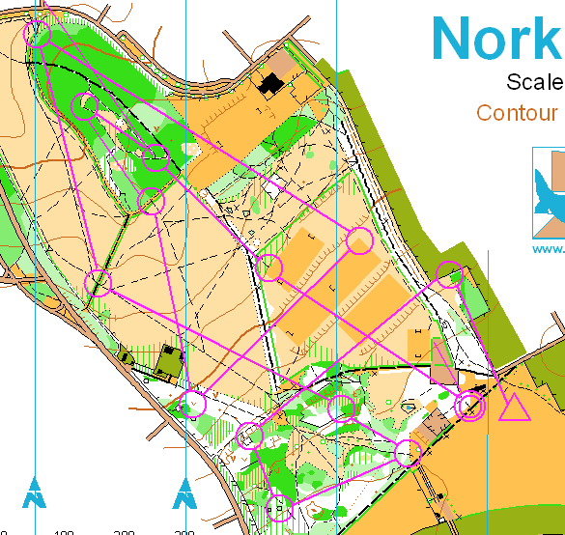

**The GLOSS is an annual handicap competition between South East Orienteering Clubs in which all club members run the same course and the handicapping system means that it is very unlikely that the fastest runner will win!**

**You will also enjoy this event if you are new to orienteering. Please come along and try a course designed for newcomers.**

**Members of Mole Valley Orienteering Club will be on hand to give help and advice.**

**NO PREVIOUS EXPERIENCE OR EQUIPMENT NEEDED**

**Parking:** Shared with the public off A232 Cheam Rd (SM3 8AJ). Enter the park through the Cheam Gate and our assembly area will be at the western end of the left hand car park. Cheam railway station (7min walk). **Toilets available at the Mansion house.**

**Entry / Registration:** Entry on the day only. Registration near the car park.

**Fees:** Seniors £6, Families and Juniors £3. SI electronic punching will be used and dibbers for this will be available for hire from registration for £1 (lost dibbers £30)

**Courses:**  Light Green GLOSS course c4km with optional extension c3km – for experienced orienteers Yellow course for beginners c2km

**Registration:** 10:00 – 11:45. **Starts:** 10.30am - 12.00pm. **Courses close 13.30pm**

**Results:** Will be available at the MV Web site as soon as possible after the event [www.mvoc.org](http://www.mvoc.org/) Details of the GLOSS series can be found here <http://londonorienteering.co.uk>

**Event Officials:** Organiser Deborah Sullivan (MV). Planner George Engelhardt (MV). General information: [info@mvoc.org](mailto:info@mvoc.org)

You are recommended to carry a whistle in case of emergency and full leg cover. As a safety check, you must report to Download. Please note that if you have competed in three or more orienteering events registered with British Orienteering and *not* joined an orienteering club which is a member of British Orienteering then you are not covered by their public liability insurance

***You are responsible for your own safety and you take part in this event at your own risk***