



**Mole Valley Orienteering Club**

(affiliated to British Orienteering)

Invites you to

**Nonsuch Park**

**Greater London Orienteering Summer Series**

**Sunday 21 July 2019**

Held in conjunction with 40th Surrey Hills Race

**Sunday 11th June 2017**

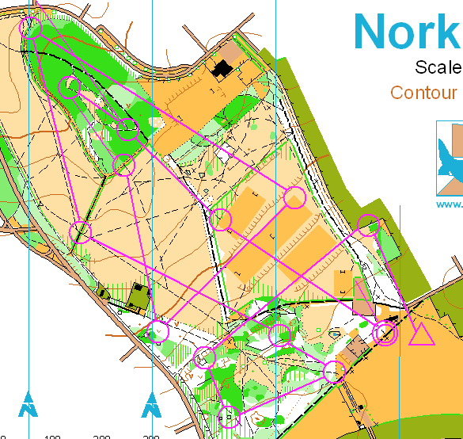

FINAL DETAILS

**The GLOSS is an annual handicap competition between South East Orienteering Clubs in which all club members run the same course and the handicapping system means that it is very unlikely that the fastest runner will win!**

**You will also enjoy this event if you are new to orienteering. Please come along and try a course designed for newcomers.**

**Members of Mole Valley Orienteering Club will be on hand to give help and advice.**

**NO PREVIOUS EXPERIENCE OR EQUIPMENT NEEDED**

**Parking:** Shared with the public off A232 Cheam Rd (SM3 8AJ). Enter the park through the Cheam Gate and our assembly area will be at the western end of the left hand car park. Cheam railway station (7min walk). **Toilets available at the Mansion house.**

**Entry / Registration:** Entry on the day only. Registration near the car park.

**Fees:** Seniors £6, Families and Juniors £3. **SIAC will be enabled** and these can be hired at a cost of £2 (lost dibbers £60). Non SIAC dibbers can also be hired from registration for £1 (lost dibbers £30)

**Courses:**

Yellow course for beginners 2.6 km 20 m 11 controls

GLOSS (Light Green) 4.0 km 30 m 13 controls

GLOSS + Extension 7.0 km 50 m 23 controls

There are a couple of short, but surprisingly steep banks on the Extension, which may be a struggle to get up in ordinary trainers, so runners might like to choose to run in studs or similar.

It's perhaps also worth mentioning that the summer undergrowth makes vegetation boundaries and runnability significantly different in some places from their depiction on the map, and that in wooded areas there are a number of unmapped minor paths and fallen trees, and that many water features are completely dry at the moment.

**Registration:** 10:00 – 11:45. **Starts:** 10.30am - 12.00pm. **Courses close 13.30pm**

**Results:** Will be available at the MV Web site as soon as possible after the event [www.mvoc.org](http://www.mvoc.org/) Details of the GLOSS series can be found here <http://londonorienteering.co.uk>

**Event Officials:** Organiser Deborah Sullivan (MV). Planner George Engelhardt (MV). General information: [info@mvoc.org](mailto:info@mvoc.org)

You are recommended to carry a whistle in case of emergency and full leg cover. As a safety check, you must report to Download. Please note that if you have competed in three or more orienteering events registered with British Orienteering and *not* joined an orienteering club which is a member of British Orienteering then you are not covered by their public liability insurance

***You are responsible for your own safety and you take part in this event at your own risk***