Project: Diamond Prices

Complete each section. When you are ready, save your file as a PDF document and submit it here: [https://classroom.udacity.com/nanodegrees/nd008/parts/235a5408-0604-4871-8433-a6d670e37bbf/project#](https://classroom.udacity.com/nanodegrees/nd008/parts/235a5408-0604-4871-8433-a6d670e37bbf/project)

# Step 1: Understanding the Model

*Answer the following questions:*

1. According to the model, if a diamond is 1 carat heavier than another with the same cut, how much more should I expect to pay? Why?

The price of the diamond with the highest carat will be 8,413 higher the diamond with the lower carat. This is because the weight of the carat is 8,413 meaning that each carat is multiplied by this amount. If all other characteristics are the same, the only difference will be an extra carat or 8,413 dollars more.

1. If you were interested in a 1.5 carat diamond with a **Very Good** cut (represented by a 3 in the model) and a **VS2** clarity rating (represented by a 5 in the model), how much would the model predict you should pay for it?

The predicted retail price for this diamond is US $10,094.8 and the recommended price for the company will be US $9,413.8 which is equivalent to 70% of the predicted retail price. The company I work for should pay no more than US$9,413.8 in the auction for this diamond.

# Step 2: Visualize the Data

Make sure to plot and include the visualizations in this report. For example, you can create graphs in Excel and copy and paste the graphs into this Word document.

1. Plot 1 - Plot the data for the diamonds in the database, with carat on the x-axis and price on the y-axis.
2. Plot 2 - Plot the data for the diamonds for which you are predicting prices with carat on the x-axis and predicted price on the y-axis.
   * **Note**: You can also plot both sets of data on the same chart in different colors.
3. What strikes you about this comparison? After seeing this plot, do you feel confident in the model’s ability to predict prices?

The predicted prices are closer to each other than the values in the database. I added the clarity to the plot and it seems that the model is not correctly correcting for this particular feature. It looks like the model is better at predicting lower clarity diamond prices and is off mark for the higher clarity diamonds. I would not trust the model for higher clarity diamonds at this point. This can be corrected maybe by estimating a new model with more weight on the clarity.

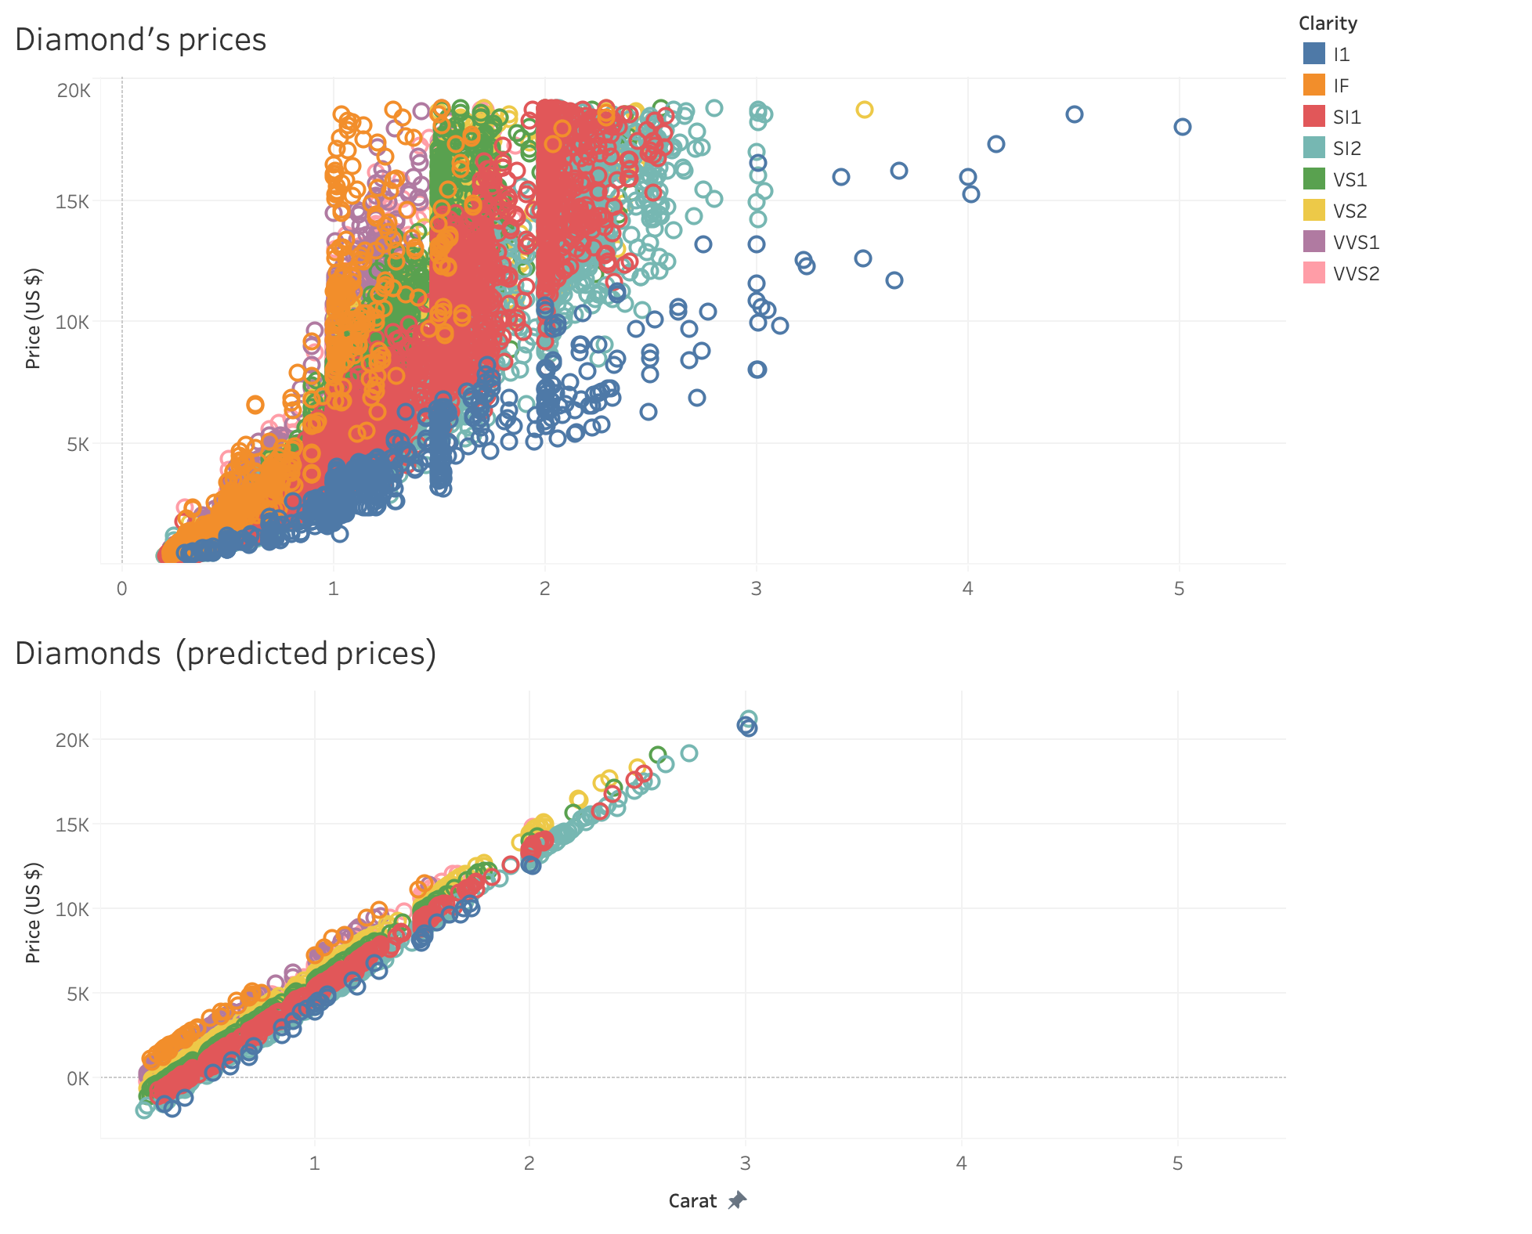

# Step 3: Make a Recommendation

*Answer the following questions:*

1. What price do you recommend the jewelry company to bid? Please explain how you arrived at that number.

I would suggest to buy the diamonds at the 70% of the predicted values for all diamonds. This number will allow for an average 30% gross profit (GP), which is what the company usually buys the diamonds for and therefore should be the expected GP for these set of diamonds.