**Title:** Why collide muons?

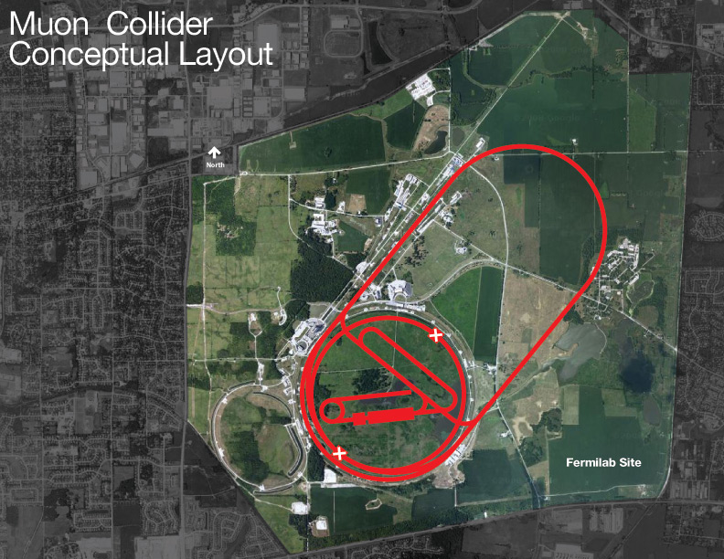

**Image caption:** Possible layout of a future muon collider on the Fermilab site. See [Muon Accelerator Program (MAP) website](http://map.fnal.gov/muon-collider/graphics.shtml) for details.

**Main text:**

Although hundreds of particles have been discovered in the aftermath of collisions, only a few have ever been used as the colliders. Electrons and protons are the most common projectiles, though some experiments take advantage of photons within the beam to study photon collisions, while others smash heavy ions (which are made of protons and neutrons, collectively called hadrons). More exotic beams bombard stationary targets, but only electrons and hadrons have been aimed at each other.

Electrons and protons each have disadvantages, though. Protons are complicated objects made of quarks and gluons, and only one quark or gluon from each proton actually collides: The rest complicate the event picture, adding uncertainty to the scientific result. Electrons are known for producing a clean, well-understood initial state, but only at low energies. When electrons are accelerated in a circle, they quickly lose the energy that each revolution adds because rounding the bend causes them to radiate. One way to avoid this problem is to accelerate electrons in a straight line, known as a linear collider, but then they can't be accelerated more than once.

Both problems could be solved by colliding beams of muons. Muons are like electrons in all ways except that they are 200 times heavier and decay in a millionth of a second. Muon collisions would produce a clean initial state like electrons, but lose two billion times less energy as they circulate in the beamline because energy loss depends so strongly on the particle's mass. Furthermore, muon collisions at the right energy produce Higgs bosons 40,000 times more often than equivalent electron collisions, and an intense source of muons decays to neutrinos, providing a bright neutrino beam as a bonus.

However, the big problem is that muons decay. Even though accelerating muons to relativistic speeds extends their lifetime, they still decay in a fraction of a second. Moreover, muons must be produced in collisions, which results in a broad distribution of trajectories. Those far-flung muons need to be collected into a tight beam, a process known as “cooling” because random motion must be reduced, like cooling a gas. The techniques ordinarily used to cool a beam are too slow — the muons would decay before they've cooled.

New techniques are being developed to solve these problems. The MuCool Test Area ([MTA](http://mice.iit.edu/mta/)) and International Muon Ionization Cooling Experiment ([MICE](http://mice.iit.edu/)) are testing the prospect of cooling muon beams by passing them through a material to absorb random motions (ionization cooling). The Muon Accelerator Program ([MAP](http://map.fnal.gov/)) organizes this research within the Department of Energy, with the goal of proving that a muon collider is feasible. A staged approach has even been proposed that would fit on the Fermilab site (see figure above), which could mean that a radically new type of collider is in Fermilab's future.