**Title:** One measurement, many implications

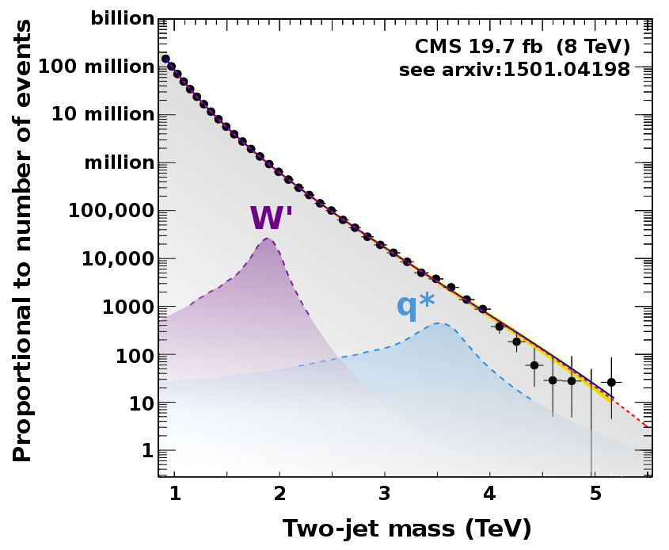

**Image caption:** Distribution of mass calculations for pairs of jets: Black points are real data and colored peaks show what two sample models would look like (W' and excited quarks). See [the paper](http://arxiv.org/abs/1501.04198) for detailed plots.

**Main text:**

Four months ago, I wrote about a CMS result that had implications for [three distinct theories](http://www.fnal.gov/pub/today/archive/archive_2014/today14-09-19.html) of new physics. I spoke too soon — a [new result](http://arxiv.org/abs/1501.04198) constrains seven.

In this new measurement, CMS scientists identified proton collisions that produce two [jets](http://www.fnal.gov/pub/today/archive/archive_2014/today14-05-30.html) and, assuming that these jets are the only products of a single-particle decay, they computed the mass of that particle. In most cases, the two jets don't really come from a particle with a well-defined mass, so this interpretation produces a smooth distribution of masses.

Many theories of new physics predict new kinds of particles, and many of them would decay into pairs of jets. If one of these new particles exists, it would show up in the two jet mass plot as a narrow peak at a single mass on top of the smooth distribution. In a recent paper, CMS scientists extended the search for peaks up to 5 TeV. Since they didn't see any, they systematically excluded theoretical models within that mass range.

I have oversimplified the search procedure a bit: The scientists used additional tools, such as methods to determine the the jets came from b quarks, and tuned some searches for special cases, such as wide jets. This paper actually represents a constellation of new physics searches based on the central theme of peaks in the two jet mass distribution.

In rapid succession, the models are: (1) Resonances from [string theory](http://en.wikipedia.org/wiki/String_theory), on the assumption that the energy scale for string theory is [much lower than it appears to be](http://en.wikipedia.org/wiki/Large_extra_dimension); (2) Scalar diquarks from [grand unified theories](http://en.wikipedia.org/wiki/Grand_Unified_Theory); (3) Excited quarks from oscillations of [smaller particles that might be inside of the quarks](http://en.wikipedia.org/wiki/Preon); (4) Axigluons and colorons, which would be heavy cousins of gluons in [extended models of the strong force](http://en.wikipedia.org/wiki/Chiral_color); (5) [W' and Z'](http://en.wikipedia.org/wiki/W′_and_Z′_bosons), heavy cousins of the W and Z bosons that comprise the weak force; (6) [Randall-Sundrum](http://en.wikipedia.org/wiki/Randall–Sundrum_model) gravitons, or gravitons oscillating between our string-theory brane and another; and (7) [Microscopic black holes](http://en.wikipedia.org/wiki/Micro_black_hole). Yes, these are the hypothetical black holes that caused so much controversy just before the LHC turned on, and there's still no sign of them.