**Title:** Protons in the PET scanner

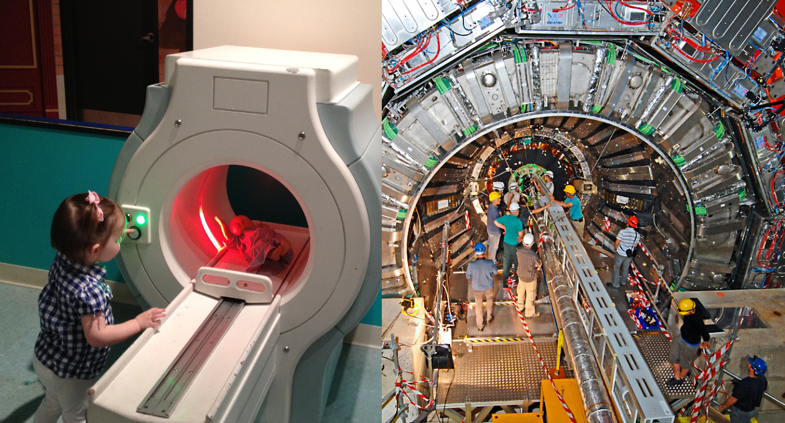

**Image caption:** Despite the difference in scale, medical PET scanners and the CMS experiment both observe the remnants of particle collisions and use them to reconstruct the source.

**Main text:**

Antimatter is becoming increasingly common in medical technology. One technique, called positron emission tomography (PET scan), follows the flow of a positron-emitting fluid through the body. Wherever an antimatter positron encounters a normal-matter electron, the pair annihilates and produces particles whose trajectories point back to the point of annihilation, allowing a computer to reconstruct the shape of structures in the body.

Orders of magnitude smaller and at orders of magnitude higher energies, CMS scientists are using a similar technique to reconstruct the shape of a single proton. A proton is not a smooth sphere or a pinpoint — it is a [seething ball](http://www.fnal.gov/pub/today/archive/archive_2012/today12-02-17.html) of quarks, antiquarks, and gluons that are constantly annihilating each other and creating new matter-antimatter pairs. If you could zoom into a proton, you would see more high-energy, short-lived quarks and antiquarks the closer you looked. But exactly how many more at each level of magnification is so difficult to calculate theoretically that it can only be measured and parameterized.

Whenever two protons collide, most of their constituent particles [miss each other](http://www.fnal.gov/pub/today/archive/archive_2011/today11-10-28.html) — usually only one part of each proton actually hits the other. When one of the stricken particles is a quark and the other is an antiquark, they annihilate and may create an electron-positron pair or a muon-antimuon pair, which are observed by the CMS detector. The frequency of these collisions, relative to their energies and the angles of their trajectories, allows scientists to actually see the proton at different levels of magnification.

The CMS collaboration [recently published](http://arxiv.org/abs/1412.1115) a thorough study of quark-antiquark to electron-positron and muon-antimuon pairs, known collectively as Drell-Yan scattering, as a function of several variables: the incident beam energy (7 and 8 TeV), the energy of the recoiling particle-antiparticle pair and their angles relative to the beamline. These measurements are so precise that they can be used to improve models of the shape of the proton: Some variations of the model parameters are compatible with the measurement, others are not. In that sense, it is like a scan of the shape of the proton.

This measurement has implications beyond just understanding the proton better: Nearly every other LHC result depends on these models. Measuring Drell-Yan scattering with exquisite precision is an indirect way of shrinking uncertainties in Higgs discoveries and extending the reach of hundreds of searches for new physics.