**Title:** The strong/weak force

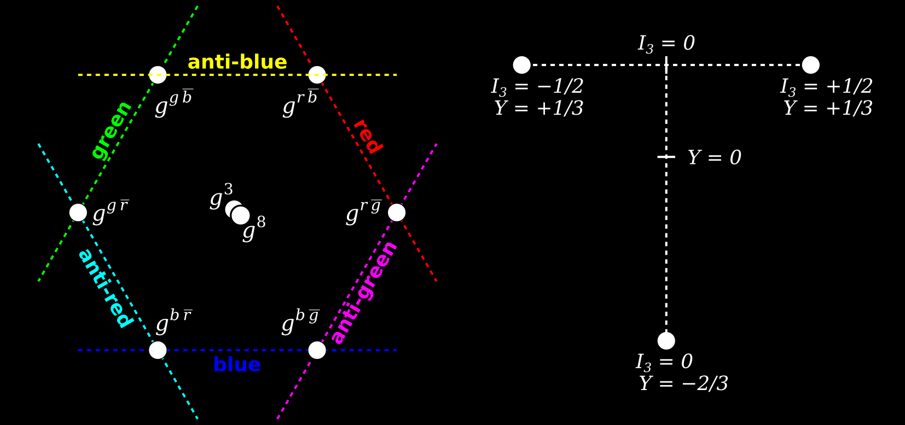

**Image caption:** The symmetries of the strong force (left) and the weak force (right) might be unified in a suite of particles that transform as a color-octet weak-triplet. (Strong force charges are called “colors” merely because they are built from three fundamental values, like the primary colors).

**Main text:**

When describing a result from the CMS experiment, I usually try to relate it to everyday experience because it reminds me that the esoteric phenomena observed in the LHC are as much a part of our world as the arc of a falling ball. These connections are more than metaphors because physics at all scales follows the same general principles, such as energy conservation, angular momentum and wave dynamics. However, [the result I’ll be describing here](http://arxiv.org/abs/1505.08118) is unlike anything we see in everyday life.

Of the four fundamental forces, the strong force and the weak force are the only two that have no visible effect on the macroscopic world (which is also why they never got good names). The strong force holds quarks together with gluons and the weak force slowly transmutes particles via *W* and *Z* bosons. As far as we know, these forces are unrelated, but there might be hidden relationships between them, waiting to be discovered.

For instance, there could be one fundamental kind of force that appears as two distinct interactions in low-energy experiments, where “low energy” means everything from daily life up to the LHC. To predict how a strong/weak force might behave, physicists generalize from the symmetries of the strong and weak forces separately and propose a new symmetry that combines them, the way that a drawing with both left-right symmetry and top-bottom symmetry must have four corners with the same shape.

For the strong/weak force, this means there would be new particles called color-octet weak-triplets (Θ−, Θ0, Θ+ with 8 color combinations). The neutral Θ0 would decay into a gluon (which only has strong-force charge) and a *Z* boson (which only has weak-force charge) or pairs of quarks such as b-quarks (which already have both kinds of charge, but not as an octet). These Θ0 particles would be produced in pairs, resulting in final states with all four decay products: a gluon jet, a *Z* boson, and two b-quarks. No combinations like this were observed in the CMS data, beyond the level expected from familiar processes, so this analysis rules out the possibility that Θ0 particles exist with a mass less than half a TeV.

However, heavier Θ0 particles might still exist, and the higher-energy [LHC Run-II](http://www.fnal.gov/pub/presspass/press_releases/2015/LHC-Run-II-20150603.html) might reveal them. Not only would this [connect the strong and weak forces](https://en.wikipedia.org/wiki/Grand_Unified_Theory), but it could also [explain how the Higgs mass can be as low as it is](https://en.wikipedia.org/wiki/Hierarchy_problem), because the Higgs could be a composite of particles bound by this strong/weak force.