**Title:** Keeping cool

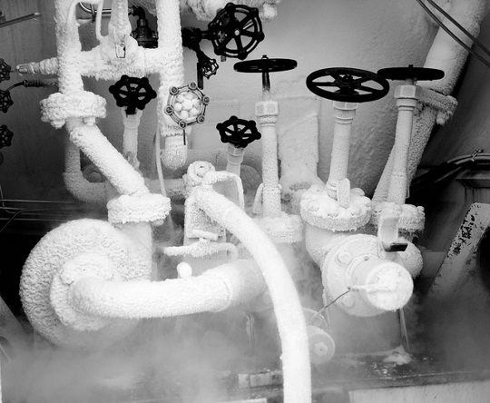

**Image caption:** Liquid nitrogen plumbing often develops a layer of ice, even in the summer [[source](http://blog.uraniumbackup.us/why-you-shouldnt-put-your-drive-into-the-freezer/)].

**Main text:**

How do you cool off in the summer? A cold drink? A dip in the pool? Air conditioning? I guarantee that it involves making something else hotter: The second law of thermodynamics requires heat to flow from high temperatures to low temperatures, unless additional energy is added to the system. Cooling off with water heats up the water, and air conditioners expel more heat outside than they extract from inside. Try standing next to an air conditioning exhaust on a hot day!

Cooling is a major part of particle physics experiments as well. Even if they’re deep in a mine or otherwise protected from the weather, many subsystems of the experiment either generate heat or only work at very low temperatures, and each of these subsystems requires a cooling system.

The farms of computers used to analyze and [collect data](http://www.fnal.gov/pub/today/archive/archive_2015/today15-06-25.html) for an experiment are designed with cooling in mind. Part of that cooling is accomplished with air flow like the fan in your laptop, but with circulating channels built into the data center to ensure good flow. Some also use tubes of water to take excess heat away, even though the water, if it spilled, could damage the electronics.

Silicon detectors are great for high-precision [charged particle tracking](http://www.fnal.gov/pub/today/archive/archive_2015/today15-03-19.html), but suffer from an ironic flaw: They can be destroyed by radiation at room temperature. However, keeping the silicon near 0°C helps it survive, even when inundated by particles from a collision experiment. The CMS tracker [recently upgraded](http://home.web.cern.ch/about/updates/2014/03/cool-running-cms-tracker) its fluorocarbon cooling system to deal with the higher collision rates expected in LHC Run 2. It can now be kept at −25°C, a typical winter day on the coast of Antarctica.

The most extreme coolant is needed for superconducting magnets. The [coils of wire](http://www.fnal.gov/pub/today/archive/archive_2015/today15-05-28.html) in these electromagnets are made of niobium-titanium, which has no electrical resistance at 10°K, ten degrees above absolute zero. To reach this temperature, you need something even colder.

Most magnet cryogenics use an outer layer of liquid nitrogen at 77°K and an inner layer of liquid helium at 2°K. The helium is in an exotic state of matter, a superfluid that flows with no viscosity and is a million times more thermally conductive than ordinary helium at 3°K. It’s an example of a large-scale quantum phenomenon, with bizarre properties such as [quantum vortices](https://youtu.be/SlXIOeOkKxU) and [perpetual fountains](https://youtu.be/2Z6UJbwxBZI), but for particle physics experiments, it’s just a good coolant.