**Title:** Looking inside Schrödinger’s box

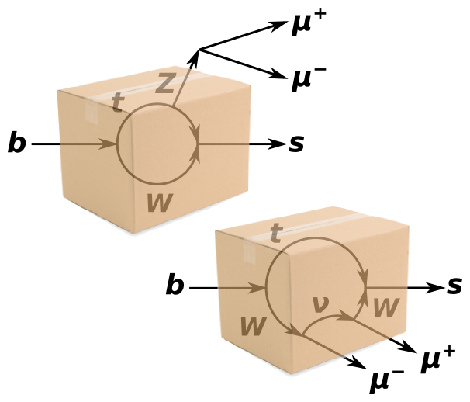

**Image caption:** Two ways that a b-quark can turn into an s-quark and µ+µ−. Everything inside the box is fundamentally unobservable, so both of these processes are happening at the same time, like the two states of Schrödinger’s cat.

**Main text:**

In a famous thought-experiment, Erwin Schrödinger proposed putting a cat in a box with a quantum mechanical device that may or may not kill the cat. Until the box is opened, the cat is both alive and dead.

There are many reasons why this can’t be done in practice, one of which is that you can’t make the walls of the box opaque enough to truly hide all information. However, particle physicists regularly deal with an analogue of the cat-in-a-box: intermediate particles that are too short-lived to be observed. These particles disappear before they can interact even once with their environment, so they are completely hidden.

Take, for example, the subject of a [recent study](http://arxiv.org/abs/1507.08126) by CMS scientists, B0 → K∗0µ+µ−. The B0 meson (which is a b-quark bound to a light quark) decays into three particles: K∗0 (which is an s-quark bound to a light quark), µ+ and µ−. For this decay to be possible, nature must find a way to connect the one-particle initial state to the three-particle final state using fundamental interactions. In the Standard Model, negatively charged b-quarks cannot transform directly into negatively charged s-quarks, so you might think that this decay can never occur.

Two possible solutions are shown above, and both involve a pair of transformations: b-quark to t-quark and t-quark to s-quark. Either way, short-lived particles are needed to bridge the gap. Much like Schrödinger’s unfortunate cat, the two intermediate processes are both happening at the same time: the t-W-Z loop lives and dies in the same place at the same time as the t-W-ν-W loop. All of the final particles can be fully reconstructed as [tracks](http://www.fnal.gov/pub/today/archive/archive_2015/today15-03-19.html), so physicists can see evidence of the two realities mixing in their [angular distributions](http://www.fnal.gov/pub/today/archive/archive_2013/today13-10-25.html).

Exciting as it sounds, that part is old news. This analysis was performed because the two overlapping Standard Model solutions might not be the only ones. If as-yet undiscovered particles interact with any of the above, there might be a third way to get from from a B0 meson to K∗0µ+µ−, further distorting the angular distributions.

This could even happen if the new particle is too heavy to create directly. Short-lived intermediaries can exist with different masses than their real counterparts, so they can be observed this way even if they are beyond the reach of the LHC. Nothing unusual was seen this time, further tightening constraints on new physics.