**Title:** Is the universe expanding or am I shrinking?

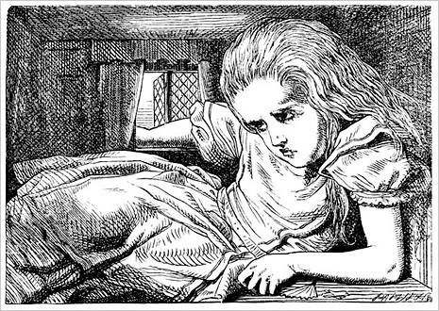

**Image caption:** Alice only knows she's getting bigger because the room isn't.

**Main text:**

It is a well-established fact that the universe is expanding. It grows without center, like an inflating raisin cake, but an infinite raisin cake filling all of space in all directions. The raisins are the galaxies.

A problem I've had with this explanation is that if everything were to double in size — galaxies, houses, you and me, rulers — then we'd never notice. I might be a towering giant, but if the room is equally huge, I wouldn't know.

The key point is that the raisins do not grow with the cake. Imagine cake batter so full of raisins that they're pressed against each other when you first put the cake in the oven, but by the time it's done, there's only one raisin per mouthful. This would be a better analogy, but it raises another question: How do we know the raisins aren't shrinking?

What if the distances between galaxies are fixed, but everything except those distances are getting smaller? Or somewhere in between— the universe grows a little while we shrink a little. For that matter, where should we put the boundary line between the scales that grow relative to the scales that shrink?

Fundamentally, the expansion of the universe is described by [one ratio that relates lengths in space with durations in time](https://en.wikipedia.org/wiki/Scale_factor_(cosmology)). As time passes, this ratio changes. The ratio, length divided by time, is a speed, and it's usually interpreted as a constant speed of light divided by a growing factor. But suppose we instead say that the speed of light (and all other particles, proportionally) slows down?

What would happen if all particles suddenly slowed down? Planets would fall in closer to the sun. Electron orbits would fall closer to the nuclei of atoms. Molecular bonds would shorten. Basically, all physical objects and bound systems would shrink, but the distances between unconnected systems would stay the same.

Alternatively, what would happen if particle speeds were left alone but the spaces between them were to suddenly increase, inflating them like marshmallows in a microwave? They'd fall back to their natural sizes, like a marshmallow taken out of the microwave. The space between marshmallows would grow relative to the sizes of the marshmallows.

Regardless of how we interpret the underlying theory, we have the same picture: distances between objects increase relative to the sizes of those objects. But that shouldn't be a surprise, since we're talking about the same physics theory in two different ways. It's all a matter of perspective.