Section 1 — Question 1

Question: Read Table 1 on its own first. What's your read on the health of this funnel? Where's the biggest problem, and how confident are you?

My read: Table 1 alone doesn't show whether the funnel is healthy; I'd first compare it with targets. The biggest drop is from Onboarding to Adoption: 960 accounts reached onboarding, but only 424 reached adoption (44.2%). That leaves 536 (55.8%) that didn't progress.

Other concern: Expansion converts just 89 of 424 adopted accounts (21.0%). But over 90 days, I'd check whether those accounts had enough time to expand before calling this the bigger problem.

Confidence: High in the calculations, moderate in the diagnosis. Table 1 combines SSF and Sales-led accounts, so I can't yet tell what's driving the drop.
Overall funnel conversions

Stage | Accounts | Rate / basis
LeadGen | 1,620 | -
LeadDev | 1,164 | 71.9% of LeadGen
Sales | 260 | -
Onboarding | 960 | 82.5% of LeadDev
Adoption | 424 | 44.2% of Onboarding
Expansion | 89 | 21.0% of Adoption

Section 1 — Question 2

Question: Now use Table 2. Does your answer change? Show the specific numbers that drive your conclusion. (You'll need to compute conversion rates the tables don't give you.)

What changed: The split points me toward SSF. Only 305 of 744 SSF accounts reached adoption (41.0%), versus 119 of 216 Sales-led accounts (55.1%) — a 14.1 percentage-point gap.

Why it matters: SSF accounts for 439 of 536 accounts that didn't reach adoption (81.9%). But SSF also makes up 77.5% of all onboarded accounts, so its lower adoption rate is a stronger signal than the larger count alone.

Other evidence and next step: Expansion among adopted accounts is 12.5% for SSF (38/305) versus 42.9% for Sales-led (51/119). LeadGen → LeadDev is similar for both (about 72%). I'd investigate the SSF onboarding and adoption journey first, then compare customer profiles and support. These numbers show a gap, not its cause.

Conversion rates by acquisition motion

Conversion | SSF | Sales-led
LeadGen → LeadDev | 72.0% | 71.4%
LeadDev → Sales | - | 86.7%
Sales → Onboarding | - | 83.1%
LeadDev → Onboarding (overall) | 86.1% | 72.0%
Onboarding → Adoption | 41.0% | 55.1%
Adoption → Expansion | 12.5% | 42.9%

Section 1 — Question 3

Question: One motion has no Sales row. What does that structural difference imply, if anything, for what happens to those accounts later?

What changes: SSF accounts skip Sales, while Sales-led accounts go through a Sales or partner process and receive a CSx owner from onboarding. SSF may have less structured human guidance as they move through onboarding and adoption.

Why it matters: SSF adoption is lower (41.0% vs 55.1%), as is expansion among adopted accounts (12.5% vs 42.9%). Less human guidance might contribute, but it isn't proven. Sales-led customers may have different needs or intent, and Sales filters which accounts move forward.

Section 2 — Question 1

Question: The Account A timeline above was written by a person. Using only the raw event data, what would you compute to arrive at the same read — and what in the written timeline can you not actually derive from these events?

What I'd calculate: First campaign on day 3 (three days after signup); three workflows created by day 7; a template created on day 6; and an AI agent created on day 8. The last recorded workflow edit was on day 19. The agent triggered six times, most recently on day 12.

What stands out: Messaging stayed steady at 88–93 sent messages per week. The account cancelled on day 71, which is 52 days after the last workflow edit and 59 days after the last recorded AI trigger. This suggests advanced-feature activity may have fallen while basic messaging continued.

What I can't prove: Creation and edit events don't tell me whether workflows continued to run or delivered value. Product events also don't show whether anyone checked in with the customer or why they cancelled. I'd verify that AI events are fully captured before saying the agent stopped. I'd say 'three workflows by day 7', not 'in week 1', because day 7 is labelled week 2 in the data.

Section 2 — Question 2

Question: These five accounts are representative of thousands. Design how you'd detect the accounts worth worrying about at that scale: what would you compute, where in the stack would each piece live, and how fresh would it need to be?

My approach: I'd build a daily early-warning view for each workspace, with a clear reason for every flag. I'd compare SSF and Sales-led accounts separately, taking account age and plan size into account rather than treating every customer the same.

What I'd measure
Activation: Days from signup to first campaign.
Depth features: Number of templates, workflows and AI agents created, recorded AI agent runs, and days since the last relevant event. These events don't prove that a workflow actually ran.
Core messaging: Sent and received messages, comparing the last two weeks with the previous two. Stable messaging alone doesn't mean the account is healthy.
Customer engagement: Lifecycle email engagement for SSF; CSx calls, follow-ups and recorded concerns for Sales-led accounts.
Commercial changes: Plan, seats, upgrades, downgrades, cancellations and renewal timing.

How I'd flag risk: Start with easy-to-explain rules, not a black-box score. I'd test a 14-day threshold for no depth-feature adoption or no new recorded depth-feature activity, but only as a watch signal — not proof the features stopped working. I'd combine it with other signals and compare against accounts at a similar stage. One meaningful warning means 'Watch'; several together mean 'At risk'. I'd check these thresholds against real outcomes before relying on them.

Where it lives and how fresh
Product events, HubSpot and Chargebee/Stripe: Incremental Airbyte ingestion into the warehouse every few hours or daily; billing changes should be kept current.
Warehouse + Dagster: Compute the workspace-level signals and reasons daily. Monitor failures and data freshness.
Hightouch → HubSpot: Sync risk status, reasons and last-updated time to the Workspace daily.
HubSpot + Make/n8n: For Sales-led accounts, create a CSx follow-up task. For SSF, use a relevant lifecycle email or a review queue. Use Slack only for urgent, high-priority cases.

How I'd check the logic: A is concerning because depth-feature events fade even though messaging stays steady. B shows little depth-feature adoption; E hasn't progressed with workflows despite CSx involvement. C and D show stronger adoption and expansion. I wouldn't label missing or delayed event data as customer inactivity — I'd mark it 'Unknown' until checked.

The goal: Give the right team an early, usable warning before a customer downgrades or cancels.

Section 2 — Question 3

Question: What's missing from this event schema — what would you instrument first, and what would you deliberately not bother capturing even though you could?

What I'd track first: Whether workflows and AI agents actually run successfully. Account A's last workflow edit was on day 19, but an unchanged workflow could still be running every day. I'd capture successful and failed runs, the last execution time, and a basic failure reason. That would tell us much more than creation or edit events alone.

What I'd add next: Template usage, paused or disabled features, and the number of invited users who actually become active. I'd also make sure events have reliable workspace IDs, timestamps and clear definitions. For example, the current user_invited events don't tell us whether their counts are new invites or running totals.

I'd join this product data with CSx interactions from HubSpot and subscription changes from billing, rather than duplicating everything as product events.

What I'd skip: Tracking every click, page view, message body or AI conversation transcript. That adds noise, cost and privacy concerns without necessarily improving our ability to spot churn risk.

The goal: Distinguish customers whose automations are quietly working from customers who created features but never really adopted them.

Section 3 - Question 1

Question: Based on what you've found so far, where does lead qualification sit relative to the other things you've seen?

My assessment: Lead qualification is important, but I wouldn't make it the top priority yet.

The clearest problem in the data is after onboarding: 536 of 960 accounts (55.8%) don't reach Adoption. SSF accounts have a particularly low adoption rate of 41.0%, and they never go through Sales. Improving sales qualification alone won't fix that.

What I'd check: The Head of Sales says reps spend half their day screening poor-quality leads. I'd take that seriously and review lead sources, disqualification reasons, and time spent qualifying leads. The current funnel doesn't prove whether lead quality is good or bad.

My priority: Investigate the adoption gap and early churn risk first, while running a quick lead-quality audit. If that audit reveals a bigger business impact than expected, I'd adjust the priorities.

Section 3 — Question 2

Question: You can't work on everything at once. Lay out your actual priority order for your first quarter, and justify why qualification lands where it does.

My priority order for the first quarter

1. Weeks 1–2 — Validate the problems. Check funnel definitions and product-event coverage. Establish an adoption baseline and quickly audit lead quality, routing, duplicates, and how much time reps actually spend triaging.

2. Weeks 3–6 — Build a small early-warning pilot. Track actual workflow and AI usage, not just feature creation. Calculate daily workspace-level risk signals, starting with SSF accounts that have not adopted depth features.

3. Weeks 7–9 — Test what helps. Try relevant onboarding guidance for SSF and CSx follow-ups for Sales-led accounts. Review adoption rates, alert accuracy and whether the actions lead to better engagement.

4. Weeks 10–12 — Improve qualification where the audit finds a real problem. Fix the highest-impact issue first, such as poor routing, duplicate leads, or a low-quality source. Measure rep time saved and downstream results before expanding it.

Why qualification comes later: Our clearest measured leak is after onboarding: 536 of 960 accounts (55.8%) do not reach Adoption, and SSF adoption is only 41.0%. Better Sales qualification would not directly fix the SSF journey. The Head of Sales may be right about wasted time, but we need to quantify it first.

What could change the order: I wouldn't leave Sales waiting all quarter. I'd fix obvious, low-effort routing or duplicate issues as soon as the audit confirms them. If the lead-quality impact turns out to be larger than the adoption problem, I'd reprioritise.

By quarter end: I'd aim to have a working adoption-risk pilot, evidence on which interventions help, and targeted lead-quality fixes based on measured impact.

Section 3 — Question 3

Question: How do you respond to the Head of Sales, and what do you commit to?

What I'd say:

"I understand the frustration. If your reps are spending half their day sorting through poor-quality leads, we need to address that. I'd like to review actual leads with your team first to understand whether the problem is lead quality, routing, duplicates or missing information. I'll own that investigation and come back with findings and recommended fixes within two weeks.

At the same time, our funnel shows a significant drop after onboarding, particularly for self-signup customers. I want to make sure we're solving both problems based on their actual impact."

What I'd commit to: In week one, talk to reps, review a sample of recent leads and measure time spent triaging them. By the end of week two, share the main reasons leads are rejected, time lost, and a short list of fixes ranked by impact. If we uncover an obvious routing or duplicate issue, I'd fix it sooner.

How I'd measure it: Rep time saved, fewer duplicate or misrouted leads, and qualified leads that turn into real opportunities. I'd review the results with Sales rather than assuming the fix worked.

What I wouldn't promise: A full qualification rebuild before the audit, or that lead quality is the root cause of the downstream adoption gap.

Section 4 — Design the system

Task (original): Build on what you found in Section 2 — both the events themselves and whatever you concluded was missing from them. Give us both a visual and a written explanation. The visual is required, and we need the actual artefact — built and included in your submission, not described. Use whatever format best carries your thinking, but it must clearly show how data moves: the flows between systems, the tool calls or connections, and the timing of each (what's real-time, what's scheduled, what's batched).

1. The outcome I'd focus on

The clearest measured problem is onboarding → adoption: only 424 of 960 accounts (44.2%) progress, and SSF is at 305 of 744 (41.0%) versus 55.1% for Sales-led. I'd focus the first pilot on SSF adoption, with a test target of lifting its 90-day adoption rate from 41% to about 46% (+5 percentage points). That's a proposed experiment target, not a forecast. I'd also watch paid downgrades and cancellations, but two weeks is too short to prove a 90-day improvement.

2. What actually makes an account 'at risk'

One record per Workspace per day in the warehouse. I'd calculate time to first campaign (activation), depth-feature setup and successful usage, last successful workflow/AI run, repeated failures, 14-day messaging trend versus the previous 14 days, active seats, subscription changes, and CSx or lifecycle engagement. Compare similar accounts by motion, age and plan. The raw data needs reliable workspace IDs, event time, event ID and ingestion time.

Proposed rules to test: After a motion-specific onboarding grace period, use verified successful workflow/AI executions to check whether depth-feature usage has stalled for 14 days. A WATCH becomes AT RISK only with additional reliable evidence, such as repeated execution failures or a meaningful fall in messaging. Until execution events exist, missing runs mean UNKNOWN, not non-use. I would show only a low-confidence 'reduced observed interaction' WATCH candidate for human review if creation/edit/trigger events fade, with no automated customer action from that proxy alone. Stable messaging and a lack of workflow edits cannot prove health or inactivity.

Account A illustrates the limitation: its last recorded workflow edit is day 19, so day 33 is a possible 14-day 'no recorded edits' review point, 38 days before its day-71 cancellation. This is a hypothetical, low-confidence review candidate, not evidence that its automations stopped running or an automatic intervention trigger. Core messaging stayed near 90 sent messages/week but doesn't independently establish account health.

3. Where the work lives and when it runs

Product events already land in the warehouse. I'd use incremental Airbyte ingestion for HubSpot CSx/lifecycle history and Chargebee subscription state and, separately, optional Stripe payment signals (never counted as another subscription) — propose every four hours to start, not expensive full resyncs. Dagster would run the daily workspace models only after the expected sources and checks finish, and send technical failures to Slack. The warehouse owns the calculations, reasons and timestamps; Metabase or Amplitude can be used to inspect trends.

After the daily model passes QA, Hightouch syncs only changed Workspace risk properties into HubSpot: status, reason codes, last relevant event, data freshness and last-scored time. Match using a verified workspace identifier; do not infer identity from an email domain or Company association. A HubSpot property-change workflow can call Make/n8n, so actions run after the CRM record updates, rather than on every raw product event.

Daily risk refresh is enough for week-scale adoption changes and avoids hourly task noise or reverse-ETL cost. The downside is up to roughly one day's alert delay. If source data is older than the agreed freshness window, suppress action and surface a data-quality warning instead. These schedules are my design proposal, not Superchat's current documented SLAs.

4. What happens when a workspace is flagged

SSF: For an account with reliable risk evidence, send one approved onboarding email or in-app step tailored to the missing feature. Sales-led: create or update a HubSpot task for its actual CSx owner, including the reason, recent trend, evidence timestamp and suggested next step. Immediately before either action, recheck current Chargebee subscription eligibility, HubSpot risk status, owner, opt-out, and recent outreach; a newly cancelled or recovered account must be suppressed. Use an idempotency key (workspace_id + risk_reason + cooldown_window), for example a 14-day window, so retries or recurring scores don't send duplicate messages or tasks. Reserve Slack for urgent exceptions and failed jobs. Store the action and resolution against the Workspace.

An LLM could turn approved, structured signals into a short task summary, but it would not decide risk status, invent reasons, access message content or send unreviewed customer outreach. The deterministic rules stay in the warehouse; people own sensitive decisions.

5. How I'd know the system works

Operational checks: source freshness, duplicate event IDs, missing workspace IDs, failed joins, incorrect statuses, Hightouch sync errors, repeat tasks and false alerts. Business checks: share of at-risk accounts contacted, completed CSx tasks, subsequent successful feature use, and eventually SSF 90-day adoption and downgrade rates versus comparable untreated or holdout accounts. Dashboards alone aren't proof that an intervention worked. I'd monitor opt-outs, unnecessary outreach and intervention load as guardrails.

6. What I'd ship alone in two weeks

Week 1: Confirm definitions with CSx/Product, audit Account A-style event completeness, validate Workspace ↔ Subscription joins and existing metrics, and model 50 paid SSF workspaces. Use existing create/edit/trigger events only for a clearly labelled, low-confidence human-review watchlist; absence of verified execution events remains UNKNOWN, and no customer outreach is triggered from this proxy alone. Request successful/failed workflow and AI execution events as the top instrumentation priority.

Week 2: Build one daily Dagster-scheduled warehouse model, dry-run the risk rules, sync a small approved set of fields through Hightouch to a HubSpot test view, and pilot a limited number of human-approved actions only when separate reliable evidence and a live eligibility check support them. Log each action, idempotency key, and false positive. I'd expand only after the team trusts the data and the next steps; I would not build a new dashboard app or a complex ML score first.

Architecture diagram — actual visual artefact

The diagram below shows the proposed connections, batches and event-triggered steps. Use the standalone PNG/SVG when a full-size version is needed.
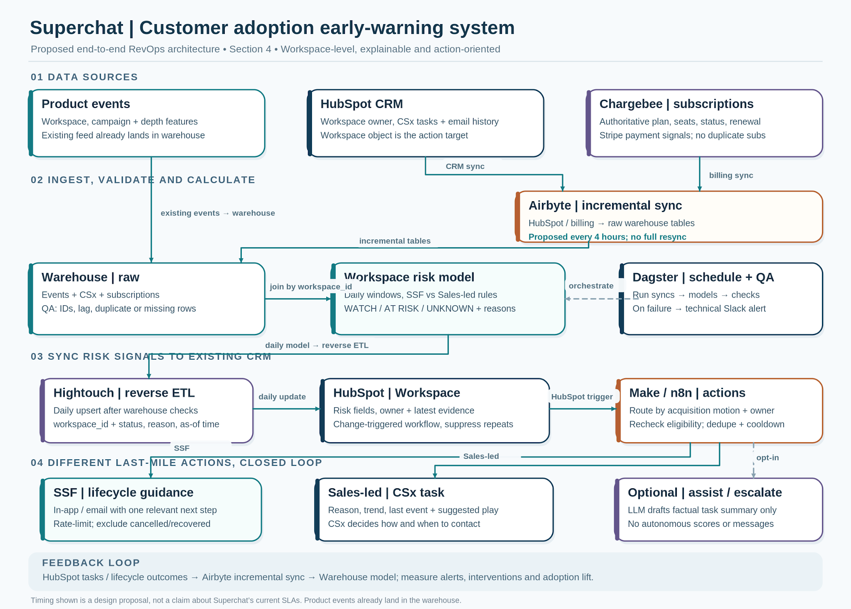

Section 5 — Question 1

Question: Walk us through what our CRM can and can't answer about the accounts above. Be specific — which questions would a CS lead, a finance person, or Jonas ask that this structure handles badly?

My assessment: HubSpot can show individual workspaces reasonably well, but it struggles to give a reliable picture of a customer operating across several workspaces.

What it can answer: At the Workspace level, we can see plan, seats, acquisition motion, the listed owner and primary contact. Each Workspace has its own CB Subscription; subscription details can be used where the associations have formed correctly. The four Beauty Lounge records have 8 + 6 + 4 + 25 = 43 licensed seats across four separate subscriptions. They look related, but that doesn't prove they're one legal customer or payer.

CS lead — 'Which Beauty Lounge locations need help, and who should follow up?' Today there isn't a reliable group-level view because Workspace → Company associations aren't consistently populated and Company parent/child links aren't used. We also shouldn't assume a shared Contact represents the right owner or context for every workspace.

Finance — 'What's Beauty Lounge's total recurring revenue and renewal exposure?' There are four separate subscription records, but the model doesn't reliably establish which belong to the same billing or legal entity. The sample has seats and plans, not prices, payer details or renewal dates, so I can't calculate group revenue from it.

Jonas (AE) — 'Do the three SSF locations belong to my 25-seat Sales-led Beauty Lounge GmbH account, and is there an expansion opportunity?' He owns the GmbH Workspace, not necessarily the other three. Shared email contacts don't establish the commercial relationship or which contract covers each location. The current model doesn't answer that reliably.

Another problem: One person can belong to several workspaces. Those User records share a login ID and can point to the same Contact, so Contact-level reports can mix activity from different workspaces or count the same person more than once. Physio Nord Hamburg and Café Milo, the other two sample records, can each be described as individual SSF Workspaces with a plan, seat count and primary contact; the sample does not establish any parent company, shared payer, wider customer group or Sales relationship for either.

My takeaway: The Workspace view works for local account facts, but missing and inconsistent associations make multi-workspace reporting, ownership and expansion decisions unreliable. I'd validate the relationships before grouping accounts, summing revenue or automating outreach.

Section 5 — Question 2

Question: Superchat is moving upmarket, and accounts like this will become more common, and bigger. Redesign the model: what changes, what stays, and why? Show the objects and how they relate.

My design: Keep Workspace as the product-level account and retain the existing HubSpot objects. Add verified Company relationships so we can understand larger customers without merging independent workspaces.

What stays

Workspace: One record per actual Superchat workspace. Keep its product ID, plan, seats, motion, lifecycle stage, owner and Section 4 risk signals here.

CB Subscription: Keep the billing record linked to its Workspace by an external subscription ID. In the example there is one per Workspace; support subscription history without overwriting past records.

User → Contact: Keep workspace-specific User records, each linked to the matching Contact for that person. One Contact can therefore relate to several Workspaces through different Users. Keep existing Leads for qualification and Deals for Sales-led opportunities; do not create Deals for every SSF signup.

What I'd change

Company becomes the verified business and reporting layer. Use Company parent–child relationships only when the corporate structure is confirmed; don't create a parent Company just because workspaces have similar names or email domains.

Link each Workspace to its verified operating Company with a clear association label (or leave it unassigned for review). Link the CB Subscription to its verified bill-to Company when needed, since the payer may differ from the operating entity. Chargebee remains the source of truth for subscription status and revenue; the Workspace–CB Subscription association links the product and billing records and must be verified.

Associate each Sales-led Deal with its actual buying Company and explicitly link the Workspaces included in the opportunity or contract. That lets Jonas see a genuine cross-workspace expansion opportunity without treating every workspace with the same primary Contact as his account.

For identity and ownership, keep the Contact as the person and the User as the membership in a specific Workspace. Keep group/account owner and Workspace CSx or AE responsibilities separate where they differ. Use stable IDs, required association labels, deduplication checks and an 'unverified' state; never group accounts automatically by domain.

Beauty Lounge example

Keep Mitte (8 seats), Charlottenburg (6), Spandau (4) and GmbH (25) as four separate Workspaces with their four subscriptions. That's 43 licensed seats in the sample, not yet a verified single customer's total. I'd ask Sales/CSx or Finance to confirm which legal Company operates each workspace, whether a parent group exists, who pays each subscription, and which workspaces (if any) Jonas's Deal covers. Only then would consolidated reporting be safe.

Why this is worth doing

CS can see group-level health and still act on the exact at-risk Workspace. Finance can roll up subscription revenue by verified paying Company and, separately, by a confirmed corporate parent. Sales can view buying relationships and real expansion opportunities. The risk model from Section 4 continues to write to Workspace, so a healthy location doesn't hide a struggling one.

What I'd avoid: No mass-merging of Workspaces, no unnecessary new custom objects, no inferred legal relationships from a shared Contact, and no changing the existing product or billing record creation flows just to make reports look cleaner.

Proposed object-relationship diagram

Solid connectors show core associations; dashed connectors show optional or explicitly verified links. Parent, operating and bill-to are distinct roles of the existing HubSpot Company object type, not three new object types. The payer can be the operating Company or a different verified Company.
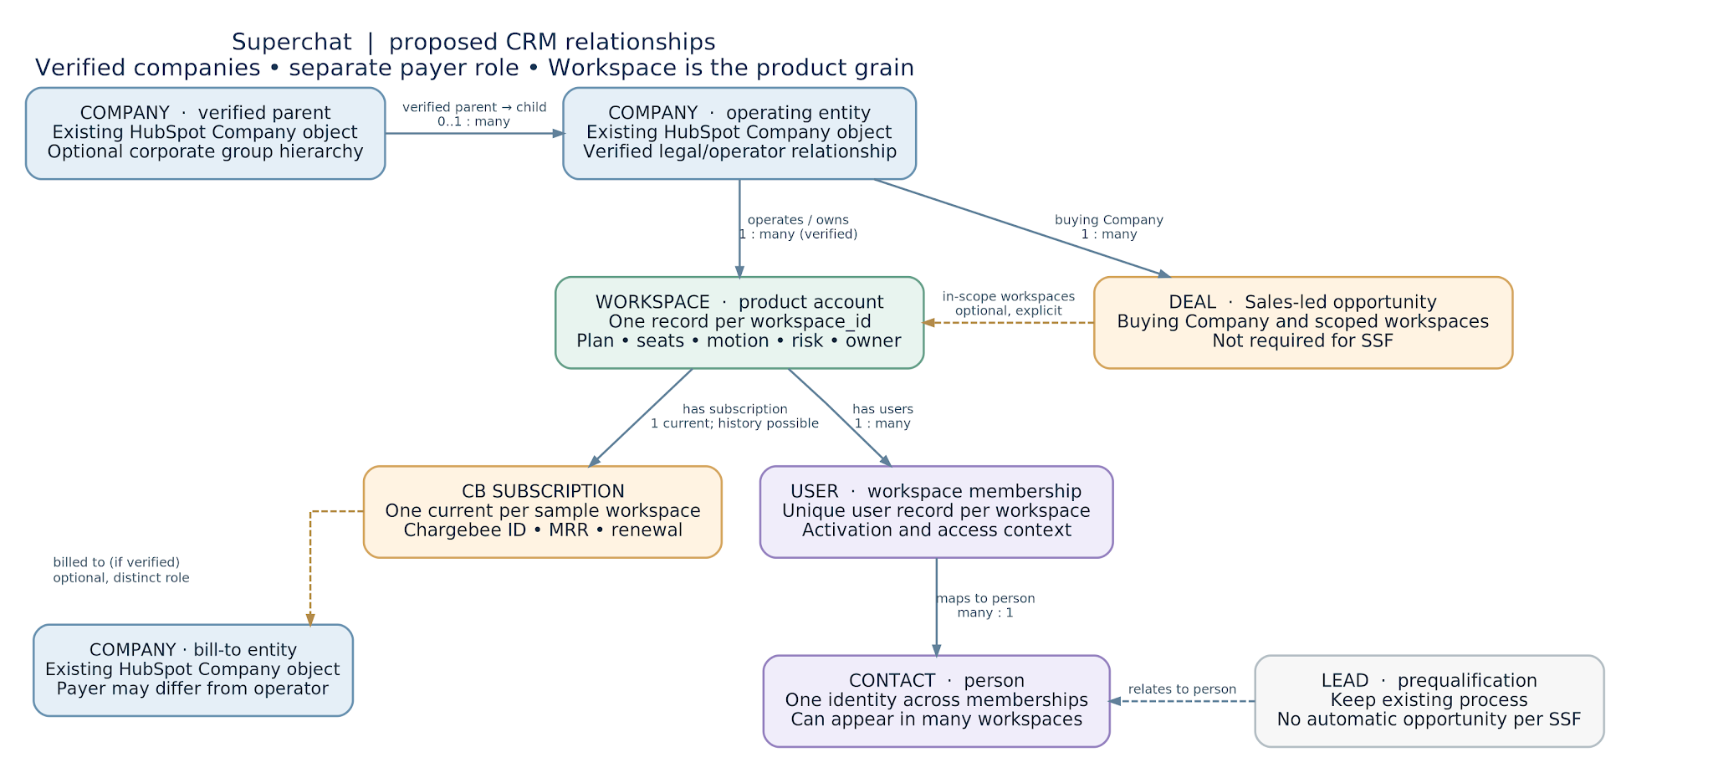

Section 5 — Question 3

Question: Your redesign has to happen on a live CRM that GTM teams use every day. What would you change first, what would you deliberately leave alone, and what could go wrong in between?

My approach: I'd improve the relationships in small, reversible steps, not rebuild a CRM that Sales, CSx and Finance already use every day.

What I'd change first

1. Audit before editing. Map the current Workspace → CB Subscription, User → Contact, Workspace → Deal and Workspace → Company associations. Review the HubSpot workflows, including retries and fallbacks for self-signup, checkout links and partners. Measure missing, duplicate and wrong links, and save the current workflow settings and association IDs so changes can be traced or reversed.

2. Agree on the rules and write ownership. Use the product Workspace ID and Chargebee subscription ID as immutable matching keys. Require confirmation from Sales/CSx or Finance for operating Companies, any different bill-to entity, and Deal scope; unknowns go to an exception queue, never a domain-based auto-match. Assign exactly one authorised writer per association type and a versioned change log; competing legacy retry/fallback branches must be tested in shadow mode or gated for pilot records so they cannot overwrite a verified new link.

3. Pilot before rollout. Start with a small, representative set, including the Beauty Lounge workspaces and different signup motions. Populate verified Workspace–Company links without replacing the existing creation or association workflows. Compare the new grouped views with the individual Workspace and Subscription records. Check that subscriptions and revenue are counted once, ownership is correct and existing CSx tasks still work. Only then backfill in small batches and widen the rollout.

What I'd leave alone

I'd keep backend-created Workspace, User and CB Subscription records, their external IDs, Chargebee as the billing source, existing Contact/Lead/Deal processes, and the proven association retry flows. No bulk Company merges, no new Deal for every SSF account, and no automatic parent–child hierarchy based on a shared email domain. The Section 4 risk system would still score and act on individual Workspaces, not the company group.

What could go wrong

Competing association workflows could overwrite the new links or create duplicates. A shared Contact could wrongly connect separate businesses; a bad Company link could inflate group revenue or give Jonas access to the wrong opportunity. New grouping rules could also send risk notifications or CSx tasks to the wrong owner. Sync delays may make records look missing when they're only late.

How I'd protect the live CRM

Run the pilot in read-only comparison views, then allow only the designated association writer to update approved records. For pilot records, shadow or gate conflicting legacy branches while preserving their configuration and retry history. Log each changed link (old/new IDs, verified source, writer, reason and time), monitor overwrites and exceptions, and reconcile subscription totals. Keep group-triggered actions disabled until approved. On a mismatch, halt that writer, re-enable the previous safe branch as appropriate, and restore affected links from the change log—without stopping backend or billing sync. Already-sent customer communications need a separate owner-led review, not just a technical rollback.

My first two-week commitment: A clear association map, a baseline of existing failures, a verified pilot and a reconciliation report reviewed with Sales, CSx and Finance. I'd scale the changes only once the team can trust the links.

Section 6 — Question 1 (Optional)

Context: Three months after the Section 4 system goes live, automatic messaging-channel updates migrate workflows in the background. Every migration emits workflow_edited, even though no customer made the change. This continues across most workspaces for three weeks; all technical syncs succeed.

Question: Trace what this does to your system — the signal, the flags, the actions. Where does the damage land first, who feels it, and after how long?

My assessment: This is semantic drift. workflow_edited remains technically valid, but no longer proves that a customer changed anything. The impact depends on whether any downstream metric or action still treats edits as customer engagement.

If the Section 4 design is working as intended: Risk is determined by confirmed successful workflow/AI executions and other independent signals, not edits alone. Background migrations can increase workflow_edited counts, but should not change risk status, CRM flags or customer actions.

Where it can break: The two-week MVP might still use 'days since last workflow edit' as a low-confidence proxy while execution tracking is incomplete. Any warehouse model, dashboard, CRM workflow or alert-suppression rule that reads an edit as human engagement could falsely improve account health. I'd audit all those dependencies, not just the main risk score.

Signal → flags → actions: As the backend emits automatic workflow_edited events, they land in the warehouse normally. On the next daily model run, the naive 'last activity' date moves forward. Some WATCH/AT RISK conditions may clear or be delayed, although real customer use has not changed; other independent failure or billing signals may still keep an account flagged. At the next daily Hightouch sync, the wrong status or reason reaches the HubSpot Workspace. HubSpot/Make/n8n then may suppress SSF onboarding guidance, close or fail to create CSx tasks, or start an inappropriate cooldown — only where automation is configured to react to that change.

Who feels it, and when: The first damage is to the meaning of the raw usage signal, followed by the warehouse's daily classifications (within roughly a day of each migration, under my proposed schedule). The next HubSpot sync and triggered workflow carry it into GTM actions, potentially the same or following day. CSx and lifecycle teams see fewer legitimate accounts to help; affected customers lose timely guidance. The problem spreads as migrations reach more workspaces over three weeks, while any 14-day activity lookback can stay misleading after the final migration. Churn or missed expansion may only become apparent weeks later.

Why everything stays green: Airbyte/Dagster/Hightouch successfully process well-formed events. Sync health checks say data arrived, not that workflow_edited still represents deliberate user behaviour. That's semantic drift, not a pipeline outage.

Illustrative check: Account A's last recorded workflow edit was on day 19; the events do not identify who initiated it. If a hypothetical migration fired on day 40, a naive 'last edit' measure would show just 1 day since an edit on day 41, rather than 22 days since the earlier recorded edit. Neither edit proves human engagement, and this migration is an example, not a claim about Account A.

First thing I'd verify: Compare workflow_edited counts with successful workflow executions and deployment history. Check actor/origin metadata and every downstream use of the event—warehouse models, dashboards, HubSpot properties, task triggers and suppression rules. Exclude system edits from engagement; if their origin can't be determined, mark the proxy untrusted.

Section 6 — Question 2 (Optional)

Question: Three weeks pass before anyone notices. Walk through the cleanup: what do you recompute, what do you do about actions your system already took on the wrong accounts, and how do you handle it when full re-ingestion is expensive?

My approach: Treat this as a data-correctness incident, not a failed sync. Fix both the risk history and the customer decisions it caused, without assuming every migrated workspace was affected.

1. Contain the damage

Pause only rules, CRM property updates and outbound actions that rely on workflow_edited as a proxy for human engagement; keep genuinely independent risk signals and normal product/billing ingestion running. Preserve the raw events, affected Dagster/Hightouch run IDs, existing daily scores and HubSpot/Make/n8n action logs. Tell CSx and lifecycle owners that recent 'Recovered' statuses or closed tasks may be unreliable until checked.

2. Find the impacted records and recompute

Ask Engineering for the deployment time and migration job IDs. Ideally classify the affected workflow_edited events by event_id, workflow_id, workspace_id and actor/origin; if the schema doesn't support that, use migration logs and timing to isolate a candidate set and mark uncertain edits UNKNOWN rather than assuming they're customer-initiated. Keep immutable raw data and record the correction in a versioned exclusion/classification table.

Recompute daily Workspace signals and risk status for the three-week incident period, with the preceding lookback required by each metric (at least 14 days for the proposed rolling usage comparison; fetch an earlier last-known-valid event if necessary). Extend the replay past the final migration until contaminated events have aged out of the rolling metrics and no longer affect account classifications; the necessary post-incident period depends on each signal. Rerun the downstream 'Watch', 'At risk', 'Recovered' and action-eligibility decisions as-of each day. The intended Section 4 model already uses successful workflow/AI executions, so those parts may not change at all; the vulnerable area is any leftover edit-based proxy, dashboard or suppression rule. Compare old versus corrected scores to produce an explicit affected-Workspace list, not a blanket assumption that all migrations produced false healthy accounts.

3. Repair the last mile

For each changed decision, join the corrected timeline to HubSpot property history, CSx tasks, lifecycle sends/suppressions and Make/n8n action logs. Split findings into: missed actions (an account looked healthy and did not receive help), actions closed or delayed incorrectly, and any unnecessary communication that was actually sent. Recheck the customer's CURRENT subscription, risk, opt-out, owner and recent contact before creating or reopening a task or sending an approved message. Use workspace_id + reason + cooldown as the idempotency key, so a replay doesn't double-contact anyone.

Messages already sent cannot be unsent. For material mistakes, have the account owner decide if a correction or apology is warranted. Log what was repaired, what cannot be reversed and any remaining uncertainty. Don't replay old customer-facing actions blindly: the account may have recovered or cancelled since then.

4. Keep the Airbyte bill under control

If the affected raw events are already in the warehouse, there is no reason for a full Airbyte resync. Apply a small correction mapping and rerun the affected warehouse models and Dagster partitions plus their dependencies in an isolated historical replay, with Hightouch writes and all customer-facing CRM/Make/n8n automations disabled. Validate the corrected history and reconcile its impact first. Then sync only current, approved Workspace changes through Hightouch, and repair justified actions separately with the existing idempotency and eligibility checks. Never replay historical risk transitions directly into live customer messaging. Where source evidence is truly missing, request a targeted API export or bounded incremental backfill from the appropriate cursor rather than reloading all history. Reconciliation should be against stable IDs and the action audit trail.

5. Prove recovery before resuming

Check that corrected risk counts and Workspace IDs reconcile, historical actions are classified, unexpected 'Recovered' transitions are explained, no duplicate tasks/sends were created, and a CSx sample agrees with the current state. Add a regression check that background workflow edits never count as user engagement. Restart affected automations in a small monitored batch with an owner and a rollback option.

Bottom line: Correcting the model is only half the cleanup; I also have to find and repair customer interventions that were missed, delayed or wrongly triggered.

Section 6 — Question 3 (Optional)

Question: You couldn't have predicted this exact change. What's the cheapest thing you could have built to catch it — and surprises like it — in a week instead of three?

My answer: I'd add one daily signal-integrity check in the existing warehouse, orchestrated by Dagster and notifying RevOps/Engineering in Slack. It's a small SQL quality monitor, not a new observability platform or a predictive model. A pipeline can be green while the meaning of an event has changed.

What I'd check

1. A change in event behaviour. For each day, calculate workflow_edited events and distinct Workspaces with an edit, normalised by recently active Workspaces. Compare daily spikes and 3–7-day drift with a rolling same-weekday baseline, and retain a versioned last-known-good baseline from before any suspected shift. Freeze that reference during an investigation so three weeks of system edits cannot gradually become 'normal'. Segment by motion or account age where volumes allow. An unusual rate is a reason to investigate, not proof of a bad release.

2. A change in what the event appears to mean. Compare edit activity with independent successful workflow/AI executions when available. If those execution events are unavailable, still monitor anomalous edit rates and WATCH/AT RISK → RECOVERED transitions that lack supporting evidence; mark edit-derived engagement UNKNOWN, and never trigger customer outreach from that proxy. Missing telemetry should reduce confidence, not silence the anomaly monitor. If actor/origin is absent, I wouldn't silently treat an edit as customer behaviour.

3. A change in decisions. Track the share of Workspaces moving WATCH/AT RISK → RECOVERED, plus tasks or lifecycle prompts suppressed for 'recent activity'. Alert on a material increase without supporting successful feature usage. This second check matters because automatic migrations roll out across three weeks: a modest but persistent shift in decisions could be more revealing than one huge spike.

How it runs and what happens next

After the daily warehouse models calculate their signals—but before Hightouch syncs edit-dependent risk fields to HubSpot—run a Dagster SQL pre-flight check against both the rolling trend and frozen last-known-good baseline. If it flags a credible semantic issue, hold only the affected edit-derived CRM fields and downstream actions pending RevOps review; let verified execution-based and unrelated signals continue. Start with review thresholds such as an edit rate above 2× a comparable baseline without a corresponding lift in confirmed executions, or abnormal RECOVERED transitions unsupported by independent activity. If executions are unavailable, check rate drift and suspicious recoveries anyway, but treat engagement as UNKNOWN. Thresholds are hypotheses to calibrate, not Superchat benchmarks; apply minimum-volume checks.

Send one deduplicated Slack alert to a named RevOps owner and Engineering with the metric, both baselines, affected Workspace count, anonymised sample IDs, data-quality caveats and a Metabase/SQL drill-down link. The owner inspects recent deployments and event origins, then confirms whether the narrow hold should continue or be released. The check doesn't change customer health itself or contact customers; it prevents only untrusted edit-dependent updates from propagating while keeping independent billing, messaging and verified execution signals live.

What I'd build in five working days

Days 1–2: Inventory where workflow_edited affects warehouse models, HubSpot and lifecycle decisions; define the active-Workspace denominator, a stored last-known-good baseline, a rolling same-weekday comparison and the owner of the pre-Hightouch gate.

Day 3: Build the versioned warehouse SQL check and Dagster dependency before the affected Hightouch sync. Track edit rate, independent execution when available, unsupported RECOVERED transitions and missing-telemetry states; persist daily counts and sample Workspace IDs.

Day 4: Dry-run past data and a gradual migration scenario; verify the frozen baseline doesn't drift with contamination, the check still alerts when execution telemetry is missing, and a flagged run gates only edit-dependent outputs.

Day 5: Enable one actionable Slack alert and the narrow pre-sync hold with an owner runbook: inspect actor/origin, successful executions if available, recovered transitions and Engineering's changelog; mark untrusted engagement UNKNOWN, release only after review, and tune false alarms weekly.

Why it's cheap and generalisable

It reuses data already in the warehouse and tools Superchat already runs, avoiding new ingestion and expensive full resyncs. More importantly, it watches the relationship between an event, verified user behaviour and GTM decisions—not the spelling or schema of one event. That gives us a chance to investigate similar semantic changes on the next daily run instead of trusting green syncs for three weeks. It won't catch every subtle drift, so I'd measure alert-to-investigation time and false-positive rate and improve instrumentation of actor/origin and successful executions over time.

Section 7 — Build the tool

Original task: Design the internal tool where GTM teammates review risk flags, correct wrong ones, feed corrections back and see outcomes. Include an actual main-screen wireframe, data flow, actions, frontend/backend choices, where AI belongs, a two-week solo MVP and three-month kill criteria.

My design: Superchat Signal Desk. The point isn't another account-health dashboard; it's a review-and-decision surface where a person can see why one Workspace was flagged, trust or reject the evidence, and take one safe action with an auditable outcome. The warehouse remains the source of the risk calculation and HubSpot remains the operational CRM. I would not make the tool a second scoring engine.

The end state — main screen

CSx works the assigned Sales-led queue, Lifecycle handles SSF onboarding cases, and RevOps owns quality exceptions, false-positive patterns and reporting. A lead can look at unreviewed workload and completed interventions. Every row is one Workspace, not an inferred Company group; verified related Companies are context, never a reason to fan out tasks to other Workspaces.

The Needs review queue contains only evidence-backed AT RISK and WATCH Workspaces. UNKNOWN cases have a distinct Data quality queue with no automatic outreach; RECOVERED goes into a separate read-only history. A selected Workspace opens its actual reasons, 14-day trend, last confirmed workflow/AI execution, freshness, model version, owner, prior contacts and action history. The correction form requires a reason for FALSE POSITIVE, and both a reason and expiry for SNOOZED; Data issue opens a QA case. Reviewers can drill into source IDs, not infer execution from a workflow edit. All values in the wireframe are illustrative, not Superchat records.

Signal Desk — annotated main-screen wireframe (illustrative)
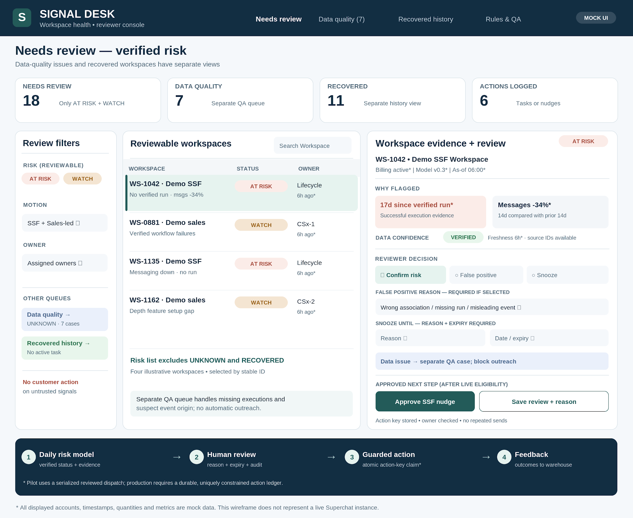

Data contract and downstream flow

1. Read-only signal. The daily Dagster model publishes workspace_risk_daily (workspace_id, as_of, model_version, status, reason codes, verified feature-use timestamps, messaging trend, confidence and freshness). Hightouch writes approved current-state properties to the matching HubSpot Workspace. The queue reads those CRM records; an evidence drill-down can query a scoped warehouse view or link to Metabase. Chargebee remains authoritative for subscription eligibility, and HubSpot for current owner, contact preferences and prior outreach. I would never join records by email domain.

2. The review action. The app writes a separate human review state, rather than overwriting the computed risk: CONFIRMED, FALSE POSITIVE, SNOOZED with expiry, or DATA ISSUE, plus a required reason, reviewer and timestamp. A disputed or UNKNOWN signal blocks edit-based/customer-facing action until checked; it does not pretend the underlying warehouse model changed. HubSpot properties/notes and associated tasks form the initial operational record. Incremental HubSpot ingestion via Airbyte returns reviews, tasks and lifecycle outcomes to the warehouse for model QA, measurement and a daily open-case snapshot.

3. One safe action at a time. 'Confirm' enables a proposed next step, not an automatic email. For Sales-led Workspaces, 'Create / update CSx task' targets the verified owner; for eligible SSF, 'Approve nudge' selects an approved onboarding template. 'False positive' requires a reason (for example, wrong association, missing execution events or misleading system edit), 'Snooze' requires a reason plus expiry, and 'Data issue' creates a separate QA case without customer contact. Before sending or creating tasks, the server rechecks current Chargebee status, HubSpot owner, consent, existing contact, risk/freshness and cooldown. Each command has an action key: workspace_id + reason_code + action_type + cooldown_window. Checking for an existing HubSpot task alone is NOT concurrency-safe: the production-grade path needs an atomic, durable claim of that key (for example, a small Postgres action ledger with a UNIQUE constraint and INSERT ... ON CONFLICT DO NOTHING). Only the successful claimant dispatches. Store the external task/message ID and state; retries reconcile pending entries rather than sending blindly.

4. Track the result. Every decision records reviewer, previous/new review state, reason, evidence/model version, requested action, action key, claim/dispatch status, API response and downstream task/message ID. An accepted claim is not proof a send succeeded: reconcile pending and failed records against downstream activity before retrying. Make/n8n handles approved routing, HubSpot holds tasks and contact history, and incremental warehouse ingestion evaluates later successful feature use, recovery, downgrade and unnecessary contacts. Corrections append audit entries instead of deleting the old decision. Actions remain Workspace-specific even where a verified Company spans locations.

Frontend, backend and access

For the fully grown tool I'd use a small internal Next.js/React screen with TypeScript server endpoints: a straightforward queue and detail view, not a platform rebuild. Server-side endpoints read approved warehouse aggregates or HubSpot properties and call HubSpot/Make APIs only for permitted operations. HubSpot remains the source for ownership/tasks and the warehouse for risk scores. The standalone version would add only a tiny durable action ledger with an atomic unique-key constraint when concurrent reviewers or automated dispatch require it—not another CRM or scoring database. Existing HubSpot review properties and notes remain the human review record. Use company SSO, server-side Workspace permissions, scoped API tokens, no exposed secrets and minimal contact data. CSx acts on assigned records; Lifecycle on authorised SSF cases; RevOps handles QA. Managers see aggregates rather than unrestricted contact details.

Where AI helps — and where it doesn't

An optional LLM could draft a brief, source-linked explanation from approved structured evidence ('No confirmed workflow runs in 17 days; messaging down 34%') or suggest which documented playbook to read. It could also cluster reviewer false-positive reasons for a weekly RevOps review. It must not assign the risk level, infer customer intent from workflow edits, change Company links, invent missing events, override a reviewer, decide who to contact or send messages. I would keep raw chat/message bodies and unrelated personal data out of the prompt. Any AI suggestion is visibly labelled and checked by a human.

The first slice — what I'd ship alone in two weeks

I would deliberately NOT build this separate React app first. Week 1: validate the Workspace risk fields and associations from Section 4, add a HubSpot saved 'Needs review' view with status, reason, confidence, scored-at time, owner and last outreach; configure reviewer status, reason, reviewer and snooze-until fields separately from the model score. Include an UNKNOWN/data-quality view. Pilot with the same small verified set of workspaces, and confirm that a false-positive decision can be recorded without corrupting the computed score.

Week 2: add a lightweight HubSpot action playbook: one approved CSx task and, only when safely controlled, a human-approved SSF nudge after live eligibility checks. For the small HubSpot-first pilot, route requests through one serialized, supervised Make/n8n dispatch path, recheck existing tasks/sends immediately before action, and store the action key plus remote ID in HubSpot review history. This reduces duplicates but does not claim transactional exactly-once delivery; concurrent/unattended sends stay out of scope until a durable unique-key ledger is available. Feed reviews and outcomes back through HubSpot → Airbyte → warehouse. Test rapid duplicate clicks, retries, cancelled subscriptions, opt-outs, stale scores, wrong owners and rollback. Pilot with one CSx reviewer, Lifecycle and RevOps. Ship the review loop and Metabase report—not a login app, AI copilot or multichannel builder.

When I'd kill the tool after three months

I'd compare it against a HubSpot-only baseline rather than justifying a tool because it exists. Proposed day-90 gates (to calibrate with GTM after measuring the starting point): at least 70% of eligible flagged Workspaces get a documented review within two business days; at least 20% lower median time per completed review versus comparable HubSpot-only cases; and no increase in duplicate or inappropriate outreach or opt-outs. I would also require that corrections actually reach RevOps and improve at least one documented rule, source-quality check or action playbook. Track reviewed/eligible cases, time from flag to decision, false positives, reviewer adoption, open-case backlog and safety incidents by Workspace. The underlying SSF 90-day adoption impact needs mature cohorts and a comparable holdout: 41% is the case baseline and ~46% remains an experimental target, not a promised three-month result.

If fewer than 70% of eligible cases are reviewed within two business days, triage is not at least 20% faster without extra workload, or the safety guardrails regress, I'd investigate the causes before expanding. If the queue remains unused, adds clicks compared with HubSpot or corrections never influence decisions, I'd kill the separate-app plan and retain only useful HubSpot views and data-quality checks. Any material privacy breach or unapproved customer send halts dispatch immediately, regardless of productivity gains. The goal is fewer missed accounts and safer, faster interventions—not maintaining another interface.

Section 9 — Feedback on the challenge (required, not graded)

1. Roughly how long did this take you, end to end?

I spent approximately 15 hours across several sessions. A good amount of that time went into validating the assumptions, building the architecture and tool sketches, and making sure the answers connected—not just writing them.

2. Which section took you the longest, and which was quickest?

Section 4 was probably the most time-consuming because designing a credible end-to-end system meant deciding where each responsibility belongs, how the tools connect and what could realistically ship. Section 7 also took time because of the actual wireframe. Section 3 was the quickest; once I'd worked through the funnel and account patterns, the priority call was relatively clear.

3. Was anything unclear, ambiguous, or missing?

The ambiguity mostly felt intentional, which is realistic for RevOps. The biggest gaps were whether product events represent successful workflow execution versus configuration activity, what reliably links Workspaces to legal/billing Companies, and what the existing risk/action tracking already covers. I made assumptions rather than treating missing evidence as proof. A brief example of the current reporting or CRM workflow setup would have helped distinguish what needs building from what already exists.

4. Which part was most interesting, and which felt least worth your time?

Section 6 was the most interesting to me. The workflow_edited scenario gets at a problem that's easy to miss: data can be technically correct and every sync can be green, while the decisions built on top of it become wrong. The least useful part was some repetition around identifying and describing the same adoption/risk signals across Sections 2 and 4. I understand why the sections build on each other, but a little less overlap would keep the focus on new decisions.

5. Anything else?

Overall, I liked that this tested judgment and trade-offs rather than asking for a perfect textbook architecture. The real stack, messy CRM associations and requirement to show actual artifacts made it feel close to the job. My main feedback is on scope: written analysis, an architecture diagram, a tool wireframe and a required video add up to a fairly substantial take-home. An indication of the expected time investment, or a slightly narrower required scope, would make it easier to judge how deep to go. I appreciated the freedom to state assumptions and choose a lean MVP rather than over-engineer the answer.

